The Patriot

B
eing at home for several months without an income stream could be devastating. Here in Nigeria, there are millions of displaced people out there. Youths have taken to the streets and flooded it with their filth of their heinous crimes as they deem it fit the only way to survive. The days that graduates of high schools needed just their intelligence, to become undergraduates have become chaff which the winds have blown away. Universities waited for young talents and brainiacs with open arms, giving them a warm reception into their various fields of indulgence. A lazy student becomes a failure as he deserves, but the workaholic counterpart? He is guaranteed of success. Little wonder the Holy Book says “Have you seen a man diligent in his work, he will seat before kings and not mean men.” but in deep anguish I say to myself, “why was I ever born in this new era – the millennial era. Here, the economy is much tough than what it used to be. Everyone had gone nerdy and techie, other values have been abandoned. Universities no longer belonged to the student that makes straight “A’s” in the High School examination by hardwork and exhaustion of mid-night candles. Our campuses have totally lost their immunity against the pathogens of lazy, decadent and narcissistic students who only have a shot at their own selfish interests.


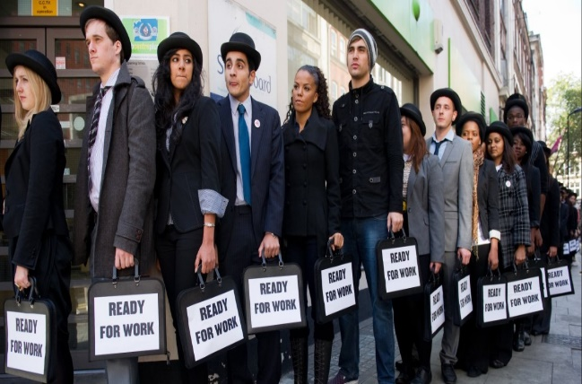
Our millennial campuses, have spurted dead minds and drone consciences into the nation. Our sons and daughters are migrating towards foreign lands for pleasures sake – not for what they have to input into the economy they infiltrate. Jobs usually waited with open arms receiving graduates of universities with a warm embrace, into their field of study.
But in today’s regime, graduands now have to go through a lot of effort, time, money and energy, getting educated in the field they had not selected for their matriculation examination, and they remain in their dark tunnels almost forever with no signs of a ray of light.

Things have gone haywire. There are a lot engineers at the bank. Jobs no longer waited for graduates, the reverse is the case. Life in the days our ancestors was about all you could get from it – but now, it’s about all you have to input. We blame our leaders for our misfortunes as a nation – yes! They also have a part to play. I have heard people say that “it is when the head is sick, that the rest of the body is affected.” That theory for me has been cooked up, just to push all the blame of the country’s downward turn on the leaders. But in actual fact there are exceptions to the rule aforementioned. I asked those who are of the opinion, “what if accidents occur, and a part of the body is damaged. Is the head also responsible?” accidents could occur technically or as a natural phenomenon; it could also be initiated by human error of judgement. accidents could be as a result of hampered planning skills. I have there correlated the nation’s perils to the fact that the head which consist the Judiciary, Legislature and Executives may be ill in most areas that affect the nation. But members of the grassroots also need cross examination. The Holy Book has painted the perfect picture when it says “train up a child in the way he should go and when he grows up he’s not going to depart from it.”
Parents of the computer age have now abandoned the roles of grooming a child to suit the nation and the world at large in terms of input. They have been corrupted themselves so much that their evil communication has become contagious. Parents now install “lies” lieu the “truth,” “when the landlord comes, tell him am not at home.” Unconsciously, the seed of deceit has been planted. And when the child who lied for them, begins to lie to them and perpetuate all evil schemes – their souls get scathed.


What would a parent who has filled its child with junk expect from such a ward when he or she becomes a leader in the future? – junk. “so the bone of contention needs to be tackled. Charity begins at home, and so does villainy. The earlier the better parents begin to fix this, our children would gain quality training, stand out and we’d have a better world, full of peace, love and harmony. Our cultures and values which have been abandoned for the so called “Western Culture” needs to be embraced. The rise of divorce, abortion, rape and serial crimes is alarming. I reminisce the times when parents had to choose spouses for their children. They made research into the background of the spouse; for any medical records, background records from the parents of the spouse, believes and traditions from the spouse’s origin, records of warfare or disagreements between the clans or genealogy of the spouse just to mention a few.
All this information is scrutinized so that the parent is sure of the kind of family their child wants to choose a life partner from. And the intending couples too can have a view of the challenges their families may be into, and know if they can be breached or not. Marriages lasted. Abortion was at the barest minimum, and rape never stood a chance. There was discipline and order. A child could never say ‘yes’ when the parents say ‘no.’

No doubt. Civilization has it fringe benefits, but it should be as polish which makes leather shoes shine better and not water that destroys it. The Whiteman innovates, creates, motivates, appreciates all resources around him. He is compassionate as well about the well-being of his fellow. His counterpart goes contrary. He never wants to see his fellow rise above him, all because the fellow too will be full of pride and not look on him with piety. Every man is for himself in the dark nation. The Whiteman has used all he could get from the Blackman to achieve his aim of advancement and development. He takes our crude oil, refines it, has his own share of it for storage and is even kind enough to sell back to the Blackman whom he got it from. He taps into the numerous mineral resources, refines them and makes them into the ornaments the Blackman fancies and has robbed him of his sense of reasoning. Foolish enough, the Blackman who breaks the four walls of redundancy, and moves to be innovative by learning from the Whiteman, ends up using his skill to serve the Whiteman. He is not totally foolish. He is not to be blamed. Coming to his fatherland to establish what he knows is almost at its peril than hell is. The government wouldn’t support. He could be tagged a “failure” and his ideas labeled “useless,” so he stays in the Whiteman’s land, explores the opportunities that flow his way.
It is high time Africa arises from its slumber. Let the sleeping giants awake. Let’s put a stop to the importation of corruption, deceit, felony and injustice that the European world bring. Let’s use the Whiteman to our own benefit and developments as well. All we cherish are the Obamas, Abraham Lincolns, Winston Churchill’s, Ben Carson’s, Jay Z’s, Rihanna’s. We have abandoned our own Obafemi Awolowo, Nnamdi Azikwe, Sam Adeyemi, Fela Anikulapo Kuti Fabian Udekwu {some Nigerians may have never heard that name} and Oladuni Taylor.


Arise Africa! Arise Nigeria!! Unleash your gigantism. Let us cherish our own. Reform and revolutionize our minds. Raise our fists of rage against the innate desires of our flesh. Halt the killings of the innocent, but murder the greed and deceit in our heart. Politics doesn’t have to be a game, it can be the nation’s haven of success and achievements if we are determined. Parents should revive the long gone discipline. The tools of western development can be used to polish our crude standards – not abolish them. Social media can be a tool of the proclamation of the gospel of discipline and Christ. Small businesses can be made from the internet and not small boys and girls who waste money accruing data just to become slay queens and kings. Let our innovations be fanned into the flames of events memorial.
This is the time to fight for our pride. It is time to spread our clothes for the left over sun rays to dry. The loyalty and royalty of our nation needs rejuvenation. Get sense from the Whiteman, he never runs away from his fatherland indefinitely. He brings home what he gets from his tours and exploration. He brings in the good and not the bad. He is embraced along with his ideas. Let’s do the same for Nigeria. The government and the people should be prepared to receive the streams of talents we have abroad with open arms and jettison all greed and corruption. Every family should implant discipline, morals, Godly values into its child. The evil that erupted from the home can also be righted in the home as the saying goes “charity begins at home.” Children should yield to their elders. An elder may not be strong enough to fell a tree, but it takes an elder to know the direction a tree felled by a child. BE WISE!!!
Let’s start the revolution today. Raise the flag of war against corruption. IIT BEGINS WITH YOU!!!

