A Senseless Shame

By

Kathy Sullivan Evans

Outline

Dedication

Preface

Chapter 1 – Sign of the Times

Chapter 2 – A Birth

Chapter 3 – Growing up in Sunnyside

Chapter 4 – Leaving it all Behind

Chapter 5 – A good man

Chapter 6 – Married Life

Chapter 7 – A Hole in My Heart

Chapter 8 – Family Secrets

Chapter 9 – Living with a Lie

Chapter 10 – A Life Without Shame

Conclusion

DEDICATION

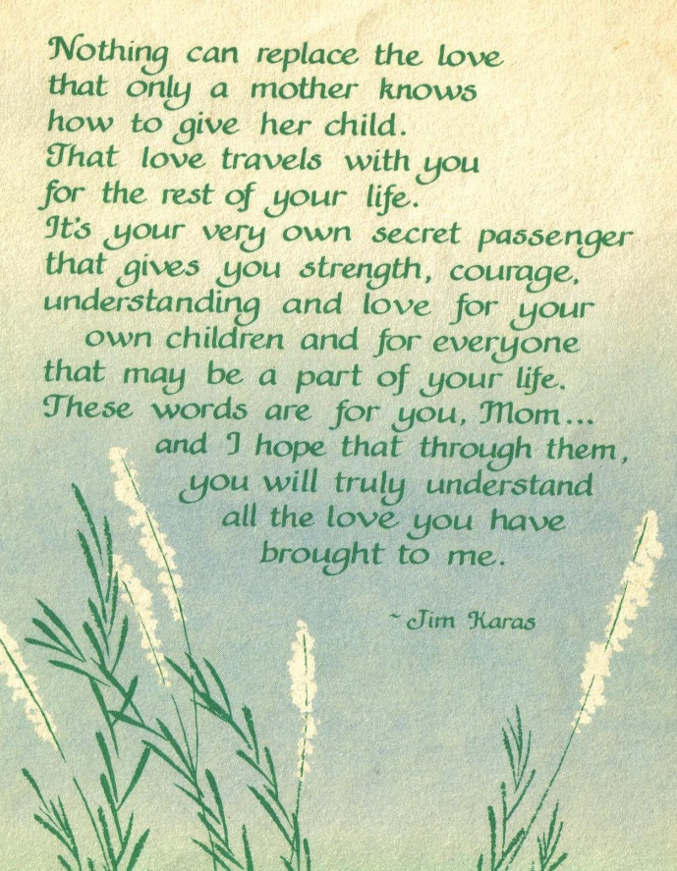
To my mother, who always reflected the image of a true Southern lady with an open heart and an endless supply of love to give to others. Mom, you are my inspiration and I’ll forever miss our daily girl talks.

To my grandmother, who I have come to understand her character and stamina from a lifetime of heartache. I can only imagine the fear and guilt she must have endured during her lifetime as a result of certain events. I love you and I have a renewed admiration of your courage.

To my great-grandmother who I’ve come to understand and admire for her strength and courage in having to make some hard life choices.

My sisters and I have been guided by their love and serve now as monuments to their strength and endurance during a time when others did not understand their choices. We will always love you and hold your memory dear to our hearts.

PREFACE

This book was inspired by actual events and attempts to show how one act of transgression touched four generations of women within one family and countless others indirectly. It follows the poignant emotions involved with having a second chance at love, the enduring marriage vows that require acceptance of each other “for better or for worse” and the trauma one woman endured when the family secret of her birth was finally revealed to her and her loved ones.

************************

Healing takes courage and we all have courage,
even if we have to dig a little to find it.
To find that voice deep inside themselves
which has been silenced by fear and
a senseless shame.

alternate beginning of the book

It was the morning of Mother's Day, my beloved Mother was dying and we knew that the time was coming soon for her to leave us and join my Dad in Heaven. For the past few weeks, she was rapidly losing weight and not as attentive as she once was. We knew we wanted to spend those last moments with her so we all spent the night in her condo sitting by her side and taking turns holding her hand and offering as much comfort as we could, all the while reassuring her that all of us would be okay and that we loved her very much.

She was quiet but her eyes told us that she was preparing herself. That night as I took position beside her bed, she motioned to me to come closer. As I sat beside her, holding her hand and her eyes softly peering into mine, she said “Honey there's something I need to tell you before I go.” With that she began to tell me her story, listening to each word that she struggled to speak but with such earnest with what she needed to say.

During the night, as I slept on the floor beside her bed I listened intently to her talk to my father as if he were in the room with us. One minute she would tell him, “I can't go - what about the girls? They still need me." Later on as the sun started creeping up over the horizon, she finally resolved herself and said to my father, simply “Well, okay then". With that I knew she was ready. I gathered my sisters around my mother's death bed and we each said our goodbyes, told her we loved her and that we knew she'd be with us always.

But before I explain what my Mother was so dead intent on sharing with me before she passed, I probably need to start at the beginning in order for you to understand the ending.

CHAPTER 1

SIGN OF THE TIMES

It was a hot, almost steamy day in great grandmother’s clapboard house on the outskirts of her hometown of Sunnyside, Georgia – population 248. While life in the rest of the country continued to struggle following the effects of the Great Depression, life in this small farm community lying just on the outskirts of Waycross, was all but standing still. The effect of the war on agriculture—which had formerly been dependent on slave labor – now was experiencing a rise in tenant farming and sharecropping, types of farming that was often accompanied by poverty and abuse. After World War I agriculture suffered further setbacks as the boll weevil caused great destruction to cotton crops and the soil became exhausted through erosion and overuse. A farm depression began in Georgia long before the general depression of the 1930’s and folks in areas like Sunnyside were no stranger to just being plain poor and hungry. Even though the famous Suffragettes had fought hard and long for women’s right to vote, the women in Sunnyside were lost in a time where women did what their husbands wanted them to do and their purpose was to bear children and keep house. – nothing more was expected of them.
This was a town where everyone knew everyone else – the local midwife had helped deliver every newborn for the past 18 years. Most of the kids only went to 5th or 6th grade, then either quit school to help on the farm or got married – yes, some girls as young as 11 or 12 years old! The local lumber mill was the only employer for 50 miles for those folks that didn’t have a farm to tend to and provided a somewhat steady, but meager, income. Yes, it was a very simple life growing up in Sunnyside – away from the hustle & bustle of the big city.

I can visualize great grandma standing at the kitchen counter once again making biscuits for the family’s evening meal. I always loved watching her make those biscuits – the pile of freshly sifted flour, making a large dip in the center in which she would break an egg and drop it square in the center. After adding her other secret ingredients, she would begin the process of folding over the flour until all the flour was mixed and then she would let the dough rise in the same light green bowl with a dish towel thrown over the top. Then, just as she turned to pour herself a freshly perked cup of coffee, her oldest daughter, Katherine, came running in thru the screen door from the back porch. She asked her about her day at school. Katherine looked dreamily out the window and mumbled a few words to her Mother but was more interested in just going to her room upstairs that she shared with her other sister, Dorothy, and just lie on her bed, close her eyes, and think about the new handsome student that just transferred from Waycross. He had the most beautiful crystal blue eyes and pitch black hair, and his smile … well his smile would just make ice cream melt! She hoped Dorothy wouldn’t try to beguil him away before she herself had a chance for him to get to know her. It was such a small school with a senior class of 12, so the pickins’ were pretty slim for dates to the Senior Prom which was coming up in just a couple of months! Matter a fact, Bertie and Dorothy should be home from school soon and George and DeWitt were already in the fields helping their Daddy, Andrew, so she didn’t have much time to daydream about Billy Joe Holton – not enough time at all.

My great-grandparents were sharecroppers and in those days it was a pretty common practice to grow your crops on someone else’s land then pay the landowner an agreed upon amount for the use of their land or a share in the crops. Sharecropping apparently began in the South after the plantation system was destroyed by the Civil War. The White Southern landowners hired the newly emancipated slaves to tend the land and grow crops in return for a place to live. The sharecropping family would do all the work of plowing and planting, weeding and harvesting but only keep a share of the crop, usually splitting the profits 50-50. Not a bad deal for the landowner but long, hard laborious work for the sharecropper and his family.

Both of my great-grandparents had been married before and were both widows when they met by chance at the church picnic in 1927 on a beautiful fall day in October.

Andrew, was tall and lean with piercing gray eyes but always carried a sadness on his face perhaps due to the unexpected loss of his second wife, Alice, from pneumonia after being married for only three short months. He had also lost his first wife, Georgia Lee, when she gave birth to their sixth child and daughter, Juanita. I know he had a very rough life throughout his school years. His days consisted of working the fields that his family owned and which they later lost when an unseasonal freeze destroyed the tobacco crop that was almost ready for harvesting. In addition, he helped with feeding the chickens, bailing the hay for the one field mare they had and clean the stalls, and looked after his younger siblings too. He didn’t get the opportunity to do much “book learnin” as there was a farm to tend to and so much more. Children grew up fast in those days. The only break from this hard existence was his brief tour in the U.S. Army during World War I. Before he went to war, he didn’t know much of anything about killing except for the time he had to shoot one of their cows who had gotten tangled up in the barbed wire fence or when their field mare had stepped in a gopher hole and broke a leg. Now, years later, he found himself in a strange land with a gun in his hand and orders to kill young men his own age just because they were Germans. As fate would have it, his term was cut short when he went into a bombed out shelter and surprised a wounded German soldier who in turn shot him in the leg. Andrew shot back instinctively and sent a fatal blow to the German soldier’s chest. Andrew was sent home from the war as a result of his wounds and he still carried the limp from his war wound until the day he died. Though he never seemed to let this disability stop him from working the fields to put food on the table, he had become more withdrawn each day that passed and his existence seemed destined to remain the same. He and his first wife, Georgia Lee, had borne a son, George, and four girls (Janie, Louise, Mary and Wylene). They also had survived the premature births and deaths of two infants (a girl, Alma, and a boy, Harold) as well as the untimely death of their daughter, Estelle, who at 12 years old was playing too close to the fireplace and her dress caught fire. Poor little Estelle lingered with severe burns for about a week then mercifully passed away. Then a few years later, when Georgia Lee died in childbirth with their last child - daughter, Juanita - he seemed to ultimately resign himself to a life of hard work with little pay but hopefully enough to raise his children until they could go off into the world to fend for themselves. Since he was unprepared to care for a newborn, he made the decision to have a neighboring farmer and his wife, adopt his little baby girl – she would be better off he thought at the time.

About six months after Georgia Lee died, Andrew met the daughter of the local hardware store owner when he went in to buy a new shovel. Alice was only 19 years old and seemed so full of life! Though Andrew was in his early 40’s, it wasn’t unusual for older men to marry much younger women in those days. He represented security to her and she was young enough to take care of the children and keep the house, as well as take care of his unquenched needs. Unfortunately, Alice came down with pneumonia and passed away after they had been married for only 3 months!

Just across the County and about the same time as Andrew married his first wife, my own great-grandmother, Mary Elizabeth, was marrying her school sweetheart – the love of her life - Charlie Hallman. While they dated, she was so happy. She and Charlie Hallman began to make plans to marry when he finished school and begin full-time work at the local newspaper as an editor – that was his lifelong dream to be a journalist and maybe someday have his own newspaper. Then, she found out she was pregnant and he was about half-way thru his junior year. She was only fourteen and had led a pretty sheltered life herself growing up on a farm and all. To Charlie, this predicament meant he had to quit school, find a home and a full-time job to support his new wife and prepare for the birth of their first child. That’s what men did in those days – they did the right thing if they got a girl pregnant. Since he couldn’t finish school, he struggled finding a permanent job so he took a laborer job at the local lumber mill so he would have a steady income. He worked hard and they were able to manage a household on the mediocre wage he was making. They even managed to put a few dollars in a little savings account for one of them “rainy days”. He stayed with the mill and soon his work ethic and common sense began to get some attention by the owners of the lumber mill. Eventually, he was offered a Foreman position, which meant a little more money but longer hours at the mill. Then, Mary Elizabeth found out she was pregnant with their second child! As the years passed, Mary Elizabeth bore three more children during their first five years of marriage. They now had a total of one boy, DeWitt, who was the spittin’ image of his Daddy and four girls (Francis, Katherine, Dorothy & Bertie). Of course, they continued to struggle to meet the needs of their growing family but they had settled in and their life seemed comfortable and happy for the next 13 years. Then tragedy struck. Charlie Hallman was asked to work the night shift as a supervisor when the regular supervisor’s wife went into labor. One of the workers called him over to help him get some gears unjammed on the assembly line – the pry bar slipped and Charlie Hallman fell into the bank of gears, killing him immediately. Mary Elizabeth was called and told there had been an accident and some company people would be coming to her house to fetch her and take her to the hospital. When the company people arrived, she knew from their faces that her sweet love wasn’t coming home. The days that followed were somewhat of a blur to her and luckily her brother handled most of the arrangements. Unfortunately, in those days in the absence of an undertaker, the preparation of the deceased fell on family members and friends. This meant that the body had to be bled out (years later my Aunt shared with my cousin the horror of toting buckets of blood out back of the house and poured into a deep hole that had been dug for just this purpose), the body then washed and clothed – then placed in a casket and would remain in the home until the day of the funeral. The time for mourning had to wait until after the funeral – there was work to be done.

