The Quetzal Skull
A story of a young man's rites of passage pitted against a drug dealing cabal.
by Margaret Gill

  Format: | 5.5 x 8.5 paperback cream
  ISBN: | 978-1-4327-6866-9
  Cover Price: | $16.95
  Trade Discount: | 50%
  Also Available: | Ebook Edition
  Pages: | 260
  Category:
  Available at: | www.outskirtspress.com/thequetzalskull
  Distributed via: | Ingram, Baker & Taylor
  Published by: | Outskirts Press, Inc.
  Receive up to 50% off at: | www.outskirtspress.com/bookstore
  Publication Date: | Jan 28, 2011

Gray’s discovery of a narwhal tusk engraved with ancient runes has alerted a drug-dealing cabal who believe the prophecy that the finder of these runes will lead to their downfall. Gray must be traced and annihilated. Is his encounter with Juan Perez, a Colombian shaman, a coincidence? And is it pure chance that links his destiny with that of a sacred crystal skull? “This is a gripping story, powerfully written, that held me from start to finish.” Pearl Luke author of “Madame Zee” “A VERY TALENTED WRITER” Charles Muller (Director of Diadem Books)

About the Author, Margaret Gill  Margaret Gill is an award winning author who has published seven novels for children and young adults.“The Quetzal Skull” is the thrilling sequel to “Narwhal”. www. margaretgill.co.uk.  For more information, visit http://outskirtspress.com/thequetzalskull | 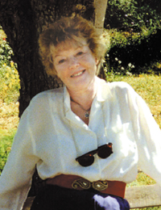

Outskirts Press, Inc., 10940 S. Parker Rd - 515, Parker CO 80134 Phone: 888-672-6657 Fax: 888-208-8601

