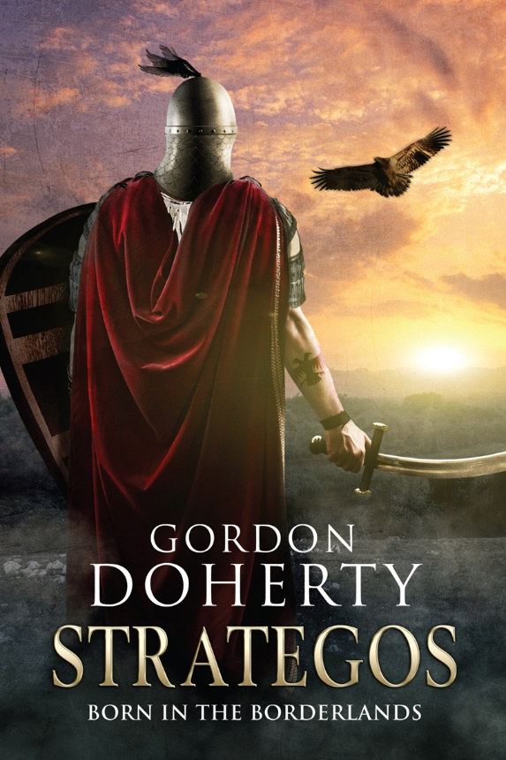
Prologue, 1026 AD: The Pontic Forest, Chaldia
I circle the grey skies, surveying the thick carpet of autumnal forest below. Then it is broken by a clearing and I am numbed by the sight of the still-smoking ruins and charred bodies strewn in the grass. It is only a small village in the borderlands of Byzantium, but it underwrites a truth that has been with me all my years: man will destroy man.
And in this part of the world it is like watching Prometheus live out his agony day after day as civilisations shatter against one another: the Greeks and the Trojans, the Hittites and the Assyrians, the Romans and the Persians. Now Rome’s heir, Byzantium, teeters on the brink of war with the burgeoning Seljuk Empire.
My age is almost past and my power cowed, thus I am little more than an observer of cruel fate, and fate has it that Byzantium is mortal. Yes, like all empires, Byzantium will fall, but I believe in the vision I had: the dark leader, not yet born, the one man who can prevent the devastation that fate has in store.
The Haga!
I sweep over the treetops, following the dirt path that snakes through the woodland. Then, some distance down that track, I sense them, Seljuk warriors, poised in the undergrowth like asps, waiting on their prey; proud men, unaware of their part in the everlasting cycle of destruction.
I sense a soul on horseback, approaching the waiting ambush. Then I feel it: he is part of the vision; he is why I was drawn here today. I cannot make this man or any other do my bidding; like a mirror to his soul I can only present to him what he already knows. But I must speak with him so that one day, when the Haga has risen, man can stand against fate.

***

Tepid rain fell in sheets, churning the forest path into mire before the depleted column of iron-clad riders. Only seven remained of the twenty five kataphractoi that had set out that morning. At their head, Cydones blinked the rainwater from his eyes and tugged at the beginnings of his dark beard, twisting it into twin points. With the light fading, the forest was becoming an army of shadows.
He shrugged to adjust his klibanion, the weight of the iron lamellar vest biting into his collarbone. Set an example, he chided himself and sat tall in his saddle. The men needed their leader to be strong after the events of the day. They had intercepted and slain all but the vanguard and rearguard of the Seljuk raiding party but had lost many friends and colleagues in the process. Yet there was no time to dwell on this latest incursion; the kataphractoi were few and precious and Chaldia was vast, the borders of the thema encompassing an area far greater than the skeleton garrisons and scant collection of full-time riders could hope to protect. As the raindrops rattled on his knuckles, he wondered at his choices in life that had brought him to this daily and brutal conflict.
Cydones’ life so far had been based on simple ideals and these were in stark contrast to those valued by the rest of his family. He thought of his older brother, Agapetes, and the wealth and luxury his sibling had amassed back in Constantinople in the family trading business. Cydones had never bonded with his brother, a cold-hearted boy and then a snake of a man who always sought to serve himself first. Agapetes had followed in his father’s footsteps and used his business nous to tap into the riches of the capital’s trade markets. That the poor bastard had died in an overloaded trade cog caught in a storm just off the Hellespont was a bitter irony, but that his father could only grieve at the loss of Agapetes the business partner and not Agapetes the son was a cold reality that Cydones just did not understand.
While his father and Agapetes had worked hard to take from the empire, Cydones had only ever wanted to fight for her. He traced a finger along the edge of the bronze Christian Chi-Rho on the chain around his neck. The symbol of God pierced the skylines of Byzantium’s cities and was painted on the shield of every imperial soldier; it was the symbol that his mother had taught him to respect and obey. His mother had been the only soul who seemed to understand him, her heart touched with warmth. When she died, his father had remained stony-faced and dry-eyed throughout the funeral, often neglecting his part in the ceremonies to attend to business. Cydones finally realised that his time with his family was over the following summer, the day he saw his father weep with joy at clinching a deal to bring regular shipments of wine and honey in from the groves and hives of Southern Anatolia.
So Cydones had left the capital and travelled east to the borderlands with only the tunic on his back, the Chi-Rho around his neck and a sling. Coinless, he had caught fish, raided beehives and trapped rabbits on the road to the region known as Chaldia, one of the easternmost themata of the empire. He had then signed up as a regular thema infantryman, a skutatos, committed to working an arid patch of land and then defending it with his life when the empire called upon him. When he had lifted the spathion and skutum, the Byzantine sword and shield, for the first time, it had been like a final closing of the door on his life back in the capital. From that point on, he had patrolled, fought and bled for the betterment of his people, quickly leaving the agricultural half of the soldier-farmer life behind as promotion after promotion came his way. And now he was a cavalry komes, in charge of fifty riders. This was his calling, and a brutal one it was. In the borderlands blood was readily spilled; brigands were a constant menace but the relentless westward progression of the Seljuk hordes was like a spear driving into the empire’s gut. They were only getting stronger year on year while the empire faltered under the squabbling of the power-hungry in Constantinople. He had seen an estuary flow crimson after one hinterland battle with the Seljuk riders; so many men dead and all just to limit the loss of imperial territory.
The clopping hooves of another mount shook him back to the present.
‘Lovely rain, hides from us all year, lets the sun scorch our crops, has us trailing halfway across the thema for a bucket of water . . . then this!’
Cydones blinked. The young, blue-eyed rider, Ferro, had ridden ahead of his ten to draw level.
Ferro closed his eyes. ‘Now I see a fire roaring back at the barracks; a plate of roast lamb and a tray of honey cakes.’
Cydones could not contain a wry chuckle. ‘I’ll add a keg of ale to the table, Ferro, when we get back . . . but keep your eyes on the treeline while we ride. Another night in this mire, then tomorrow, once we’re out of this damned forest, we can ride at a decent pace . . . ’ his words trailed off at the screeching of an eagle. He glanced up at the canopy of forest above; what he could see of the sky was an unbroken grey. When he looked forward again, his eyes were drawn to the undergrowth. A fern shook and then settled. The breath froze in his lungs.
‘Sir?’ Ferro cocked an eyebrow, hand resting on his pommel.
Cydones made to raise a hand for a full stop. Then a roar pierced the air.
Two packs of men burst from either side of the undergrowth; at least thirty of them, dark-skinned and moustachioed. Akhi, Seljuk infantry, hoisting broad-bladed spears and wearing felt caps and jackets. Immediately, two of his men toppled from their horses, impaled on the spears.
‘To arms!’ Cydones roared, ripping his spathion from his scabbard as his horse reared at the oncoming swell of spearmen. He snarled, hacking through the flurry of spear thrusts aimed at him before chopping down on the nearest attacker, snapping through bone and gristle, lopping the man’s arm off in one blow. A hot arterial spray coated his face and the Chi-Rho dangling on his chain.
‘Come on then, you whoresons!’ he bellowed, storming into the fray. He turned to the growing roar of a spearman rushing for his back. He hefted his spathion up to strike and heeled his mount round to face his attacker, but his blood ran cold as his horse struggled to turn in the mire under hoof. He felt time slow as he tried to pull his foot from the stirrup to twist in his saddle. The spearman’s eyes bulged, spear point only a pace away from Cydones, when a sword point burst through the spearman’s neck. The man toppled like a felled tree to reveal the snarling Ferro, dismounted, clutching the hilt of his spathion, the blade coated in crimson gore.
Ferro leapt back into the melee and Cydones turned to hack off the spear point of the next akhi before swiping his sword back round to behead the man. The grating of iron on bone was disguised only by the whinnying of horses and the screaming of men. The fine armour of the kataphractoi ensured the skirmish was swift, and as the akhi lost their numerical advantage they broke for cover in the forest. At this, the kataphractoi were quick to nock arrows to their bows, felling all but one of the retreating men. Ferro leapt on his mount again and charged after the last of the fleeing akhi. With the flat of his sword, he smashed the man on the back of the head, toppling him like a sack of rubble.
‘Easy!’ Cydones roared as Ferro leapt from his horse and lifted his sword to strike again.
‘Just being careful,’ Ferro countered, kicking the dagger from the akhi’s hand and digging his boot into the man’s throat.
The felled man groaned, rolling round to face the encircling kataphractoi unit.
‘Your head will sit on a spike on the walls of Trebizond by nightfall,’ Cydones spat.
The Seljuk had looked bleary but then his face curled into a sneer. ‘And all of your people will cower under the Falcon’s blade before too long.’
Cydones slid his helmet from his head, running a hand over his bald pate and biting back the instinctive reply that came to his lips, the spiteful rhetoric seeming foolish as his heartbeat calmed. Sultan Tugrul, the Falcon, had indeed cast a shadow across these lands, a shadow that was growing with every passing year. This lone spearman’s life or death would not change that. This must be the rearguard of the raiding party, he realised, lost and terrified in a foreign land. The man he had hoped to catch was gone: Tugrul’s young protégé, the shrewd Seljuk rider who had continuously beaten, and beaten well, the armies of the thema in the last year would be long gone with the vanguard. Enough blood, he thought.
‘Should we just stick the bastard, sir?’ said the bull of a rider by his side. ‘I don’t fancy taking him all the way back to the barracks.’
Cydones glared at the rider, who dropped his gaze and took to studying the nearest tree intensively. ‘Bind his hands,’ he said, then jabbed a finger at the big rider. ‘He rides with you.’

***

As night cloaked the forest, the rains stopped to present a clear sky above the small clearing. Due to the humidity, the remaining five kataphractoi had chosen not to erect their pavilion tent. They lay instead in their quilted blankets on the soft bracken of the forest floor, spears dug into the ground in readiness should there be a night ambush. The Seljuk prisoner was bound to a tree and had fallen into an exhausted sleep. Snoring from the soldiers and the occasional snort from the horses could be heard, breaking the constant rustle of the overhead canopy and the sporadic hooting of owls.
Cydones yawned, then muttered a curse at his selfless offer of taking the middle watch. Yet he knew the men respected a leader who would not baulk at hardship. His belly rumbled; they had eaten a simple meal of toasted bread and salt beef washed down with water, but the rations barely compensated for the full day of riding.
Focusing on the toppled beech just a handful of paces ahead, he felt his eyelids droop and his thoughts dance freely, and an instant later, his head lolled forward. Then the piercing screech of an eagle wrenched him to his senses. He leapt up and felt for his spathion but then he realised he had been dreaming and settled back against the trunk with a nervous chuckle.
Then he saw her.
She stood only paces away, wearing a grey robe that clung to her knotted figure. Barefoot, her face was puckered, her eyes were clouded milky white and her hair was perfect silver. He felt an unexpected sense of ease and no compulsion to raise the alarm.
‘Be at ease, soldier,’ she said, crouching. Her tone was soft, like a mother’s words to a child. She looked nothing like his mother but he felt a familiar warmth touch his heart as she spoke. He made to reach for his Chi-Rho neck chain, but his arms felt curiously leaden.
Cydones cast a glance around the forest. There was nobody else.
‘You fought well today,’ the woman spoke.
‘You were there?’ Cydones asked as she sat on a tree stump across from him.
‘I saw it all.’
‘Then you were with the akhi?’ Cydones asked, suddenly aware of the prisoner, but a glance reassured him that the Seljuk akhi was still safely bound and asleep.
‘No, but I feel for them.’
‘You’ll have seen us butcher the rest of them?’
‘As they would have done to you, had you not been on your guard,’ she said. ‘Much blood was spilled and that was a great pity, but you also made a fine choice,’ she nodded toward the sleeping prisoner. ‘That man could have been easily slain and left to rot on the forest floor.’
‘Two of my men died today at the hands of his party,’ Cydones countered. ‘So his head will still end up on a spike.’
‘Perhaps, but that will not be of your doing. You made a choice that was unpopular with your men, when it would have been so simple to make things easy for yourself.’
Cydones shrugged. Inside he hoped she was right. Then he noticed her bare feet and gnarled toes; they were clean despite the damp forest floor. ‘Why have you come here? There are no settlements for miles around,’ he asked, thinking back to the incinerated settlement they had passed that morning. ‘You must have walked for . . . ’
‘You are a young man, Cydones,’ the old woman cut in. She did not flinch when he gawped at her use of his name. ‘You are bound for a long career; some would call it glorious, some would call it ghastly.’
‘What do you know of my future?’
‘Little more than you do. You know in your heart that the empire is in great danger from the peoples of the east. The years ahead will be troubled and dark for Byzantium. How dark only the actions of men will decide, but no matter what happens, you are a good man. You must remember this and stay true to yourself and your ideals. Now, you must listen to what I say next and listen well.’
Cydones nodded, uneasy as the woman’s features became taut.
‘When the falcon has flown, the mountain lion will charge from the east, and all Byzantium will quake. Only one man can save the empire.’ She gripped his wrist. ‘Find the Haga!’
‘The Haga?’ Cydones frowned, thinking of the old Hittite legend: the mythical two-headed eagle. It made no sense. ‘How, where, would I find such a man?’
She leaned in to his ear. ‘You will know when you meet him. He is one man torn to become two.’
He shook his head, frowning, searching for questions. Then he saw that she stood away from him, past the fallen beech. He rubbed his eyes and then saw that she stood even further away, arms outstretched to the sky. Then he blinked, realising he was looking at a sapling beech, two branches sprouting either side. He was alone.
An eagle shrieked high above.
His thoughts echoed with her words.
Find the Haga.

Hope you enjoyed the sample! You can buy ‘Strategos: Born in the Borderlands’ at http://getbook.at/Strategos1
The trilogy in full:
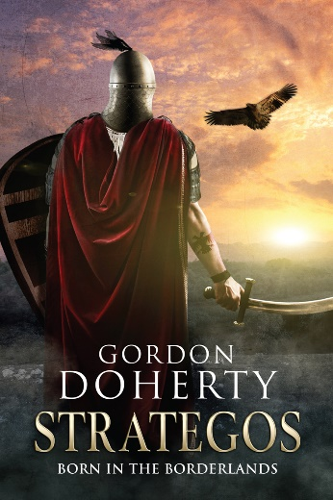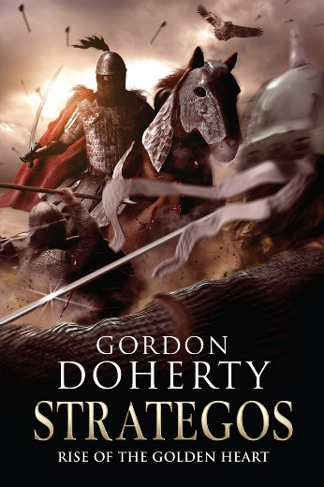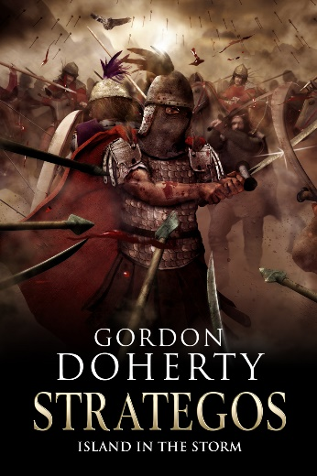
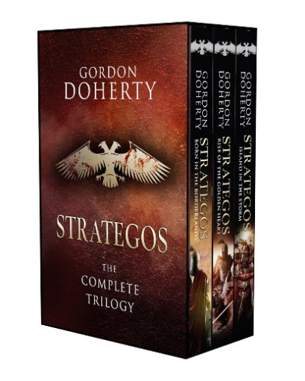

Feel free to get in touch with me at www.gordondoherty.co.uk
And you can follow me online:    

