Sample Chapter Indian River Air:
By Vernon B. Bushway Jr.
Chapter One:
Getting Started:
It was January 1946, the War in the Pacific had just ended in August 45, and I James Donovan, and George Jones, took our discharges at Clark AAFB, to start an Air Freight Service from the city of Manila, the capital of the Philippines Islands to Tokyo Japan. Both of these cities had suffered heavy damage during the War as well as most of Asia.
In the Army Air Corps as member of Fifth Air Force, I had flown the B-24 heavy bomber and the B-25throughout the South Pacific Campaign. I flew with my longtime co-pilot George Jones, who everyone called Jonesie and I naturally picked up simple Jim. The B-24 Liberator, as it was called, was introduced in the South Pacific in May of 1942. It was a four engine aircraft, with Pratt & Whitney R1830-43 Radial 14 cylinders, 1220 Horsepower engines, which made it extremely, fast for a heavy bomber. It had a range of 2,200 miles fully loaded and 3,500 miles empty and a ceiling of 33,000 ft. with a maximum speed of 330 mph. We flew 125 missions in the old crate, as we called it, from Australia, New Guinea the Philippines in 1944, which the retaking of the Philippine Islands, by General Douglas MacArthur and our last two missions over Iwo Jima. In early 1945, after those last Iwo Jima missions, we were transferred to Clark AAFB on Luzon Island in the Philippines, for submarine patrol duty.
While at Clark, we subsequently became friends with General Mark Zoba, who was the Commanding Officer of the South Pacific Theater. General Zoba had informed us to the availability of war surplus aircraft, especially theC-47 and the C-46 twin-engine cargo/troop aircraft.
Jonesie and I had save a few dollars, since there wasn’t anywhere you could spend money during the War, and we use those dollars to purchase two C-47B Douglas Skytrain aircraft for our proposed airfreight business. We also had enough cash left over to fund a lease for a couple of hangers and purchase the necessary maintenance equipment from the AAFB at Clark Field, just outside the city of Angeles, in the Philippines. It wasn’t normal for the Army Air Force to allow civilian aircraft on a Military Field, but while I was flying all those missions, I had put in a request to the War Department to be able fly out of Clark Field. It took about one year, but one day, I received a call from my CO, I had been approved for a five-year lease, from the day hostilities ended for two hangers and landing rights, for one dollar per year. There wasn’t any rhyme or reason for their action, but what did I care!
The C-47s were much easier to fly than the B-24and the workhorse of the Air Corps, along with the C-46, but handled better in rough air and easier on the gas consumption. The C-47B was the aircraft that flew many missions over the Himalayas delivering supplies to the China and Burma Theater, so the Chinese and British & Americans could carry out their campaigns against the Japanese who were trying to conquer those countries.
We knew there would be a considerable freight going into the Japanese Islands, due to the total destruction of their homeland by the 15th & 7th Air Force B-29’s out of Guam, Saipan, and Tinian Islands, in the Northern Mariana Islands. Most of their major cities, Tokyo, Yokohama, Nagoya, Hiroshima, Nagasaki, and others lay in ruin. So, we took our saved money, plus our mustering out pay, travel pay, and went ahead with our plan to become the biggest airfreight line in the Pacific.
Our decision to obtain the C-47B was its range and capabilities, powered by two Pratt & Whitney R1830-90C 14 cylinder radial 1200 horsepower engines with super-charges and extra fuel capacity to cover the China Burma India routes.
The C-47 had a crew of three and a payload of 6000 lbs. and in addition it had a service ceiling of 10,000 ft. and a range loaded of 2100 miles with the extra fuel capacity and a cruising speed of 160 mph and a maximum speed of 224 mph.

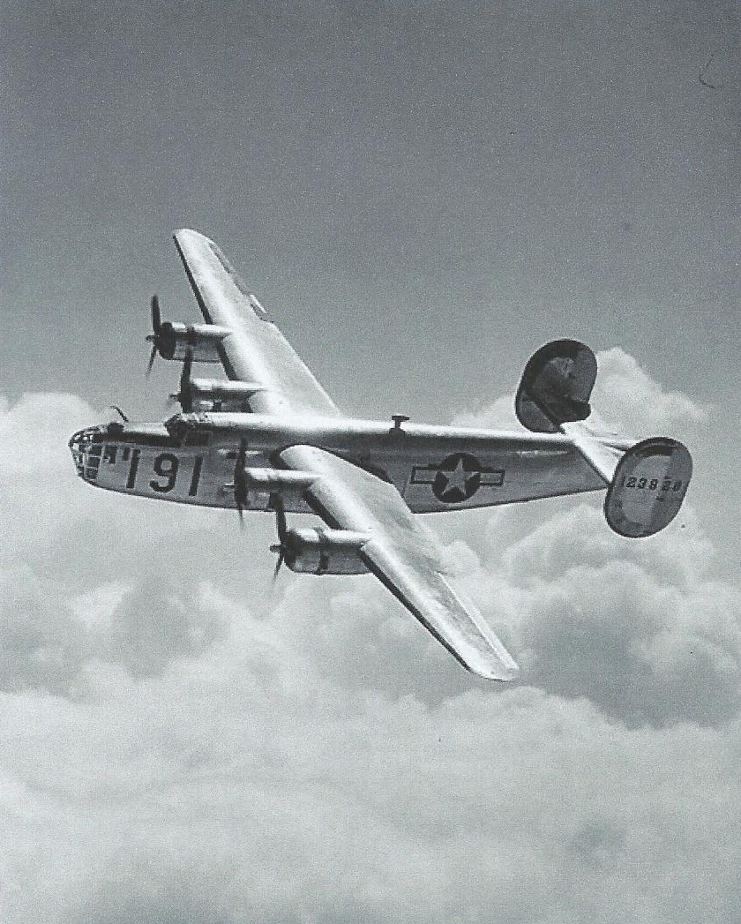
Consolidated B-24 Liberator (USAF Photo)

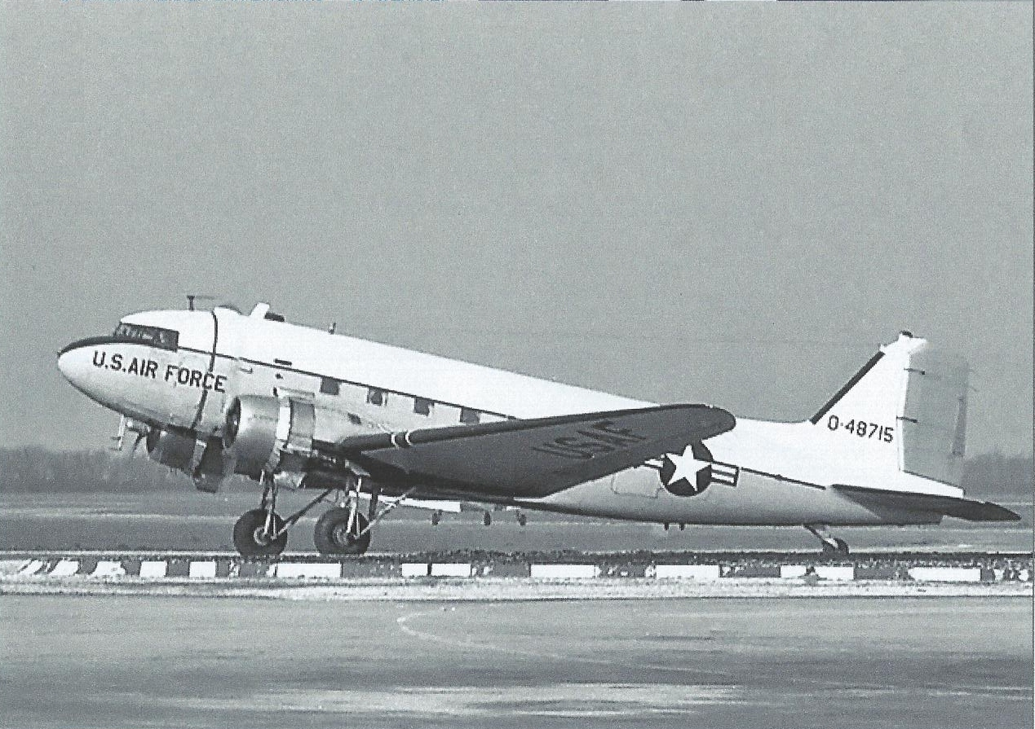
Douglas C-47/DC-3 (USAF Photo)

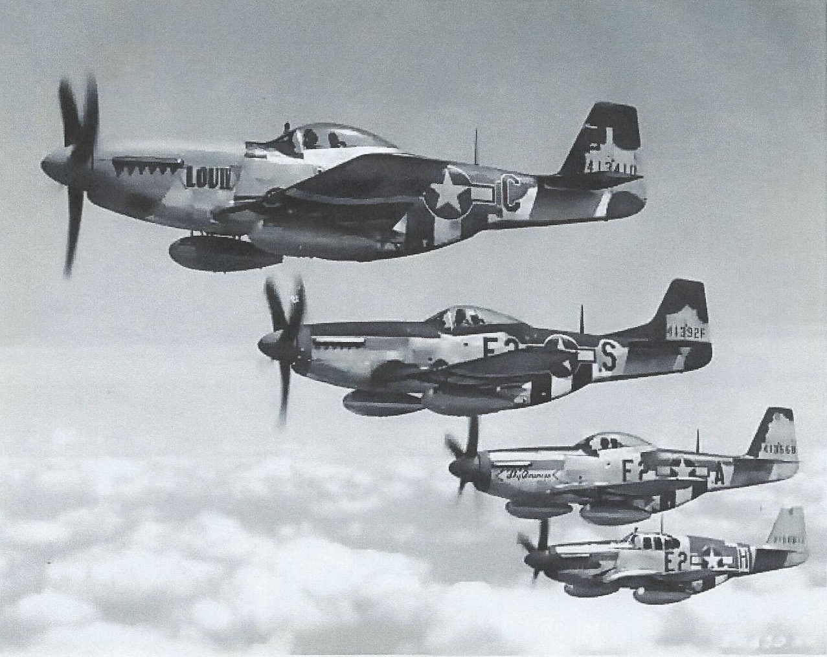
North American P-51 Mustang (USAF Photo)
Indian River Air by Vernon B. Bushway Jr. may be purchased from Amazon in the E Book or Paper Back Formats.
Other Novels by Vernon B. Bushway Jr. are:
Hunt for A Killer:
A Warriors Long Journey To China:
Murder In Studio City:

