On Sunday, April 21, 2013 (8am-5pm)
Mount Haven Country Resort and Restaurant
Presents

Multi-Author Book Signing / Meet and Greet Event

"No Turning Back" by Carolyn T. Holmes-Hood -A life changing story with a strange twist.

"A Life Not My Own" by TM. Brown - A heart wrenching true story about growing up and coming of age.

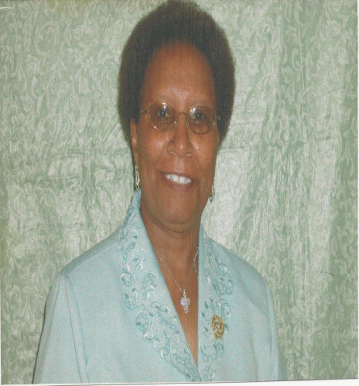

“Tabernacle in the Wilderness, As It Relates to Jesus” by Edith Lazenby –This book takes you on a revelatory journey through the tabernacle of Moses.

Mount Haven Country Resort and Restaurant
Log Tavern Road Milford, PA 18337 (1-800-553-1530)
- "No Turning Back" by Carolyn T. Holmes-Hood -A life changing story with a strange twist. When Grace Pond disappears and her body is not recovered, the local detectives are stumped. As they keep watch on her gun loving husband John, details of their marriage reveals much from her church family in Dingmans Ferry, which eventually leads to uncovering her long kept secret. When the body of Grace is discovered and no one recognizes her, you discover secrets of unworldly events and what happens to John as God deals with unrepentant sin. This work of Fiction inspired by local sites in Dingmans Ferry Pa. walks you down paths your feet may have been. Read on and discover where the body of Grace Pond was located for seven years.

- “A Life Not My Own" by TM. Brown - A heart wrenching true story about growing up and coming of age under trying circumstances. Young Tina is forced to raise herself and her brother in Baltimore city while discovering how love changes your life forever. Told in a fashion that places you in the setting and brings your own life into perspective. Visit the places around the world as Tina joins the military on the run from the very thing that holds her a prisoner. Another can't put down read

- “Tabernacle in the Wilderness, As It Relates to Jesus” by Edith Lazenby –This book takes you on a revelatory journey through the tabernacle of Moses whereby you will behold the beauty of wooden articles overlaid with gold that depict the humanity and deity of Jesus.

Multi-Author Book Signing / Meet and Greet Event
Mount Haven Country Resort and Restaurant
Log Tavern Road
Milford, PA 18337
Phone: | 1-800-553-1530

