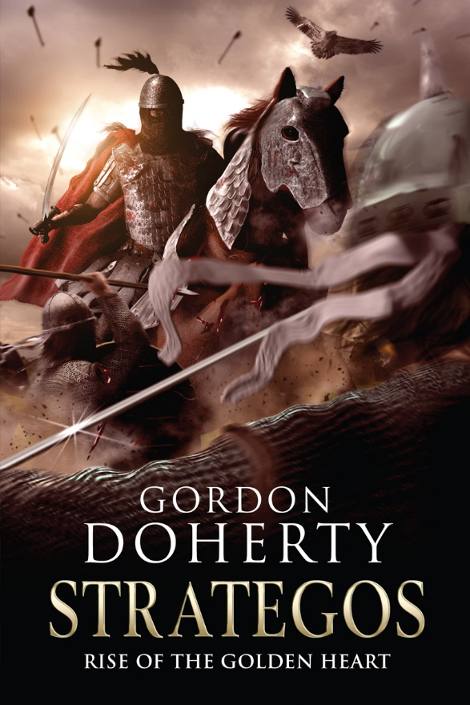
1. April 1067 AD, Charsianon, Eastern Byzantium

A zephyr lifts me ever higher and the spring sun beats upon my outstretched wings as I soar across the rugged, golden heartlands of Anatolia. The first navigators to set foot on this realm named it the Land of Sunrise. Yet had they only known what torment was to be played out in the ages ahead, they may have chosen a more suitable moniker.
These last years have been more brutal than many past. Driven by the death of his uncle Tugrul, Sultan Alp Arslan and his Seljuk hordes have torn these lands asunder, smashing against the dying embers of Byzantine resistance with the tenacity of a beating black heart. The boots and hooves of his armies and the broad wheels of his war machines have ploughed the earth year upon year, sowing the corpses of Byzantine farmer-soldiers in their wake.
Of the few Byzantine souls who refuse to crumble under this pressure, one troubles me greatly. Once I thought he was the man capable of defying my greatest adversary, Fate. Now I see in him more darkness than light. The boy once known to me as Apion has become an embittered husk of a man, a strategos who leads his beleaguered border army into battle as though he relishes the prospect of death. In victory, he sees only the failures of his past, while his men chant the name that has come to define him.
The Haga!
Twelve long and bloody years have passed since I last spoke with him, but I know that I must visit him once again. For I see a tumult of portents as to what Fate might throw in his path. I see bitter conflict, bloodshed, betrayal, loss and pain . . .
But, most vitally, I see hope.
Yet before I go to Apion, there is another to whom I must speak. One who has lost himself in hatred. He has pursued Apion like a vulture for so long that I fear he has forgotten those lost years when they were once like brothers.

***

Bey Nasir scoured the noon heat haze, his grey eyes framed by the studded rim and noseguard of his helm. The jagged, sun-bleached valleys of Charsianon seemed to be devoid of life. Still, he thought as he eyed the bend in the valley ahead, they were in enemy territory and there was much potential for ambush.
He twisted in the saddle of his chestnut mare to glance over his Seljuk warband. Two thousand men marched with him. Seven hundred were ghazi riders. These nimble steppe horsemen were armoured in light quilted vests and armed with composite bows, scimitars, war hammers and lassos. Bolstering the ghazis were one hundred Syrian camel archers, swift and hardy. They rode at a good thirty paces behind the ghazis though, as the ghazi mounts were notoriously skittish around camels. To the rear marched the infantry; over one thousand akhi spearmen, wearing iron mail vests or padded jackets, iron conical helms and carrying circular shields painted in turquoise, green and tan. In their midst marched one hundred of the finest engineers from the heart of Persia along with the wagons that carried their siege implements and the warband’s supplies.
No, he assured himself, squaring his broad shoulders, his scale vest glinting in the sun, the Byzantine forces are weak and scattered. No ambush can trouble my forces today.
But almost as soon as the thought started to calm him, one of the nearest ghazi riders called out, pointing to the western end of the valley. ‘Sir!’
Nasir spun to face front once more. His gaze locked onto the dust plume approaching. In the heat haze, he could see only a blotch of darkness at its source.
‘Halt!’ he barked, raising one hand and tugging on the reins of his mount. Behind him, the warband rippled to a standstill, the drumming of hooves and boots died and was replaced by a rattle of spears being levelled.
Nasir’s brow dipped as he watched the approaching shape. A bead of sweat danced down his cinnamon skin. For just a heartbeat, he imagined the two-blooded cur who had plagued his life for so many years now; the black-plumed helm, the crimson cloak, the ivory-hilted scimitar. The whoreson who had led the Byzantine resistance for so long. Too long. His lips curled into a grimace and he raised a hand, readying to wave his riders forward.
Then, from the heat haze emerged a rider in a light linen robe, saddled on a piebald steppe pony. It was merely the scout rider he had sent out earlier. A chorus of relieved muttering rang out from the column and Nasir’s heart slowed, his hand dropping and his grimace melting.
The young scout slid from the saddle, his robe drenched with sweat, panting as he crouched on one knee before Nasir. ‘Bey Nasir, by noon we will be in sight of the town of Kryapege. From the end of the valley I saw the farmers retreating behind its gates and the defenders bolstering the battlements.’
Nasir’s eyes narrowed. ‘So the Byzantines will not face us in the field? Instead they choose to cower inside their decrepit walls?’
The rider nodded with zeal. ‘It seems they fear even the news of your approach!’
Hubris laced Nasir’s blood and he waved the warband forward once more. He would strangle the life from the place, then destroy the dog who had cursed his being. Memories of his childhood flitted through his mind and his knuckles trembled white on his reins. He saw all that he had lost since then. All that he had lost because of that bastard. He saw her face.
Maria.
Then as they rounded a bend in the valley, he slowed, his blood cooling.
‘Bey Nasir?’ the rider nearest him asked nervously as the men slowed behind him.
Nasir’s eyes hung on an ancient Hittite carving etched into the rock, high up on the valley side. A two-headed eagle, its wings vast, clutching a bull in its dagger-sharp talons.
The Haga.
At this, the grimace returned and his heart thundered once more. He grappled his scimitar hilt and slid it clear of his scabbard, holding the blade aloft in a clenched and shaking fist. Then he kicked his mare round to face his warband.
‘On the plain ahead we will hew timber for our siege engines and we will sharpen our blades. Then we will strike Kryapege from history!’ He boomed, then punched his free hand against his chest. ‘Allahu Akbar!’
Two thousand cries filled the valley in reply like raging thunder.
‘Alla-hu Ak-bar!’

***

Within a day, Kryapege was surrounded. Nasir’s two thousand had wrapped around the crumbling red brick walls like a noose while a sparse line of Byzantine defenders looked on from the battlements.
For the next week the blockade continued, and the Seljuk siege line was abuzz with activity as they prepared for war. Hammers tap-tapped as the siege engineers went about their work. Horses snorted and whinnied as their riders groomed and fed them. The screeching of iron upon whetstone filled the plain like the gnashing fangs of a predator readying to feast. Today, they were almost ready to crush Kryapege and those within its walls.
Nasir stood in the midday sun by a semi-circle of yurts, a small fire and a stack of fresh kindling. He swirled his cup of freshly brewed salep and supped at it again. The heat of the sweet, creamy cinnamon and orchid root drink was just enough to bring a mild sweat from his pores, cooling his skin. He smoothed at his pony tail with one hand and his eyes flitted from the town’s eastern gate to the siege plan he had etched into the dust before him. But he could not focus his thoughts. Instead, the words of the oath he had once made with the Haga, in a lost age, pushed to the fore.
Until we’re both dust.
He frowned and pinched the top of his nose between his fingers.
Then the screeching of an eagle startled him. He looked up to see only an unbroken, azure sky and shook his head. He looked to the nearby chief engineer, who was barking his men into a rhythm as they hauled a trebuchet frame upright. He made to stride over to inspect the goings-on, when he noticed something from the corner of his eye.
A hobbling form walked towards him, cloaked and hooded in white.
He frowned at the painful gait of this figure. There were no elderly or crippled amongst his army, and the plain was deserted before and behind his siege line. Agitated at this distraction, he filled his lungs to bellow at the figure.
But the figure pre-empted this, and lifted a hand, extending a bony finger. ‘Save your breath, Bey Nasir,’ an old woman’s voice croaked from the hood, ‘for we have much to discuss.’
Nasir spluttered at the nerve of this crone. ‘You are no Seljuk . . . and how do you know my name?’
She ignored the question and lifted the hood down, revealing puckered features framed by silver, web-like hair. Her eyes were milky-white and sightless; despite this, they seemed to scrape at his soul. At once, he recognised her. It was the hag who had come to him many years ago, when Maria slipped towards death. When the darkness had first gripped his soul.
‘You . . . ’
‘Sit, sit!’ she said impatiently, waving him down.
Anger flared in Nasir’s chest and then, like the passing eye of a storm, it disappeared and was replaced with a warm sense of ease. Bemused, he found himself sitting. Now he had no inclination to yell for his guards, all of whom seemed oblivious to this intruder.
‘So, Nasir,’ she said, sitting across from him, resting her back against the kindling pile and pouring herself a cup of salep from the urn over the fire, ‘where do we start?’
‘Why are you here?’ he asked. It seemed like the correct question.
She smiled ruefully. ‘Ah, that is one answer I cannot offer you. Like you, I have been drawn here. But I have many questions for you.’
Nasir nodded. ‘Very well.’
She supped her salep and puckered her lips, then let out a contented sigh. ‘You are a brave warrior – that so many men follow you is testament to your greatness. But do you not fear your leader, the Mountain Lion?’
Nasir’s heart clenched at the mention of the name. Alp Arslan, the Mountain Lion, the Seljuk Sultan. The sole monarch of all Persia from the river Oxus to the Tigris. The sultan was engaged in war far to the south, and had demanded that the beys he left behind were to resist raiding Byzantium until he could return to join them. He looked to the crone, his lips taut. ‘I respect him, but I do not fear him,’ he lied.
‘Clearly,’ the crone chuckled, her eyes widening.
Nasir frowned and shuffled where he sat. ‘He is the finest of warriors, a master of the sword . . . ’
The crone raised her eyebrows and cut him off. ‘That is the least of his talents. His mind is far sharper than any blade.’
‘Aye,’ Nasir conceded, ‘yet his strategy drives a wedge between him and his armies.’ He swept a hand around the Seljuk siege works. ‘These men are hungry to complete the conquest of Byzantium that was promised to them many years ago when his uncle Tugrul was sultan. That is why they are here. Because while Alp Arslan chooses to war with the Fatimids in the south this year, he denies the warriors he left behind the chance to seize that glory.’ He cast his gaze over his warband and thought of the other seven thousand who besieged the nearby city of Caesarea. ‘Bey Afsin and I have given them that chance once more.’
The crone nodded wistfully. ‘Yet when Tugrul led his armies here, he was beaten back. And Alp Arslan has led his vast armies here many times in retaliation for that defeat and been repelled every time. Many Byzantines have been slain, but still they resist. Now your sultan chooses to wait until he can focus his armies entirely on Byzantium before he strikes again. Do you not think this strategy is shrewd?’
Nasir looked away from her and to the walls of Kryapege.
‘Your silence speaks volumes, Nasir,’ the crone said, then stabbed a bony finger towards him. ‘You are not here for conquest; you do not share Bey Afsin’s impetuous motives or those of the men you will lead in this siege. You are here for Apion.’
Nasir felt the mention of the name like a blade to his heart. ‘What of it? I have lost much because of that whoreson.’
She raised her eyebrows. ‘Loss? I’m not sure that . . . ’
‘Loss comes in many forms, old woman,’ Nasir snapped, cutting her off. He fixed his baleful gaze upon the walls as he thought of Maria.
‘Perhaps,’ the crone nodded in acquiescence. ‘But have you ever considered how much more you have lost in the pursuit of the man who was once your friend?’
With every breath, Nasir thought.
‘And what makes you think you can best him?’ The crone continued. ‘Despite years of trying, both you and Alp Arslan have been unable to defeat the Haga.’
Nasir feigned a scoff at this, his mind flitting back to the carving of the two-headed eagle on the valleyside. ‘The Haga? Do not try to dazzle me with myth, old woman. The Strategos of Chaldia is flesh and blood and nothing more. He rallies the few wretches that remain of the Byzantine border armies, yet he carries a curved Seljuk blade in his hand.’ His heartbeat quickened and his breath grew shorter. ‘He doesn’t even know who he is anymore, fighting for a cause he no longer believes in because he cannot remember how to live beyond the battlefield. He chases answers at the edge of a blade – answers he will never find,’ he said, unable to contain the wavering in his voice.
‘Because those who could allay his torment withhold those answers,’ the crone cut in, wagging a finger at him in reproach.
Her gaze seemed to pierce into his heart, and he felt a welling of guilt there. At last, he dropped his gaze, swiping a hand through the air as if to break the crone’s glare. ‘I alone am not to blame for the Haga’s torment. There are many ghosts in his past, and they have all but destroyed him!’
‘The ghosts of his past have all but destroyed him . . . have they? Have they indeed?’ The crone stared at him. ‘When you next look upon a mirror, think upon those words, Nasir.’
Nasir looked up with a frown. But the crone was gone.
The kindling pile was charred to the core, with silvery wisps of smoke curling into the air. An eagle screeched once more, and Nasir shot his gaze skywards.
The sky was pure, unbroken blue…

Hope you enjoyed the sample! You can buy ‘Strategos: Rise of the Golden Heart’ at http://getbook.at/Strategos2
The trilogy in full:
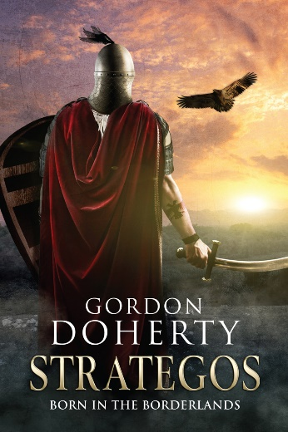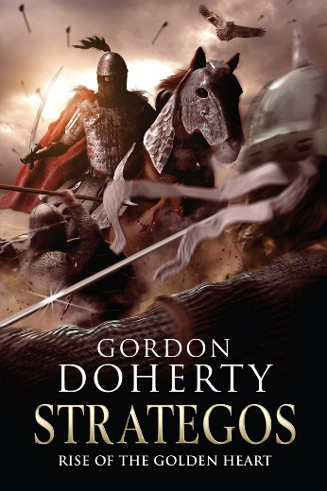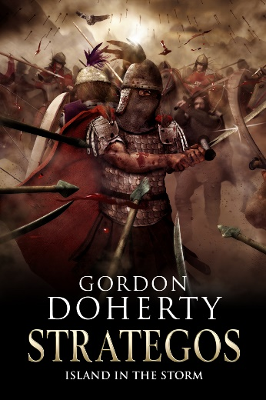
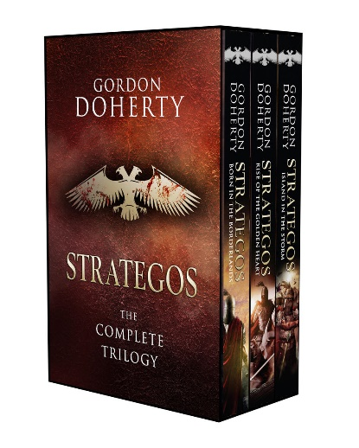

Feel free to get in touch with me at www.gordondoherty.co.uk
And you can follow me online:    

