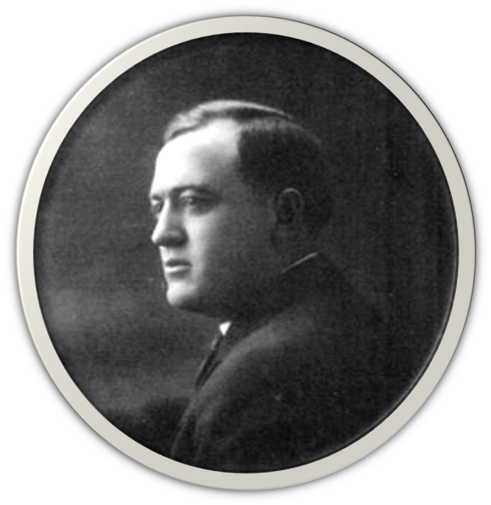
George Wingfield circa 1910 (Central Nevada Historical Society)
Chapter One
Everyone Starts Somewhere
Nevada grew on the power and draw of its mining towns. The lure of gold and silver is universal, and once there were miners, there were saloons, and gambling, and prostitution. The standard Nevada evolutionary scale repeated over and over again with each new gold find, and even as the 20th century dawned it was still the Wild West. Prospectors shot each other over rich mining claims, women, and whiskey. Lawmen were shot right in their homes, or outside their favorite brothels.
The Big-Four who controlled Reno for decades first took up force in Goldfield, Nevada. George Wingfield arrived first, running a string of winning poker hands in Reno into a train ride towards the gold strikes 200 miles south. In the boom town, he went partners on a saloon and bought mining claims that made him rich. His favorite saloon and mining partner, Nick Abelman, arrived in 1904 from Detroit, in an automobile of all things, while most everyone else was still sitting horseback! They were the same age, 28 when they met. Their younger partners, Bill Graham and Jim McKay, arrived later.
Goldfield was the talk of the country at the time, and fanciful accounts of prospectors falling into riches in gold and silver sold plenty of newspapers, which in turn drew more people to the dangerous, dusty Nevada towns. Eventually, even Virgil and Wyatt Earp heard the news. Wyatt came to town in 1902 and opened a saloon, dealt Faro Bank, did some prospecting, and took a position as a Deputy U.S. Marshall.
Brother Virgil arrived in 1904 and was appointed deputy sheriff for Esmeralda County, Nevada. By then most of the best mining claims were gone. So were they a year later. Virgil died of pneumonia in Goldfield. Wyatt moved on to other gold strikes with his common-law wife, Josephine.
By the following year, George Wingfield was the richest man in the state. He plied the mining trade, pushed miners off their claims, sold puffed-up stock, consolidated valuable claims through any method necessary, and lived the good life.
He and his partner George S. Nixon consolidated the best mining claims in Goldfield into the GCMC and entered the local stock market. They repeatedly manipulated news, ore conditions, and stock prices to their own benefit, but not without notice from other shareholders. When the stock rose they offered a 30-cent dividend some shareholders found well-undervalued.
When prices fell, Wingfield bought more stock. When the stock began to rise after a group of Nevada politicians bought up shares with early knowledge about favorable legislation (some things never change), Nixon and Wingfield’s Goldfield bank dumped shares on the market, pocketed the windfall themselves, drove the price back down, and rebought.
When the local miner’s union demanded wages higher than the $4.50 per day they were receiving, beatings were used to quell the rumblings, but nothing lasts forever, and the union went on strike, demanding the AFL-affiliated carpenters join them. Things got ugly for both sides, and innocent people like restaurant owner John Silva suffered. Silva was shot and killed for serving one of the non-striking carpenters a meal.
When ore prices dropped, local banks failed as the investment market shrank and mining stock that had been used as collateral turned out to be worthless. In November, 2,000 miners walked off their jobs. Wingfield kept his bodyguards close at hand.
In response to the strike he took his owners group to the state capitol in Carson City and convinced Nevada Governor John Sparks to wire President Theodore Roosevelt about the labor disputes and ask for federal troops to prevent the “serious labor trouble in the district of Goldfield and adjoining camps, which may result in violence and great destruction of both life and property.”
Roosevelt fell for the rouse, and federal troops arrived in Goldfield December 7. The miners went back to work, but not until they agreed to sign notices during the re-hiring process that they were not members of the local miners’ union and were accepting daily pay of just $4. The work stoppage ended, the union was broken.
After that fiasco, Wingfield had few friends left in Goldfield other than his casino managers and his ex-bodyguards and stock brokers, all of whom were now well-off. It was time to move on.
From his new home in Reno, Wingfield dissolved his partnership with George Nixon, taking GCMC stock for all their joint banking and real estate holdings except the Goldfield bank, John S. Cook & Co., where he became the sole owner.
Senator Nixon continued as a banker and real estate investor, while Wingfield stayed with saloons, gaming, real estate, and his mining interests. His opinion, as quoted in the Tonopah Sun in April 1909, was “I have took over everything.”

