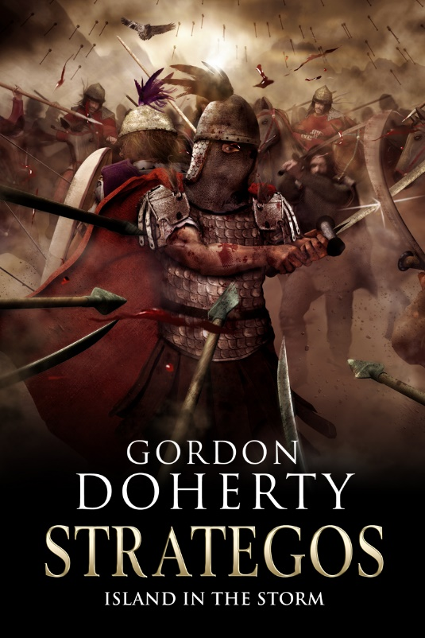
Prologue
Manzikert
Friday 26th August 1071 AD
A lone tamarisk tree stood upon a deserted hilltop, bathed in dawn light. The cicadas nearby chattered as if today was just another day. Then the clopping of hooves sounded, scattering a pair of song thrushes from the tree. A lone rider galloped up the hillside, his iron lamellar armour shimmering, his crimson cloak and the black eagle feather plume of his helm flitting in the breeze. He came to a halt near the tree and removed his helm. A gentle wind whipped his silver-amber locks across his face. It was a face furrowed with age and determination: deep-set and saturnine emerald eyes looming under the heavy shade of his brow, a nose battered and scarred across the bridge and taut lips guarded by an iron-grey beard.
Apion slid from the saddle and led his war horse to a trickling brook by the tree. ‘Slake your thirst, rest your legs. She will come to me soon,’ he whispered, glancing up at the sun-streaked sky as he smoothed the chestnut Thessalian’s mane. The gelding snorted in appreciation before gulping at the water. Apion strode over to the tamarisk tree, then sat back against its gnarled trunk and took a long pull on his water skin. Pensively, he looked back to the south, down the hillside from where he had come.
The breeze conducted the tall grass of the slope into a rhythmic dance and at times, when it stood tall, he could see nothing of the plain below – only the Anatolian sky and the snow-capped peaks far to the south. When this happened, his mind wandered in the echoes of the past: those lost days tending the goat herd on the Chaldian hillsides overlooking Mansur’s farm. Trapped in a vice of darkness and pain before and after, those few years were the light, the force that kept him holding on, the reason he had wielded his sword to this day.
‘Yet it’s all . . . gone,’ he mouthed, his whisper carried away by the breeze. He lifted a dark lock of woman’s hair from his purse and stroked at it absently. Her name rang in his thoughts. Maria. His search for her had been fruitless, and today would surely end any lingering hope.
The shriek of an eagle stirred him, and he realised he was no longer alone. From the corner of his eye he recognised the shrivelled, white-haired crone sitting by his side. ‘Wiser men might have kept riding, and fled this land,’ she said, her milky, sightless eyes fixed upon him. Then she turned to look downhill with him, extending a bony finger towards the waving curtain of tall grass. ‘Look, Apion.’
As if quelled by the frail old woman’s words, the breeze died and the grass fell limp, revealing the plain below and the two opposing masses of shimmering warriors there, red dust and woodsmoke pluming above them like a low-lying storm cloud. Romanus Diogenes, Emperor of Byzantium, the Golden Heart, was to lead his armies against Sultan Alp Arslan, the Mountain Lion, and his Seljuk hordes. The hillside trembled as the last few regiments of Byzantine spearmen filed from their camp and the Seljuk cavalry wings rumbled into place. The air reverberated with the Christian chanting of the Byzantine ranks. Swords, spears, bows, shields and bright standards were held aloft by both armies. The shatranj board was all but set. This was the clash these lands had feared for so long. Destiny would be forged on this plain.
Apion glanced from the opposing armies to the nearby, black-bricked fortress of Manzikert by the foot of this hill, and then to the snow-capped mountains far to the south – Mount Tzipan the tallest of them all. These great slopes masked all but a glimpse of Lake Van, sparkling in the sunlight, and the speck on the shore side that was the sister fortress of Chliat. The crone placed a hand on his shoulder, and he recalled something she had foreseen, years ago.
I see a battlefield by an azure lake flanked by two mighty pillars.
The meaning, Delphic then, was all too evident now. His gaze passed across the plain once more, drawn to the heart of the Byzantine ranks where Emperor Romanus sat proudly astride his stallion, defiant in the face of all that had happened in the preceding months. Across the battlefield, behind the Seljuk lines, he could just make out the Sultan’s command tent. The rest of the crone’s augury came to him;
At dusk you and the Golden Heart will stand together in the final battle, like an island in the storm. Walking that battlefield is Alp Arslan. The Mountain Lion is dressed in a shroud.
He turned to the old woman, wishing to ask her if this meant victory lay in store for Byzantium’s forces today, and dreading both possible responses.
But the crone spoke before he did. ‘The storm is almost upon us, Haga. The answers you seek dance within its wrath.’
Apion felt a stinging behind his eyes, an invisible hand grasping at his heart. ‘Do they?’ he replied through taut lips. ‘All I know is that a vast Seljuk horde awaits, blades sharpened. Alp Arslan, his armies and . . . ’
‘And your son,’ the crone finished for him flatly.
The truth chilled Apion’s blood. He scanned the forming Seljuk lines, unable to discern any of them at such distance but knowing that his boy, Taylan, was there – his heart aflame with a desire for revenge, his sword eager to spill his father’s blood. Apion let his head loll back against the tamarisk bark, his eyes shut tight. Death had hunted him for years. Today, death would take him . . . or Taylan. How had it come to this?
‘Perhaps you were right – I should have kept riding,’ he snorted. ‘Then I would not have to clash swords with my boy.’
‘Yet Taylan would still seek you out on the battlefield, unaware of your absence. Still he might fall. Still you would be without knowledge of Maria.’
Apion dropped his head into his hands. ‘Tell me, old woman: what wickedness has brought today about? Is it Fate, the one you curse so fervidly?’
She shook her head, her face lengthening. ‘It is the black hearts and venal curs in the courts of Byzantium and the Sultanate that have brought about this day. Yet it is noble men who will perish down on that plain.’
‘Then what hope is there?’ Apion said, numbly.
She leaned a little closer. ‘While good men do what is right, hope can never die.’
He traced a finger over the faded red-ink Haga stigma on his forearm. The effigy of the mythical two-headed eagle there had all but become him and he it. ‘You seek good men? Then why do you come to me, old woman?’ He turned to her. But she was gone. He was alone once again.
Suddenly, the Seljuk war horns snarled down on the plain. A shiver of finality prickled on his skin. A great empire would be humbled today. All that lay undecided was which.
He stood, walked from the shade and into the sunlight, resting his sword hand on the worn ivory hilt of old Mansur’s scimitar. The iron lamellae of his klibanion vest chinked rhythmically with each step. He took his gelding’s reins and vaulted onto the saddle. From horseback, he could see that the opposing battle lines were almost ready, their destiny ever closer. He closed his eyes to clear his mind, inhaling the sweet scent of jasmine before what was to come.
It was a fine day to die.

Hope you enjoyed the sample! You can buy ‘Strategos: Island in the Storm’ at http://getbook.at/Strategos3
The trilogy in full:
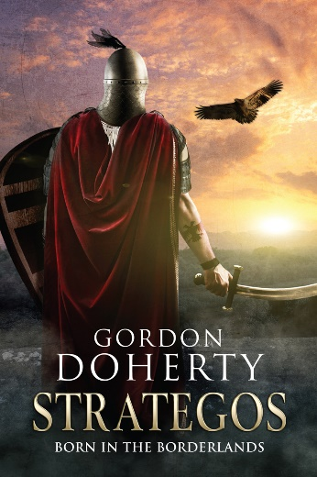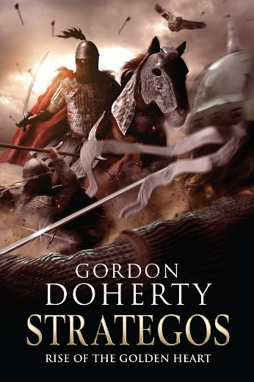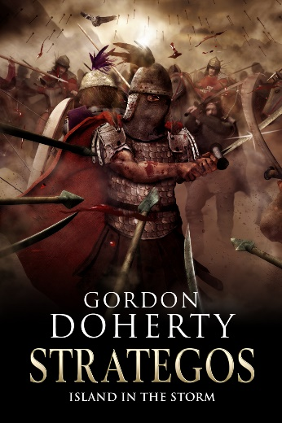
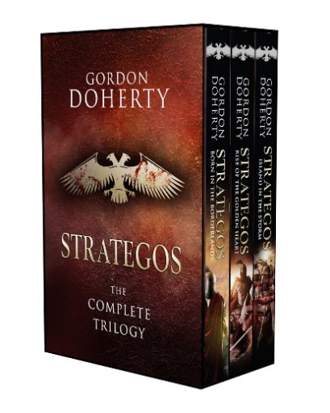

Feel free to get in touch with me at www.gordondoherty.co.uk
And you can follow me online:    

