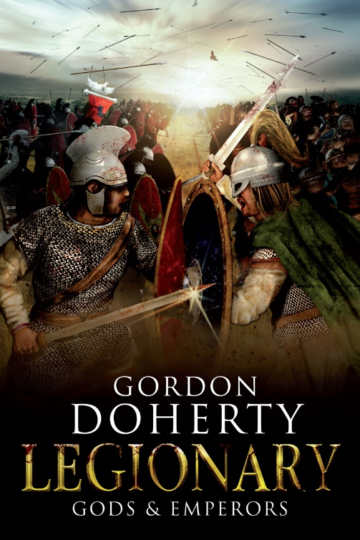
Prologue:
Antioch
April 3rd 378AD

Three scale-clad legions filed along the narrow, dusty gorge road. Mount Silpius and Mount Staurinus – each precipitous, burnt-gold and dotted with hardy shrubs – loomed over the path like watching titans, casting them in shade and sparing them from the heat of the fierce morning sun. The rumble of their boots and jostling armour echoed through the ravine as they went, every pair of eyes flicking anxiously to the steep, sun-bleached bluffs either side of them, every mind recalling the many tales of brigandage in these parts – legions crushed under falling rocks or showered with missiles and the corpses robbed of purses and armour. But on they went, eager to set eyes upon their destination: the mighty Iron Gate, eastern entrance to the imperial city of Antioch.
Emperor Valens rode at the head of the column, a light veil of sweat beading on his sun-darkened, age-lined features and his snow-white locks discoloured by golden dust thrown up from the ride. The path widened and the shade slipped away, the intense sun glowering down on them all once more. His cobalt eyes narrowed as they rounded a bend in the canyon, then he saw it at last: the fortified, shimmering limestone gateway up ahead. Its thick towers and iron-strapped gates stood like a mighty dam, blocking the route through this baked valley, while the sturdy curtain walls either side followed the rise of the mountains, claiming the high ground as part of the city. The men saw it too, and a murmur of excited voices sounded behind him.
A refrain of cornua on the gatehouse heralded his approach, the G-shaped horns glinting in the sun. He shuffled to sit straight in the saddle, his purple cloak falling back from the white steel shoulders of his scale jacket. This was it, he realised: after months of summoning his forces, the time to act was upon him.
He glanced back over his men. These were the last three regiments of his Praesental Army to be drawn from their posts around Roman Syria and gathered here at Antioch. All other available units had already congregated within the city’s walls or in the sprawling camp on the plains outside the northern walls; twenty seven thousand men all told. A vast flotilla of ships moored in the River Orontes waited to take them across the sea to their destination: the troubled Diocese of Thracia… and the Gothic War that raged there. Over the last few weeks he had witnessed the optimism and bravado of those already convened. They talked of the Gothic War as a minor trouble, a foregone glory. Yet not one of them bore Valens’ iron burden.
Every soul in the East lives or dies on your word. Every life rests in your hands.
He dipped his head a fraction, pinching the top of his nose between thumb and forefinger. Six thousand men would be left behind to garrison the desert forts and cities of the Persian frontier – just six legions to protect Rome’s most easterly territories against the Sassanid Empire. But the Sassanids were not his greatest fear. No, for while the Shahanshah and his armies made war much like the Romans, the Goths awaiting him across the sea were different. Savage, dogged, proud . . . fighting for their very existence. His mind raced over the flurry of correspondence that had come from Thracia in these last months: the mountain strongholds had fallen, the legions had been driven back into the cities… now some one hundred thousand Goths roamed Thracia under Iudex Fritigern’s command. The war to come would not be one of empires seeking glory. This would be a contest of survival. A feral game where precious life would be dashed in swathes.
Or, he reasoned, might there yet be parley?
Fritigern was a shrewd and at times ruthless leader, but one of the few Gothic noblemen who understood the meaning of nobility. An Arian Christian like Valens, Fritigern had sought treaty with the empire when he had first led his Goths across the Danubius and into Roman lands. His horde was to farm Roman lands and serve in the imperial legions, but that hope had crumbled in a mire of treachery and recklessness. Nearly two years of war had ensued, with the Goths seizing the Thracian countryside, penning the Roman citizens and the tattered remains of that land’s legions inside the major cities. The war had grown like a boil, and was now throbbing, ready to burst. It had to end, and like most wars, that likely meant one thing: a battle that would vanquish one side or the other. Yet he had received word, albeit indirectly, that the Gothic Iudex still yearned for treaty instead of battle. How much faith could he place in such anecdotal reports? Especially when he had despatched messengers to the Gothic Iudex in hope of instigating such talks himself – only for those couriers to seemingly vanish on their travels. Was parley a fanciful aspiration? Perhaps, he mused, but it would only be prudent to advance on Thracia armed with both regiments and rhetoric.
And if it comes to a clash of steel? he wondered, his shoulders tensing.
He thought then of his nephew, Gratian, Emperor of the West. He had sent numerous messages to Augusta Treverorum in faraway Gaul, beseeching Gratian to bring his armies to Thracia to aid the effort and to swing the balance of numbers. Gratian had once been an affable youth, but power and the struggle to hold onto it had changed him drastically and he had been cold towards Valens since rising to the Western throne. Still, reports indicated that the Western armies were mobilising in response to his pleas. Valens lifted his Chi-Rho necklace and kissed it in a gesture of hope. To have to plead with his nephew was an affront, but without the boy-emperor’s legions to supplement his own…
A clop-clop of hooves sounded, scattering Valens’ thoughts. He looked up to see two of his candidati range ahead of him with some urgency. These men – his ever-present, white-robed personal guards carrying spears and white shields etched with a gold Christian Chi-Rho – cantered to a spot in the road just ahead and dismounted. Valens slowed and stopped and the column halted likewise. He frowned as he watched the two guards: they stalked towards something on the roadside, kohl-stained eyes vigilant, levelling their spears and taking the stance of battle as if the sharp slope at the foot of Mount Staurinus was their foe. Valens eyed the pile of rocks there. He saw nothing of note. Then he blinked and gasped.
There, coated in the golden dust so as to almost blend in with the hillside was a man, without a thread to clothe him, sitting upright, his back supported by the sharp incline of the mountain. His gaze was fixed on Valens, staring, unblinking, a forlorn look in those gemstone-green eyes.
‘Who are you?’ one of the candidati who had approached him barked, looking over the rogue then quickly scanning the mountainside for any signs of ambush.
‘On your feet and speak, dog!’ the other candidatus pressed. The pair had been told to expect no civilian traffic on this road today.
Valens heeled his stallion into a cautious walk towards the scene, two more candidati hurrying to escort him. The stranger sitting at the roadside remained where he was, utterly motionless, heedless of the two candidati speartips now hovering under his chin, his piercing green eyes remaining fixed on Valens. He was a man in his thirties, Valens reckoned, though it was hard to tell, for as he drew closer, the countless welts, bruises and lacerations on the wretch’s skin became apparent. The fellow had been flayed without mercy. All over his face, his arms and legs and his torso were deep and recent gashes, the bloody wounds only hidden by a coating of the infernal dust.
‘On your feet!’ the candidati demanded once more, this time with a snarl.
Valens dismounted, raising a placatory hand to his guards before approaching the stranger then crouching adjacent. ‘Who did this to you?’ he asked, his voice dry and cracking. The man’s eyes told a sorry tale, such sadness they revealed.
A gust of warm wind swirled, casting more dust over the stranger. It was then that Valens saw how it coated the stranger’s staring eyeballs. The man did not blink or flinch. Only now, Valens realised he had been talking to a cold, dead corpse. His skin prickled with dread as he sensed the candidati – his most tenacious protectors – backing away, eyes widening as they looked at the corpse and then him. Behind him, he heard the three legions break into a concerned murmur. Words of prayer were spoken by many of them. He stood, feeling as naked as the dead man, devoid of his authority. He closed his eyes to compose himself, but was assailed in that darkness too: from somewhere deep in the recesses of memory, he heard something that had haunted him for years. A distant roar of rushing water. Then he saw it, coming from the blackness behind his eyelids: a colossal wall of foaming, lashing seawater, quickening towards him, eager to swallow him whole. It thundered closer and closer, towering higher and higher until he thought he could see nor hear nothing else. When its shadow fell over him, he grew blind with panic.
‘Come, Domine,’ one candidatus whispered in his ear, breaking the spell, routing the memory at once. He blinked his eyes open, seeing the sun-baked ravine and the worried faces of his ranks, hearing just their whispers and the croaking of insects. Cold sweat trickled down his ashen features. ‘We should not linger here,’ the candidatus pressed.
Valens saw how the guard shot anxious looks to the muttering column and the city walls, where the garrison soldiers on the gatehouse were straining to see what was happening.
‘We should hurry,’ the candidatus added, ‘lest the men begin to whisper of this as some grim portent for the expedition to Thracia.’
Valens nodded, then silently mounted his stallion and waved the column on towards the Iron Gate. As he rode, he looked to the gates, to the garrison, and let the cornua chorus sail around him, hoping it might lift his heart. But try as he might, he could not rid himself of that image of the corpse’s plaintive gaze… nor the dark memory of the onrushing, ravenous tide.

Hope you enjoyed the sample! You can buy ‘Legionary: Gods & Emperors’ at http://getbook.at/Legionary5
The series in full (as of July 2018):
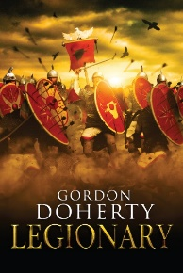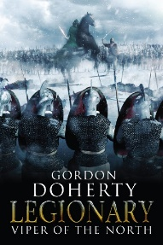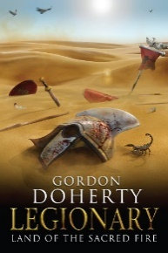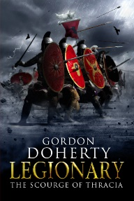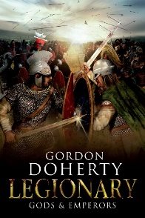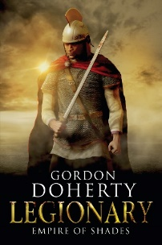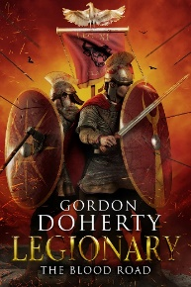

Feel free to get in touch with me at www.gordondoherty.co.uk
And you can follow me online:    

