In The Beginning
Bible Reference: Genesis 1-2

Close your eyes. What did you see? Darkness! The world was just that way before God decided to make the universe. For Earth, God spoke the words, “Let there be light,” and there was. He divided the land from the waters. He placed all the animals on the land, in the air, and in the waters. He made all the plants and trees. He placed the sun, moon, and stars to light our day and night. He made man in His own image to take care of everything on Earth. This took God only six days. He rested on the seventh day which He called Holy. God gave Adam a beautiful place to live called the Garden of Eden. He gave Adam dominion over all living creatures. But Adam was lonely. God decided to give Adam a help mate. God caused a deep sleep to come over Adam. God took one of Adam’s ribs and made a woman whom Adam called Eve because she came from man. God gave Eve to Adam to be his help mate and live in the Garden of Eden and care for it. Adam was no longer lonely.

Memory Verse- Genesis 1:1
In the beginning, God created the heaven and the earth.
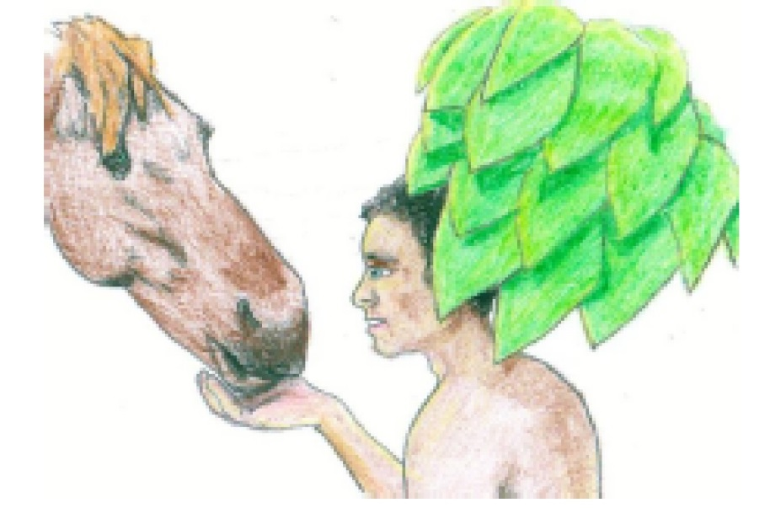

Application for Life:
Yesterday, today, and forever you can know that God created everything for us. We should love, respect, and take care of our world. God has awesome power and He shared it with us. God, also, has amazing love which He shares with us every day. God created you and He has a special purpose in your life. If you love Him and follow Him, He will show you His plans for your life. The world could never compete with what God has planned for you.

