Easter Island Sorta

Excerpt from "Uncommon Notions" one of seven short stories. Easter Island Sorta is about a man searching for Easter Island without ever leaving Cleveland in the end he finds it and himself through this adventure.
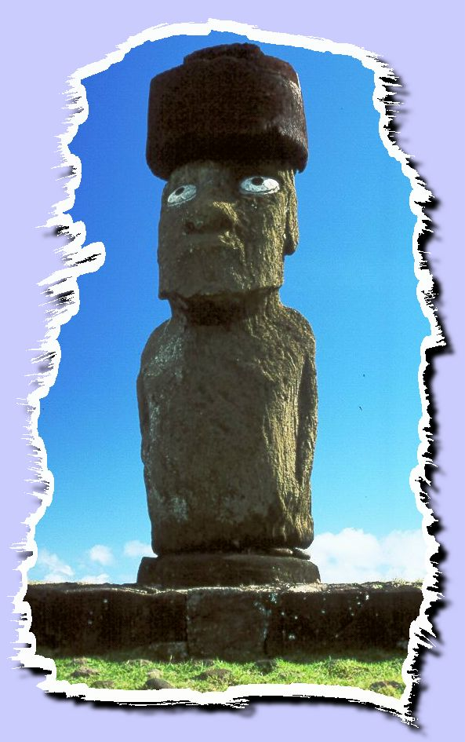
Every since I was knee high to grasshopper, I wanted to pack my bags and dash off to Easter Island. Well maybe not dash off. At forty-nine and sixty pounds over weight, I don't dash off anywhere except maybe to the john. However you get my meaning. As I was saying there is something magical about a place in the middle of nowhere where for some unknown reason, someone has decided to erect gaint stone figures all wearing stone hats perched on their heads while staring out across the sea. Gives me goose bumps every time I think about it.
You see some people dream about following in the footsteps of Bob Newhart, moving to Vermont opening a country Inn, and writing how-to-fix it books. Some people want to be astronauts, fly off to Mars and discover something no one has discovered before, and possibly live there as opposed to Cleveland. Actually, most of us just want to be left alone.
I fall in the all three categories, but for some weird reason I want to go and check out Easter Island if only for no other reason than just to satisfy my own curiosity that there really is such a place. I suppose I could just take the word of those more inclined to know these things.
Being that I was born a curious nature, I like to ask around, kinda get the feel-if you know what I mean-before I swallow the whole hook, line and sinker. Now I have read two maybe three articles about the place. Watched a television show, a documentary made in 1964, and have asked my neighbor his opinion. He is one of those people who just wants to be left alone.
So I decided rather then talk to someone half asleep all the time, I would seek out an expert on the matter-rather than swallow the whole hook, line and sinker.
I began my first real expose' into the mystery of Easter Island by combing through the yellow pages, the only book I had close by my Lazy Boy, that and the T.V guide, which I had already given a careful examination.
I figured since my wife was visting her mother for the weekend, I would take this time to research Easter Island; maybe with some newfound insight on the place she would take me more serious on the subject. Up till now whenever I bring it up, she takes off to her mother's house. I bring it up a lot.
My wife is also one of those people that just wants to be left alone. Moreover, her mother can't leave anyone alone. I figured somewhere between the Doctor and Lawyer ads, I could find an expert on Easter Island. This approach pretty much got me nowhere at first.
I relized I was going about it all wrong. They would only be of help if one of the stone figures fell on me. I needed to check out one of those New Age weirdo book places that specialize in stone faces and people with stone hats on. I found what I was looking for, an ad that read.
Books and Stone Statues of Unsolved Mysterires. Visit our in house expert on Solving the Unsolvable.
Thought the ad was a bit much, with all the little statues and weird symbol things, Nevertheless, like a mouse to cheese, I was caught in the trap of salesmenship.
After about an hour of percrastination, and judge Judy, I retrieved a Diet Coke from the refrig and poured it into my Big Glup cup. I jumped into the old Rambler Ambassador, turned the key five or six times until the starter finely caught the flywheel, peeling off a couple more teeth in the process. A puff of oily exhaust coughed out the back and I was almost ready to go, but first I popped in a David Allen Coe Eight track and wondered when was the last time my wife called me by my name.

