Chapter Three

Disaster at Sea:
First Taste of Battle and Casualties

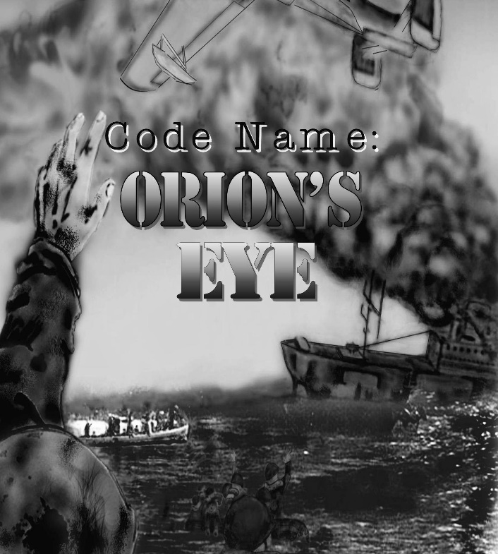
The Cover Art for the Novel Featuring the Experiences of 1st Fighter Control Squadron

It was early morning, 0530 local time, on 11 November 1943 and SS Cape San Juan was steaming on a westerly course at 14.7 knots per hour, about three hundred miles southeast of Fiji. The weather was clear and the seas slightly choppy with a few whitecaps. The sun had not yet risen, but it was light enough to see clearly.
The 2nd Mate, William J. Dorcey was on watch and the ship’s Master, Walter M. Strong, was on the bridge standing just to the port side of the binnacle stand. Most of the one thousand four hundred and sixty four men on board were still in their bunks, although breakfast in #2 Hold was just beginning to be served.

The American troopship, SS Cape San Juan, was on her second voyage, sailing unescorted from San Francisco to Townsville, Australia. She had fifty-seven Merchant Crew, forty-two Navy Armed Guards, and three radio operators, and was transporting three US Army Air Corp units to the Pacific War Theater:

855th Engineer (Aviation) Bn, “All Negro”—811 men
The 253rd Ordnance (Aviation) Company—162 men
The 1st Fighter Control Squadron—367 men

There were also twenty-one “permanent” army personnel, commanded by Major Robert A. Barth, who were responsible for the troops while being transported, plus one unidentified civilian.

Total: 1,464 men.

SS Cape San Juan was blacked out, zigzagging, and had lookouts posted with the Navy Armed Guard crew at general quarters. As she was executing a turn to starboard in accordance with her zig-zag plan, torpedo tracks were spotted by lookouts. Within seconds she was hit by a torpedo fired by the Japanese Imperial Navy I-21 submarine commanded by Commander Hiroshi Inada.

The account of that day that follows represents the greatest loss of life of any American-Hawaiian Steamship operated vessel. While no Merchant Mariner or Armed Guard were among the casualties, the loss of life among her US military passengers was significant. But as significant as that loss was, the fact that over a thousand men entered the oily, shark infested, fifteen foot rain-swept seas that November morning in the South Pacific, and all but 117 made it out, is nothing short of a miracle. A miracle created by men selflessly putting their own lives at risk to help others—from ship and aircraft crews to the soldiers themselves in the cold water, encouraging their buddies and total strangers to “hold on just a little longer.”

Various eyewitness accounts described the morning:

“Two water spouts seen at a distance of approximately 2000 yards; relative bearing 120 degrees. Wake seen on water when 15 yards distant from the ship; very straight path; approximately 2 feet wide; went aft of vessel, missing stern by 20 yards. Wake was light greenish color; water itself was deep dark green. Left slight white foam on surface.”

Another eyewitness claims he saw the wake of this torpedo some 300 feet out on the starboard quarter and claims that it missed the ship’s stern by only 15 feet. A few seconds after first torpedo passed aft of vessel several armed guard lookouts saw two water spouts, generally described as from 6 to 10 feet high and from 2 to 3 feet in width. Both spouts broke the surface at a distance of from 1500 to 2500 yards, relative bearing 130 degrees. They were described as egg-shaped by one witness, as fan shaped by another, and as being “in the shape of a pine tree” by another.

“When some 250 yards from ship, this wake broke and an object skimmed on the surface of the water, in the line of the wake, for a distance of some 20 feet. It traveled so fast that no one could identify color, shape or size. When object submerged, wake did not reappear and explosion against starboard side of ship immediately followed. Torpedo struck starboard, abreast of the after end of No. 2 hatch, far below water line.”

Because of the quantity of oil which emerged to the surface immediately after torpedo hit, it is believed to have struck very close to the double bottom. A heavy oil slick immediately appeared. Inasmuch as the ship immediately took on a hard starboard list, the exact position, size, shape of hole and damage done to the hull could not be viewed or ascertained.
When the torpedo struck, eye witnesses stated that,
“Immediately on the impact, a great flash of light came up over the gunwale on the starboard quarter, reaching as high as the ship’s bridge and covering a width of over 20 feet.” They went on to describe the color of the explosion, the smoke that immediately followed, and finally the water that cascaded back down onto the vessel.”
They described the impact, “The ship shook and shuddered and the bow raised slightly, then settled and the vessel took on an immediate 10 degree to 15 degree list to starboard, and then settled to a 20 degree to 25 degree list within a few minutes.”

The torpedo struck below where the troops from the 855th were berthed—the #2 Hold. The hatch covers over the hold were blown upwards, and then collapsed down into the void, killing and injuring several men. An SOS was sent along with the message, “Torpedoed, ship sinking fast.”
Inexplicably, the Officer in Charge of the radio, Lt. (j.g.) Harris, ordered the radio destroyed immediately afterwards and then he abandoned ship, so no further signals were sent. Some effort was made to repair the equipment, but to no avail.
The Navy Armed Guard returned fire immediately towards the area the submarine was believed to have fired from. All guns fired intermittently for about ten minutes. Occasional shots were fired throughout the day to let the enemy know they were still aboard.
The ship’s engine were ordered stopped and she coasted to a stop as she continued her turn to starboard. The evacuation, mainly of the enlisted Army personnel, commenced about fifteen to twenty minutes after being hit. More torpedoes were expected at any moment. The seas started to deteriorate into fifteen foot seas with white caps. The #2 Hold flooded quickly and the ship settled down by the bow with the starboard list increasing.
It is unclear exactly how many men perished from the initial torpedo explosion, subsequent flooding, and the collapse of the hatch structure. Some men drowned during abandon ship by jumping over board in full combat gear, and others were lost who were in the water near the ship when large wooden rafts were released over them.
Understandably, most men in the water, and even in the rafts, tried to get to the few life boats, which soon became heavily overloaded. The #4 motorboat was swamped and lost when too many men, estimated at sixty-five, attempted to board it. Another came very close to capsizing. Some rafts drifted away before they could be manned, described as “not less than two and not more than six.”
Many of the men initially ended up with nothing but a life vest. These were a mix of cork and kapok and years later, survivors Chester Driest and James Reed would laugh at how some of the life vests were stenciled For Inland Waterways Only.
Wind and wave action quickly dispersed the men in the water to the south and the oil caused severe eye irritation and even temporary blindness in some cases.

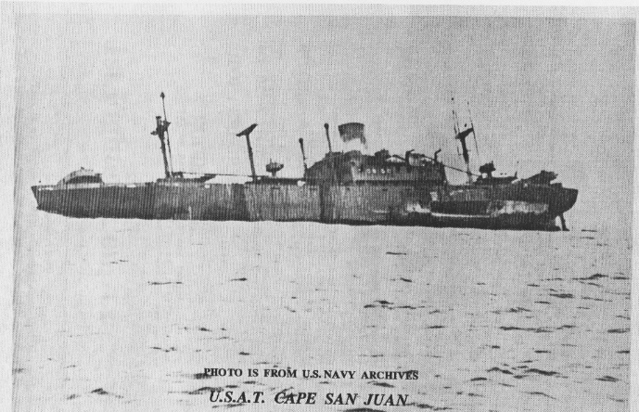
The apparent gash along the port stern is an illusion. It is a result of burned paint and the angle of the light.
(Ed. Note: The Navy’s designation, USAT, is United State Army Transport. The common designation is SS - Steam Ship)

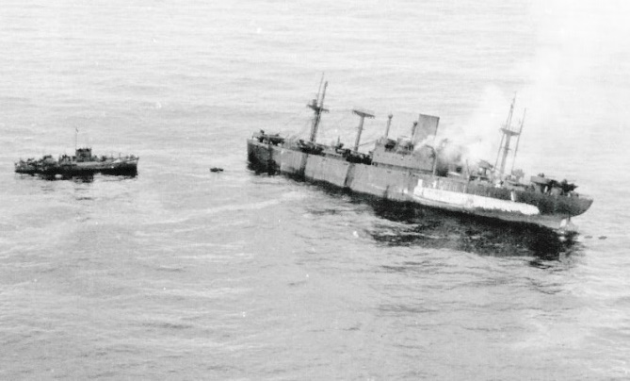
A photo from a Royal New Zealand Air Force aircraft. The small rescue vessel at left is probably the mine sweeper YMS-241.
The first rescue ship on the scene that day was the Liberty Ship Edwin T. Meredith, commanded by Murdock D. McRae. She arrived five and a half hours after the torpedoing.
After transferring the casualties and excess survivors still on board SS Cape San Juan, Meredith circled the ship for eight hours, picking up survivors in the water. Several of her Merchant Seamen and Navy Armed Guard crew exhibited extreme courage by diving into the heavy, shark infested, oil covered sea to pull exhausted men to the side of the ship where they could be hauled up to safety.

Chief Mate Al Appelbaum of the Edwin T. Meredith, described the scene of horror he found when his ship reached the scene of the torpedoing,
“Sharks tore bodies from partially submerged life rafts in their hunger for human flesh. Some of the sharks had already made off with screaming men, and the blood from the bodies of those boys attracted more sharks. There were schools of them, I don’t know how many, but they were seven to ten feet long—they even pulled men off rafts.”

The Meredith’s captain asked for volunteers to man a motor lifeboat and go over to Cape San Juan.

Chief Mate Appelbaum reports,
“It was raining and there were heavy seas. First Engineer Maurey Scott of Venice, California, went with me as engineer in a motor lifeboat, and we had three sailors.”
“I pulled alongside (Cape San Juan) and asked Captain Strong for instructions. He asked that we first take stretcher cases off immediately—men wounded by the torpedo hit.”

More small boats went into the water to aid in the rescue. Chief Appelbaum continued,
“All this time the water was infested with men on rafts, men clinging to wreckage, and men just swimming. The sharks were already there. Some of the rafts were partly submerged, and I saw men actually pulled off by the sharks.”
“On one of the trips over I saw an Army captain going down and a shark circling around him. I dove overboard and got the captain into our boat. We got him aboard ship and he had a pint of whiskey on him. We didn’t have a drop of whiskey on the ship, but this captain would not share a drink with us—said he was saving it.”

The merchant seamen continued rescue operations until some of them dropped from sheer exhaustion. They won the unreserved praise of those who were there.
Eighteen-year-old Donald Peter Adams, one of the Navy men cited for bravery in rescuing a man from drowning in the shark-infested waters, brushed off his experience with, “I just went down into the water, grabbed him, and helped him aboard—that’s all.”

Other vessels that responded to the rescue call were the destroyer USS McCalla, DD-488, the mine sweeper YMS-241, and the submarine chaser SC-654. The heroic actions of the crews of these vessels in the rescue operation is documented elsewhere.

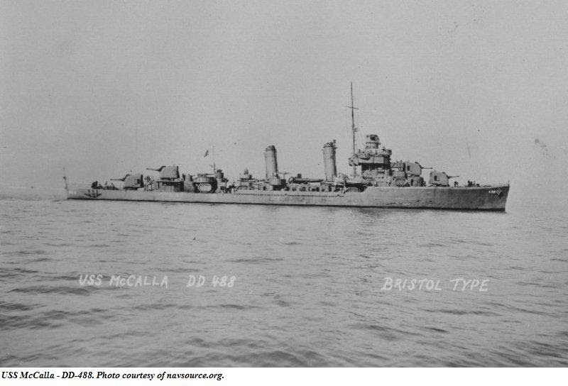
USS McCalla DD-488

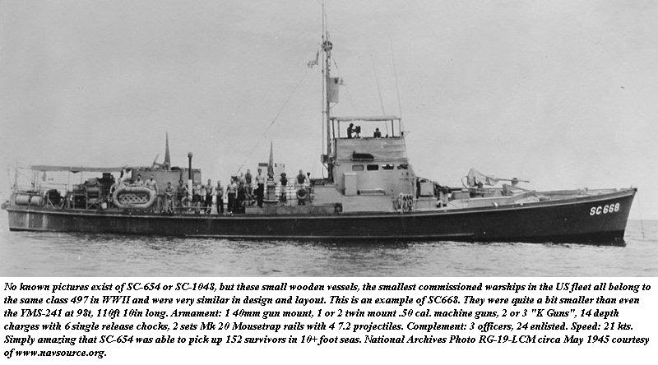
SC 654 has no known photographs. Above is a similar vessel.
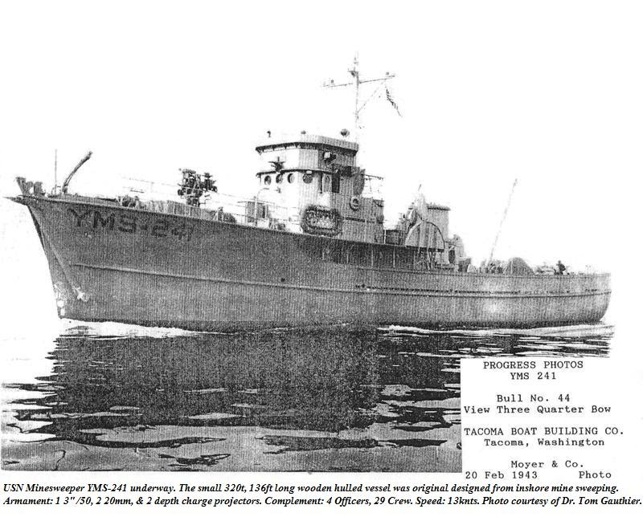
Minesweeper YMS-241

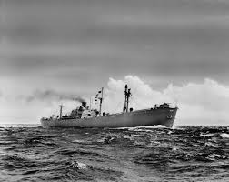

Vessel of same type as Liberty Ship Edwin T. Meredith

