Chapter 2 - "You're in the Army Now"
(1942-1946)

My father was a confident young man with a worldly outlook and an affinity for exhilaration and the adrenaline rush associated with it. Even though he preferred the silence of libraries basking in academic excellence, he accepted the battlefield. Despite his small stature, he began serving the Army with enthusiasm and gusto.
Dad never let the disappointment of being appointed to the rank of a private keeping him from serving his country with honor, respect, and devotion. The norm in those days was to serve in the war for six plus months, instead of the usual four years of duty.

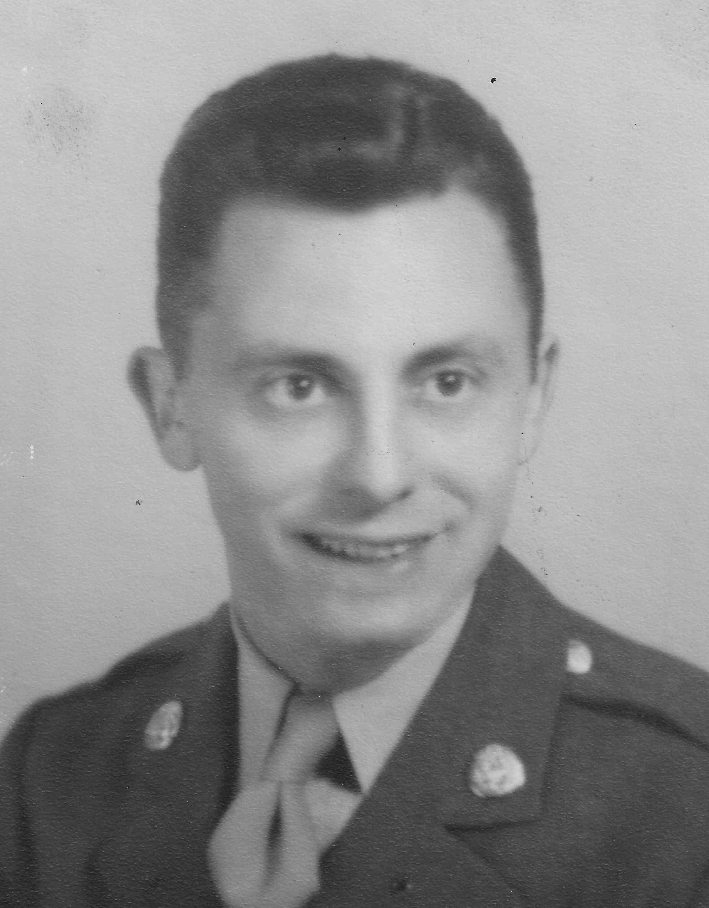

Dad rarely talked about his WWII experience, but he would often talk about P.O. Box 1142 during our conversations. I never questioned him about the infamous” P.O. Box” till I came across an article in the Washington Post dated February 25, 1993. In the article titled "Uncovering the Secrets of MIS-X,” I learned about this highly classified organization and Dad's involvement in it. In the article, my father was mentioned for socializing with MIS-X agents while working at Fort Hunt, which was also Virginia’s interrogation center during the war.
After reading the article, I was able to garner information about the MIS-X and MIS-Y. According to the October 18, 2007, issue of the Congressional Record, which chronicles the debates, proceedings, and activities of the United States Congress: Congressman Jim Moran, from Virginia, stated, "Known only by its mailing address, P.O. Box 1142, the men and women at this post provided military intelligence which helped bring an end to World War II and gave the United States an early advantage in the Cold War."
P.O. Box 1142 was an interrogation center headquartered in a national park at Fort Hunt, Virginia, where residents had enjoyed outings and picnics. Then the Army leased the property and constructed a fort, which the locals thought was a camp for prisoners of war (POWs). The fort had 150 buildings, imposing guard towers, and alarmed fences.
Throughout the war, those at the fort interrogated nearly 4,000 of the most important German prisoners of war. Most of these prisoners were flown in from England and transported to the fort in buses with no windows. The staff who interrogated these POWs were fluent in German. As many of the interrogators were Jewish, to them, the war was a catastrophe which tugged their heart’s strings and left their lives scarred. Dad’s proficiency in the German language and involvement with German culture while living in Munich, gave him the edge for getting assigned to the new MIS-Y program under the auspices of the Military Intelligence Service (MIS). This was a massive advancement towards his eventual career as a spy.

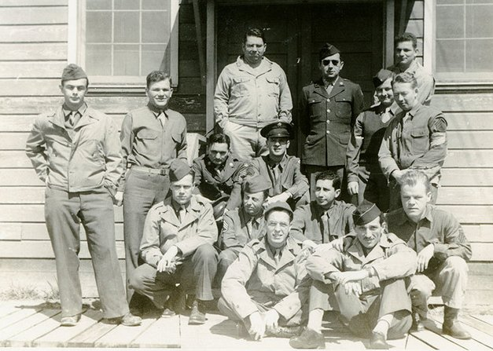
MIS-Y Group. Dad is second from left sitting on the second row from the bottom

The MIS-Y served as a strategic interrogation program, where thousands of high profile German prisoners were investigated regarding troop movements and scientific advancements. One of the most important interrogations was held when a crew and passengers of a U-boat surrendered to the U.S. Navy. The boat was captured before it could complete its mission to provide personnel and material to help Japan, in a bid to support its war against the Allies. The passengers included: Lieutenant General Ulrich Kessler of the Luftwaffe; Colonels Sandrat and Neishling, also of the Luftwaffe; civilian rocket and jet experts; and the most enigmatic of all, Lieutenant Commanders Hideo Tomonaga and Genzo Shoji of the Imperial Japanese Navy, who committed suicide before they could be caught. The secret cargo was even more impressive with tons of dossiers and war materials including the two crated ME-262 jet fighters and ten gold lined containers, marked ”Japanese Imperial Army." Those containers had held 1,200 pounds of uranium oxide! The fate of the containers was never disclosed, but rumor had it these boxes were transferred to the Manhattan Project's Oak Ridge diffusion plant, where the ingredients were used for the creation of atomic bombs.
Unlike modern investigative techniques, the interrogators at Fort Hunt never resorted to torture, violence, or cruel tactics such as sleep deprivation, electrical shocks, or water boarding. Their captives were neither abused sexually nor were they ever humiliated to procure vital information. Instead, the most effective interrogation technique used back then was to initiate a casual dialogue process to attain the trust of their captives. It was almost like hypnosis. Though not in a spell, they spoke willingly about their experiences. The interrogators conversed, played card games, took walks, and discussed their private lives with captives. Some prisoners were supplied magazines and liquor. Once a few German POWs went shopping for Christmas at a Jewish-owned department store in Washington D.C., where they bought lingerie for their wives in Germany.
Despite the apparent simplicity of these methods, these interrogations resulted in the discovery of Germany's most secret weaponry programs. Those assigned to P.O. Box 1142 learned about research conducted on the development of the atomic bomb, the jet engine, the V-2 rocket and other critical intelligence. This later proved to be essential for waging a Cold War against Soviet adversaries. Despite the quintessential nature of the interrogations done at P.O. Box 1142, the activities of those at P.O. Box 1142 remained closely guarded secrets amongst those who worked at the Fort. Many of these men never disclosed what happened behind those closed doors even to their family members. Even today, there is little information on the Internet or archives regarding this secret organization.
In addition to MIS-Y, there was another program called the MIS-X. The sole purpose of MIS-X was to assist POWs to escape at each of the 64 German POW camps in Europe. It was a highly classified program, whose existence was not known by Congress, or the military leadership. Only a few of the crème de la crème of the War Department and the President were aware of its existence. Even the commanding officer of Fort Hunt, Colonel Walker, did not have direct knowledge of the unit's operations in the fort.
Modeled after the MI-9 Intelligence British service, the mission of the MIS-X was to teach methods of evasion, from captivity to methods of evasion from the POW camps via coded communications. The unit commenced its first project when it received a letter from the British MI-9 which had received communication from Lt. Colonel Albert Clark Jr. who was the second American fighter pilot captured by the Germans. Initially, Colonel Clark had been trained by the British in coding letters. At MIS-X, Master Sergeant Silvio Bedini, a good friend of Dad's, and a talented cryptanalyst, decoded the letter, and the MIS-X was up and running with its first mission. The coded letter system worked! The system was based on teaching a few men on methods of coding letters before being deployed overseas. If captured, they were instructed to report to the Allied commanding officer at the POW camps where they updated the officer on the latest developments of the coding system. MIS-X not only accomplished this feat by supplying codes but also special escape aids; hidden in recreational and clothing supplies along with food parcels to distract the Germans from the escape aids. To avoid any disruption in the parcels sent to the POWs, the MIS-X created fictitious humanitarian organizations such as the War Prisoners Benefit Foundation. In the event of detection, the activities of the International Red Cross would not be affected, and a new non-profit organization would be created.
The escape aids were ingenious; a straight-shaving brush handle would be cut off and hollowed out with a router. Once completed, items like maps and compasses would be placed in the hole and wrapped with German Reich marks bills preventing the compasses from rattling. The handle was then glued back and varnished to disguise any evidence of tampering.

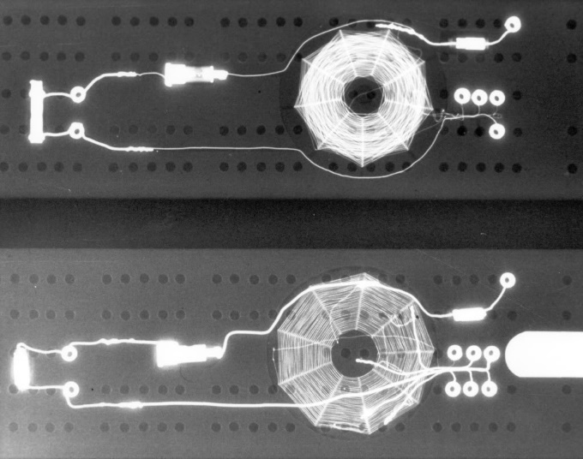
X-ray photograph of a radio concealed in a cribbage board (U.S. Air Force photo)

New devices were constantly sought and new concealments such as hollowed baseball bats, and cigarette packs with escape maps, were created.
According to government records, thousands of U.S. military personnel were able to evade the Germans or escape from their POW camps. In August 1945, an order to cease operations and destroy all evidence was passed. Visiting Fort Hunt today, there is nothing left.
Having completed two years in the MIS-Y program, Dad was promoted to the rank of Master Sergeant and assigned to the X-2 Counter Espionage Branch in the Office of Strategic Services (OSS) 12th U.S. Army Group, in France.
The OSS was a relatively new organization as intelligence gathering in the U.S. had no direction, coordination or control; it was formed on an ad-hoc basis by the different branches of the military and departments of the Executive branch. On June 13, 1942, President Roosevelt established the Office of Strategic Services (OSS) to collect and analyze intelligence gathered from around the world. The OSS was led by Major General "Wild" Bill Donovan. OSS agents were trained in such a way that was befitting top-notch cloak and dagger spies. The best and the brightest brains graduating from the Ivy League colleges were taken on board. Even movie stars, sports figures, and other famous individuals were hired. The OSS earned its reputation as "Oh So Social" and the "Cloak and Dagger club." The OSS was involved in many bold operations including the provision of support of numerous resistance groups and conducting acts of sabotage, and assassinations.
My dad, a first-generation American, was extremely honored that a Roman Catholic of Italian heritage could be of such important service to his country in time of war. He certainly faced greater challenges, and setbacks, because he was not a graduate of an American military academy or elite university, and lacked the social camaraderie connections gained from attending these institutions of higher learning. However, my father’s strong foreign language skills (French, German, Italian and Spanish) proved to be an asset to the military intelligence service. He particularly enjoyed being assigned to X-2 Counter Espionage Branch. In his new assignment, he interrogated and collected information from captured Germans. If any one of the captives expressed opposing views on the war, my father often recruited them to be Sauerkraut agents, who made their way back to enemy lines to distribute anti-Hitler propaganda. He was also a part of "Operation Paperclip" which involved recruiting scientists from Nazi Germany for employment in the U.S., just after the war ended. It was a covert operation to recruit one of the greatest spoils of German resources, the Nazi scientists. Dad was ordered to proceed to numerous German cities to interview and recruit the German scientists. These recruitment areas included Heidenheim where 444 persons of interest were detained where the U.S. Navy was holding 200 scientists and engineers including wind tunnel experts; and Bad Kinnengen where the Army Air Force had 150 Luftwaffe engineers and technicians. Dad never mentioned names, but some of the most famous were Wernher von Braun who invented the V2 rocket and later crafted rockets for the U.S. Apollo program. In addition was Kurt Blome who was the highest ranking Nazi scientist and director of the Nazi biological warfare program. Although the OSS played an integral part in the intelligence arena, many in Washington, D.C. felt that there was something amateurish about them as they were known for their extravagant ways and a non-serious attitude in spying. It was also looked at as an easy way out for the well to do to avoid combat, yet, fulfill their obligations towards the country. This led to their demise, and in August 1945, the OSS was abolished by executive order. Many of the components and attributes of the OSS were taken up by various agencies.

