EPILOGUE

If you board the wrong train, it is no use running
along the corridor in the other direction.
-- German theologian and dissident from the Nazi era
Deitrich Bonhoeffer

Over the years I have thought many times of my adventures in the USSR. My six-month odyssey in what Soviet emigres often referred to as “Wonderland” was indeed a pivotal point in my life. At age 25, I thought I'd seen pretty much everything the world had to offer after four years in the Army, a little over two of which were spent in Germany. But it is truly eye-opening for people born into and raised under a system characterized by individual freedom and personal liberty to witness firsthand what life is like in a closed, totalitarian society.

My only personal exposure to the Soviet system previous to this journey had come through the headsets I wore at an Army Security Agency listening post in West Germany while monitoring the activities of Soviet military units stationed across the border in East Germany. But 1972 provided me with an “up close and personal” view of that system. For me, the most illustrative example of the cavernous difference between a free society and one ruled by the iron fist of totalitarianism was and remains in my memory to this day the seizing of a young dissident at the exhibit in Leningrad. The USSR had been hermetically sealed since the 1920s, walled off and isolated from the rest of the world by barbed wire and minefields. The KGB was in full control of every aspect of Soviet life.

At the time of writing this book, forty five years have elapsed since my trip to the Soviet Union. Little did we know at the close of 1972 that within a mere nineteen years after our departure, the monolithic communist state would collapse, liberating the people of the fifteen so-called “republics” comprising the USSR, as well as those living in Soviet client states in Eastern Europe. As columnist Mark Steyn succinctly puts it: “The appearance of permanence is the illusion of every age.”

None of us who had served in Europe in the US military of the 1960s or spent time in the Soviet Union during the 1970’s could have foreseen in our wildest dreams the demise of that totalitarian behemoth. William F. Buckley’s prophetic words at our dinner in Donetsk were the only truly accurate predictions I had ever heard on the subject.

In an interview with the producers of a 1998 CNN documentary entitled “The Cold War,” Czech dissident writer and first president of the post-Communist Czech Republic Vaclav Havel said of Communism: “Something that goes against life may last a long time, but sooner or later it will collapse.” And the Soviet empire in Russia and Eastern Europe did indeed disintegrate in the final decade of the twentieth century.

I recall President Ronald Reagan calling the Soviet Union an “evil empire” in the early 1980’s. This was ironic in the sense that since the earliest days of the lead-up to the Russian Revolution in the early twentieth century, through the entire history of the USSR, and virtually until its ultimate dissolution in 1991, Marxist-Leninist doctrine taught that it was the capitalist West which had oppressed and exploited working people. Reagan was completely correct in pointing out the oppressive nature of the Soviet Union even though he was roundly criticized for doing so.

Years after my trip to Wonderland, I discovered the following quote concerning the society I had personally visited in 1972:
In my study of communist societies, I came to the conclusion that the purpose of communist propaganda was not to persuade or convince, nor to inform, but to humiliate; and therefore, the less it corresponded to reality the better. When people are forced to remain silent when they are being told the most obvious lies, or even worse when they are forced to repeat the lies, they lose their sense of probity…. One's standing to resist anything is thus eroded, and even destroyed.
This quote reminds me of the reaction of an old man in Riga after reading aloud the slogans which appeared in huge letters atop nearby buildings. And there was the stark contrast between an article in Pravda praising the “record harvest” of 1972 and the almost empty bread section in the miners’ dining facility in Donetsk above which hung a sign which read “Take only the bread you need for your meal; Bread is a treasure – conserve it.” During virtually the entire reign of the Communist Party in the USSR, generations of people, realizing that things were unlikely to change in their lifetimes, were forced to accept the blatant hypocrisy of Soviet propaganda and go about their dreary daily lives despite it.

The only effective antidote to such mind-numbing propaganda is truth. As the old saying goes, “Sunlight is the best disinfectant.” And, in a small way, we who served in the old USIA cultural exchange exhibit program did provide a bit of sunshine by telling ordinary Soviet citizens a different side of America’s story from that with which they were constantly bombarded in the Soviet media, in Soviet schools, and by the Soviet Government.

Over the years since my return to the United States I had the opportunity to work with many former Soviet citizens. Space does not permit me to share all the things they related to me about life in that place – only some of which I had seen with my own eyes in 1972. Two instances remain in my memory as examples of the lasting scars Soviet Communism left on people.

The first occurred during a conversation with a woman who had grown up in Leningrad. She was discussing life in the USSR and suddenly said, “You know, it’s strange. Many of us [former Soviet citizens] are still afraid.” I asked her what she feared. Her answer was indicative of the lasting effect of living under totalitarianism. She said, “I don’t know. But we are still afraid.”

The other is a personal story which I found to be totally revealing of the brutal reality which was the Soviet Union. An elderly former Soviet citizen told me how he had come to lose his left arm. He had spent time in the infamous GULAG and frostbite had claimed his arm. He said that his most vivid recollection of those years was when the guards came into the barracks at dawn one cold, snowy winter morning and rousted the (political) inmates, herding them outside for their morning formation. They were given long poles, then marched deep into a dense forest, and ordered to knock ice accumulations off the trees.

During a rest break a few hours into their assignment, this man had occasion to strike up a conversation with a young KGB guard. He told the guard that he was not surprised that the prisoners were forced to work, but asked if it wouldn't perhaps be better if they were given something productive to do, rather than the inexplicably inane chore of knocking ice off trees in a remote and deserted forest. The guard sneered and replied, "You still don't understand? We don't need you to work. We need you to suffer."

And suffer the Soviet people did. Through revolution, Lenin’s terror, civil war, secret police repression, “corrective” labor camps, Stalin’s Great Terror fed by his paranoid delusions which created a hell on earth, political persecution, deprivation, famine, constant police harassment and persecution, imprisonment of the innocent, and substandard economic conditions with frequent shortages of basic consumer goods routinely available in the West. As retired Soviet and Russian General Dmitri Volkogonov wrote, the Soviet Union was founded on “Bolshevik ways – ways that were based on class cruelty, confrontation, and the cultivation of the lie.”

All this and more was endured by people who, like the vast majority of their ancestors, had never experienced individual liberty. For generations of Soviet citizens, “self-determination” was just another in a long line of meaningless propaganda slogans used against the West during the Cold War in the Soviets’ effort at spreading Communism throughout the world. The term had absolutely no relationship to the manner in which the USSR itself was governed.

In 1991, the longsuffering Russian people were finally able to throw off the chains of their many decades of Communist oppression. Unfortunately, in the 1990s, the transition from a completely closed, authoritarian society to an open, democratic country was less than smooth. Boris Yeltsin – himself an old Communist apparatchik – heralded the fall of the Soviet Union as a joyous time of freedom for the Russian people. However, Yeltsin must have known that Soviet Russians had never had a say in how their country was governed. Only twice in recorded history had Russians enjoyed any form of democracy – the Novgorod Republic of ancient times and a very brief period of semi-democracy after the abdication of the last Russian Tsar – Nicholas II – in 1917. How, then could they be expected to instantly participate in a free and open democracy?

Suddenly, after centuries of autocratic rule and seventy-four years of totalitarian dictatorship and oppression, the Russian people were asked to chart the course of their own lives. Sadly, as the decade of the 1990s would prove, they were simply not prepared psychologically and societally to chart that course through the admittedly messy business of democratic self-rule. A grave mistake was made in the transformation away from totalitarianism to democracy. Unlike postwar Germany in 1945, the demise of the Soviet Union was not accompanied by a period of thoughtful self-analysis and societal purification, as it were. Since Russia remained a nuclear superpower, no external force was going to require them to administer justice to the officials who had overseen the infliction of so much repression and violence against their “enemies” as had been done with former Nazi officials in postwar Germany.

This meant that numerous secret police and Communist Party officials, instead of being held accountable for their role in propagating the long history of Soviet crimes against humanity, were permitted in post-communist Russia to retire into seclusion and peacefully live out their lives. This was a colossal injustice with which Russia and the world have never come to grips.

Many Russians nowadays mockingly refer to the fledgling democracy of the 1990s as “dermocracy,” which would roughly translate to “crapocracy.” It was natural for Russians, given their long subjection to autocracy, to revert to it. This partially explains the rise and current popularity of Russian President Vladimir Putin.

These and other related factors combine to explain how it came to be that Russia has to date been unsuccessful in moving from a totalitarian system to a free, truly democratic one. As Russian historian Dmitri Volkogonov put it “All of Russia’s misfortunes stem from the fact that she was never able to come to terms with liberty.”

At the time of the writing of this book, numerous stories about Russia have made their way into the news in America. What has been lost in the hectic twenty-four-hour news cycle is the virtual impossibility of accurately understanding Russia and her current role in the world without an in-depth study of the society which produced today’s Russian Federation. Absent this historical link, it is unlikely that those in the West will ever comprehend the motives and intentions of the current Russian leadership.

History indeed has many lessons to teach us, but, as Aldous Huxley was quoted as having said: “That men do not learn much from the lessons of history is the most important of all the lessons of history.” As stated in the preface to this book, among my intended audience are the growing numbers of Americans who are too young to remember the Soviet Union. There is much that Americans can and should learn from the history of the USSR.

What I saw and experienced in that society, as well as what we now see in places such as Communist North Korea and Socialist Venezuela, combine to remind me of the wisdom of the oft-cited notion that a government big enough to give you everything you want is big enough to take away everything you have. It seems this refers not only to material things, but also to a person’s freedom, rights, and privileges. Such blessings are either guaranteed by the rule of law, or they will be subject to the whims of a powerful government.

Although I can barely remember the days of my youth as a teen, I do understand the lure of promises to “transform” America into a society where, it is argued, we can link arms and join the “struggle” for concepts such as social justice, income equality, and other utopian outcomes. However, a study of history reveals how Socialists and Communists have played on these themes for centuries. It also clearly shows that the societies they created have never ended well.

Now, in the twilight of my life, as I begin my eighth and likely final decade here on earth, I feel an obligation to add my personal experiences from 1972 to the historical record. Although some may perceive it as such, this book is not primarily intended to be a political or ideological treatise. Rather, it is my hope that by reflecting on the examples of Soviet life provided in this book, the reader – and most especially the young reader – will develop a sense of the relevance of history to decision making about the future.

Hopefully free people in the West will avail themselves of the wisdom of an old Russian proverb “Measure the cloth seven times before making the first cut.” Would that the Russian people had followed this advice themselves in 1917!

In his comprehensive treatise on Soviet history, General Volkogonov wrote the following:

For many years I was an orthodox Marxist, and it was only late in life, after a long and tortuous inner struggle, that I was able to free myself of the chimera of Bolshevik ideology. I felt enormous relief, and at the same time a sense of deep regret that I had wasted so many years in Utopian captivity …. Disillusionment first came to me as an idea …. Finally [it came] as the determination to confront the truth and understand it.

It is my fervent hope that future generations of Americans won’t have to look back upon their lives as this Russian general’s conscience forced him to do in his later years. One way to avoid having to do that is to carefully consider the path we are currently traveling in light of documented tragedies such as the oppression which Soviet Communists foisted upon so many innocent people for over seventy years in the twentieth century.

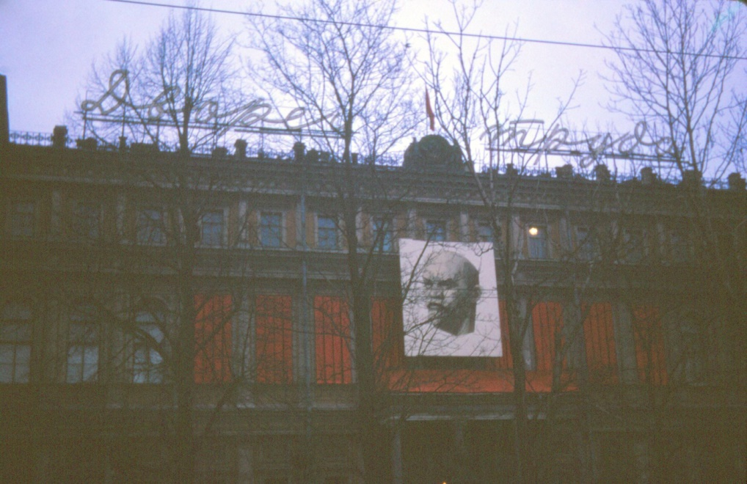

Lenin, Lenin, everywhere. Images of this Soviet figure were visible throughout the entire Soviet Union
for over 70 years. He was seen in every Soviet classroom, on buildings, in offices, and on monuments as part of
the deification of this man and the supposed infallibility of the system he created. These images were also
constant reminders of the power and presence of Big Brother.

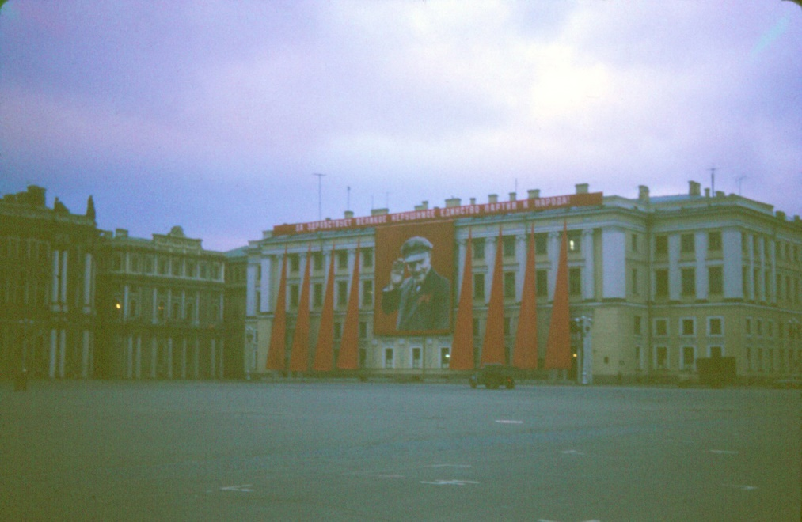

While portrayed as a friendly father figure, Lenin, who banned all non-communist parties, also established a
Dictatorship, instituting terror as a mechanism to control the people. He was revered by Soviet myth as a great
man and a successful leader. Lenin started his country down a path which led to the slaughter of countless
millions of innocent people and yet was glorified by the Soviet state. Sadly, to this day his body still lies in
honored repose in the Lenin Mausoleum on Moscow’s Red Square.
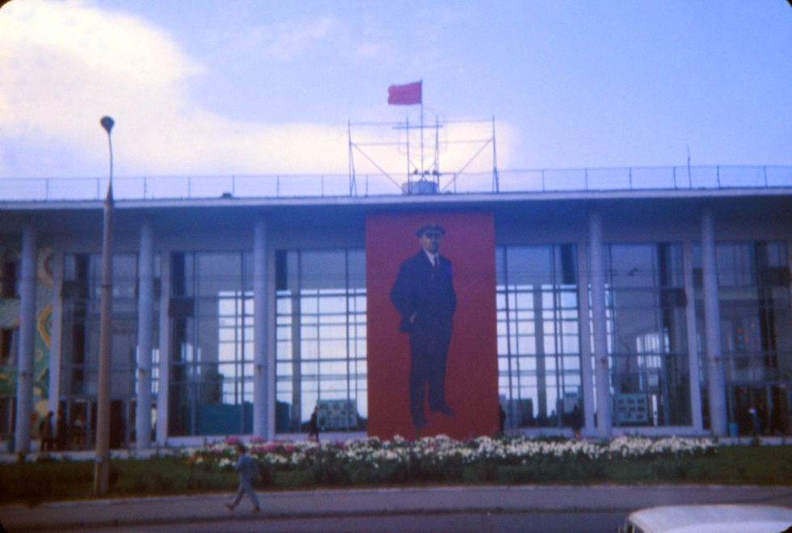

The ever-present, mythical figure of Lenin – the man whose word was law in the USSR – seemed even
after his death to be personally supervising every aspect of Soviet life. Thus the Soviet slogan “Lenin lived,
Lenin lives, Lenin will live.” It was a classic case of the kind of society George Orwell famously described in
his book 1984.

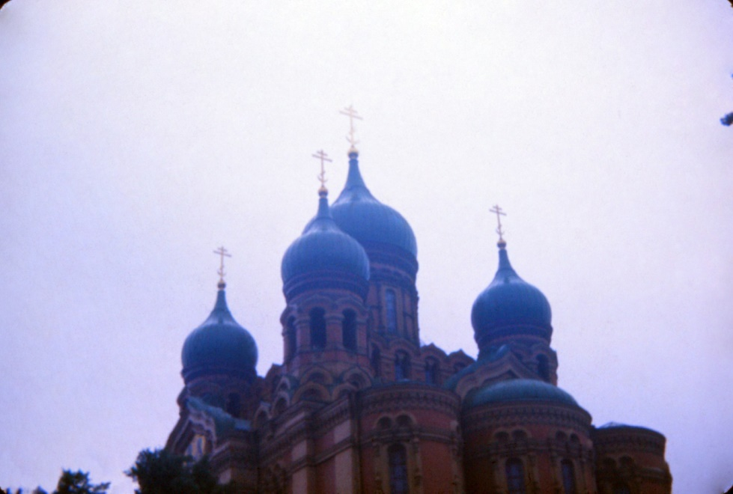

As early as 1913, Vladimir Lenin had said that the very thought of God or religion was “unspeakable
vileness.” After the revolution, he set about destroying churches, killing priests, and conducting an all-out war
against the Russian Orthodox Church. Tens of thousands of churches were either destroyed or converted to
other uses such as skating rinks and museums promoting the wisdom of atheism. Countless priests were either
executed outright, or sent to the slave labor camps of the Soviet GULAG.
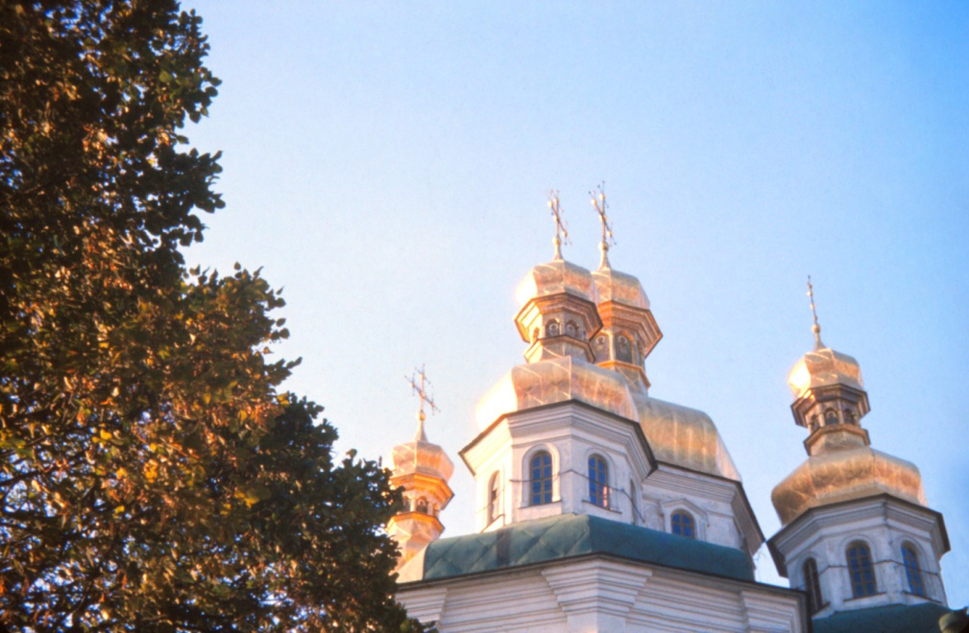

Despite the Soviet Constitution’s “guarantee” of freedom of religion, dictator Josef Stalin’s Great Terror
intensified Lenin’s brutal campaign against religion. By the early 1940s, thousands of churches had been
destroyed and Stalin’s infamous GULAG had been filled with priests and churchgoers. The oppression of
religion, while not as brutal as under Stalin, continued throughout the remainder of the Soviet era in Russia.

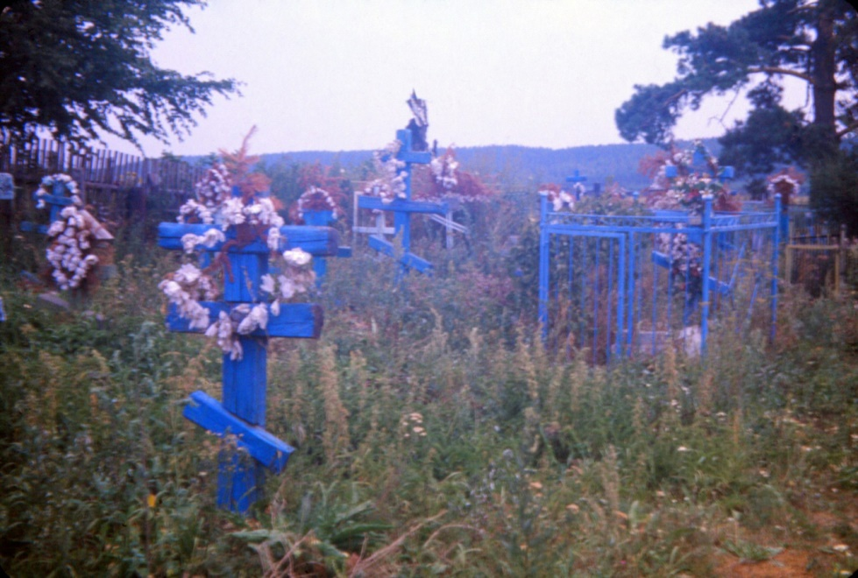

Despite all the Communist mythology, the cult of personality of Lenin and Stalin, the constant propaganda, and the falsification of history, the landscape of Russia contains a constant reminder of what really happened there during the Soviet era. The country is dotted with thousands of cemeteries such as this one – places where the innocent victims of a brutal system of oppression and terror lie in silent testimony to Soviet atrocities. They stand as a stark warning from history of what can happen when too much power is concentrated in too few hands. They also call out to mankind: “Please don’t ever let this happen again!”

Mr. Buckley, when asked about the fate of the Soviet Union, answered simply: “It’s imperiled.”
British author and social commentator Anthony Daniels who writes under the pseudonym Theodore Dalrymple.
As the Director of the Soviet Institute of Military History, Volkogonov had full access to a wide array of Soviet archives and based his historical treatise, Autopsy of an Empire, on them. (see bibliography).
This concocted word is built upon the Russian word dermo which means excrement or, colloquially, “crap.”
Autopsy of an Empire, by Dmitri Volkogonov (1998), page 432.
Autopsy of an Empire, by Dmitri Volkogonov, page xxvi.

