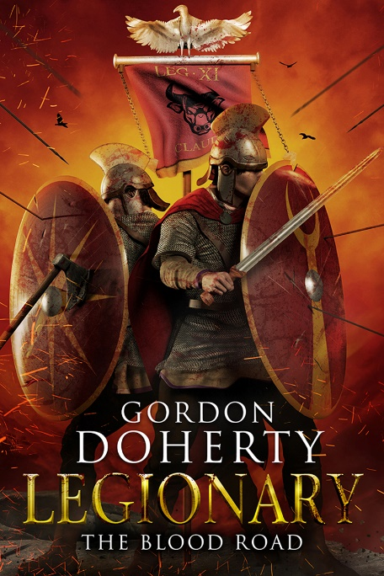
Prologue
Jan 1st 381 AD

A glacial wind screamed along the frozen banks of the River Danubius. The waters – grey like the bruised sky – foamed and churned, ragged chunks of ice bucking and clashing like warring galleys. At a section where the currents fell calm, the ice had gathered, uniting to form a broad, frozen rib that stretched from bank to bank.
From the thickly-forested north, a whinny split the air, and the sound of hooves rose like a speeding drumbeat. With a puff of falling frost, a lone Hun rider burst from the treeline and sharply reined in his stocky mount. Zolt was a warrior of many years with a face that was more scar than skin, bald but with a ring of thin hair that hung to his shoulder blades and a threadlike moustache. He walked his horse to the river shallows, eyeing the ice bridge with suspicion. Tentatively, he heeled the steed forward. Clop…clop, went the hooves as the animal stepped gingerly out onto the wintry walkway, snorting and nickering. An eerie crackling sounded all around, shooting off in every direction. He slowed for a moment, stricken with terror… but the ice held. Rolling his shoulders, he sucked in a breath and guided his horse on, his eyes widening and his lips peeling back in glee as he reached the southern banks. He sped on up the short stretch of scarp there, frost flicking from his mount’s hooves, before riding onto the plain. There, he circled, eyes switching across the land: white, deserted, just the low moan of the winter wind. He twisted in the saddle and shouted back to the northern banks in a throaty, strange voice: ‘Tengri the Sky God has shown us the way. The bridge is good. The door to the empire lies open!’
The northern woods shook, frost and dead pine needles toppling in a shower, before a thunder rose and Zolt’s band spilled into view. Seven hundred Hun riders, wrapped in grey-brown furs and goatskins, backs laden with quivers, bows, ropes, axes and spears, their horses small but hardy and muscular. ‘Whoop!’ they cried as they milled and jostled at the northern end of the ice bridge, eager to join their leader on the other side. They began crossing in a column, two abreast, chattering and laughing amongst themselves, some swishing their swords in the air as if lacerating invisible victims. The cries faded for a moment when the bridge groaned and crackled in protest… but the ice again held good. The first of them reached the end of the bridge and climbed up onto the southern banks to gather around Zolt.
‘Tengri has laid out great treasures for us,’ said Zolt. ‘See the rising smoke there?’ he pointed to the pale wisps rising from the south, about a mile away. ‘It is a farm or a settlement of some kind.’
The riders around him rumbled with excitement. For nearly five years the growing Hunnic bands on the north side of the river had watched the goings-on in the empire, locked out by this angry and unbridged artery of water. There had been shambolic and disastrous attempts to craft boats, but skittish horses and poor craftsmanship had seen each effort fail. Zolt himself had spent entire days gazing over at the pasture and croplands – and that was nothing compared to the greater treasures rumoured to lie further south. His clan’s kam had regaled them with tales of the towering spires of marble, terraced orchards and golden palaces that lay beyond the eye’s reach. But then he recalled the old storyteller’s voice, throaty and crackly, falling low as he warned of the steel-clad sentinels who guarded these lands and their riches: the legions.
‘No longer,’ Zolt whispered, his lips quirking at one side. He had witnessed the chaos that had unfolded after the Goths had been allowed to cross the river, five years ago on a now long-gone bridge of boats. Hundreds of thousands of them – lost prey for the Huns. At first, it had all gone quiet. Then, he had noticed a slow thinning of the dutiful Roman watchmen on the stone turrets that dotted these southern banks, hearing cries from others summoning them away. Gradual at first, then a sudden and complete withdrawal. The kam had translated for those who did not know the Roman tongue: fire and steel sing across Roman Thracia, he had said, the Goths are in revolt! Soon, the great stone turrets and forts were empty, the parapets bare. The hinterland too – devoid of imperial soldiers, wagons and mule trains taking wheat and wine between the distant cities. The war with the Goths had been like a tornado, sucking everyone and everything towards the heart of the Roman lands, far from this now-forgotten border. The memories faded and his eyes once again beheld the faint smoke column. Had some brave Roman or Goth dared to make a home here again?
‘Whatever structures we find there, we will raze. We will take the people’s heads and rope them to our saddles, fill our bags with their precious things.’ As his men cheered, he pulled on a baked leather helm with a trailing soft leather aventail, the V-shaped browband giving his already baleful face the look of a hungry predator. One hundred and fifty of his men had crossed the bridge now. Enough, he thought, eager to act, to urge his horse on across the frost-veined ground and lead the charge, the rest can catch up. He dipped his head, filled his lungs and shaped his lips to roar them onwards.
But the flat-faced rider beside him decided to snatch his thunder. ‘Forward, for Tengri the Sky Go-’
The ‘o’ in god drew out into an ‘aww?’ as Flat-face saw something blur up from the south – near the smoke column – and hurtle up through the grey sky. Zolt and the rest of the riders stared up too, muttering in awe… then rising in a clamour of fright as the strange object began to dip, speeding down towards them. Flat-face’s mouth was still open in astonishment when the smooth ball of granite – half as big as his head – punched through his face like a fist through a watermelon. Blood, skull and brain showered all behind him in the heartbeat before the rock then plunged on down and into the ice-bridge’s southern end. Flat-face’s headless body swayed and listed in the saddle as his horse bolted ahead onto the hallowed southern plain, taking the sagging corpse on its final journey. Zolt and the rest of the riders gawped at the sight, then jolted at the stark crack that rang out behind them. Zolt twisted in his saddle to stare at the two jagged lines shooting from each side of the hole where the rock had smashed through the ice. More than one hundred riders were on the bridge and each of them halted, grasped by fear. ‘Move, move… mo-’ Zolt stammered.
His cries were drowned out by what sounded like a groan from a waking giant, as the bridge shifted and tilted violently. Showers of frost and freezing water sprayed up. Horses and men fell and slid as huge sheets of ice rose like the fins of river monsters. With gouts of foaming water and hefty splashes, Hun horsemen plunged into the icy currents, thrashing, most never having washed let alone learned to swim. A fraction of them sped and leapt over onto the southern banks in a flurry of spinning hooves as the icy crossing dissolved into the raging torrents. But more than eighty were carried off downriver, flailing and screaming or blue-faced and staring, shocked through with the cold. More than four hundred riders stared from the northern banks.
Zolt stared back at them, then at the shard bridgeheads, and finally at the one hundred and seventy or so riders stranded with him here on strange lands. His heart thundered with indignation. The riders wheeled in a circle around him, panicked, beseeching him for direction. Zolt’s head snapped round to the south, to the smoke column and the unseen demon’s mouth that had spat out that rock.
‘Leave none alive,’ he shrieked, kicking his horse on to lead the others in a headlong gallop through the frost. They screamed as one as they rode, lassos whirling overhead, leather aventails and hair flailing, bows drawn and nocked, eyes fixed on the low rise obscuring the source of the smoke.
Up, up over the rise they pelted… and then saw the iron line of nearly one hundred and fifty men crouched on one knee just beyond the crest, spears pointing like a set of fangs, ruby-red shields arrayed like a wall, sinister eyes shadowed under the rims of their silvery helms. The Hun horses screamed and whinnied, many running onto the lances, bellies tearing, ribs cracking. Some riders were thrown over the legionary blockade, skidding and rolling through the frost some way behind. Zolt pulled up just in time, loosing his bow into the eye of one Roman, his mount kicking a second in the head. He flicked his lasso to loop it around the neck of a third, and yanked tight to break the man’s neck, but in the instant before he claimed that third life, a Roman spatha slashed through the lasso rope. The sudden release of tension caused Zolt to topple from his mount and roll through the frost, backwards down the rise. The absence of the saddle under him was like a missing limb. Shame! the kam’s voice screamed in his head. We sleep, eat, fight and die on horseback!
Every time he tumbled over he saw, stalking towards him, a Roman officer with a fin-topped helm and a vest of iron mail, his crimson cloak billowing behind him. He had the look of eagles about him, dark-eyed, pointed and gaunt. Neither young nor old – some twenty-five summers, no match for me! thought Zolt. The Roman swung his spatha once in his grip. Zolt rose and drew his sickle and a dagger in his other hand for good measure. He crouched and weaved like an acrobat as all around him the rest of his men tangled with the other legionaries. He flashed his sickle towards his opponent’s flank, only for the officer to dodge spryly – suffering just a slash across the hand. He then went for the Roman’s other side, only for the officer to block. Zolt staggered back, surprised by the strength of the wolf-lean man. He had little time to dwell on such matters, however, as the Roman followed up to swing an elbow into his nose. An explosion of sparks and light filled his head. When the daze lifted, he realised he was on his back. The fin-helmed officer stood over him, sword held blade-down over his chest, the red cloak fluttering in the wintry wind, blood trickling from the slashed hand.
‘Do it,’ Zolt said in a strained hiss of broken Greek. ‘The rest of my clan and the thousand others of the steppe will avenge me when they pour across the next ice bridge. They’ll pluck your head and parade it high on their spears.’
He half-expected some kind of instant riposte, but the Roman officer stared at him… no, through him. Those hazel eyes were lost, elsewhere. ‘Then they had best be quick, rider,’ the Roman said at last in a low burr, ‘for I am but a walking shade.’ With that, he brought the sword down, piercing through armour and ribs, slicing Zolt’s heart in two.

Pavo worked his sword clear of the corpse with an unctuous, sucking noise, then drew the blade across the frosted grass to clean it of blood. His pulsing heart slowed and the grip of battle slackened. Behind him, the smash of iron on iron and screams of dying men faded to be replaced by gasps and croaks and whispered prayers of victory.
‘For the Claudia,’ panted one voice, thick with emotion.
He turned to the rise, seeing the men of the First Century slacken in relief. Seven legionaries lay still on reddened earth; another dozen groaned and clutched wounds. Pavo betrayed not a chink of emotion, the ‘soldier’s skin’ like a layer of old boot leather around his heart. He quietly stooped to pack a little frost around the stinging gash on the back of his hand. Primus Pilus Sura, his most trusted man in the legions and out, wrenched his spear clear of the shoulder of another Hun corpse, his blonde hair shuddering and his boyish features ruined by a snarl. ‘We weren’t sent here to fight Huns,’ he seethed at the toppling body.
‘Thank Mithras we were here though,’ said Pavo, peeling his helm from his head and scruffing a hand through his short, dark hair. He offered a nod to the onager crew – fifty strides back – who had measured the range and unleashed the rock that had destroyed the ice-bridge. ‘Imagine we were not. These bastards would have poured across, then sent back word to others. The nightmare on the far banks would have spilled over here in its entirety.’
‘Still a bit of a nightmare on this side too, Tribunus,’ said Centurion Libo, throwing his helmet to the ground and scratching behind his ear like a dog, flakes of dry skin spraying from his wild, matted hair. His painted, wooden eye remained fixed and staring while the good eye swivelled to look south, he like the many others thinking of the turmoil still ongoing many miles away.
‘There will be an end to it, soon,’ Pavo said in a tone he hoped might convince his charges, even if he didn’t believe it himself. It was the popular rumour: that the Gothic War would end soon. The ‘Black Horde’ of Alatheus and Saphrax had been destroyed near the city of Sirmium along with those two wretched warlords. Only Fritigern’s half of the Gothic forces remained. Only, Pavo thought with a snort, thinking of those vast numbers camped in the south. It was said that the armies of the West would soon march to these lands in full to join the patchwork Eastern legions and crush Fritigern. The possibility enthused most Romans, but not Pavo. For the Western legions would be hunting more than just the Goths. They had another quarry too. Come on then, Pavo mouthed into the wintry ether, his eyes shadowed by his dipping brow, his top lip curling like that of a cornered hound.
‘Rig up some pallets for the wounded,’ boomed Rectus, the lantern-jawed medicus, sweeping his peak of hair back only for the wintry gale to dishevel it again instantly. He set about guiding the men in fashioning stretchers from leather sheets and spears and hoisting the injured legionaries onto them while others dug graves for the seven fallen ones.
Pavo paced to and fro as the graves were filled in. It was a wretched thing, seeing the lifeless faces of the men he had trained vanish under spadefuls of earth and crystals of frost. One boy legionary, barely fifteen summers old, stared lifelessly into the sky. As the first tumbles of cold earth fell upon his face, Pavo felt an invisible hand wringing his heart, but the callus around it – the hardness known as ‘the soldier’s skin’ – held good, grew thicker. As the last spadeful of earth was patted down on the graves, Pavo crouched to one knee before the seven mounds ‘You walk with Mithras now, Brothers,’ he whispered, knowing full-well he would be seeing their faces again… tonight, in his dreams.
He rose and turned away while the men hitched their spades and weapons. There was something about this open, wintry waste that made him uneasy. Out here in this emptiness, they could come at him from anywhere. A hawk shuffled and cawed in the bare branches of a nearby poplar, and Pavo’s eyes met the bird’s. Hunter’s eyes. Watching…
‘They shot one of my testicles off,’ a voice groaned, startling Pavo from his thoughts.
He twisted to see big Pulcher on a stretcher – four men struggling to carry his weight. His brutish, pox-scarred face was warped in agony and he wrung his meaty fingers through his short, black curls. His trousers had been torn through at the crotch by a Hun archer.
‘Found it,’ said Sura, lifting an enemy arrow. Hanging from the bone tip by a few veins and sinews was a bloody white orb. With a shrug, he picked up a twig and flicked the testicle away. It plunged into the dense undergrowth nearby. Big Pulcher shot out a hand and whimpered like a man seeing his lover walk out on him. Sura did his best to console him. ‘You’ll not need it anyway – you’re, what, one hundred and six?’
Pulcher’s face boiled in sudden anger and he tried to rise from the stretcher before clutching his groin and wailing in a fresh wave of agony.
A twinge of pity and a guilty spike of amusement almost lifted Pavo’s lips into a smile. Almost. But when the hawk watching them shrieked and sped off from the poplar branches in a flurry of wings, Pavo’s senses sharpened, his head snapping round. What had disturbed the creature? His gaze latched onto the lazy wisps of smoke to the south, a short way through a knot of low hills, and his eyes narrowed. He could see nothing, hear nothing… but that was how they operated. Silent, unseen.
‘Back to the camp,’ he snapped.
The wind cut through them like knives as they marched, searching within their cloaks, mail and woollen tunics and trousers, the ruby bull banner hanging from the legion’s silver eagle standard stretched almost horizontal in the gale. Opis, the legion’s aquilifer used the standard like a mountaineer might use a pole to pick a path. The men’s teeth chattered hard. When they entered the lee of the hills, the wind dropped away. The gentle scent of woodsmoke offered a small promise of comfort when they eventually reached the approach to their camp. Pavo had stationed twelve men from this First Century to watch the basic shelter.
‘I don’t like it out here. Not one bit,’ Sura grumbled. ‘The sooner we get to this rendezvous point, the better.’
‘Why us?’ moaned Libo. ‘Why always us? While we’re sent up here into the frozen wilds to meet with… him, those feckless bastards in the Flavia Felix were tasked with “ensuring the naval supply routes run smoothly”,’ he said this with a simpering look on his face and a deliberately imbecilic voice. ‘They are billeted in the wharf at Thessalonica – right next to the tavern row. One door away from the brothel. By all the gods they’ll have worn their cocks to the nub by the time we get ba…’
He fell silent. Pavo turned to see the centurion’s good eye narrow, his nostrils twitching. Libo had the nose of a hunting dog, and Pavo had come to trust the man’s olfactory skills implicitly. He threw a hand up, halting the century.
‘Sir?’ Sura whispered.
Pavo watched as Libo crept forward another few paces, then fell to his haunches. He sniffed the air again before twisting his head back. ‘Can you smell it? The sweet woodsmoke grows sour.’
‘Sour?’ Pavo whispered.
Libo nodded once, slowly, his face lengthening. ‘With the stink of death.’
Pavo felt corpse-hands stroke his back. He stared ahead, along the tight, shallow gully that led to the campsite. He motioned with his hands, one pointing left and one right. The century parted, one half creeping up the gully’s western side, the other half the eastern side. Pavo went with the second group, Sura leading the first. They moved like cats, silent bar the odd shush of ringmail and crunch of frosted ground compacting under boots. At the gully end was the small hollow they had chosen as a campsite. Now Pavo could smell it too: the wretched stink of torn intestines. Like a tavern floor mixed with a butcher’s bin and a ripe latrine.
He halted his half of the century then fell prone, wriggling forward like an asp to the edge of the hollow in time with Sura on the other gully-side. He saw the small square ditch in the hollow floor, the picket stakes, the twenty or so tents where last night they had enjoyed warm stew and soldier-wine… and then the twelve naked bodies, roped at the wrists and hanging from tripods of spears like game, lower legs and feet trailing on the ground. Their ribs had been opened like gates, and the contents of their chests and bellies had been scooped out and lay in still-steaming piles around their feet. While they were still alive, he realised, seeing the look of steely terror fixed on one of the poor men’s lifeless faces. The rest wore death rictuses or haunted looks as they stared into eternity. The rest of the camp was deserted.
Pavo rose and picked his way down towards the dead men. Sura and Libo hurried to flank him while the bow-equipped legionaries on either side of the gully nocked and drew their weapons, watching for any surprise attacks on their tribunus.
Pavo saw the tell-tale footprints in the silvery-veined ground of the men who had done this: how they had entered the camp, creeping over the southern palisade; how they had crept up on the sentries’ backs… seeing how they had stolen away again. He approached the red-stained ground around the dead men and reached up to the dagger embedded in the haft of one tripod-leg spear. His fingers flexed around the hilt, the thumb tracing the motif on the bolster: a staring eye.
The sight was like a cold, ragged blade being drawn across his soul. Forget the dark figure they were supposed to rendezvous with here. Forget Fritigern and his vast horde. Forget the Huns and their attempts to spill into the empire. One enemy was at his heels already, neither Goth nor Hun. A Roman: the mightiest Roman alive: Gratian, Emperor of the West.
The hawk from earlier cawed nearby.
Only his most trusted men in the legion knew of the matter. He rolled his eyes to look at Sura, the most trusted of all. Sura regarded the knife hilt and then shared a look with Pavo. Both recalled the aftermath of that frantic battle against the Goths of the Black Horde, when they had fled from the blazing halls of Sirmium, the Western Emperor craning from one window, screaming after Pavo: I know who you are, legionary. You are a walking shade… for I know who you are!
It was not the eventual arrival of Gratian’s Western legions he would have to fear. But that of the Speculatores. Agents of the Western Emperor, black to their core. They were Gratian’s eyes and ears, his razor-talons. How many of them had done this? How many more watched right now or waited nearby? The wind keened above the sheltered hollow, offering no answers. He knew only one thing.
It had begun.

Hope you enjoyed the sample! You can buy ‘Legionary: The Blood Road’ at http://getbook.at/Legionary7
The series in full (as of July 2018):
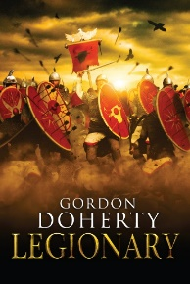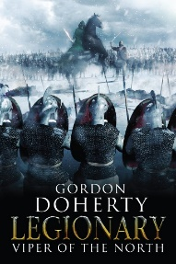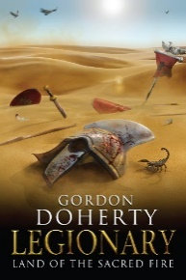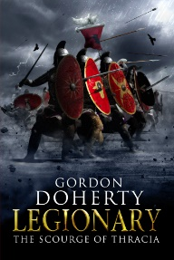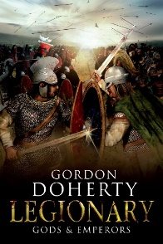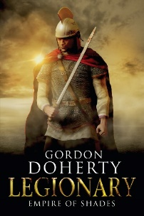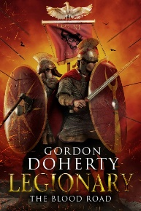

Feel free to get in touch with me at www.gordondoherty.co.uk
And you can follow me online:    

