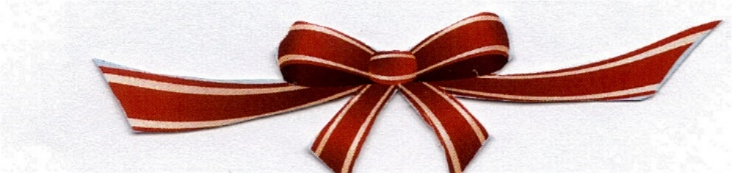
PART I
CHAPTER 1: THE FIRE

As the song says, it’s the most wonderful time of the year. Yet, it can also be the most terrible time of the year. There's just something about the Christmas season which magnifies both joys and sorrows.
The previous December had been one of true uninterrupted delight, despite the news of South Carolina's secession from the union. Upon reading that somewhat disturbing piece of news in the newspaper, Henry had smiled a sort-of half-way smile and said, “They'll learn. They'll soon come back, begging to be let back in.” He had just sent his patriotic poem “Paul Revere's Ride" into the Atlantic Monthly and had been hoping that its publication might serve to remind the nation of its start and in doing so, help to bring about unity.

Soon the news of South Carolina's secession had been forgotten and Christmas cheer was in full swing. In addition to the tree trimming, the cookie baking, and the present wrapping, there were those horse-drawn sleigh rides through the countryside to view the lighted houses and the Christmas trees which might be seen through open windows. He had driven the horse with his wife and five children behind in the huge sleigh, all bundled up in their heavy coats and scarfs and woolen caps, talking, laughing and singing the beautiful carols of Christmas, led by his wife, Fanny.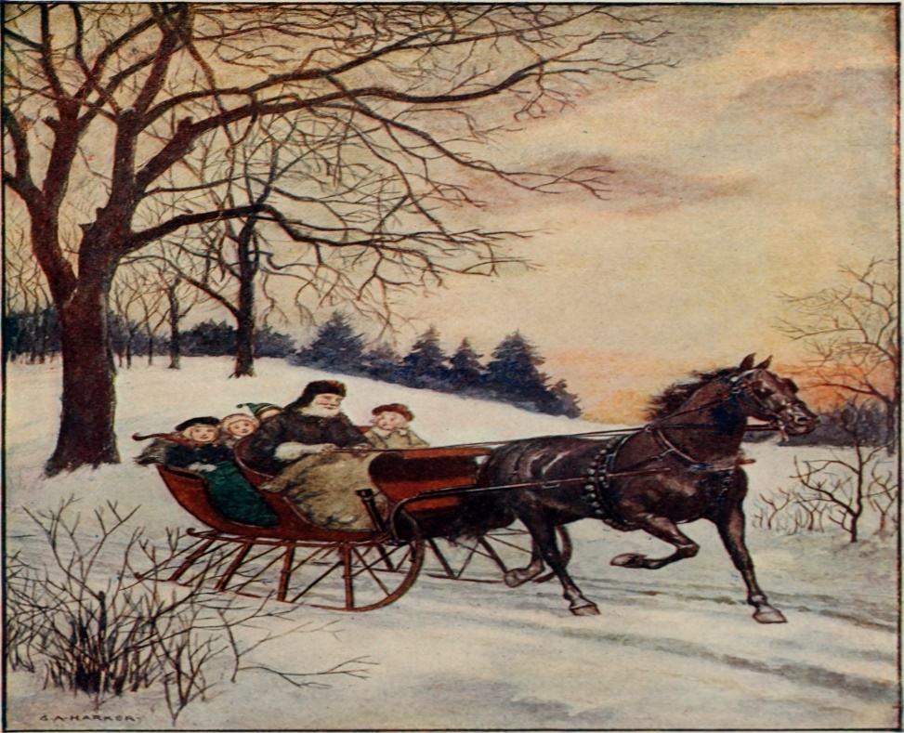

(Source: Flicker Commons / brooks primer)

There was little Edith, 7 years old, Alice Mary who was 10, Francis, who was 13, Ernest, who had just turned 15, and Charles, the eldest, now 16. They had glided along under starry skies, between snow-laden pines and though blankets of snow to the sound of sleigh bells and the occasional ringing of church bells. As they passed by the icebound Charles River, they could see the multicolored lights from many gelatin cup lamps reflected in the ice, and even from those houses yet unlit for Christmas shone the yellow light of the kerosene lamps whose reflection seemed like so many Christmas candles. Whenever they came upon an especially beautifully lighted house or saw a beautifully decorated tree, either in a yard or through an unshaded window, they would yell out: “Wow, look at that one!”
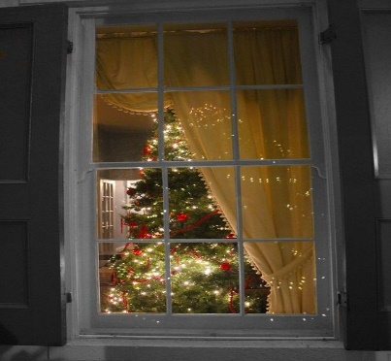
(Source: Pinterest: Tumblr: Christmas Lover) / (Source: Pinterest: Charismas 4u)

(Source: Flickr: Roger W.[https://www.flikr.com/photos/24736216@N07/4864248263])

He recalled one of those rides in particular when they rode by one particular house which had a large set of crudely carved and painted nativity figures on the lawn, clearly visible from the glow of the nearby brilliant gas lighted streetlamps. Seeing the figures reflected in the ice of the river, little Edith had asked, “What are these people and why are they looking up at us from the ice?”
Fanny, the mother, had smiled and said, “They are looking up because you are looking at the reflection in the ice. Who they are is that they are the Holy family of the nativity.”
“But who are they and what's a 'tivity?” asked little Edith, not having heard the whole word.
“They are Mary, Joseph, and the Baby Jesus.” Fanny had replied. “The nativity is a term we use to refer to His birth because He was born to bring peace to the earth.”
“Oh, I see—kinda like Saint Nicholas.”
“Kinda.” And that was all that had been said.
Then, as they drove under a clump of trees, the bare branches above them would release a shower of sparkling snow and the children would giggle with delight as the snow would hit them in various parts of their bodies. It soon became a game to see who would get hit where next.
“I bet the next one hits you right on the head.”
“No, it's gonna hit you in the nose.”
“Whoops! You were both wrong. It hit Edith on the chest.”
But this year was to be different. There would be no sleigh rides this year—No carol singing and no giggles. This December, 1861, as he sat in his study staring blankly out the window at the beautifully lighted tree his children had decorated, Henry was filled with a strange sense of ambivalence. He missed his dear wife, Fanny so much that it hurt. She loved Christmas so. She would always be the one to get the ball rolling, so to speak—to encourage the children to trim the tree, to go shopping with them and help them wrap their presents, to bake the cookies—he could almost smell the aroma of her cookies baking now. It had been five months since the fatal fire, but he could see it in his mind’s eye as though it were yesterday. In fact, Henry could see that whole disastrous summer in his mind’s eye. It had been a time of great disappointment indeed.
The first real disappointment had been the war. Even though a total of seven states had seceded from the union, he had still harbored hopes that the peace conference would bring about their reinstatement. What it had brought about, however, was only a strengthening of the southern position, with the passage of the crown act which had forbidden Congress to interfere with slavery. Upon reading that piece of news in the paper, Henry had sighed and said, “Well, then, I suppose slave owners can treat their slaves any way they like.”
“Do you think most of the owners beat their slaves, Father?” Charles had asked.
Henry had simply sighed and said, “I don’t know, Son. I don’t know, and I don’t know how we can know for sure.”
Yet, the new president, Abraham Lincoln, had seemed to be just the man to reunite the country. Henry recalled that he had been filled with hope as he had read Lincoln's inaugural address in the newspaper. It had seemed so full of promise. “Thank God,” Henry had said, after reading the address. “It looks like we’ve finally got a president who can get something done.”
Yet, he also recalled that lovely spring day when he had been speaking with his oldest son, Charles, now 17, about the possibility of civil war.
“I know that Lincoln has promised not to attack first,” Charles was saying, “but, with the way the south is now, don't you think civil war is a distinct possibility?”
“No Son, I don't,” he had replied. “If anyone can unite this country, President Lincoln can.”
But just then, they had heard the newsboy outside, ringing his bell and yelling out news of war. “Rebels attack Fort Sumter. War is declared! Read all about it!” He had sent Charles out to buy the paper and had slumped back in his chair, greatly disappointed. He had thought that surely Lincoln would be able to keep the country united and avoid war. He had slumped further down in his armchair and dozed off to sleep.
******
It was two and a half months later, and he had again been talking with Charles when the news came of Union defeat.
He had been telling Charles “It looks like we have a good chance of winning the war.”
“Yes, Father.” Charles had replied. “Perhaps this stupid war will be over soon.”
“Let's hope so, Son.”
But just then, they had heard again the newsboy's bell and the boy yelling out the headlines: “Union forces routed at Carthage. General Sigel withdraws. Read all about it.”
“Oh no!” he had sighed. “It looks like it's going the other way.” Again, he had gone into his study and had slumped down in his easy chair. Again, he had begun to doze off.
It had been unseasonably hot that July and Fanny had decided to trim the heavy locks of their seven-year- old daughter, Edith's hair. Dozing off, he had been able to faintly hear them speaking in the adjacent room.
“But, mother, I don't feel hot, really.”
“Believe me, Edith, you'll feel a lot better without all that hair. Let me just trim off a few of these locks.”
“Well, alight mother, but could you be quick about it? I want to go out and play.”
At this point, he was in dreamland. He hadn’t heard Fanny say, “There, that's perfect, and these locks are so perfect that I think I'll save one for posterity,” or Edith ask: “O.K. Mother, can I go out and play now?” He hadn’t heard Fanny remark as she heated the wax to seal the envelope, “Yes, dear, but change into your play clothes first.”
“Must I mother?” the child had replied, still unheard by the slumbering Henry. Fanny had been about to answer, when, perhaps because of the distraction of Edith's question, some of the hot drops of wax had fallen unseen onto her dress. Then, as if on signal from an unseen evil force, a boisterous breeze had blown through the open window and set the smoldering dress aflame.
“Oh, mother, mother! Your dress is on fire!” had yelled Alice Mary, who’d been standing in the doorway, watching the whole procedure. In an effort to protect her young daughters from the flames, Fanny had rushed, screaming into her husband's study.
He had awakened with a start, yelling, “What in the world? O my God, Fanny!” He had first tried to extinguish the flames with a rug, and, when that had failed, he had begun to throw his body onto his wife, severely burning his face, arms, and hands, yelling all the while.
By now all the children had gathered and begun yelling hysterically as well. Then, Charles had yelled out, “Silence! We will get nowhere by panicking. You other children, lead them to their bedroom, while I go for Doc. Buridge.”
Soon Charles was back with the doctor. Henry had lain there in pain, as the doctor applied the ointment to him and to his wife beside him.
When he had awakened the next morning, she was still beside him. She had asked for a cup of coffee. Charles had brought it to her. She had drunk it and lain back in the bed. An hour later she was gone. Henry had called her name, but she had not answered. He had gotten up and tried shaking her, but there had been no response. He had gazed in disbelief and shock at her lifeless body.
He had asked God a thousand times since that fateful day, why. Why had she been taken from him when he felt he needed her so? Or why had he not died along with her? But he realized that this was just selfish thinking. If he were gone too, who would take care of the children?
He had tried to forget about her and the terrible fire, first by turning to laudanum and ether, which he obtained from the nearby apothecary. They had also helped to ease the pain from the burns, but he’d soon found himself becoming too dependent on these substances and had realized that they could also leave him helpless at times to tend to the children when they most needed him. So, he had decided to stop the drugs and to start a new writing project instead. He had come up with what he thought was a good idea for a new book--a group of poems centered around a wayside inn. The burns had begun to heal and be less painful, and his concentrated effort on his new writing project had helped him forget about the fire and his loss for a while. But then, the awful memories would come flooding back.
This Christmas season, 1861, the house seemed especially empty even with the cheery voices of the children. They had somehow gotten over their mother's death. Children are somehow more pliable than adults—they bounce back easier. He felt he would never get over it. And now that it was Christmas time again, he thought that it may never really be Christmas again without her.
He was in his study, staring at a blank page as the children played noisily outside. Edith, the youngest girl, said to the other children “It's almost Christmas. I wonder if we're going to go on the sleigh rides again this year.”
Charles, the eldest, replied: “I doubt it seriously. Father is still grieving Mother, so we have to be patient and don't bother him about rides or anything until he's ready.”
But would he ever be ready, they wondered.
“Well what about the Christmas tree?” asked Edith.
“We’d better not bother him with that either,” replied Charles, “and I don’t think I’m up to chopping one down and bringing it in, either. It would be quite a task, even with all of you helping. So, why don’t we just decorate that big fir tree that’s there outside the window? We can look at it through the window, and it will almost be the same thing.”
“Well,” sighed Edith, “It won’t be exactly the same, but I guess it’ll do.”
Henry was trying to concentrate on his new book when he noticed the children taking the box of decorations and gelatin cup lamps outside. He wondered what they were up to, so he asked, “Children, where are you going with those things?”
“We’re taking them outside to decorate the tree outside the window,” replied Charles.
“Yes,” added Mary Alice, “we didn’t want to bother you about cutting down a tree for the inside.”
Henry smiled. “Well, that’s quite thoughtful of you children.” Then, as they continued out the door, his thoughts went back to his book, and then back again to Fanny.
He managed to buy a few gifts for the children and, they made some token gifts for him and they exchanged them in the living room, on Christmas morning, while viewing the live decorated tree through the window. But, somehow, for them, it just wasn’t the same, and for him, his heart just was not in it. They tried to cheer him up, but he would have none of it.
“Come on, Father, it's Christmas. It's the time to be merry.”
“You be merry!” he replied. “My dear children, I doubt if I shall ever be merry again.”
“We miss her too, Father!” said Edith, almost in tears herself.
“Yes, we do,” added Charles. “She was our Mother! But life goes on!”
“Does it?” he asked cynically. “My life has ended. I'm just existing.”
Nothing they could say or do could snap him out of his deep depression. So, they gave up and left him to his misery.

Also by James M. Becher
Of Such Is The Kingdom, A Novel of Biblical times in 3 parts
Of Such Is The Kingdom Part I: Discontent & Insurrection,
Of Such Is The Kingdom, A Novel of Bibllical Times
Of Such Is The Kingdom, Part II, Robbery and Redemption,
Of Such Is The Kingdom Part III: Power And Persecution, A Novel of the Early Church and the Roman Empire
Standalone
Impossible Journey, A Tale of Times and Truth
Principles Of The Kingdom (God's Success Principles)
The Christmas Victory, A Gem of a Sermon, All Wrapped Up In a Historical Novel
Of Such Is The Kingdom, A Novel of Biblical Times in 3 parts

