To Timothy John Pavlenko, my husband:

Thank you for bringing
love, peace, and joy
back in my life.

To my readers:

If you yearn for someone to share your life,
please don’t give up.
It’s never too late!

Pegasus Itinerary

10-Day Western Caribbean Cruise
To and From Fort Lauderdale

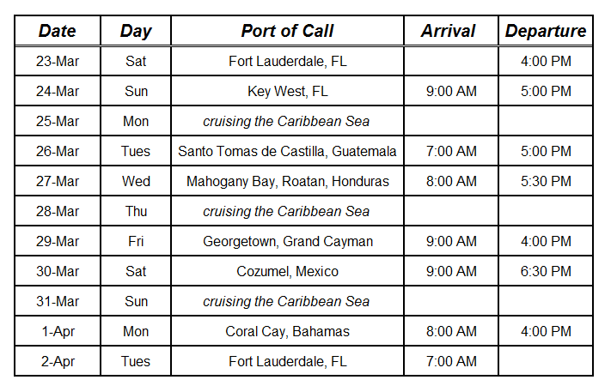

Contents
────────▼────────

Prologue…………………………………………………... |  | 1
Chapter 1: | “Come Sail Away” …...…….…….……….. | 7
Chapter 2: | “Caribbean Queen” ……………………….. | 13
Chapter 3: | “Little Lies” ……….…...…...……….……... | 20
Chapter 4: | “Private Eyes” …...…………..……….…… | 29
Chapter 5: | “Dancing in the Moonlight” …..………….. | 40
Chapter 6: | “Simply Irresistible” …...……….………… | 48
Chapter 7: | “What a Fool Believes” …………..………. | 57
Chapter 8: | “Lowdown” …...…………………………... | 64
Chapter 9: | “Fool (If You Think It’s Over)” ………....... | 72
Chapter 10: | “Who Are You” ...……….………………... | 80
Chapter 11: | “We May Never Pass This Way (Again)” ... | 91
Chapter 12: | “Games People Play” …………...……….... | 102
Chapter 13: | “Lonesome Loser” ….……….……………. | 109
Chapter 14: | “Heartache Tonight” ……...…..…………... | 118
Chapter 15: | “Run Around” ……….……...…………….. | 126
Chapter 16: | “Watching the Wheels” ….………….…….. | 135
Chapter 17: | “Tin Man” ……………………………….... | 142
Chapter 18: | “The Voice” ………………….…………… | 150
Chapter 19: | “Goodbye Stranger” ………..…..….……… | 161
Epilogue….……………………………………………….. |  | 171
Compatibility Dating Quizzes………………………..…… |  | 175
Copyright Acknowledgements……………………………. |  | 189

PROLOGUE

────────▼────────

Saturday Morning
23rd of March
5:57 AM EDT

“Is that my cell phone vibrating?” Alec asked from under the bedcovers.
Instead of answering him, Paige detached the phone from its charger. When she handed it to Alec, she remarked, “I can’t imagine who’s calling you at this time of morning. Our ship just docked in Port Everglades a few minutes ago.”
While Alec was barking into the speaker about the early hour, he suddenly laughed and gestured for Paige to get him a pen and paper.
As she handed him the items, she mouthed, “Who is it?”
Holding the phone a few inches from his stubbly chin, Alec replied, “It’s our friendly homicide detective, Dan McGill.”
Apprehension swept over Paige’s face as she perched on Alec’s side of the bed and tried to read his scrawl.
Now chuckling, Alec interrupted McGill’s monologue to dispel his wife’s fears and proffered, “Don’t worry, Lass. No one has been murdered. At least, not yet.”
Alec resumed writing, smiling on and off while commenting, “You don’t say,” and, “No kidding.”
When Alec hung up, Paige demanded, “What did he want?”
Rising from the bed, Alec kissed her slender neck and cooed, “Our upcoming cruise to the Western Caribbean is going to be more interesting than we’d thought. A bunch of middle-aged singles are going to board the Pegasus today, and a few of them might need to be closely watched.”

It didn’t take the DunBartons long to shower and dress. Alec brought Paige up to date as they readied for their day. Since neither of them were needed to help with the passenger disembarkation process, Alec suggested breakfast on the Lido Deck, followed by a quick chat with the ship’s cruise director. Alec swiped his notes off the bed and hurried Paige out the door.
The Lido Buffet was crowded. Passengers were seated at tables toying with leftover food and waiting for their debarkation numbers to be called on the ship’s loudspeaker. Among those present, there were some impatient to catch their flights home and others dreading their inevitable return to work.
Alec led Paige through an obstacle course of luggage. After passing tote bags containing vacation souvenirs and duty-free liquor, the DunBartons approached the dining table inhabited by the ship’s physician and Alec’s accounting assistant. Dr. Douglas Abbot and Regina Hill were deep in conversation when they arrived.
Glad to see his closest friends and two vacant chairs, Alec greeted his shipmates, exclaiming, “We’re in for an exciting cruise!”
Raising his brow, Dr. Abbot grunted. “I’m too old for your kind of ‘excitement.’”
Regina, a year older than the good doctor but more of an adventurer, quipped, “Don’t pay him any mind, and tell me what’s going on.”
While Paige set off for croissants and coffee, Alec explained. “Dan McGill called me bright and early this morning to give me a heads-up. A group of eighty-seven singles from an organization known as the Cruisin’ Singles is going to board today. Two of them got into a brawl last night at the Lux Grand Beach Club, where the singles cohosts had a welcome reception.”
Paige reappeared before Alec could continue and interjected, “Did you tell them about that woman and the hotel bartender?”
Now intrigued, the doctor inquired, “What happened?”
Paige, not allowing Alec to speak, grinned. “One of the single women, Jackie Miller, went into a tirade with the bartender. She had talked to him on a dating site a month ago. Days later, she received pictures of him naked and ‘raring to go.’”
Regina nodded. “I expect that goes on a lot.”
“There’s more,” Alec resumed. “Jackie, while in an inebriated state, sexted pics of herself. When she refused to send more in the cold light of day, he threatened to put the earlier photos on the internet, along with her name and personal details.
“Jackie told him to ‘go to hell’ and didn’t give it further thought until she recognized her blackmailer’s face last night. After she threw a drink at him, a man attending the singles reception joined her and confronted the lothario.”
Alec paused to check his notes and continued, “A Sean Pennisi got physical with the bartender, and the Fort Lauderdale police were called in.”
“That’s how Dan learned about the incident,” Paige added.
Finishing his boiled egg, the doctor cautioned, “Hmm. A bunch of singles looking for love. That’s a recipe for disaster.”
Regina patted Dr. Abbot’s arm. “Don’t be such an old coot. I hope some of them find what they’re after!”

From the Lido Buffet, the DunBartons headed to the cruise director’s office. Luckily, they found Faith Rossi at her desk. Upon inviting them to take a seat, she asked, “What brings you down here?”
Getting to the point, Alec inquired, “Do you know anything about the singles group that’s going to sail with us for the next ten days? I’d like to know how our cruise line accommodates these passengers.”
“It can be confusing.” Faith smiled. “The group embarking today signed up through Cruisin’Singles.com, a travel agency in Orlando, Florida. The company books about six cruises a year for people in specific age ranges and on ships that have interesting itineraries. We were chosen on this occasion because CS is hosting middle-aged singles and our ship caters to seasoned passengers.”
“Do you have to arrange their activities?” Paige frowned. “It must be an enormous undertaking.”
“It is!” Faith agreed. “Thank goodness, this company sets up its own events. I just have to familiarize the cohosts, Jane and John Smith, with the ship and get them situated. They’ll take over from there.”
Suddenly aware of the time, Faith rose. “The Smiths are going to board in half an hour, and I’m supposed to meet them at the embarkation area.” She took a moment to hand Alec a flyer and said, “Here’s a program containing some of the Cruisin’ Singles events.”
The DunBartons and Faith walked out of the office together. It wasn’t until Alec and Paige returned to their cabin that Alec glanced down at the handout he was given.
It read:

Cruisin’ Singles Events
The place to meet!

Pre-Cruise:
Complimentary Roommate Matching
Facebook Group Page for your cruise
Online Message Board
Pre-Cruise Hotel Stay
Airport Transfers
Welcome Cocktail Party at the Lux Grand Beach Resort

Activities during the Cruise:
Afternoon Tea: Daily
Bar Hopping: March 26th
Black and White Gala: March 31st
Board Games: March 24th, March 29th
Classes:
Pros and Cons of Online Dating: March 25th
Who Are You: March 28th
Love and Lust: March 31st
Cupcake Challenge Bake-Off: March 31st
Coral Cay Beach Games and Barbeque: April 1st
Farewell Dinner and Photos: April 1st
Ice Cream Socials: March 25th, March 27th, March 29th
Icebreaking Games:
Speed Meeting: March 23rd
Lock and Key: March 27th
Karaoke Nights: March 24th, March 29th
Latin Dance Lesson: March 30th
Lifeboat Drill: March 23rd
Line Dancing Class: March 27th
Mexican Fiesta Night: March 30th
Movie Nights: March 26th, March 28th
Pizza Parties: March 24th. March 28th
Poolside Get-Togethers: March 26th, March 30th
Orientation: March 23rd
Seventies Moonlight Dance: March 25th
Shore Excursions: Based on the number of participants
Single-Mingle Dining: Daily, 8:15 PM
Trivia Games: March 24th, March 28th, March 31st
Wine Tasting: March 30th
Yoga Morning Stretches: Daily

Post Cruise:
Airport Transfers
Post Cruise Get Together at the Lux Grand Beach Resort
Post Cruise Hotel Stay and Tour
Overwhelmed by the sheer number of events, Alec exclaimed, “Blimey! They’re going to be a busy bunch.”
With a glint of amusement in his eye, he added, “We may need to infiltrate the group.”
“But we’re no longer single!” Paige protested.
“We can always pretend, Miss Anderson. I wouldn’t mind wooing you all over again.”

