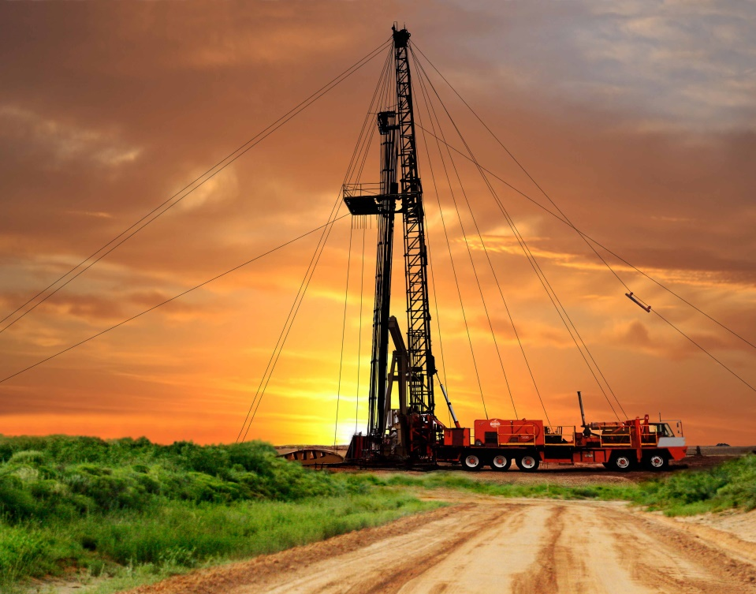

Rig Whore
A few days after returning home to California, just shy of a two-year stay with Dad in West Texas, I went and applied for a rig-hand job at a local oil field drilling and well servicing company. With hardhat and Igloo lunchbox in hand, I entered the front office of the well-pulling company and inquired about a job.
The lady looked at me with a kind of ‘not-trying-to-laugh’ sort of smile, and directed me to the main yard dispatch office, “See Leo.”
As I entered the dispatch office, there sat Leo; a big burly roughneck-looking man that appeared to be in his middle 60s or so. I explained to him why I was there and that I just got back home from Odessa, Texas; I described the bulk of my rig experience which was on well servicing, workover, and well abandonment type rigs.
After a little ‘rig’ and ‘down-hole’ talk, Leo pointed to a huge board on the wall with rig numbers and people’s names.
Pointing to a column with a rig number, he said, “You start tonight on this rig.”
He also mentioned that I would be on the ‘extra board’ and for now would have to start on their nine-week trainee program - a sort of ‘make-it’ or ‘break-it’ type of thing. Apparently, after nine weeks, they set you up with hands’ wages. I think Leo started me on the trainee program because of my young age and maybe felt a little leery of my self-proclaimed experience.
My first night shift was from 3:00pm to 11:00pm. Rig hands were expected to leave and be at the yard and rig early enough to relieve daylight crew no later than 3:00pm.
I remember when they told me the hours of my eight-hour shift; I laughed to myself, as all the shifts on rigs in Texas were twelve-hour shifts … and if relief crew came one man short, then somebody would have to pull a double-shift and still work their next regular shift. That’s just the way it is out there.
First day, first rig in California, and I did not know what to really expect. Being on the ‘extra board’, I would be filling in for hands that, for whatever reason, were not there to work on the rig that shift or if they needed a four-man crew for a type of well pulling service. I was told that people on extra board got more hours than they could handle, many times sixteen hours a day. Some of the hands coined the extra board hand as ‘rig whores’.
I remember one day on the way to lease in tool trucks, the coworkers were sizing me up and asking questions like, did I work Derricks, and stuff like that. I guess they figured because I was new and on the trainee program was just a ‘worm’ - an industry term for green, unexperienced, inept. Using that word, or saying that to the wrong person could easily get your ass kicked.
When we arrived at LBOD Lease (Long Beach Oil Division), we were eagerly greeted by the daylight crew, as they were really anxious to get out of there. I assessed the rig site; it was a typical rod well with an IDECO RAMBLER rig that was positioned over it. I was familiar with that type of rig, the job task was to rig-down, move to a new location, and rig-up, then proceed to service the well.
When I was breaking-out on the rigs in Texas, I was often reminded that some of the best rig hands in the world are from West Texas. After all, Odessa Midland is the oilfield capital of the United States.
The way I was taught to work on a well servicing rig, which typically is a three-man crew, was from a traditional standard that most well servicing rigs practice out there. When rigging up or rigging down, floor hand takes care of the driller’s side of rig and the Derrick man takes care of the other side. They always do it like that; does not matter if you ever worked with that crew or not because most all of the well pulling outfits do it the same way. I guess it’s different out here as when we were rigging down that other hand was all over the place it was kind of funny.
We moved the rig to the new location; same thing when rigging up: everybody everywhere, the rig was not spotted square to the well, and of course, the driller had me work Derricks which was fine with me. The driller and floor-hand soon found out I was a ‘pipe latching fool.’
I remember once back in Odessa, when I was going to work Derricks on this one rig. The Driller was known for running the blocks up to Derrick very quickly, and he ran the rig hard. Me, being relatively new and young, was probably in their eyes still a little wormy and was forewarned from the floor-hand and other previous hands who worked Derricks for him to be careful.
I climbed up to Derrick to the tubing board which is just a steel framed rectangle with a twelve- to fourteen-inch wide diamond plate platform in the middle (diving board) to walk on with handrails welded along outside of frame; the tubing board swivels off the Derrick legs and is suspended with cables on the other end.
I put the belt on and adjusted the oil drenched rope lanyard that was affixed to back of belt and the fastened the other end to the handrail directly behind me. I stood there, nervously waiting. I forgot to mention there were about sixty stands of 2-7/8” work-string tubing racked and ready to be run in the hole.
The idea when ‘tripping pipe’, Derrick man takes one stand of pipe walks to edge of diving board and leans out with stand until rope tightens against the back of his belt and when blocks are sent up then latches stand of pipe into tubing elevators while blocks are still moving it literally jerks the stand out of your hand, it takes a while to get used to leaning out over edge of board and trusting that belt.
Anyway, to make a long story short, they were right. The driller proceeded to run them blocks wide open at me! It shocked me a little at first, the tempo at which the driller was running that rig, but I soon really got into it and did not miss or snag one stand.

After we finished tripping pipe in the hole and I was taking the last few steps down ladder, I could hear the floor-hand yelling something like, “Hey latch-hand, hey latch-hand!”
I was on the ground, walking to the front of the rig with a big dumb smile on my face when the floor-hand reached up and pulled the front brim of my hardhat down past my eyes and said “Yea, he was running them at you!”
I cannot describe how good that made me feel to hear that! I will never forget that day. But, again on the other hand, I remember another time that I will never forget: the very first rig I ever started on. It was probably four or five months into the job, working on a workover rig based out of Midland Texas on a four-man crew driller, and three hands.
It was around mid-day and I was killing time doing a little housekeeping on the rig. I was cleaning tools, scrubbing different stuff down with a five-gallon bucket of diesel and long-handled scrub brush when the other two hands approached me. One of them made a comment about something they were trying to show me earlier that day.
I must of snickered or rolled my eyes, or something because when I walked started to walk away the one guy shoved me hard in the chest, sending my hardhat flying and knocking me back about six or eight feet where I landed on my ass.

They both stepped up to me, looked down and said something to the effect of, “We don’t want to keep showing you how to do everything if you don’t want to learn;” He motioned with extended arm and index finger, “It’s too much work and if you don’t like it, Midland is thirty -five miles that way.”
It was weird, I wasn’t mad or anything. You,ve heard the expression, ‘knocking the sense into someone’? After all, these were two very well-seasoned roughnecks willing to take the time to show this young curly haired kid from California how to do something the right way.
So back to my first day, first rig, in California on the LBOD lease. -After rigging up and bleeding down the well head, and tooling up to pull rods and tubing, I headed up to my spot up in the errick as requested and did my job. I think I exceeded their expectations for new guy on a trainee program. In fact, I think it was less than a week later that I was off the extra board and set up with hand’s wages when a driller from another rig offered me a home on his rig.
Kind of funny looking back, I remember a couple times sitting in a local California oilfield bar seeing those hands from my workplace - pretty much fresh off the nine week trainee program with their hand’s wages, walking around the bar with their oil patch hats on and wearing their beepers like bigshots so everybody could see it. They walk in, talking and acting like they know it all. I think if these rig hands were put on a West Texas rig, the next day they might have another thing coming.

