SUNDOWN DREAMER SAMPLE

Kisa gazed down the long dirt road that led from the house where she lived to the highway. On each side of the road were fields throbbing with life. Golden stalks of corn stood proudly in the sunset. Responding eagerly to sunlight and rain, they looked like golden soldiers standing at attention. She squinted. Her eyes could barely see the trees on the other side of the highway. She lifted her eyes and peered deeply into the blazing red-orange rays of the setting sun that illuminated the dusky sky just in back of the woods.
There! There it was! She was just able to make out the approach of the familiar gold gilded coach as it started up the shimmering, marble and jeweled road that led to her castle!
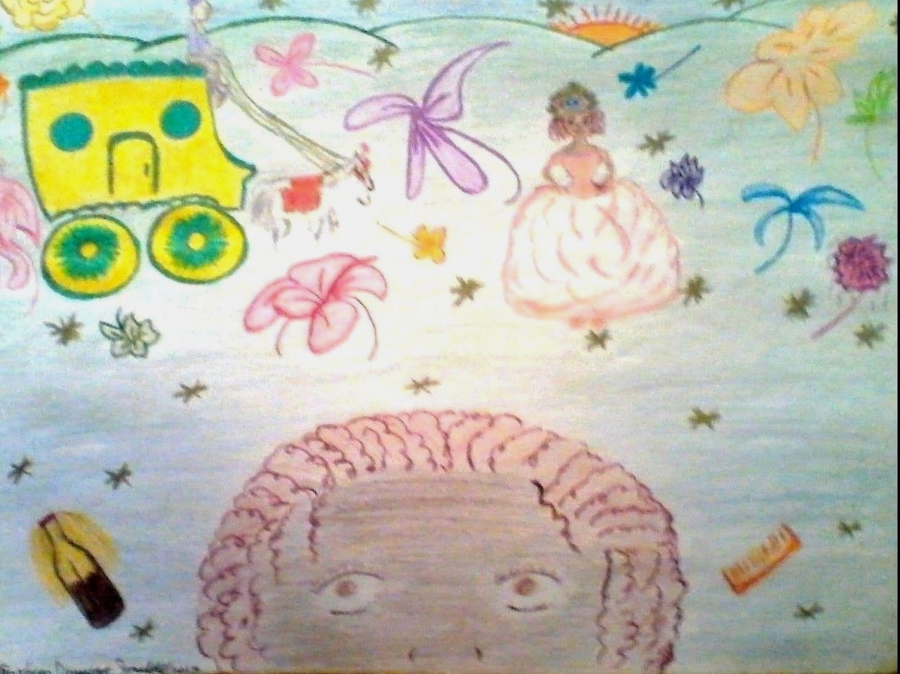
Figure 3
Kisa again parted the hair of her glass doll and started on a second braid, and as she watched the white prancing horses that pulled the coach up the road, she sat there on her palace stairs and marveled when their reins glistened here and there in the twilight. On each side of the marble road were forest-green, well cut lawns with bushes of beautiful, full-bloomed flowers of all descriptions and colors. Kisa inhaled their tantalizing aromas.
As the coach drew nearer, she inspected her lavish peach colored gown, its well fitted bodice spreading at the hips with folds of delicate lace and silk. Starting on the last braid, she reached up and straightened her tiara, making sure it fit snugly on her beautifully styled hair.
The golden coach was almost there and her heart began to beat faster. Soon...soon she would be on her way!
“Kisa! Kisa!”
Someone was calling her name!

