Kisa moved from the window to her suitcases beside her bed and began to unpack. As she put her clothes on hangers and hung them up, she took a glimpse of herself in her new full length mirror each time she passed it.

At one point, she stopped and surveyed herself from head to toe. She was not, she decided with great satisfaction, abnormal at all in her appearance, as she had always thought. In fact, she was quite normal...in every way. She admitted to herself, with a slight wiggle of her nose, that while she might be somewhat ‘advanced’ in certain areas of her physical development, she was designed just how God wanted her to be.

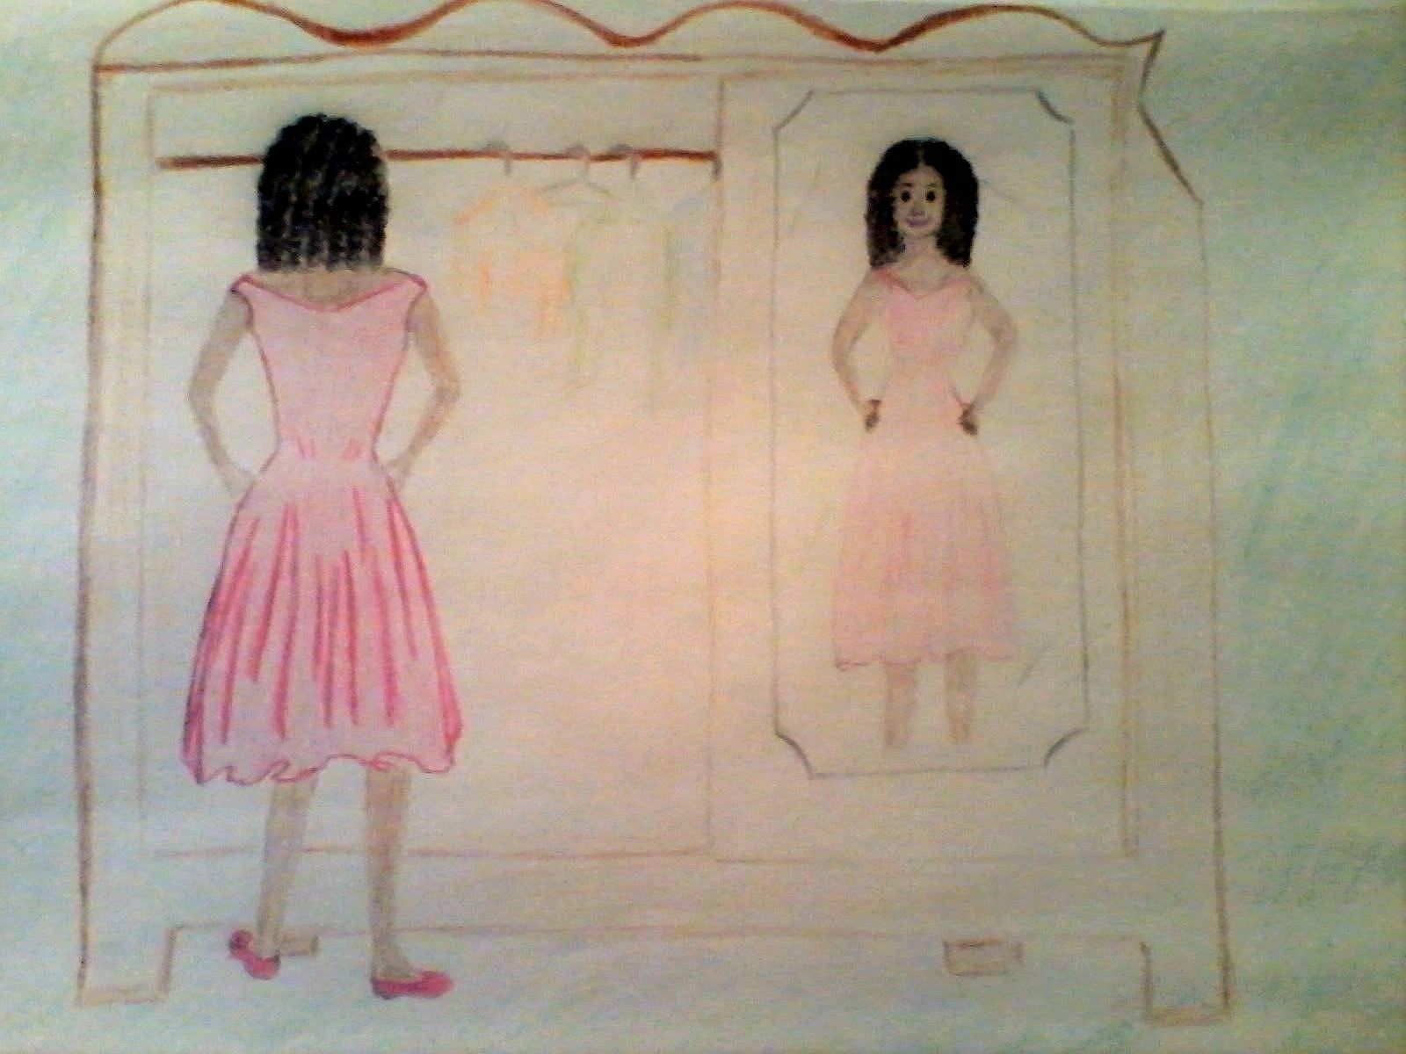

Still eyeing herself in the mirror, she put her hands on her hips and held her head high. She smiled as memories of the summer cascaded through her mind. Thrusting her chest forward, she threw her shoulders back and moved several steps back before she moved forward. Letting her hips lead the way, like she had seen the models do on the runway in New Orleans, she watched herself as she pranced and floated, leaning from side to side. Kisa was so taken with her newly discovered self that she was unaware of other eyes, which observed her in utter amazement. Her aunt standing in the doorway was stunned unto silence as she watched her niece, hypnotically.

Was this Kisa?! She asked herself. Kisa, who had always shied away from mirrors and who had never shown the slightest inclination of ever having an extrovert personality? Why, it was as if after years of dormancy, a flower bed had suddenly bloomed, bringing forth the most spectacular flower.

