SUNDOWN DREAMER SAMPLE, BOOK 1

Kisa gazed down the long dirt road that led from the house where she lived to the highway. On each side of the road were fields throbbing with life. Golden stalks of corn stood proudly in the sunset. Responding eagerly to sunlight and rain, they looked like golden soldiers standing at attention. She squinted. Her eyes could barely see the trees on the other side of the highway. She lifted her eyes and peered deeply into the blazing red-orange rays of the setting sun that illuminated the dusky sky just in back of the woods.
There! There it was! She was just able to make out the approach of the familiar gold gilded coach as it started up the shimmering, marble and jeweled road that led to her castle!
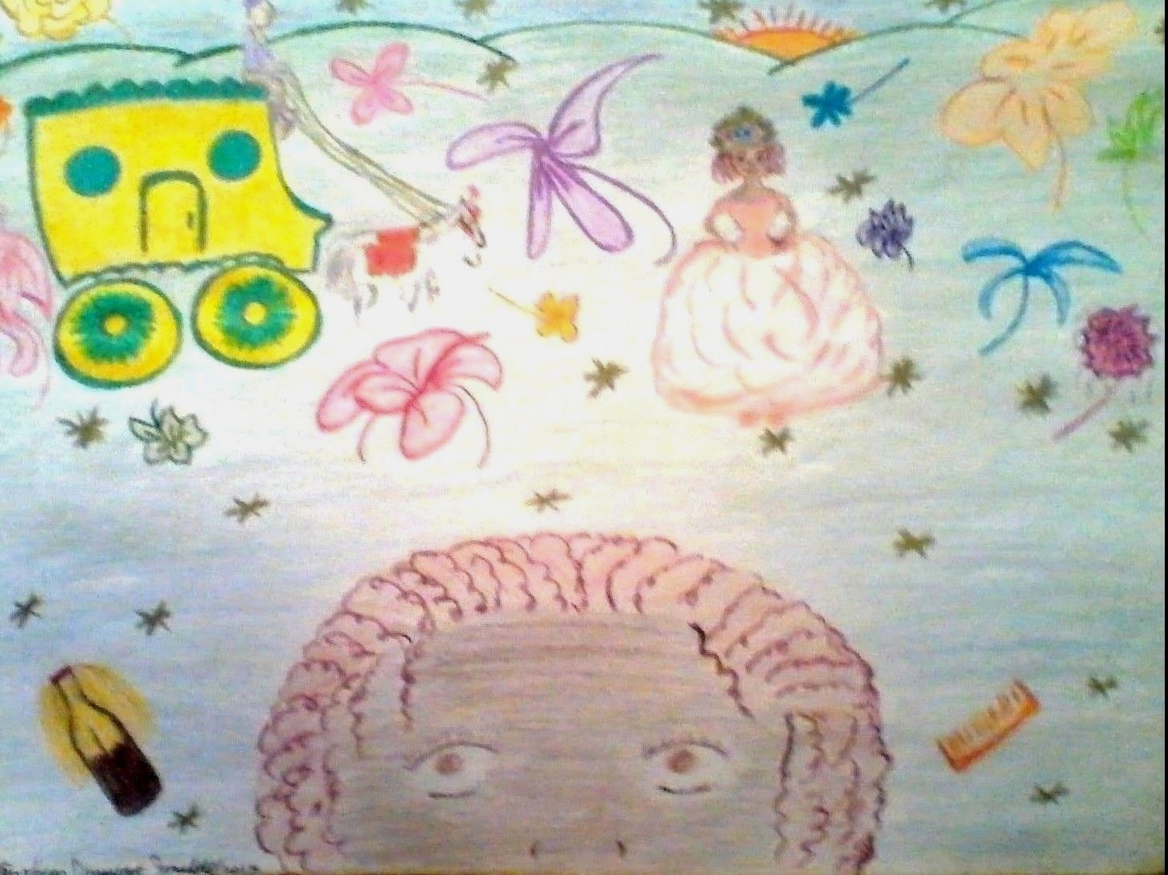
Figure 3
Kisa again parted the hair of her glass doll and started on a second braid, and as she watched the white prancing horses that pulled the coach up the road, she sat there on her palace stairs and marveled when their reins glistened here and there in the twilight. On each side of the marble road were forest-green, well cut lawns with bushes of beautiful, full-bloomed flowers of all descriptions and colors. Kisa inhaled their tantalizing aromas.
As the coach drew nearer, she inspected her lavish peach colored gown, its well fitted bodice spreading at the hips with folds of delicate lace and silk. Starting on the last braid, she reached up and straightened her tiara, making sure it fit snugly on her beautifully styled hair.
The golden coach was almost there and her heart began to beat faster. Soon...soon she would be on her way!
“Kisa! Kisa!”
Someone was calling her name!

Kisa gazed down the long dirt road that led from the house where she lived to the highway. On each side of the road were fields throbbing with life. Golden stalks of corn stood proudly in the sunset. Responding eagerly to sunlight and rain, they looked like golden soldiers standing at attention. She squinted. Her eyes could barely see the trees on the other side of the highway. She lifted her eyes and peered deeply into the blazing red-orange rays of the setting sun that illuminated the dusky sky just in back of the woods.
There! There it was! She was just able to make out the approach of the familiar gold gilded coach as it started up the shimmering, marble and jeweled road that led to her castle!
Kisa again parted the hair of her glass doll and started on a second braid, and as she watched the white prancing horses that pulled the coach up the road, she sat there on her palace stairs and marveled when their reins glistened here and there in the twilight. On each side of the marble road were forest-green, well-cut lawns with bushes of beautiful, full-bloomed flowers of all descriptions and colors. Kisa inhaled their tantalizing aromas.
As the coach drew nearer, she inspected her lavish peach colored gown, its well fitted bodice spreading at the hips with folds of delicate lace and silk. Starting on the last braid, she reached up and straightened her tiara, making sure it fit snugly on her beautifully styled hair.
The golden coach was almost there and her heart began to beat faster. Soon...soon she would be on her way!
“Kisa! Kisa!”
Someone was calling her name!

MOONLIGHT DREAMER SAMPLE, BOOK 2
Kisa moved from the window to her suitcases beside her bed and began to unpack. As she put her clothes on hangers and hung them up, she took a glimpse of herself in her new full length mirror each time she passed it.

At one point, she stopped and surveyed herself from head to toe. She was not, she decided with great satisfaction, abnormal at all in her appearance, as she had always thought. In fact, she was quite normal...in every way. She admitted to herself, with a slight wiggle of her nose, that while she might be somewhat ‘advanced’ in certain areas of her physical development, she was designed just how God wanted her to be.

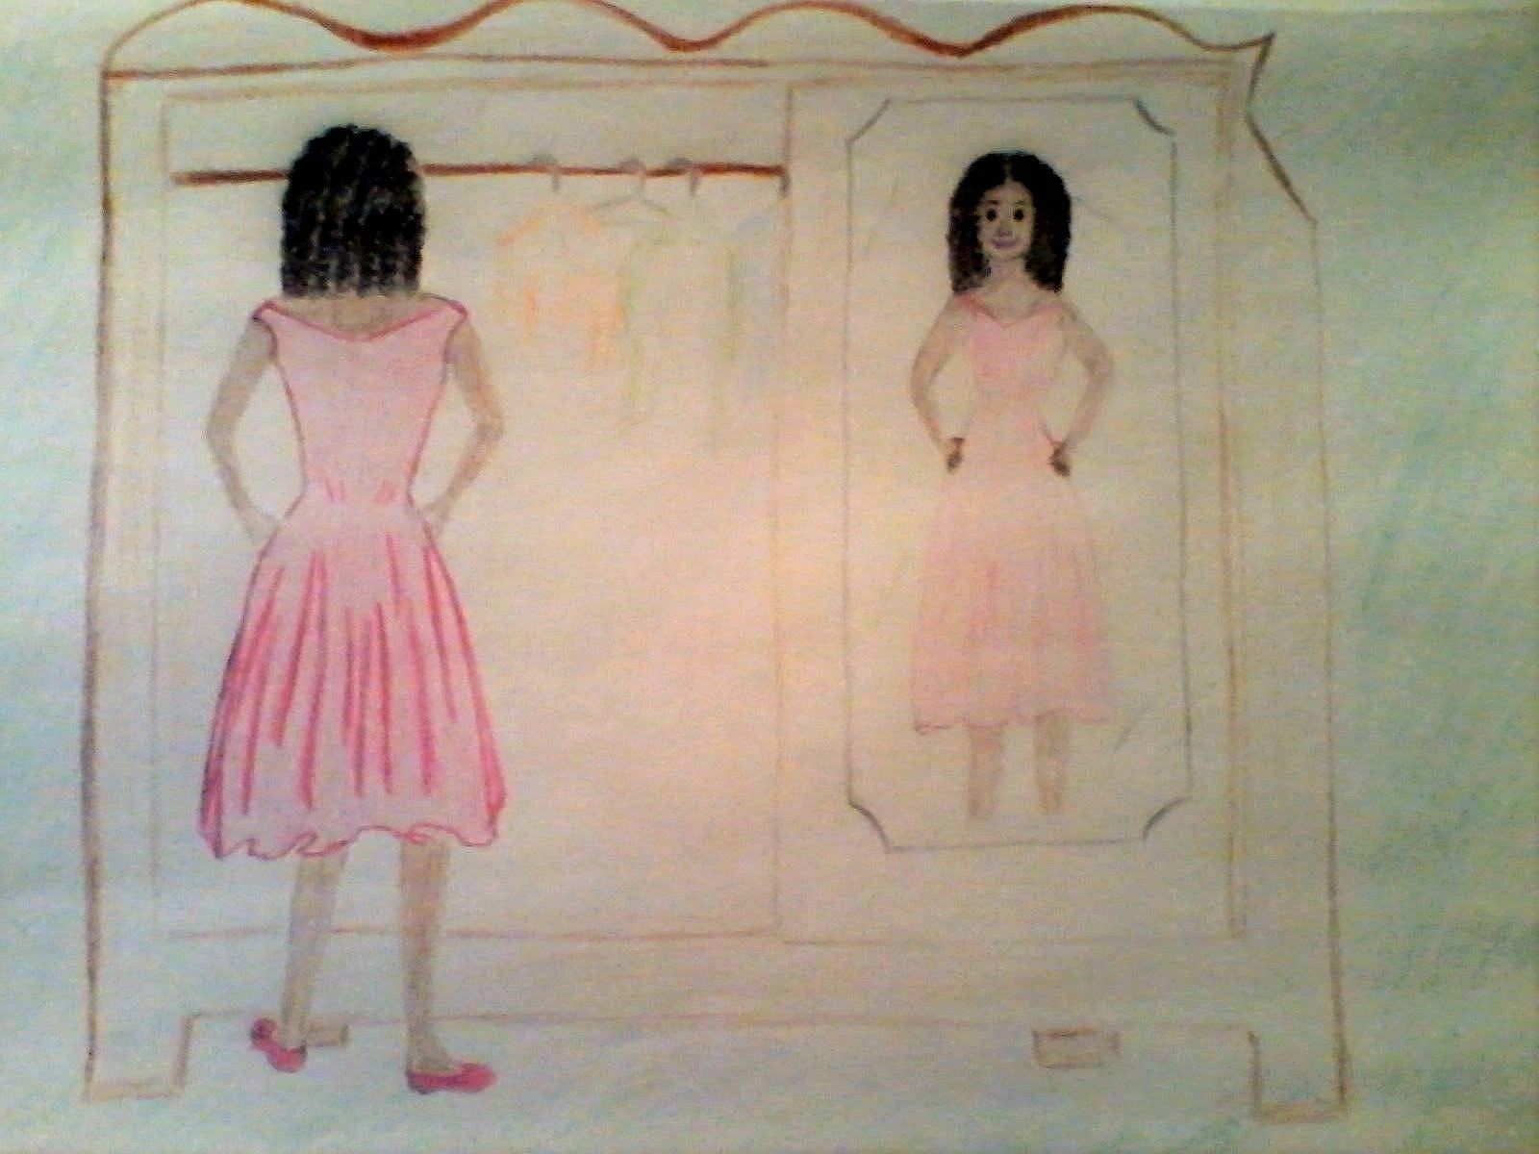

Still eyeing herself in the mirror, she put her hands on her hips and held her head high. She smiled as memories of the summer cascaded through her mind. Thrusting her chest forward, she threw her shoulders back and moved several steps back before she moved forward. Letting her hips lead the way, like she had seen the models do on the runway in New Orleans, she watched herself as she pranced and floated, leaning from side to side. Kisa was so taken with her newly discovered self that she was unaware of other eyes, which observed her in utter amazement. Her aunt standing in the doorway was stunned unto silence as she watched her niece, hypnotically.

Was this Kisa?! She asked herself. Kisa, who had always shied away from mirrors and who had never shown the slightest inclination of ever having an extrovert personality? Why, it was as if after years of dormancy, a flower bed had suddenly bloomed, bringing forth the most spectacular flower.

SUNRISE DREAMER SAMPLE, BOOK 3

The next day was Saturday and as soon as Dee pulled up, Kisa jumped off the porch and ran to the car. They had been driving for a few minutes when Kisa closed her eyes and took a deep breath through the open window.
“I think the thing that I’m going to miss most of all is this crisp, clean country smell.”
“I know what you mean,” Dee answered, “and I’d like to say that it’s the main reason why I’m not going away to school, but it isn’t.”
“Yeah, I know.” Kisa answered, without looking at her friend. “You still haven’t altered your plans?”
“Uunh, ah.”
“Suppose Mr. Right doesn’t come along?”
“He already has.” She tapped her ring finger on the steering wheel.
“Oh, my God!” Kisa cried out, “wha?!...girl, stop this car immediately!”
Dee was giggling wildly at the shocked look on her friend’s face, as she carefully pulled to the side of the road out of traffic. The car had barely come to a full stop when Kisa grabbed her hand and ogled the diamond ring on her finger.
“Jesus! It’s gorgeous, Dee…!” Excitedly, she looked at her questioningly “…George?!”
“Of course! Who else could it be?! The two girls gleefully laughed out loud together.
“I didn’t see this yesterday!…did I overlook this yesterday!?”
“No…it happened last night! I was ‘flabbergasted’…he came over and…!!!” Her eyes grew big, her cheeks puffed up and her hands were flying every which way in the air.
“I can hardly believe it, Dee! You…a bona-fide married lady!” Suddenly Kisa stopped laughing. “Dee, are you…I mean…?”
“Do I look like I’m crazy? Wedding night, honey…wedding night! If my momma didn’t pound nothing else in my head, she sure pounded that in.”
“Oh, thank God! But, what about the rest of it, are you ready Dee? Like being a wife and a companion, and…and a mother?!”
You know I am,” Dee responded confidently, “see, while you’ve been dreaming about being a doctor, I’ve been dreaming about nothing but being a wife and a momma. I’ve been cooking some fine Sunday dinners for the last year! And not just for him, his mama and daddy been over too!”
“I hadn’t realized it had gone that far!”
“Huh…hu, and our families like each other,” she gave her friend a big smile, “and him being in business with his daddy ain’t hurting a bit. Plus, he’s going to be 21 in July of next year and by then I’ll be 19 and we’re getting married in August.” She gave her friend a dreamy look. “God has smiled on me…He’s giving me everything I’ve ever wanted!”
“Oh Dee, I’m so happy for you! Congratulations! I can actually see the happiness on your face!” She hugged her friend and leaned back in her seat.
“Whew…that was a whopper, indeed!”
“I know,” was Dee’s bubbly response, “you are going to be my maid of honor… aren’t you?!”
“Why, of course! Who else?!…oh, well…I did forget about Wanda and May for a second…”
“They are going to be my bridesmaids. I’m only having two…I only need two! Oh, my goodness!” Dee exclaimed loudly, “I just can hardly be-l-i-e-v-e it myself!!!”
When Dee finally pulled back into traffic they laughed and chattered until it quieted down and Kisa found herself deep in thought as she looked out at the passing tranquil scenery. Then she spoke to her friend, quietly.
“I’ve never had a yearning to be anything but a doctor. I care for Kevin, but I’ve never wanted to be married to him, or anything…at least – not now. I mean, I’ve never had the kind of dreams you’ve had…and I wonder why?
Dee kept her eyes on the road when she responded.
“Different callings, Kisa. We can’t all be doctors, lawyers and Indian chiefs and we need to be satisfied with that. God calls us all for different things but they are all worthy things – just…different, that’s all.”

