Coelacanths are an order of lobe-finned fish. Before1938, coelacanths were known only from fossils and were thought to have gone extinct approximately 65 million years ago (mya), during the great extinction in which the dinosaurs disappeared. The most recent fossil record dates from about 80 mya but earlier records date back as far as approximately 360 mya. At one time, coelacanths were a large group, comprising about 90 different valid species that were distributed around the world in both marine and freshwaters. Although Latimeria is a genus distinct from the fossil forms, all coelacanths share numerous features and are easily recognized by their distinctive shape and lobed fins.

Chapter 1. Introduction—About the Coelacanth

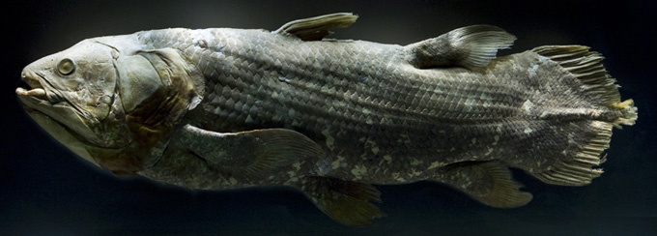
Fig. 1 Coelacanth
A coelacanth (seel-uh-kannth, Figure 1) is a member of the Order Coelacanthiformes (Side Bar A, B, C), a group of primitive bony fishes. An adult coelacanth can grow at least to 180 cm in length and weigh 98 kg. It is dark blue, changing after death to grey/brown. Each fish has a distinctive pattern of pinkish white blotches, like a fingerprint, which enables scientists to distinguish one individual from another.
The skull is in two parts with an intracranial joint, which allows up and down movement between them. A strong pair of muscles beneath the skull-base lowers the front half of the skull, giving the coelacanth a powerful bite. The coelacanth is the only living animal with that structure.
The eyes and olfactory organs are in the front part of the skull, and tiny brain and inner ear are in the rear. In adults, the brain is incredibly small, occupying only about 1 percent of the cranial cavity; but in the smallest juveniles, the brain completely fills the cranial cavity. In the middle of the snout is a large cavity filled with a jelly-like sac, which opens to the outside through three pores. This sac is called the rostral organ .It may be used to detect weak electric currents and help the coelacanth to find hidden prey.
Coelacanths belong to a group of bony lobe-finned fishes and have 8 fins (2 dorsals, 2 pectorals, 2 pelvics, 1 anal and 1 caudal). The first dorsal fin of the coelacanth is much like that of other fishes and can be folded down or erected. The other fins have a well-developed, muscular, limb-like basal lobe projecting from the body wall, and a fringe of unbranched rays like a fan attached to the outer end of the base. The fleshy scale-covered lobe can be bent or rotated so that each fin can work like a paddle or sculling oar. The caudal fin (tail) has three divisions: a characteristic small projecting middle lobe between the longer upper and lower lobes of the fin (Figure 2).
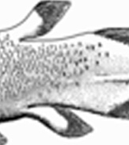 Fig. 2 Lobed fins
The lobed fins are extremely mobile and can be rotated through 100 degrees. The coelacanth can swim fast for short periods, but it usually swims around slowly using its paired and median fins as sculls to push itself through the water. When cruising, the fish works the right pectoral fin in tandem with the left pelvic fin and vice versa. The coelacanth likes to hover near the sea bottom with all fins fully extended. Unlike most fishes that have a gas-filled swimbladder, the coelacanth has a large swimbladder filled with fat. Being lighter than seawater, the fat provides buoyancy.
Most of the skeleton is made of cartilage. In place of the vertebral column, a large notochord extends from the skull to the tip of the caudal fin. The notochord is a thick-walled cartilaginous tube filled with oil-like fluid, which is under slight pressure; it is tough and elastic and does the job of a backbone, whereas no complete vertebrae are developed around it. In most other vertebrates, the notochord is replaced by vertebrae in the embryonic stage of development. The body is covered with hard scales with small toothy-like growths (Figure 3) called denticles on the outer surface, which protect the coelacanth from the rocks and predators.
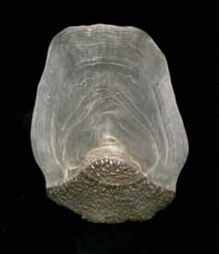 Fig. 3 Coelacanth scale with denticles in the dark section of the scale. The lighter portions show growth rings.
Coelacanths are ovoviviparous, meaning that the female retains the fertilized eggs within her body while the embryos develop during a gestation period of over a year. Typically, females are larger than the males; their scales and the skin folds around the cloaca differ. The male coelacanth has no distinct copulatory organs, just a cloaca, which has a urogenital papilla surrounded by erectile caruncles. It is hypothesized that the cloaca everts to serve as a copulatory organ. Coelacanth eggs are large with only a thin layer of membrane to protect them. Embryos hatch within the female and eventually are given live birth. The gestation period is estimated at 3 years, which is the longest known in vertebrates. Young coelacanths resemble the adult, the main differences being an external yolk sac, larger eyes relative to body size and a more pronounced downward slope of the body. The juvenile coelacanth’s broad yolk sac hangs below the pelvic fins. The scales and fins of the juvenile are mature completely; however, it does lack odontodes, which it gains during maturation.

