Getting to know the General
“Hey, General,” said Charlie, “tell me about racing. What’s it like?”
“It’s tricky, but it’s a lot of fun. At first, you’ll go in easy races, but they’ll get harder when you have experience,” said General.
“What if I am tired and I don’t want to race?”
“You still must try your best. Sometimes when you get going, you get in a better mood because you really like to run,” said General.
“Thanks, General. Will I be able to stay here while I’m learning?”
“No, Charlie, you will need to go to a special barn for training,” said General.
“I don’t want to go,” Charlie said, stomping his foot. “I’ll miss Glory and Buddy.” I’ll miss my mama too, but I’m brave, so I’m sniffling back tears.
“That’s true, said General, “but training is part of growing up. Besides, if you are dreaming of winning the big races like the Southern Derby, you must work hard. You’ll need to run to strengthen your muscles. You’ll build your endurance so you don’t feel tired during the longer races. Maybe your trainer will be Misty Canby. She’s kind and she’ll see you have everything you need.”
“We’ll all hear the news about what you are doing,” said General “It’s most important to use whatever talents you’re given. You’ll only become a star if you remember how important it is not to give up when you have a bad day. We all have them, but we must overcome our fears. Stay focused on what you want most and you will do fine.”
“We’ll need to talk more before I leave for training so you can teach me as much as you can. Maybe I should give you a professor’s hat. I saw one. It had a funny shape with gold strings hanging from one side.”
“You’re thinking of the hats called mortar boards. People wear them at graduations. Sometimes teachers wear them, too,” said General.
“What a funny name for a hat. Who would want to wear a board on their head?” asked Charlie.
“It’s a funny name. It isn’t really a board on your head.”
Time flew by for Charlie. He loved racing in the field with his friends, but he knew he was nearly old enough to leave for the training farm. When the day finally arrived, he stopped to chat with Glory and Buddy.
“Hey guys, this is it,” said Charlie. “I’m off to the working world. I’ll be looking for you at the races. Remember to do your best when it’s your turn for training and racing.”
“We’ll give it our best shot, we’ll see you around,” they said, turning away when little tears trickled down their faces.
Charlie stopped by General’s stall. “Hey, General, do you have any last-minute advice for me before I leave? As soon as my legs are bandaged for the trip, I’ll be on my way.”
“Just concentrate on doing your best. Remember when you’re racing, don’t get stuck where you have no room to run. Sometimes the other horses block you in so it’s easier for them to win.”
“Okay, thanks for everything. I’ll be thinking of you.”

In the working world
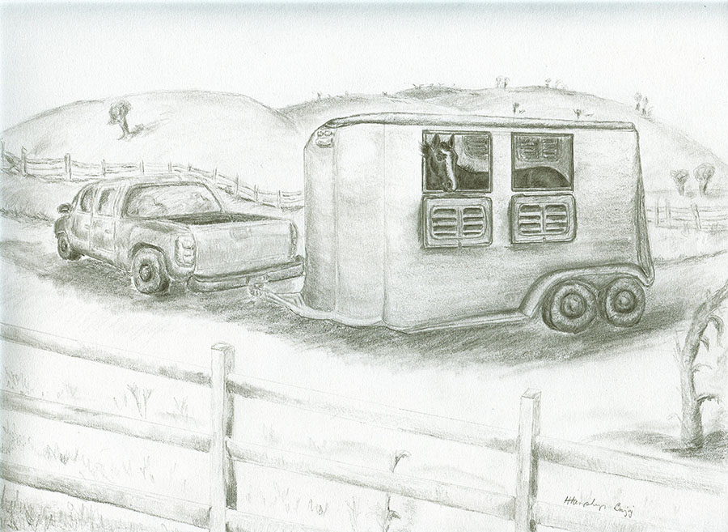
Charlie goes to training
Charlie looked out the window of the trailer as it bounced along down the driveway and on to the highway. He took one last look at Racing Haven, trying to think about the adventures ahead. I feel sad, but I’m trying to be brave, even when I miss everyone here.
It wasn’t a long ride to Sweetbrier Racing Stable. I see many barns and racetracks. I’m glad there are fields where I can play.
Mr. Bains, the barn manager came out to greet Charlie. “Hello there, big fella,” he said, patting Charlie’s neck.
“There’s a whole new world waiting for you here. You’ll be a working man from now on, but Misty Canby will train you. She’s the best around.”
Oh boy, I got Misty for my trainer. I wanted her because the General said she is the best.
Mr. Bains led Charlie into a big stall. Charlie looked out the window and watched the horses working or relaxing in the fields. Jimmy, one of the farm workers, came by Charlie’s stall.
“Hi Charlie,” Jimmy said, “we’re going to be good friends. I’ll make sure you are comfortable and happy. You’ll settle in for a couple of days before you go to work.”
Everyone here seems nice, thought Charlie. The working world might not be so bad.
The real work starts
Misty stopped by to visit Charlie. “Hi, big boy,” she said, patting his neck. “We ‘re starting your training today. There is nothing to fear. You’ll learn many new things before you start racing. It’s like kids going to school. They do the easy things first.” Good, Charlie thought. I’ll do easy stuff first.
The first day of training was different than Charlie expected. Misty put sand bags on his back. “This will help you get used to carrying weight,” she said. “You need to know how it feels before we put a person on you.”
Why can’t I play in the sand instead of carrying it?
As if that were not enough, Misty put a metal thing in his mouth. It was part of a leather thing on his head. “This is the bridle. When you are racing, the jockey will steer you by using the reins in his hands,” Misty explained.
***
Misty walked Charlie around the round pen outside of the barn so he could feel the weight on his back. The round pen is a closed area where horses exercise or start their training.
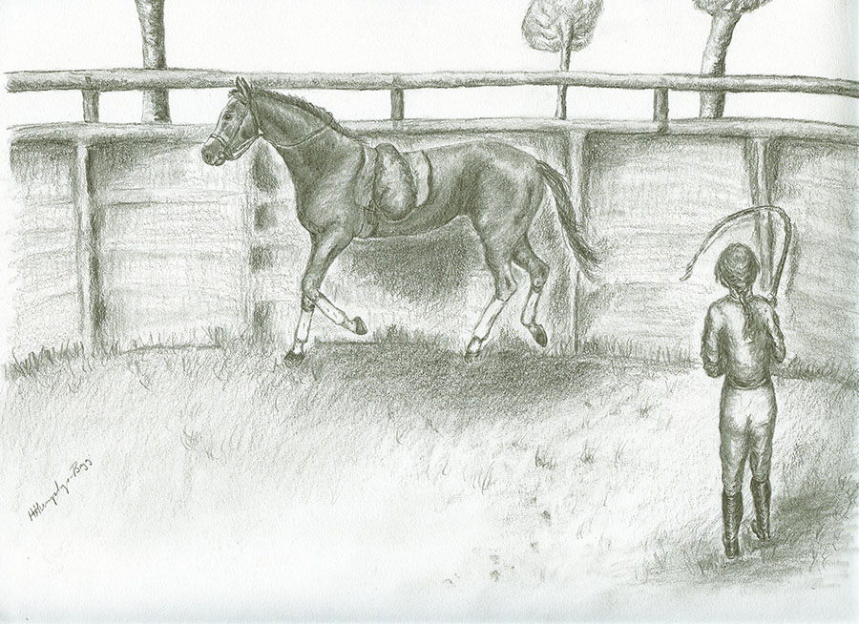
Charlie and Misty in the round pen
Charlie shook his whole body to see if the weight on his back would fall off. It didn’t. Maybe the weight is stuck there. I’ll have to get used to it. If I have a person on me, he will be stuck too? He tried hopping up and down. Still, the weight was there. Misty put the weight on him for a couple weeks until Charlie seemed relaxed with it on his back. Then she added the saddle with the weights tied on it.
This saddle thing is strange. I have something around my tummy to hold it on. It doesn’t really pinch, but I can tell it’s there. I heard people calling it a girth. Now and then, people make sure the girth is tight enough so the saddle doesn’t slide. I can hold my breath and make my tummy a little bigger so people don’t make the girth too tight. I can do that little trick if I want. But when they’re not looking, I can breathe again and I have a tiny bit more space between my tummy and the girth.

