CHARLENE THE STAR

By Deanie Humphrys-Dunne
Illustrated by Holly Humphrys-Bajaj

All rights reserved copyright 2017 Deanie Humphrys-Dunne

The opinions expressed in this manuscript are those of the author. The author warrants and represents that she has the legal right to publish or owns all material in this book.
No part of this book may be reproduced, stored in retrieval system, or transmitted in any form, or by any means, electronic, mechanical, photocopying, recording or otherwise, without prior permission from the author.
Dedication for Charlene the Star

This book is dedicated to Barbara and Eileen, two absolute Angels in my life. They have shared their wisdom and talents with me. They have been models of excellence for me-truly a blessing in every way. I thank both of you for helping my dreams come true.
The Debut of Charlene

“Good morning, Charlene,” said Mama horse to her young foal. “Welcome to the world here at Racing Haven Farm in Kentucky. Look at your dark red coat. I wonder who else had red hair in our family. You have my long legs, pretty brown eyes and a star on your forehead. But you don’t have white stockings like your big brother, Charlie. Your dad’s name is Charles the Great. My name is Star Quality, but I’ll always be Mama to you. I’ll call you Charlene the Star. Your name is a combination of your dad’s name and mine. I talk to you and other animals, but not people. I can’t wait to see if you love racing like I do. First, you must drink lots of milk so you grow big and strong. We’ll spend all our time together, because you’re a baby. My job is to keep you safe while you’re growing bigger and stronger every day.”
“Mama, what do racehorses like to do?”
“Racehorses love running faster than any of the other horses, dear.”

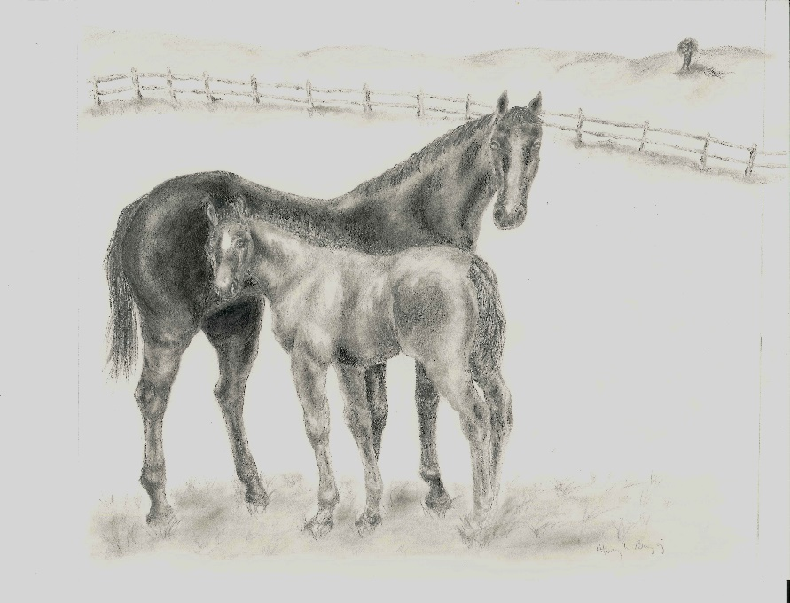
Charlene and her mama

“When I’m bigger, I can decide if I like running fast.”
“That’s fine, dear. First, we must give you time to grow and play. Before long you can play with some of the other young female horses. They are called fillies.”
“Oh, Mama, I’d love eating the green grass in the fields with you. Are the fields like a playground for me?”
“Yes, the field is your playground, you can run and play there and we know there won’t be rocks or ruts that could hurt your hooves. Humans call those their feet.
Charlene thought to herself, I wonder what I’ll do in the playground besides eating and running. I like spending time with Mama. What would happen if I don’t like racing? Right now, I’m too little to worry.
“Charlene, continued Mama, “When you have questions about racing, please ask me. You should know as much about it as possible. I’d love to coach you in racing to help you do your best.’
“Don’t worry, Mama. I will.”
***
“Charlene, look how you’ve grown. You’ve lost your soft, thick baby hair. It protected you from getting hurt. My goodness, now your red coat looks even prettier than before.”
Mama’s right. My legs are much longer too. I’ve figured out how they work so I don’t trip all the time. I wonder if I’m getting fat because my middle is growing.
“We’ll take a tour of the fillies’ barn tomorrow. Then you’ll go out in the field with them.
“Goody, I can’t wait,” said Charlene, kicking up her heels.

Meeting Blossom and Ann
I’m following Mama to the fillies’ barn now. I’m walking slowly. “Come along, Charlene, don’t be afraid. You can talk to the fillies from the pasture. They can look out their stall doors to chat with you, while you and I are in the pasture,” said Mama.
“Charlene, this is the fillies’ barn. Here is Shy Ann. Don’t you love her shiny grey coat?
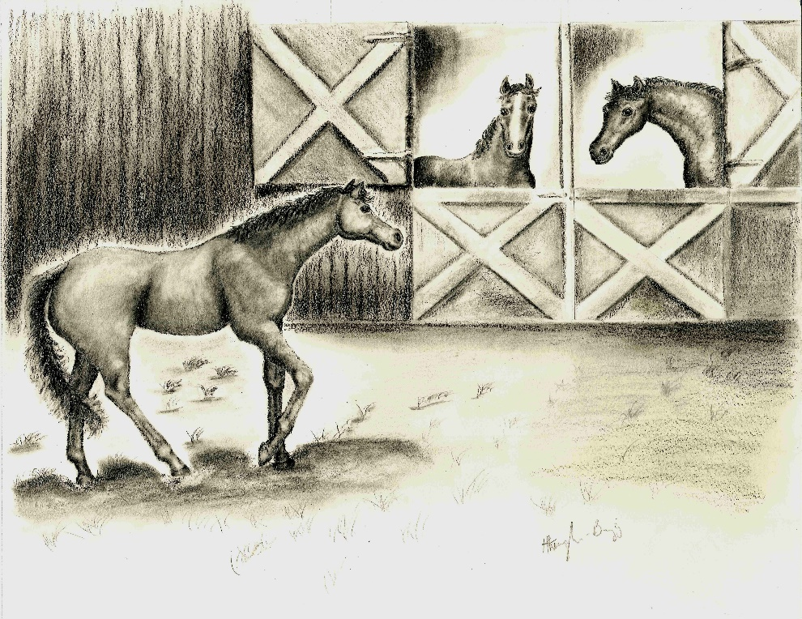
Charlene meets Ann and Blossom

“Hi Ann, you are pretty.”
I noticed Ann was blushing. She seems shy like me.
“Hi Charlene, I love your beautiful red coat,” said Ann. “You’d really stand out on the racetrack.”
“Ann, are you sure you’ll become a racehorse when you grow up?” asked Charlene. “Have you ever thought of doing anything else?”
“No, Charlene, I wouldn’t dream of becoming anything but the best racehorse I can be. I heard that your mom was a very good racehorse. Maybe she’ll give me some tips on it. Everyone I know wants to be a racehorse,” said Ann.
She’s lucky to have big dreams already. I hope I find out what I’d like to do soon.
“Charlene, here’s Blossom. Doesn’t she have a lovely blaze on her face? It looks nice with her brown hair. She comes from a well-known racing family. Her Dad won the Kentucky Derby AND the Belmont Stakes. That’s a talented family”, said Mama.
“Hello, Charlene, I’m glad to meet you,” said Blossom. “I can’t wait until we start training. Racing sounds like fun. I saw a picture of your big brother, Charlie. He’s mighty handsome! He won the Southern Derby. It’s one of the biggest races around.”
I should change the subject. Ann and Blossom are talking about racing. I’m not even sure I’ll like it. Everyone has different gifts, but I don’t know what mine is. That’s kind of scary.
“That’s true, he loves racing and he wants to be the best racehorse he can be. I hope to meet him when I go for training at Sweetbrier Racing Stable,” said Charlene.

Ready, Set, Go!
A few days later Charlene, Blossom, and Ann finally got their chance to play in the field. “I can’t wait to start training,” said Ann. “I love to run. Would anyone like a game of tag? We can see which one of us is the fastest.”
“Sure, we’d love to play tag,” said Ann and Blossom together.
“I’m not sure how good I’ll be at running,” said Charlene. “I’ll give it a try. How about running around the field twice?”
“That sounds perfect,” said Ann. “Ready, set, go!”
Blossom zoomed to the lead. The others were rounding the corner on the first lap. Suddenly, Ann and Blossom were neck and neck. Charlene was a distant third. Blossom stuck her head in front in the last few strides.
“Hooray,” shouted Blossom, kicking up her heels. “I won. That was so much fun.”
I tried my best thought Charlene. But I couldn’t keep up with them. It seemed like Ann and Blossom had wings tucked away. Where did they hide them?
“Gosh, you both did well,” said Blossom, trying to console her friends. “I don’t want you to feel sad. Besides, it was only playing. It wasn’t a real race.”
“It’s all right,” said Charlene. Ann nearly won. But I didn’t have fun at all.”
***
I’m back in the barn. I feel the tears trickling down my cheeks thinking about telling Mama I don’t think I’ll like racing. My head is drooping while I try to hold back the sniffles.

Charlene’s First Crow Hop
“Mama, today I played tag with Blossom and Ann, but I was the slowest even though I tried hard,” said Charlene. “I didn’t like running. Maybe I should do something else. We had a visitor in the barn the other day. She said she wants to be a model when she grows up. What does a model do?”
“They are pretty. But models are always careful about not becoming too heavy. They spend time under bright lights.”
“My lovely coat would look gorgeous under the spotlight. But I’d need to eat less hay and oats to keep my slim figure. That would make me grumpy.”
“Don’t be discouraged, dear. I think you should start your training for racing and see how you feel about it.”
“But Mama, I don’t like running. I might get dizzy running in circles,” said Charlene, stomping her foot.
“Charlene, why are you doing crow hops?” asked Mama.
“I’m having a tantrum,” said Charlene. “Little people have them. I can have one, because I’m a little horse, right? Besides, jumping up and down feels good.”
“That’s not proper behavior. Soon you’ll be going to Sweetbrier Racing Stable, like your big brother Charlie did. You won’t know whether you like racing until you try it. After a short time, you’ll have your answer.”
“I guess I could try it for a little while,” said Charlene. “What if I still don’t like it?”
“If that happens find a way to show your trainer you’d rather do something else. Trainers are good at sorting out your body language. I’ve heard across the street there is a stable called Jumping for Joy Farms. All the horses there are trained to jump,” said Mama.
I wonder how you are trained to jump. Does that mean you can win prizes for jumping up and down? I liked jumping up and down during my tantrum. I’ve heard people say practice makes perfect. My outbursts could be almost perfect already. Maybe that could be my specialty.

Leaving Racing Haven
“Mama, I heard I’m leaving for training tomorrow,” said Charlene. “The time flew by because it’s fun here. I’m going to miss, you and my best friends, Blossom and Ann.”
“I know you’ll miss us, dear. Try focusing on the new things you’ll learn. Say goodbye to Blossom and Ann before you leave.”
***
“Hi Ann and Blossom,” said Charlene. “I’m leaving for training at Sweetbrier Racing Stable tomorrow. I’m a bit nervous because I have no idea what it will be like.”
“Charlene, I’m going to miss you,” said Blossom. “Don’t worry; we might see you at the race track sometime. We could even be training together.”
“Yes, Charlene, I’ll miss you too” said Ann. “I’m yawning. It’s time to take a nap.” She turned away quickly. Charlene noticed the little tear trickling down Ann’s cheek.
***
The next morning Charlene walked on the trailer for the short trip to Sweetbrier Racing Stable.
I’m glad the trailer is moving slowly down the driveway. I can look at Racing Haven one more time. Who knows when I’ll be back or how I’ll like racing? I tried not to cry but when no one was watching, I couldn’t help it.
Introducing Sweetbrier Racing Stable
“Hello Charlene, I’m George, the stable manager here. Let’s walk down the ramp of the trailer so I can have a good look at you. My, you’re pretty. I love patting your soft, shiny coat. My job is to make sure you have everything you need. We’ll put you in a special stable. You’ll be across the aisle from your big brother, Charlie. Tomorrow you’ll meet Ted, the trainer here and Eva, the exercise rider. You will like them. They’ll work hard to make sure you are the best racehorse you can be.”
Charlene waited until everyone left. She whispered to Charlie, “Hi Charlie, I’m your little sister Charlene. Congratulations on winning the Derby. My friends Ann and Blossom think you’re handsome.”
“Hi, Charlene, don’t be afraid. You don’t need to whisper. I promise not to be mean. Don’t hide behind the door. That’s it. Let me see your face. What a lovely red coat you have. Do you have a fiery temper?
“When I get angry, I do crow hops. Mama got annoyed when I did that. I told her when I played tag with my friends I was last. But Mama said I have to try it anyway.”
“I think Mama’s right about that. Nobody knows what they can do until they try. Imagine if the famous baseball players had given up? Or the well-known racehorses hadn’t tried running? They’d have missed a lot of fun and they might not have found out what they love.”
“Gee, I never thought about it that way. I’ll try my best, but if I don’t like it, I’ll have to find a way to let the trainers know.”
“Good girl, Charlene. I can’t wait to hear how you like racing.”

So, this is Racing
“Good morning Charlene the Star,” said Ted. “I’m your trainer. My job is to teach you about racing. We’re going to start with the easy things so you won’t be afraid,” he said. “Oh, here comes Eva the exercise rider. She’ll be the one who helps you the most in the beginning of your training.”
I’m glad we’ll be doing the easy stuff first. Who wants to start with tricky stuff?
“Hi Charlene, I’m Eva, your exercise girl. We’re going to be great friends. We’ll start training tomorrow.”
Oh, I smell something yummy. It might be peppermints. Eva is chewing them and she has extra ones in her pocket. If I sniff her pocket and maybe, she’ll give me one.
“Charlene, stop nibbling on my pocket. There’s nothing in there but peppermints,” said Eva.
‘Oh, I see. Do you want to try one? Okay, here it is.”
Eva is holding her hand flat so I can’t bite her fingers by mistake. These peppermints are good. I’ll put my nose in her pocket again. Maybe she’ll give me another one. If I’d become a model I might never have tasted peppermints.
“Okay, Charlene, that’s enough. We don’t want you getting too heavy to race. You might earn more if you do well with your training.”
Everyone seems nice here. I wonder what Mama, Blossom and Ann are doing now.
***
“Good morning, Charlene, said Eva. “Let’s walk into the round pen where we’ll start your training. I’m placing sandbags on your back. They’ll help you get used to carrying weight,”
The sand bags feel strange. Maybe they’ll fall off when I start to walk. Now Eva is tightening something around my tummy. It might be a belt. Should I have a tantrum so Eva knows I’m not sure about this stuff? I’ll try stomping my foot but maybe there’s nothing to get upset about yet.
“It’s all right, Charlene. You don’t need to stomp your foot,” said Eva.
I’ll work on being brave for these new things.
“Now I’m going to put something over your head. It’s called the bridle and part of it goes in your mouth. That part is called the bit. Charlene, open your mouth. No, don’t clench your teeth. I warmed the bit with my hands so it would be more comfortable for you. Now I’ll slide your halter over it so I can use the lunge line to control you when you’re working.”
“Good job, you’re all dressed for work. Oops, your crow hops are showing me you’d rather not walk in circles.” Charlene galloped quickly. Eva held tight on to the lunge line. “We can’t end the training session until you’ve settled down. That’s better. Now you’ve slowed down to a trot.”
I’m not sure I like all this fuss. But I’ll keep trying to be good.
“Save the tantrums for the important stuff, when you’re really upset. We walked around and you did well. Now I’m going to take the bridle and sandbags off so you can relax.”
Hooray, I wondered how long the sandbags would be on my back. Isn’t it nice I won’t have to sleep with them on me?

***
“You’ve done well walking, trotting and cantering for the past two weeks with the sandbags. Today we’re going to put the saddle on and I’ll ride you, said Eva. “Okay, Charlene, let’s begin. No, don’t stop to look at me, walk forward. Charlene walked a few steps before stopping. Eva nudged Charlene with her heels and pressed the saddle with her legs. Good girl, you’re getting the idea. When you feel, my legs press against the saddle, walk forward.”
Do I walk around forever? When do I stop? Maybe I walk until someone calls me for dinner. I could work up an appetite if I walk for a long time.
“Whoa, Charlene,” said Eva.
When I felt Eva pull on the reins, I stopped. Poor Eva fell forward. Now that I know what to do, it’ll be smoother next time.
“We’ve worked hard the last few weeks, Charlene,” said Eva. “You’ve learned to listen when I want you to trot and canter. You’re smart and you learn quickly. Tomorrow we’re going to show you the starting gate.”
I wonder what that is. Is it a gate that starts by itself? Do I have to play tag with it? Maybe I’ll find out tomorrow. Meanwhile, I worked up a big appetite. I hope dinner is ready when I get back to the barn.

What Does the Starting Gate Do?
Charlene galloped around the racetrack when Charlene came to an abrupt stop. She snorted and tilted her head. What’s that big metal thing in the middle of the track? It looks like a bunch of narrow little stalls on wheels.
“Charlene, this is the starting gate,” said Eva. Charlene nudged it with her nose. She jumped back. Don’t worry, it isn’t scary and you don’t have to be in there long,”
It doesn’t seem to be moving. I wonder if the gate moves when I’m in it and that’s why they call it the starting gate. Does it roll down the track while I watch? Maybe I can back out. Charlene turned her head and saw the gate was closed now.
“Now Charlene, walk into the starting gate,” said Eva. “Don’t put your feet out and refuse to move. Walk in. That’s it.”
When the gate opened, Charlene began running as Eva instructed. Shortly after that, she stopped running and looked back at Eva.
“Keep going when you hear the bell,” said Eva. She leaned forward encouraging Charlene to run. Charlene tossed her head and whinnied, wondering what to do next.
Who’s going to give me something to munch on? I’m getting worried and that’s giving me a big appetite. A few peppermints would help.
“That’s it, Charlene,” said Eva. “Keep running until I pull back on the reins. I’ll tell Ted how well you did today. Maybe he’ll want to show you something different next time. Because you did so well, how about a peppermint when we get back to the barn?”
The Surprise
I’m sleepy this morning. It was noisy last night. I wiggled around trying to get comfortable, Charlene thought, as she yawned, stretched her legs and fought to keep her eyes open. I don’t want to miss breakfast. That would be a first. Who’s across the aisle? I can’t believe it’s Ann and Blossom.
“Ann, Blossom is that you?”
“Yes, Charlene. We both came for training,” answered Blossom.
“You’re looking grown up, Blossom. Your blaze looks even prettier than I remember and your coat is shining.”
“Thanks, Charlene.”
“Ann, you’ve gotten much taller and your grey coat is gorgeous. I’ll bet you’re excited about training,” said Charlene.
“Yes, I can hardly wait,” said Ann, bouncing up and down in her stall. “Guess what? Your mom’s a great teacher. She told us even if we’re not feeling like racing, we should try to do our best. I can’t imagine not wanting to run. I’d be sick if that happened.”

Trouble for Charlene
I can’t believe I’m on the racetrack again. When will I see Ann and Blossom? Who’s that handsome horse next to me? I wonder if he wants a date. Does he like redheads? Maybe he wants to play tag. I noticed Ann and Blossom next to him. I’ll whinny to them so they know I’m here.
“Charlene, settle down,” said Eva. “You don’t need to talk to the other horses. Let’s see how fast you run when you have competition.”
There’s the bell. I’m galloping as fast as I can but all the horses are far ahead. Blossom and Ann are battling for the lead. It’s a great time for crow hops. I’ll show Ted and Eva running isn’t my thing. I’ll yawn too. Racing is boring.
“Charlene, why are you doing all these crow hops? Are you upset you couldn’t keep up with Ann or Blossom? Ted and I will talk about this when we get back to the barn,” said Eva.
***
Back at the barn, Charlene couldn’t wait to talk to her big brother, Charlie.
“Charlie, I think Eva and Ted will decide I’m not good at racing. I feel sad because my friends are good at it. Maybe I won’t be good at anything. Today I raced against Ann and Blossom and another horse. Ann and Blossom were far ahead. Even the other horse beat me to the finish line. It’s embarrassing,” said Charlene, lowering her head, staring at the floor.
“Don’t worry, Charlene,” said Charlie. “Everyone has different abilities. Ted and Eva are smart. They’ll figure out what you’re meant to do. Don’t feel unhappy. Imagine how boring it would be if everyone had the same talents.”
“Charlie, you’re a good big brother. You’ve helped me feel better.”
“Thanks, Charlene. That’s what big brothers are for.”
***
“Eva, I’ve noticed when Charlene’s at the track she doesn’t seem happy. I think she did those crow hops today as a protest to show she wants to do something else. She might be well suited for jumping. I’ll speak with Charlene’s owner, Mr. Benson, and see if we can transfer her to Jumping for Joy Farm across the street. She might love it.
Ted walked to his office and sat at his desk. He dialed Mr. Benson’s number. “Hello, Mr. Benson, I’m Ted, the trainer at Sweetbrier Racing Stable. Would you consider moving Charlene across the street to Jumping for Joy Farm? She’s a fine horse, but she doesn’t seem to enjoy racing. I think she’d be well suited for jumping. Charlene could have great career as a show jumper.”
“That’s a great idea, Ted,” said Mr. Benson. “I wouldn’t want Charlene to be unhappy. I can’t wait to see how she does as a jumper.”
“Fine, I’ll speak with Mary Harris the trainer at Jumping for Joy Farm and we’ll bring Charlene there as soon as possible.”

New Adventures for Charlene
Charlene nibbled her hay and thought about the future. I heard I’m moving to Jumping for Joy Farm. It sounds like a happy place. I hope I’ll like it there. Is jumping like doing crow hops any time I want?
***
“Here we are Charlene,” said Eva. “We’re right across the street from your old home. I know you’ll like it here and I’ll stop by to see how you’re doing with training. Ted might stop by sometime, too. I know you’ll be a star someday.” Eva stroked Charlene’s mane.
***
Mary walked into the barn to meet Charlene. She opened the stall door.
I hope I become a star. Setting goals should help with that.
***
“Hello Charlene, I’m Mary, the trainer here at Jumping for Joy Farm. Today you’ll relax and get used to the new home. In a few days, we’ll start your training. Charlene, this is my dog, Elliott. How do you like his big, handsome head? He has brindle spots (brown spots with stripes) and freckles mixed in for good measure. That’s it, Charlene. It’s okay to touch him with your nose to say hello.”
Charlene did just that. Elliott licked her nose with his big, wet tongue.
Elliott is handsome, thought Charlene. Maybe we could become great friends. He’s smiling. His oversized head gives him charm. I hope we can spend time together.
***
“Good morning, Charlene,” said Mary. “I’ve brushed you until your red coat shined. I see you enjoyed your oats I fixed for you this morning. Here’s a carrot for dessert.” Charlene carefully took the carrot from Mary’s hand. “Are you ready for your first workout? Let’s see what you know by galloping slowly around the ring. Good job, that’s enough work for today. We’ll walk around now. I’ll bet you’d love you a bubble bath.”
Mary’s patting my neck. Am I supposed to do my crow hops? I’d better wait until she tells me to. A bubble bath sounds like fun. I wonder if I sit in a big tub.

The First Real Jump
“Today we are trying something new. Here we go. When I squeeze the saddle with my legs, you jump over the cross rail,” said Mary.
Here I go trotting up to the little jump. I sailed over it. Whee! That was fun.
“Good job, Charlene,” said Mary, patting Charlene’s neck. “You didn’t seem afraid at all. Eva told me you like peppermints so I might surprise you with one. Ah, you whinnied. You must approve,”
That’s good. I worked up an appetite today. My belly is rumbling. I hoped there’d be a snack bar on the side of the ring, but there wasn’t one.
“Charlene, we’ve been practicing the cross rails for two weeks. You’ve gotten quite good with them. I noticed you yawned the last time we jumped them. Are you trying to tell me you are bored? Do you want something different to do? Today we’re going to try some post and rail jumps. They are higher than the cross rails. Don’t be afraid. You can do it.”
She’s showing them to me again so I won’t worry. Here we go. The first jump was fun. Oops! Here’s the second jump. I wasn’t quite ready for it. I hit the rail. It hurt my legs. I did a crow hop after the second jump because I was mad at myself for not paying attention. I’ll remember that next time for sure.
“Good girl, Charlene. You learned a lot today and you saw what can happen if you don’t pay attention. I have a feeling you didn’t like it when you hit the jump. It’s all right; making mistakes is the way you learn. You’ll still get a bubble bath and extra oats tonight. Maybe you’ll even get peppermints for dessert.”
Extra oats are good, but peppermints- you can’t beat them. I’m still a growing girl so I need to keep my strength up.

Elliott to the Rescue
“Mary, I hated to call you to the barn so early this morning, but I’m concerned about Charlene,” said George. “She hardly touched her breakfast and she seems sad. She’s constantly walking around her stall. I offered her a peppermint from my pocket, but she refused it.”
***
Mary rushed to the barn. She stood in the stall, stroking Charlene’s neck. “I’m sorry you’re not feeling well, Charlene. We’ll ask Dr. Howard to stop by and check you out.” Mary walked briskly to her office to call the doctor and he said he’s be right over. Mary paced the floor until she heard Dr. Howard’s truck rumbling up the driveway.
“Let’s have a look at this pretty red horse,” the veterinarian said, patting Charlene’s head. He gave her a careful examination.
“Dr. Howard you’ve checked her over head to toe. What do you think?”
“I can’t find anything wrong with her. She does seem upset though, but I can’t give her medicine when she’s not sick,” replied Dr. Howard. “Maybe you could give her a short rest and see how she reacts.”
“We’re glad to hear she’s not sick,” said Mary. “I’ll have lunch and think about what to do next. Thank you for coming, Dr. Howard. I’ll let you know how Charlene is feeling in a few days.”
Mary sat in the office staring at her lunch, pushing it around the plate. Suddenly, she jumped out of her chair. Speaking out loud she said, “I’ve got it. We’ll get a goat for Charlene. Goats are supposed to calm horses and make them happy. On second thought, that won’t work. I remember having one for another horse and the goat ate everything in sight—straw hats, watches, and wood. He was like a living garbage disposal.”
Elliott sat at Mary’s feet. He nudged her hand, looking for attention. “Elliott, are you trying to tell me something? Aha, I’ll bet you want to be Charlene’s special friend. Wouldn’t you like to sleep in her stall and keep her company? It might cheer her up. I think that could work out perfectly. Good boy,” said Mary, patting his head.
“Ruff, Ruff,” Elliott barked. He smiled at her, stomping his paw, the way he did when he wanted a biscuit. He licked his lips too, in case she wasn’t sure what he wanted.
“Okay Elliott, here’s your treat.” He took the biscuit carefully from Mary’s hand, making sure he didn’t touch her fingers.
“Elliott let’s hurry to see if we can help Charlene feel better,” said Mary. Elliott trotted along ahead of Mary as if he couldn’t wait to get to Charlene’s stall. Elliott, why are you barking? Do you want Charlene to know you’re coming? I’ll open the door to her stall so she can hear you.” Charlene came to the door and nuzzled Elliott. He greeted her with a kiss on her nose, showing her he’s not the shy type. He settled down for a nap in the corner of her stall. Charlene went to her feed bin and started nibbling on her leftover breakfast. Mary tossed a biscuit to Elliott. His eyes widened when he saw it flying. He jumped high enough to catch it before it hit the floor. “Good boy, Elliott. You never miss a chance to get a biscuit.”
Once Mary left the barn, Charlene said, “Now that we’re alone Elliott, I can tell you how happy I am you’re here. I was hoping to spend time with you,” said Charlene. “I feel calmer and happier already.”
“Aw shucks. I was just tryin’ to help out someone I care about,” said Elliott.
“Can I ask you something?
“Sure,” answered Elliott.
“I was wondering if your head gets bigger when someone gives you a compliment.”
“Gee, I never thought about it. But I don’t think so, because it’s already big. It could get too heavy to carry around.”

Visitors and Bigger Challenges
I had a few days off. I’m feeling fine and ready to work. When will Eva and Ted come to see me? I miss them. Here comes Mary.
“Good morning,” said Mary. “Charlene, guess what? Ted and Eva are going to stop by to watch you jump. You’ll see some new jumps today. But don’t worry. I’ll show you the jumps first. Isn’t that exciting?”
***
“Eva and Ted, it’s nice to see you both,” Mary said, as she shook their hands. “Charlene is warmed up and ready to jump. When we’re finished working, I’ll stop by the rail so you can pat her. For now, she must pay attention to her work.”
Mary showed me different kinds of jumps. One has rails with barrels under it. Another one is a wooden stonewall and the last one looks like two jumps close together. I’ll need a running start.
“Charlene, take your time. Look at each jump and don’t rush. You’ll do well,” said Mary. She patted Charlene’s neck and started to jump the course.
Here comes the funny looking wide one. I think it’s called a spread jump or an oxer. What a funny name. I sailed right over it. Ted and Eva are clapping. These jumps are even more fun than crow hops. I’m going to concentrate on being the best jumper anywhere. I’ll bet that’s why Mama put the word “Star” in my name.
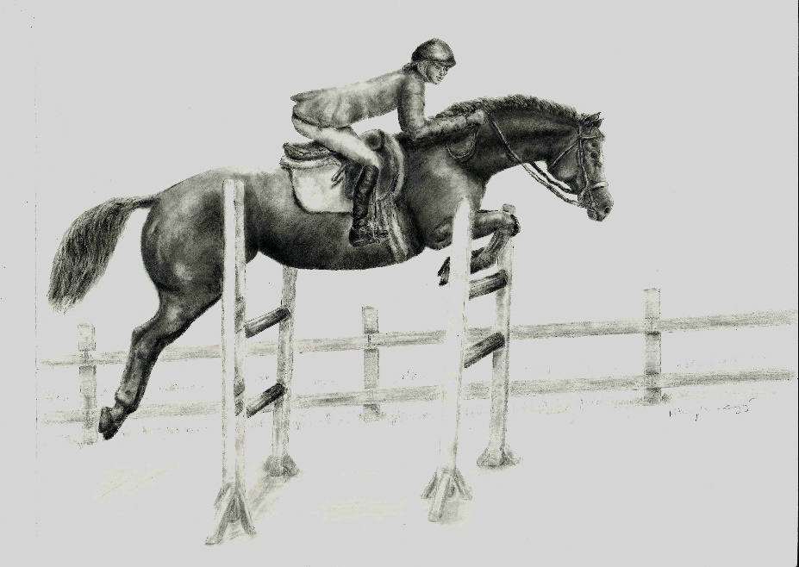
Charlene and Mary

“Wow, it was definitely the right decision to send Charlene to Jumping for Joy Farm. She learned jumping quickly. She has lots of natural ability. Isn’t it great we found out what she loves?” said Eva.
“I agree. When are, you going to put Charlene in some jumper classes?” asked Ted.
“Funny you should mention that,” said Mary. “I think we’ll enter her in the show at the Horseman’s Club show next week. It’ll be a great place to start, since the top competitors probably won’t come.”
“That’s a great idea. We don’t have any races next weekend so I’ll come take care of Charlene and make sure she’s looking her prettiest,” said Eva.
“Okay, it’s a date. I’ll see you next Saturday morning,” said Mary.

In the Spotlight

It’s the morning of the show. I’m looking out the window wondering what will happen. Will I be scared? Will I do my best? Can I show people I’m the star jumper?
***
We’re in the trailer on the way to the show. Elliott’s sitting on the hay, looking out the window. Look, there are many green striped tents in the distance. The trailer stopped. Eva is leading me off it. She’ll put my bridle and saddle on so I’ll be ready.
***
“Okay, Charlene,” said Mary. “We’re going to ride around the ring so you can get used to the jumps. We’ll look at the jumps you might see in your class.”
Mary is riding me around showing me the jumps for practice before our classes.
“Here we go, Charlene. Take your time and look at each jump,” said Mary. “Good girl, you sailed over every jump without touching anything. What a great practice session.” Mary patted Charlene’s neck. Charlene tossed her head to show she was happy with her work.
“It’s time to get ready for your first class, Charlene,” said Eva. “Don’t let the noisy crowds bother you. Pay attention to Mary.” Eva wiped Charlene’s coat with a soft cloth to remove any dust. She walked her over to the ring where the class would be held.
I’m next in the Green Jumper’s Class. Shouldn’t I enter the Red Jumper’s Class because of my red hair? I remember now. “Green” means I haven’t been showing long.
Mary trotted me into the ring, and patted my neck. “Here we go, Charlene. Do your best,” said Mary. “That’s it, don’t rush. Good girl, you’re doing great. Here’s the last jump, the in and out.”
I forgot to take one stride between the in and out. I snuck in a small extra stride, so I knocked the rail down. I tried my hardest but the other jumps were perfect. I hear Eva cheering and clapping for me anyway.
“Good job, Charlene,” said Eva. “I’m proud of you. One horse didn’t touch any jumps, so he’ll win first place. We’ll find out if you won a ribbon when they announce the winners at the end of the class.”
When will they decide? I can’t wait to see if I win a ribbon. I’ll listen with both ears. Finally, it was time to announce the winners.
“Ladies and gentlemen, we have the results of the Green Jumper’s Class. First place, number 12, Jumpin’ Jiminy, second place, number 62, Charlene the Star, ridden by Mary Harris,” said the announcer.
Wow, I can’t believe we won second place in my first jumping class. Mary did a great job. The most important thing is that I learned something so next time I can do better.
“Charlene, the pretty red ribbon looks nice on your bridle. It makes your red hair look even prettier,” said Mary. “We have one more class this afternoon. You’ll get sponged off with cool water beforehand so you’ll feel refreshed.”
I can’t wait for my sponge bath. If I do well in the next class maybe Eva will reward me with peppermints.
After my refreshing sponge bath, Mary came to get me. “Charlene, it’s time to get ready for the second Green Jumper class. Try to pay extra attention to the in and out.”
It looks like the jumps are the same as before, except they’re in a different order. I’m being extra careful not to touch any jumps. Here comes the in and out jumps. I’m in. I took one long stride and flew over the last part. This time we didn’t knock anything down. We finished the course and Mary is giving me pats. I’m hopping up and down to celebrate.
“Charlene, you showed how talented you are. Didn’t it feel great to have no faults? Maybe you won first prize this time,” said Mary.
Why can’t the judges hurry up? I’m stomping my hoof to let them know I’m anxious.
“Ladies and gentlemen, we have the winners of the second Green Jumpers’ class. First place: number 62, Charlene the Star, ridden by Mary Harris,” said the announcer.
Mary is patting my neck. She’s telling me I’m the star. I’m listening with both ears. I’m glad I found out jumping is my gift, just like racing is Ann, Blossom and Charlie’s talent. I hear Elliott barking from the bleachers.

A Party for Charlene
Eva washed Charlene and prepared her for the trip home. She wrapped Charlene’s legs with soft blue bandages. Elliott trotted into the trailer and hopped up on the manger. He sat on the hay. “Come along, Charlene,” said Eva. “We’ll walk on the trailer to join Elliott. That’s it, good girl.”
A short time passed before the trailer rolled up the driveway at home. Eva led Charlene to her stall and prepared her oats with carrots and peppermints on top. “Eva is getting your bubble bath ready,” said Mary. “When you finish that, your dinner will be waiting for you. You shouldn’t have peppermints every day, but I think you earned them today. You’ll have some time off now before we plan what to do next,”
Goody, vacation time, a bubble bath, extra oats and peppermints; my favorite things are happening all at once.
“Gee, Charlene, I saw you at the show today and you were super. I’m proud of you for doing so well and working so hard,” said Elliott.
“Thanks, Elliott. I heard you barking from the bleachers. I’m glad you were cheering for me.”.
“Aw, any good friend would’ve done the same. It was nothin’. I’d have clapped for you if I could, but I didn’t want to make a scene.”
***
Meanwhile, Mary walked into her office to call Charlene’s owner. “Mr. Benson, this is Mary calling from Jumping for Joy Farm. I wanted to tell you Charlene is a natural jumper. I’ve noticed she tries hard to please me every day. Guess what happened today? We entered the Horseman’s Club show and Charlene won a first place and a second place. She’ll have a wonderful future as a show jumper. Based on her performance today, we might plan to enter the Sterling Club show next month.”
“How wonderful Mary. Thanks for sharing the news and keep up the good work. I’m looking forward to hearing about your adventure at the Sterling Club.”

The Big Day at the Sterling Club
Mary rode me twice a week. She wanted me rested for the big show at the Sterling Club, but still well prepared. How will I do against horses that might have more experience?
“Charlene, the show at the Sterling Club is tomorrow,” said Mary. “We’re entering two Green Jumper classes. If it rains your new rain shoes will keep you from slipping.”
I never thought about the weather. How does jumping in the mud feel? I’m not going to lose sleep over it. I need to rest so I can do my best.
***
Yikes, it must’ve rained all night. I looked out my window this morning and there’s mud everywhere. At least it’s only sprinkling now. The sun is trying to peek out from behind the clouds. Goody, here’s my breakfast. I’d better eat everything so I have lots of energy for the big jumps.
On the morning of the show, Mary entered the barn. “Charlene, it finally stopped raining,” said Mary. “Try not to worry about the mud; look out the window while you’re riding the trailer and relax.” Mary led Charlene onto the trailer where Elliott was waiting for her. Charlene stuck her head out the window.
We’re out in the country. We passed some horse farms. Mary is slowing down. She might be parking the trailer. I’ll grab more bites of hay so I’m not hungry when we start to work. I see horse vans everywhere.
“Charlene,” said Mary, “here we are. “I’ll tack you up (put your saddle and bridle on) and we’ll look at the jumps. I want you to get used to the way the mud feels under your feet.”
***
Mary is riding me and we’re looking at the jumps before we practice them. One is strange. It looks like a plastic ditch with water in it. The water is in front of the post and rail jump. Why did they put water there? They could’ve left the mud instead.
“Charlene now that you’ve seen the jumps, we’re going to practice jumping them. Here we go. Be careful not to touch the jumps. Here’s the water jump.”
The water jump looks scary. Should I stick my foot in it? I need to stop and have another look at it. Mary gave me a little kick. I don’t think I did the right thing by stopping. Now I took another look. It isn’t so bad. I must jump it again. When I make a mistake, I can’t give up.
“Here we go again, Charlene. Keep going and don’t worry. You can do it,” said Mary.
I can feel Mary squeezing me hard with her legs. That means I should keep going. We made it. I didn’t put my foot in the water, hooray.
“Good girl, Charlene. I knew you could do it. If you jump the same way during your class and you’ll do fine.”
Mary is patting my neck. I can tell she’s happy and I’m glad I took the jump the right way. Now I’m not afraid and I’ll be more confident when it’s time for my class. Eva’s walking toward me. She’ll make sure I look spectacular for my class.
“Charlene,” said Eva, “You look beautiful, relaxed and rested. I know you’ll do well today. You and Mary have worked hard. It’s time to show people what you can do. Here’s a peppermint to keep your spirits up.”
“All riders please come to ring three for the Green Jumper Class,” said the announcer.
I’m going to watch some of the other horses. They don’t seem to like the mud. Some of them are slipping. Maybe they’re not wearing rain shoes.
“Okay, Charlene, we’re next. Remember to take your time. You’re talented so it’s time to show it. All you need to do is your best and I’ll be proud of you,” said Mary. “I’m taking you in a wide circle so you have plenty of time to see the jumps. That’s it, good job. Here’s the water jump, the last one.’
I did it. Now Mary is happy. She’s patting my neck.
“Good job, Charlene. We didn’t have any faults. I’m proud of you. Now we need to wait for everyone else to take their turn. Then the judges can decide who won,” said Mary.
Today I’m number 13. Will it be lucky? I can see Elliott sitting in the front row of the bleachers. His front paws are crossed in front of him. I guess that’s like people when they have their fingers crossed.
“Ladies and gentlemen first place in the Green Jumpers’ Class is number 13, Charlene the Star, ridden by Mary Harris,” said the announcer.
I hear people clapping and cheering. Elliott’s barking, letting everyone know he’s excited. I’m glad I tried hard. Otherwise, I wouldn’t be the winner.
“I’ll give you a nice drink of water, Charlene. Then you’ll have a sponge bath so you’ll be refreshed before your next class. You can have a snack, too. I know you worked hard today,” said Eva.
I can hardly wait for my snack.
***
“It’s time to go back to work, Charlene. We’re next in the Green Jumper Classic,” said Mary.
Here we go. It’s still muddy so I should be careful. Here comes the water jump. I’ve got the running start. We made it. One more jump to go. My foot slipped but I kept going. I tried hard not to touch the jump after my foot slipped. We finished with no faults. Mary is patting me. Now we have to wait for the judges to decide.
“Ladies and gentlemen, we have a tie in the Green Jumper’s Classic. Numbers 13 and 23, Charlene the Star and Jumpin’ Jack will have a jump off. These two horses will jump the course again. This time, some of the jumps will be higher. The horse and rider with the least number of faults will win first prize,” said the announcer.
I’ve never been in a jump off. Jump off is a funny word. It sounds like you hop from something. I hope I win. Mary and I are jumping first. I heard the announcer say some of the jumps are higher. I’ll look at them carefully and pick up all my feet.
“Okay, Charlene,” said Mary. “I have faith you’ll do your best. That’s all I ever expect of you. Here’s the first jump, a wide spread jump.’
Here’s the in and out jump. I must have only one stride in between. I can hear the crowd cheering and clapping for us. Eva might be cheering louder than anyone. Mary’s patting my neck so I know she’s proud. I hear Elliott barking loudly. He wants me to know he’s happy, too.
“Charlene, I’m proud of you. Even when you slipped, you didn’t give up. I know jumping in the mud feels different. Some horses can’t handle it but you were brave. We’ll wait to see what the judge decides when all the riders have finished.”
“Ladies and gentlemen, the judges have made their decision,” said the announcer.” First place goes to Charlene the Star, ridden by Mary Harris with a total of eight points today. They are also our Green Jumper Champions. Charlene was the star of the show today,” said the announcer.
I’m the champion. I can hardly believe it. But, because I’m the champion today, doesn’t mean I can stop trying. I must always do my best so I’m proud of myself.

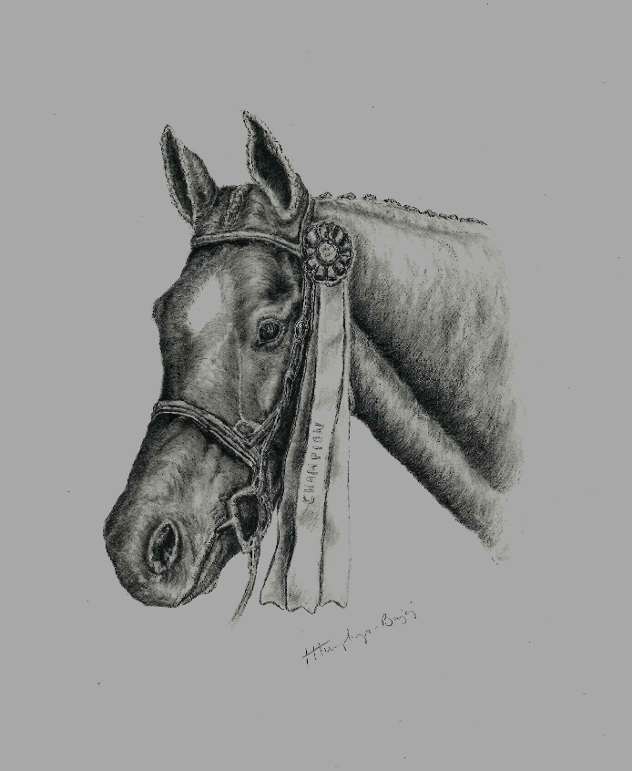
Charlene the Champion

“Charlene, you are amazing,” said Mary. “You are a champion in every way. You do your best every day, even if you’re afraid, or when you have a new experience like jumping in the mud. You’ve earned a nice vacation. I’m going to let you spend time with your friends Blossom and Ann. Of course, you can visit your mom too. But that’s not all. We will plan a party for you when we get home. You’ll munch on extra oats, and peppermints. Your picture will be in the paper tomorrow because you are a champion.”
I’m thrilled I learned about my talent for jumping. It’ll be marvelous to see Ann, Blossom and Mama. We’ll talk about jumping and I’ll hear about all their racing adventures. They’re still my best friends. We’ll have an amazing celebration together. I can’t wait.

How well do you know the story?
- What did Charlene’s Mom tell her about training as a racehorse?
- How did Charlene show her trainers she didn’t like racing?
- What was the name of the farm where Charlene started her new career?
- What was Charlene’s special talent?
- What was Charlene’s favorite treat?
- What do you think was an important message in Charlene’s story?
- What was your favorite part?

Answers:
- Charlene’s Mom said she had to try racing first before deciding she didn’t like it.
- She did crow hops and yawned to show her trainers she didn’t like jumping.
- It was Jumping for Joy Farm.
- Her talent was jumping.
- Charlene loved peppermints.
- It’s okay to have different talents than your friends. We should all use our natural gifts.
- What was your favorite part?

For more information:
Website: www.childrensbookswithlifelessons.com
Email: Deanie@dhdunne.tk

Other books by Deanie Humphrys-Dunne:
Tails of Sweetbrier
Charlie the Horse
Charlene the Star and Hattie’s Heroes
Charlene the Star and Bentley Bulldog

