Charlene the Star
and
Hattie’s Heroes

By Deanie Humphrys-Dunne
Illustrated by Holly Humphrys-Bajaj

The opinions expressed in this manuscript are those of the author.
The author warrants and represents that she has the legal right to publish or owns all material in this book. No part of this book may be reproduced, stored in a retrieval system, or transmitted in any form, or by any means, electronic, mechanical, photocopying, recording or otherwise, without prior permission of the author.

Copyright © 2018 Deanie Humphrys-Dunne
All rights reserved.
ISBN 13: 978-1986031578
ISBN 10: 1986031578

DEDICATION

This book is dedicated to our awesomely handsome, gifted, special cherubs, Brendan and Shane. You’re the best by actual test.

A New Career

Introduction:

“Hi, my name is Charlene the Star. I’m a horse who loves jumping. Mary is my rider. This is a story about me and my animal friends. Some of my friends are Wooliam the sheep, Hattie the chicken and Elliott the dog.
***
Charlene thought, Now Mary is steering me toward the big water jump. It has a small ditch with water in front of it. I remember seeing one at the Sterling Horse Show when I won the Green Jumper Championship. I stopped to have a good look at it. Why did they put the water there? Maybe I should welcome challenges. That way, I can prove worthy of my name.
Here comes the in and out. They can be tricky. You only have one or two strides between them, so you must concentrate, or else anything can happen.
Mary said, “Charlene, you’re not concentrating. You’re looking around like you’re sightseeing. Even though you’re a champion jumper, we need practice. In fact, we’re practicing while you’re here visiting Racing Haven Stables in Kentucky. It’s my version of a working vacation. You’ll visit your friends Ann and Blossom, but you need to work sometimes to stay in shape.
“Let’s gallop toward the oxer. Remember, it looks like two jumps pushed together, so build up speed. That’s it, you sailed over it,” said Mary, caressing Charlene’s neck.
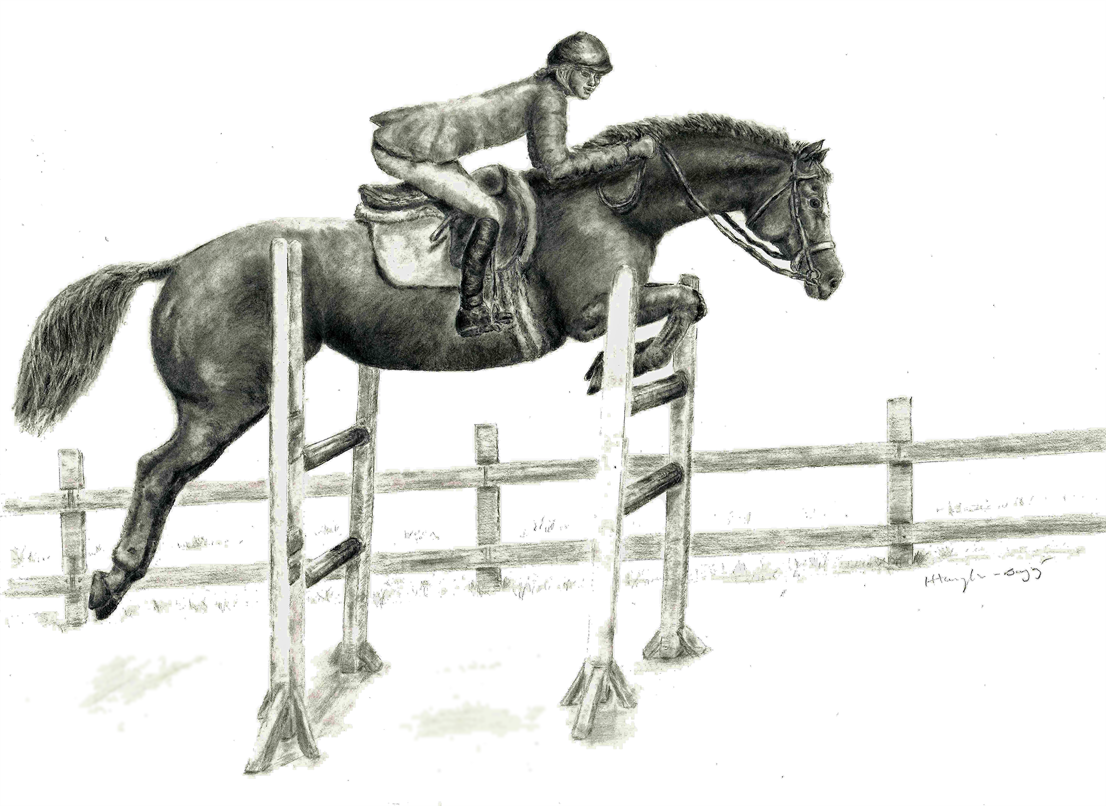
Mary and Charlene jumping the oxer

“Good job, Charlene,” Mary said, kissing Charlene’s shiny red mane. Mary jumped off Charlene and walked her around before returning to the barn. “Let’s walk back to the barn to visit with your friends. Charlene why did you stop short? What are you looking at in the field? Darn, now you got loose by pulling hard until I let go. Oh no, you jumped the fence to get to the field,” said Mary, stomping her foot.
***
“Hattie, what’s wrong?” asked Elliott, tilting his head.
“I was adjusting my bonnet when I heard Charlene’s hoof beats. I peeked out the barn door and saw her racing around the field.”
“Mary will not be pleased. I’ll go outside. Mary needs time to settle down,” said Elliott, running toward the door.
“Charlene, come get your oats,” called Mary.
Charlene thought, I’m in big trouble now. Geez, I only wanted to say hello to the deer grazing in the pasture. But, I guess Mary didn’t see it. She’s mad at me for running off. I’ll behave and trot over to her. Still, I won’t get any peppermints tonight.
***
Back in the barn, Charlene said, “Hello, Ann. It’s nice to see you again. We’ve been friends our whole lives. But your talent is racing, while mine is jumping. Your gray coat looks as beautiful as ever. I’m glad we talk among ourselves, but not with people. Who knows how they’d react? Oh, I heard you won the Acorn Race. That’s impressive, congratulations.”
“Why, thank you, Charlene. Personally, I’ve always admired your dark red coat. Did you wear a green blanket under your saddle to qualify for the Green Jumper Championship?” asked Ann.
“No, Ann, in horse shows, if you enter the Green Jumper Classes, it means you haven’t had experience jumping in shows.”
“Silly me, I imagined you’d have to dye your dark red coat green, or at least, use a green saddle pad.”
“We haven’t seen our friend Blossom this morning,” said Charlene.
“Blossom, are you awake?” called Charlene.
“Yes,” answered Blossom, still yawning and stretching. “My friend Hattie the chicken is here. She tapped me with her wing, trying to wake me up. She’s adorable and she likes to wear hats. This morning she’s wearing her favorite red bonnet. She has shiny red feathers. Hattie’s great at calming me when I’m nervous before races.”
Charlene said, “I don’t know where I’d be without my dog, Elliott. He keeps me calm at the shows. I love his big brindle marks. They look like spots with stripes. Elliott does a great job cheering for me from the bleachers. I recognize his bark and he keeps his paws crossed for me when I’m jumping. It’s like a person crossing fingers for you. Oh, I almost forgot to mention Elliott does tricks. He’ll wave hello or goodbye to you and he opens gates with his paws by pushing the latch up. When Elliott wants to have more fun, he’ll step on the button that opens the starting gate when we’re waiting to race.
“Here’s Hattie, speeding down the aisle holding her bonnet,” said Charlene. “Good morning Hattie. It’s nice to meet you. This is Elliott sitting next to me waving hello to you,” added Charlene.
“Why, thank you,” said Hattie, taking a bow, while she caught her breath. “I do love to wear hats. My mama said when I was born part of my shell was sitting on top of my head, so she named me Hattie. Besides, Mama said I should do something important with my life. I have fun with Blossom, but I’ve been wondering what else I might do in my spare time. It’s hard for chickens to show they have talent. Chickens don’t get any respect. Do chickens attend important events? Have you ever heard of the ‘” Chicken of the Year Award?” If we go to a banquet, we hide under the tablecloth and check the menu to make sure we’re not on it.”
Charlene said, “Isn’t it odd, I’ve been wondering about the same thing? Jumping is my favorite thing, but my mama said we should try to develop as many talents as we can so we don’t get bored.”
“That’s true. What do you think you’d like to do?” asked Blossom.
“Gee, I have no idea. I’ll give that some thought,” said Charlene. “It’s getting warm out here. I can see Eva riding a small black horse on the racetrack. Boy, that little horse is flying around the track, but the other horse who’s working with her just bumped her. Now she won’t move at all.”
“Hi, Charlene,” said Eva, patting her soft red coat. “It’s been a tough day. I’m puzzled by horses like little Tiger Lily, who stops dead when another horse bumps her while she’s racing. I need someone who understands the way horses think. I’ve had many horses with training problems. I haven’t even had time to fill out the work schedule for my horses. I spoke to Mary Harris, the manager at Jumping for Joy Farm, where you usually stay. It’s across the street from us and I thought she might have some ideas.”
“Hey, everyone come quickly. I’ve got a terrific idea,” shouted Charlene.
Charlene said, “Hattie, slow down. You’re racing down the aisle. You don’t want your favorite bonnet to fly right off your head. That’s it, hold your hat and be careful. You were running so fast you almost tripped.”
Elliott jogged along behind Hattie and sat next to her, while they waited anxiously for Charlene’s big announcement. Hattie couldn’t sit still. She flapped her wings and hopped around.
Charlene shifted her weight from one foot to the other waiting for everyone to settle down When she stomped her foot, everyone quieted down. She said, “I heard Eva saying many horses have trouble with their training. Some are shy and others don’t know where they fit in. How about starting a coaching business for horses? Isn’t that a great idea? Let’s advertise in The Gazette. We’ll start out small and branch out. Maybe someday we’ll coach horses at Jumping for Joy Stables. If we do our best, we could even become coaches of the year.” She twirled in circles imagining the new adventure.
“Charlene, you’re a genius,” said Hattie, hopping around, cackling. “That’s a great idea, don’t you think, Elliott?”
“It’s fantastic, I can help horses with low self-esteem. I’m a good listener and the horses could look at my big head and know I have confidence.”
“Great!” exclaimed Charlene. “We’ll put an advertisement in The Gazette. Hattie, get your pencil. You have the nicest handwriting. It’s not like chicken scratch at all. Here’s what we’ll say… Are you a shy horse? Do you have low self-esteem? Not sure where you fit in? Help is on the way. Call 1-800-Hattie4U. Let’s call our company ‘Hattie’s Star Coaching.’”
“This is exciting. We could change a horse’s life. Now, that’s a way to make a difference,” said Hattie, hopping around. “Besides, with my capable assistants, Elliott and Charlene, we’ll have clients in no time.”
***
Charlene was in the pasture with Blossom and Ann a few days after the advertisement appeared in The Gazette. Charlene jumped sideways because she was startled when she saw a small black horse peering around the bush in the paddock.
“Um, hello, my name is Tiger Lily. I love racing and I can run fast, even though I’m small. But I get scared when I’m racing and another horse bumps into me. I stop. Then I shiver, trying to show my trainer I’m scared, but he hasn’t figured it out yet. Also, I hate getting dirt kicked in my face when I’m racing. It distracts me and I can’t run fast. Oh, I saw your ad in The Gazette. Can you help?” asked Tiger Lily, almost whispering.
“Of course, I’d love to,” answered Charlene. “By the way, I’m Charlene, and these are my friends, Blossom and Ann. Blossom is the lovely brown horse with the blaze and Ann is the one with the sleek grey coat,” explained Charlene. “Were you working on the racetrack today? I think I saw you and you were lightning fast,” said Charlene.
“Yes, I was zooming along until the other horse bumped me and I slid to a stop.”
“If you could do anything you wanted, what would it be? What do you dream about?”
“I want to be the best racehorse anywhere. I ‘d love to be as famous as your big brother, Charlie because he won the Southern Derby.”
“How can you do that if you give up? It would be like driving on a dead-end street. It doesn’t take you anywhere.”
“Gee, I never thought of that. I’m not sure I can keep going when I’m afraid, though.”
“Of course, you can. Try believing in yourself. Imagine yourself flying to the finish line first. Think of how proud you’ll feel when you’ve accomplished something you never thought you would. Remember, you’re very talented,” said Charlene.
“I’ve got an idea,” said Charlene. “I heard there’s going to be a full moon tonight. We can sneak over to the race track tonight when no one is in the barn. Elliott can open the door for us. Ann, Blossom and Tiger Lily can take a practice trip around the track. Tiger Lily, Ann or Blossom might bump into you when you’re on the race track, just to see how you react. But it’s only practice so there’s nothing to be nervous about.”
“I’m afraid I’ll be nervous anyway. Even practice makes me worry. I might not eat my dinner tonight,” said Tiger Lily, already feeling her knees shake.
“Tiger Lily, don’t feel afraid. The only way to build confidence is to do your best and overcome your fears. Ann and Blossom won lots of races. They learned to keep trying even when other horses bumped them. They learned to run in the mud, too,” Charlene replied.
“That’s right, Tiger Lily. I don’t like the mud either, but we can’t always have nice sunny days. When I’m racing in the mud, I think of how much I like racing and how happy I am when I win. I don’t focus on the mud. Besides, we wear special rain shoes so we don’t slip around in the mud,” said Ann.
“Elliott, are you ready? The moon is bright now. Let’s go to the race track with Tiger Lily. Ann, Blossom, I see you’re anxious to run. You’re wide awake and prancing in your stall. Good job opening the door, Elliott. I didn’t even need to remind you,” said Charlene.
“Yes, we’ve been waiting for you to tell us it’s time to go play on the track,” said Ann and Blossom together.
***
Tiger Lily thought, here we are in the starting gate. I see Ann next to me and Blossom’s after her. I hear my knees shaking. It feels like they’re bumping each other. Too bad they’re not musical instruments. I could lull the other horses to sleep so they’d forget to run. When will Elliott push the button? I’d better get ready to run as fast as I can. Maybe nobody will catch me if I get a head start.
Tiger Lily settled into second place with Blossom in the lead. Then Ann caught up so the three of them were in line across the track. When Ann and Tiger Lily were head and head, she bumped Tiger Lily’s side. But, Tiger Lily took a big breath and kept going.
I can’t believe I’m still running, thought Tiger Lily. Yikes. I lost my concentration and now Ann is ahead of me. I should have paid attention. Ouch, another clump of dirt hit my face. I don’t feel like running today. I’ll let Ann win.
The beautiful gray horse won easily, coasting past Tiger Lily.
“Tiger Lily, you might have won if you didn’t give up. You were brave when Ann bumped you. Weren’t you proud of yourself for running?” asked Charlene.
“Well, I got discouraged the second time she bumped me, so I let her win,” said Tiger Lily, lowering her head because she felt embarrassed.
If you want to be a great racehorse, you’ve got to do your best every time, not only when it’s easy. You made progress today” said Charlene.
“Thank you, Charlene. I feel more confident already. I’ll think about the things I learned today,” said Tiger Lily.
Buy here:
www.childrensbookswithlifelessons.com
Thank you!

