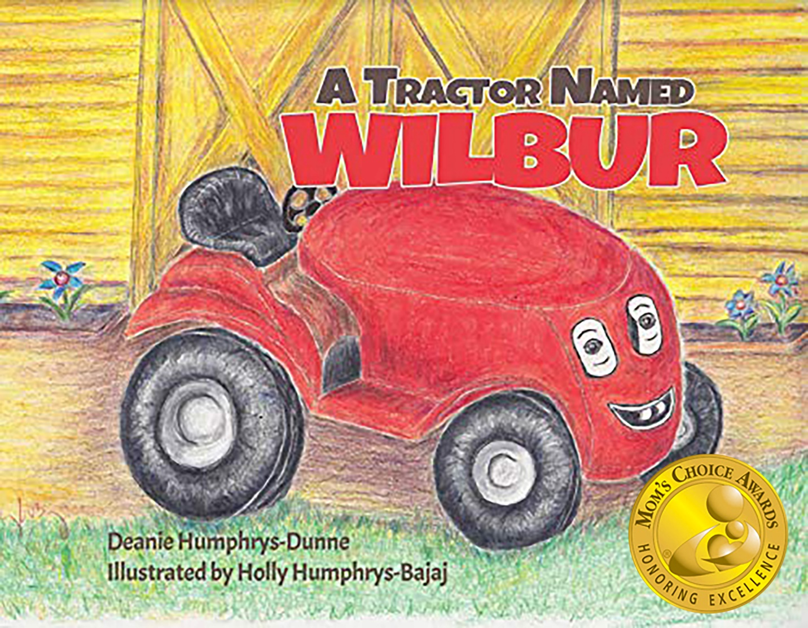
Jim McNab opened the door to the barn where his little red tractor stayed. “Top o’ the mornin’ to you, Wilbur. The grass in the yard needs mowing. Would you like to help?”
“Let’s go,” said Wilbur, bouncing on his wide tires.
“Who’s coming to see us?” asked Wilbur. He flashed his headlights to show he was excited.

“Remember, I promised to find a new home for you with someone who loves you as much as I do? Now that you’re getting o-l-d-e-r,” he whispered, “I would be very sad if you got hurt mowing my big vegetable garden. A nice man is coming to see you.”
“What if I don’t like this man? What if I don’t feel comfortable when he comes to see me?”
“Try not to worry, Wilbur. If something bothers you and you’re too shy to speak up about it, you can always flash your lights. That will be our signal, and I’ll say something.”
“Thank you, Jim. No wonder you’re my best pal.” Wilbur took a big breath and smiled, thinking of how lucky he was to have such a kind friend.
“Let me rinse the grass off of your tires,” said Jim.
Jim washed Wilbur’s tires with warm soapy water. Then he opened the toolbox, took out a soft cloth, and dried the little red tractor’s wheels. Will my new owner do that?”
“Don’t worry, Wilbur. I’ll tell him about the things you like.”
“Let’s put your blanket on so you’re nice and cozy when you’re sleeping tonight.” Jim took the fluffy green blanket out of the toolbox and covered Wilbur.
“I love my blanket. It’s my favorite color and it has my name on it.”
“Goodnight, Wilbur.”
For more about Wilbur’s New Home visit: www.childrensbookswithlifelessons.com/

