Marcie was on the phone when I walked out of my office, so I leaned up against her desk and surveyed the large, busy lobby. It was a warm Wednesday afternoon and guests of the Peabody were enjoying the comfort and hospitality provided by a luxury hotel. The lobby bar was crowded, the shops were busy and individual parties were happening on all parts of the hotel’s main floor and Mezzanine. Even the ducks seemed to be enjoying the day.

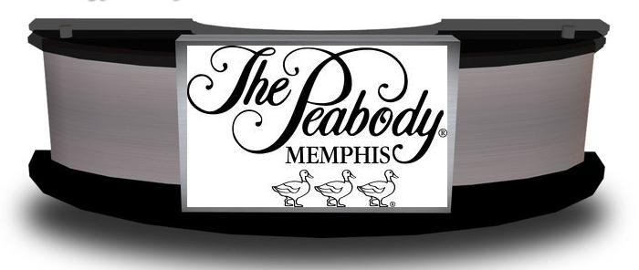
“How was Mrs. Ava Beaumont?” she asked casually after hanging up the phone.
“Different, and very bossy.”
“All rich people are bossy,” she quipped, “and usually different.”
“Perhaps, but Mrs. Ava Beaumont is different in a…well…in an evil sort of way.”
“Evil,” Marcie frowned at me. “What do you mean by evil?”
“I’m not sure, but she’s not the kind of woman I would want for an enemy. I think she could be dangerous.”
“Well, whatever she is, she certainly comes wrapped in a nice package.” Marcie winked.
“I know, and that’s the scary kind!” I laughed, and then changed the subject. “Make me reservations on the five o’clock flight to New Orleans and book me a room at the Monteleone for tonight. Leave the return ticket open, but I expect to be back sometime tomorrow.”
“Well,” Marcie smirked. “I guess you and Liz are slipping off for a lover’s getaway. It must be nice.”
“I wish,” I sighed. “The weather is just too pretty to be working, but this will be a quick and profitable trip. Maybe I can find some time to enjoy the weather this weekend.”
“You need a car in New Orleans?” Marcie picked up the phone.
“No, I’ll take a cab. Have you heard from Joe?”
“Yes,” she answered before dialing. “He called while you were with Mrs. Beaumont. Business in Little Rock has been handled and he’s on his way back.”
“Good. Tell him I’ll try to call from New Orleans tonight and brief him on what’s going on. I haven’t eaten so I’ll grab some lunch at the airport.” I took another quick look at the crowded lobby, then used the south exit and out to the parking garage.
~
My flight from Memphis to New Orleans was smooth and uneventful. The beautiful skies reminded me of my need to get outside and enjoy this weather while I had the chance. Golf was in my thoughts, and when I finished this little task for Ava Beaumont I would dust off the clubs and find a golf course. Perhaps Liz and I could spend a few days in Humboldt, chasing each other along with an occasional golf ball – that idea had a good ring to it.
After a short cab ride from the airport to the New Orleans French Quarter, I stepped out onto Royal Street in front of the famous Monteleone Hotel.
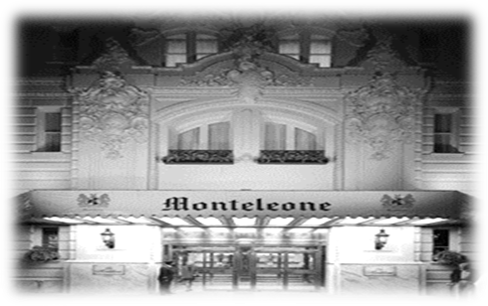
Dodging the crowded entrance, I used the garage access and found my way through the giant lobby to the check in area near the rear of the room. It was 7:15 on a beautiful Wednesday evening.

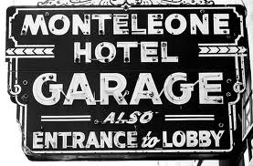

The sheepish desk clerk handed me my key and mumbled that I had no messages. I headed for the bar.
Luckily the street side bar wasn’t crowded and I found a stool allowing me to watch activities at the check in area and the Royal Street entrance. Ava hadn’t been specific, so I didn’t know if my contact with Donovan Tanner would be in person or by phone. It only took a few minutes to find out.
~
The bartender had just delivered my first Jack Daniel’s and Coke when a short man wearing a Monteleone bellhop uniform walked into the bar and called my name. Searching the room for a response, he finally saw me waving and walked up to my barstool.
“Mr. Reno,” he said shyly, “you have a call on the house phone. You can take it in the lobby, if you wish.”
Looking at my untouched drink, I left a dollar on the bar before following him into the lobby. He pointed to a phone near the registration desk and I handed him another dollar before walking across the large room.
“This is Carson Reno,” I said after picking up the receiver. “I understand you have a call for me?”
“Yes sir,” I heard from a nice female voice. “I’ll connect you now.”
After a moment of silence, a rough voice answered the call. “Is this Carson Reno?”
“Yes it is,” I obliged. “Who’s this?”
“Did you bring something for me?” he asked, avoiding my question.
“Is this Donovan Tanner? If yes, then I do have something for you. Is this Donovan Tanner?” I asked again.
“Meet me at the Royal Sonesta in thirty minutes. I’ll be in room 212, and come alone. You also better have an envelope for me – a thick envelope. If not, your client will be sorry.” He hung up without answering my question.
“Damn,” I said replacing the receiver and staring at the phone. The asshole never told me who he was, but…well…I guess I would go to the Royal Sonesta and ask him that question in person.

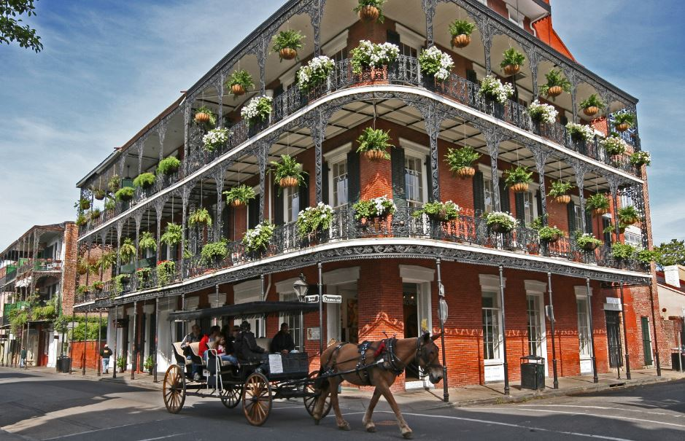

The Royal Sonesta is another old and beautiful hotel located in the French Quarter. Although smaller than some others, it still offered the flair, flavor and elegance of old New Orleans. It also was only a block away on Bourbon Street, an easy walk from the Monteleone on this beautiful evening.
Crowds grew thicker when I stepped onto Bourbon Street and turned right toward the lights of the Royal Sonesta. Sidewalks, balconies and the streets were full of party goers enjoying their night in the ‘Big Easy’; I wondered why I wasn’t doing the same instead of delivering blackmail money to a stranger. My work had its good side, and it also had its bad side. This was the bad side. I didn’t know it then, but it was only going to get worse.
~
An old black gentleman dressed in a weathered tuxedo was standing behind the registration desk and smiled a hello when I walked up.
“Welcome to the Royal Sonesta,” he said with a grin showing his mouthful of white teeth. “How can I help you?”
“A mister Donovan Tanner, please,” I smiled back. “Could you direct me to his room?”
Suddenly his smile disappeared and he picked up a stack of cards from under the desk. Hurriedly fumbling through them, he gave me a couple of glances before returning them to the desk and looking back at me.
“I’m sorry, we don’t have a Donovan Tanner registered with us. Could his registration be under another name?”
“No…no,” I shrugged, and turned to leave. “I’m sure there’s just some confusion about his plans. I’ll check other hotels, thanks for your help.”
“Certainly must be some kinda’ BIG confusion,” he said nodding his head. “You’re the second person in the last thirty minutes that’s been looking for Mr. Donovan Tanner.”
“Really,” I stopped and turned back to face him. “Do you know who that other person was? I mean…did they leave a name?”
“Nope,” he said frankly, “and I don’t know who you are either. But just like I told the lady, if you want to leave your name and message I’ll give it to Mr. Donovan Tanner if he happens to show up.”
“Lady?” I said to myself.
“A right nice lookin’ lady,” he said when his smile returned. “But, she didn’t leave no name or message and I assume you ain’t going to either. So, have a nice evening and I hope you folks find Mr. Tanner.”
He returned to his business and I strolled across the lobby, wondering what might be waiting in Room 212 of the Royal Sonesta Hotel. Avoiding the ancient elevator, I stopped to busy myself with some tourist literature while watching the old man behind the desk. When his attention was distracted by another customer, I stepped through a door marked ‘STAIRS’ and walked quickly up to the second floor landing.
Peeking out the stairwell door, I saw the hallway was empty and hurriedly stepped onto the thick carpet, pausing to look and listen for anything unusual. Room 212 was only a few yards to my right and I neither saw nor heard anything.
After walking cautiously down the narrow hall, I stopped in front of Room 212 and stared at the door. Something was wrong. The door wasn’t completely closed; it was open about an inch, but not enough to see inside the room. I pulled out my .38 and paused at the partially open door.
Listening through the small opening I could hear sounds, not voices but a soft mumbling noise coming from inside the room. Using the barrel of my gun, I pushed the door. It easily swung on its hinges and into Room 212 – permitting light from the hall to enter the dark room.
“Knock, knock,” I said through the doorway and into the shadowy room. “Anybody home?”
“Ugggh,” I heard someone moan before speaking softly. “Come in and close that damn door.”
“What!” I shouted to the unidentified voice.
“Come in and close the damn door, I need some help.”
Stepping into the shadows and without closing the door, I pointed my gun at the noise, grunts and mumbling voice coming from a far corner of the room.
“If you need help, then tell me who I’m helping,” I said seriously. “Identify yourself or I’ll shoot.”
“Carson, will you please shut the door and turn on the damn lights? You can also put that gun away; nobody in this room will be shooting back.”
I still had no idea who I was speaking to, but followed instructions. Closing the door, I flipped a switch next to the entrance and a bedside lamp turned on. I did NOT put my gun away.
Lying on the floor in the shadows, and leaning up against the closet door was Lydia Longstreet – the younger sister of Lilly Longstreet. Lilly was a private investigator who had met a violent death during my recent adventure, ‘Dead End’. I had almost met the same fate. Following Lilly’s death, Lydia picked up where her sister left off – operating a small private detective business in Memphis. However, I could not imagine what or why she was in New Orleans and speaking to me from the floor of a room that was supposed to be occupied by Mr. Donovan Tanner.
“Lydia,” I shouted. “What the hell…”
“Carson, put that damn gun away and get me a wet towel. My lip’s busted.”
Staring at what I couldn’t believe and without moving, I simply shook my head and glared. Lydia’s right hand was covering her right jaw, and she was using her left arm to keep from lying completely on the floor. Shoulder length black hair pointed in all directions, and her dark skirt was pushed up past mid-thigh – revealing more than she would have wanted. It was obvious that Lydia Longstreet had suffered some sort of trauma, which resulted in her being in the floor and now struggling to get up.
“Carson, are you deaf or blind? Get me a wet towel and stop looking at my ass,” she yelled.
Still shaking my head, I put the gun away and located the small bathroom behind me. Retrieving a towel from the rack, I ran water over one end of it and walked back into the room. Lydia had managed to stand up while I was gone - she immediately jerked the towel from my hand and placed it against her jaw.
“Lydia, what are you…”
“Calm down Carson, I’ll tell you all about it,” she said looking around the room.
Spotting an open bottle of Jack Daniel’s on the dresser, she poured a glass full, dipped the dry end of the towel in the whiskey and placed it against her busted lip. Giving me a long look before shaking her head, she picked up the glass and drank the rest of the whiskey. Then she sat down on the edge of the large bed.
Lydia Longstreet was a beautiful woman, much like her older sister but in different ways. Lydia was taller, probably by more than an inch, and had a figure that placed more emphasis on her breasts – she’d gotten what Lilly had missed. Soft tan skin, piercing dark eyes and coal black hair were appropriately highlighted by dark clothes – offering the observer a ‘sexy, but dangerous’ appearance. In so many ways Lilly and Lydia were the same – and in so many other ways there were different.
I pulled up a chair and sat down, watching Lydia use the whiskey soaked towel to doctor her lip.
“Carson, I came here to see a Donovan Tanner and give him some money. In return, he was supposed to give me documents, which I would take back to my client. When I arrived the door was closed and I knocked, but nobody answered. I tried the handle, it wasn’t locked. So, I pushed the door open and walked in; somebody slugged me and then you showed up. That’s it.”
“Humph,” I snorted. “Who’s your client?”
“Who’s yours,” she snapped.
“I asked first,” I smiled.
“You know I’m not going to tell you that, so why ask.”
“Do you still have the money?”
“Close your eyes,” she said slowly.
Lydia stood and pulled her skirt up to her waist. Stuffed in the stockings on her right leg, and just below dark lace panties and garter belt was a large envelope.

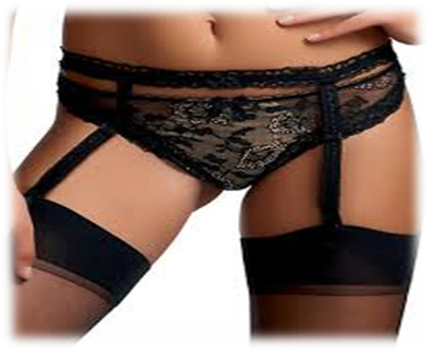
“Yep, still here,” she said smiling.
Also, strapped above the knee on her left leg was a small .32 caliber pistol – just like Lilly used to carry.

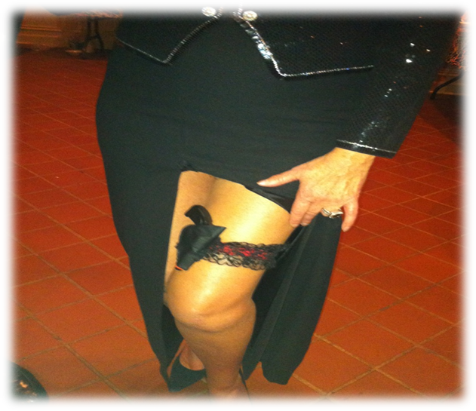

“You looked,” she said sitting back down.
“I’m sorry, I couldn’t resist,” I grinned, ignoring her comment and pouring myself a cup of whiskey. “Tell me Lydia, who’s your client?”
“Who’s YOUR client?” she snapped back.
“Okay,” I sighed. “You came up here to see Donovan Tanner – he slugged you and ran off. Why didn’t he take the money?”
She didn’t speak, but stuck out her empty cup asking for more whiskey. I poured it almost full and asked, “Well…what happened?”
“Carson, the door was closed when I got here but I could hear noises from inside the room. I…I opened the door, stepped inside and…BAM…somebody belted me.”
“Why would Donovan Tanner do that? I mean…didn’t he want the money?”
“It wasn’t…it wasn’t Tanner. It was a woman who slugged me, I’m sure of that.”
“Huh?”
“Carson, unless Donovan Tanner was wearing perfume it was a woman who hit me. I’m certain of that, and I even recognized the brand.”
“Huh?” I said again.
“Love Hurts is the brand and it’s expensive.”
“Huh?” I said for the third time.
“Carson, stop saying ‘huh’ and let’s get out of here. I could use a real drink.

~
Avoiding the desk clerk, Lydia and I slipped out the side door of the Royal Sonesta and stepped onto Bourbon Street. It was still congested with tourists and I turned east – trying to avoid the crowd.
“Where are we going?” Lydia asked, while using her hand to brush her long hair back in place.
“It’s a nice evening; let’s walk up Bourbon and chat. I’ve got a lot of questions for you.”
“Questions for me!” she grunted. “How about I ask YOU some questions? Who put you in charge?”
“Alright,” I said calmly and putting my arm around her shoulder. “Let’s just SHARE information and see if we can figure out how we both ended up in the same hotel room. Will that work for you?”
We started a slow walk, but Lydia didn’t speak for few minutes.
“Okay, but only if you go first,” she finally said. “And where are WE going? I need a drink and there’s a bar on every corner.”
“Lafitte’s Blacksmith Shop Bar,” I said pointing up the packed street. “It’s just a few blocks and may not be so crowded. Perhaps we can find some privacy there.”

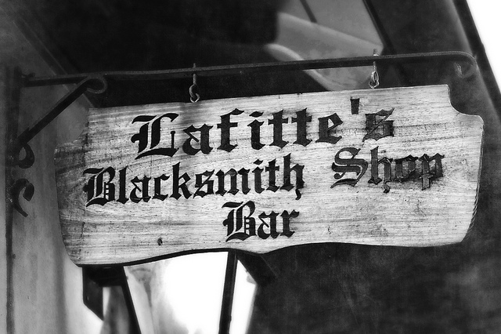

“I don’t need privacy,” she snapped again. “I need a drink.”
“You’ll like it, trust me. And I’ll tell you my story while we walk.”
“Lilly told me you were domineering, and now I understand what she meant,” Lydia said shaking her head.
We strolled the six blocks to Lafitte’s and I shared everything with Lydia Longstreet, finishing just as we found a table near one of the open sidewalk doors.
“Damn,” Lydia said before sitting down. “That just doesn’t make any sense. I mean…”
The waiter interrupted and we both ordered a Jack Daniel’s and Coke.
“Tell me your story and we’ll try to sort it out,” I offered.
“You showed me yours, so now I show you mine. Is that what this is?”
“Isn’t that what we agreed?”
“How’s my lip look?” Lydia asked, just as the waiter delivered our drinks.
“As beautiful as ever,” I smiled. “Now, are you going to tell me why you were in Room 212?”
“I told you already. I went there to give Donovan Tanner some money and he was going to give me some documents.”
“The same documents he was going to give me – right?”
We looked at each other for a few moments and sipped our fresh drinks.
“Yeah, I guess,” she finally added. “But instead of documents I let some bitch give me a busted lip. How does my lip look?” she asked again.
“I told you your lip is beautiful. It’s probably going to be a little…well a little sore for a day or two. I wouldn’t recommend any heavy necking until the swelling goes away.”
“Necking!” she said louder than necessary. “Necking is what teenagers do in the back seat of a car. I’ve outgrown that.”
“I know…you showed me,” I grinned.
“I told you not to look – that’s your fault.”
“Yes, but what you haven’t told me is who you’re working for. Who gave you the money for Mr. Donovan Tanner?”
Lydia finished her drink and signaled the waiter to bring us another round before answering.
“Byron Wolfe, he hired me to bring an envelope of money to New Orleans, retrieve some documents and bring them back to him. I was told to register at the Hotel Mazarin and wait on a call from Mr. Donovan Tanner, who would tell me where and when to make the swap. Tanner called almost as soon as I checked in, and said meet him in Room 212 of the Royal Sonesta Hotel. I followed instructions, but when I got to the room no one was home. The door was closed but not locked. I went in the room, somebody slugged me and then you showed up. It’s really that simple. Wolfe claimed to be some big shot on a building committee for the Baptist Hospital in Memphis and there were some things in these documents that he didn’t want public. I didn’t ask him how Donovan Tanner came by the documents, but according to you he’s a private detective who’s giving the profession a bad name.”
“Blackmail’s a dirty and dangerous game,” I added when she finished, “and it gets twice as dangerous when you peddle your product in two different markets. It seems that Mr. Donovan Tanner was trying to sell his information to separate clients.”
“You think he was selling the same information to my man Wolfe and your lady Beaumont?” Lydia questioned.

“Probably, and unless somebody went public with what they paid for, which isn’t likely, neither one would have known about the other.”
“But where is Mr. Donovan Tanner?” Lydia said just as the waiter delivered our drinks. “He didn’t collect money from either one of us, and according to you, he wasn’t even registered in the room where we were supposed to meet.”
“What did you just say?” Her comment caught me off guard.
She dabbed her napkin in the whiskey and then put it next to her busted lip. “I said he didn’t collect any money, and according to you, he wasn’t registered in Room 212. Why?”
“You mean you didn’t speak to the old black man at the registration desk? He told me that a woman had asked about Donovan Tanner earlier in the evening.”
“Musta’ been the bitch who hit me, cause I didn’t speak to anyone at the Royal Sonesta. I went straight to his room and…and well I told you what happened.”
“Interesting,” I rubbed my chin and sipped on my fresh drink.
“Look Carson,” Lydia said looking at her watch. “I need to get back to the hotel and call my client. He was expecting to hear from me over an hour ago, and probably has my phone ringing off the hook. What are you going to do?”
“Nothing,” I answered candidly. “I plan to get a good night’s sleep and take a noon flight back to Memphis.”
“You don’t plan on calling your client?”
“No, not yet - or at least not until I get back to Memphis. Donovan Tanner was planning on collecting a lot of money tonight, and for reasons we don’t know, that didn’t happen. If he still wants to swap documents for money, he’ll surface again. I’m going to give it a few hours to see if that happens.”
“Well I’m not,” Lydia said standing up. “I’ve got other things to do and I’m tired of carrying this money around in my underwear. Call me when you get back to Memphis – we’ll swap some more stories.”
Lydia stepped out onto the sidewalk and quickly disappeared into the crowd. I leaned back in my chair, listened to the sweet jazz music coming from the bandstand and finished my drink.
~
Something was missing from this story and it wasn’t just Donovan Tanner. Obviously somebody else was looking for those documents and somehow managed to beat Lydia and me to Room 212 at the Royal Sonesta. The mysterious woman could be a third blackmail victim or working on their behalf, but that didn’t answer my question - there was still something missing. If the mysterious woman was meeting him to exchange money for documents, then why didn’t it happen? He was waiting to receive money from two, perhaps three different people and evidently got nothing.
My suspicion was that Mr. Donovan Tanner split before the mysterious woman showed up. She could have been coming for the documents, and she might not have been expected. She may have also been bringing something other than money to facilitate the exchange!
Those were my thoughts as I made a slow walk back to the Monteleone Hotel on this beautiful evening.
~
The street side bar wasn’t crowded, and I managed to find the same stool as before – unfortunately my earlier delivered and untested drink had disappeared. I was forced to order another.
My idea was to watch the Monteleone lobby for an hour and see if perhaps Mr. Donovan Tanner might decide to renew our meeting arrangements – this time in person. Obviously using the Royal Sonesta hadn’t gone as planned, so perhaps a more direct approach would work better. He knew that Lydia and I had brought him blackmail money, and I’m sure he would find some way to collect.
However, when I heard the large grandfather clock that stood guard over the lobby strike eleven, I decided to give it up. Mr. Donovan Tanner and I would get another opportunity to meet, I was certain of that.
~
Again the sheepish desk clerk informed me I had no messages and I quickly found the way to my room and bed – it had been a long day. A call to Joe at his apartment wasn’t successful and I quickly fell into a shallow but restful sleep.



