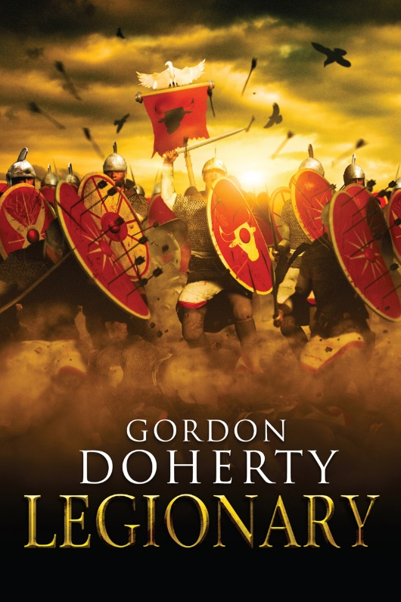

Chapter 1

Summer, 363 AD
Constantinople stewed in the midsummer sun. The Augusteum writhed with squinting faces, basted in sweat and seasoned with dust; a thick tang of roasting garlic and the fuggy stench of drying horse dung permeated the air. Raised market stalls clad in vibrant fabrics pierced the throng, sucking the hungry shoppers in like swirling currents. Hemmed in by the towering grandeur of the Hippodrome, the Imperial Palace and the Baths of Zeuxippus, the market square was a surefire hotpot for moneymaking.
Dead centre, with no respite from the midday inferno, one craggy-faced trader grinned as he scanned the eyes of his rapacious clientele; nobles, senators, businessmen and almost certainly all of them crooks. He could feel the weight of their purses – eager to be lightened. The trader’s gold teeth glinted in the sunlight.
‘Bring ‘em out!’ he bawled over the hubbub.
Two incongruous figures dressed only in loincloths were pushed up onto the rickety timber platform; a towering Nubian, scarred on every inch of his charcoal flesh and a stumpy, pale Germanian. The crowd broke into a keen babble.
Without turning from his audience, the trader swept a hand back towards the platform. ‘Slaves are the foundation of any man’s business. An’ today, my friends, you’re boun’ for a bargain.’ He jabbed a finger at the Nubian. ‘Will it be the mighty warrior from the distant sands of Africa – a power’ouse who will serve as a brave bodyguard or a fine labourer,’ he shifted his hand towards the Germanian, ‘or the ‘ardy northern swordsman – this ‘un’ll fight for you till ‘is ‘eart bursts!’ he revelled for a moment in the rising hum of interest. ‘Or will it be the agile youth, a boy of legionary stock…’ His voice trailed off as the crowd began to mutter in confusion. Then he turned to the platform and the conspicuous space beside the Germanian and the Nubian. The crowd broke into a chorus of laughter.
‘Where’s the boy?’ he hissed to his trade hand.
‘I’m sorry, master,’ the scab-coated figure yelped as he swiped into the slave-cart parked by the platform. ‘He’s being…difficult!’
The trader growled, thumping over to the cart. The laughter rose into a chorus of cheers as, with a snarl, he wrenched the wiry form of a boy from the cart, dangling him at arm’s length by the scruff of a filthy tunic. With a shaven head, a beaky nose dominating his gaunt face, and sharp, hazel eyes tucked under thick brows, he had the look of a malnourished hawk. The boy kicked and punched in a fury, spurring the crowd into raptures.
‘Only in ‘is seventh year,’ the trader fought to regain control, dumping the boy on the platform, while his trade hand clipped an ankle-manacle into place, ‘the boy comes as the son of a seasoned legionary. Don’t be fooled by ‘is frame. This lad has years ahead of ‘im, and a bargain at ‘alf the price!’ At last, the crowd seemed to be coming round to him once more.
‘C’mon – all three could be yours, let’s start the biddin’!’ he roared. ‘Who’ll be takin’ ‘ome the bargain today?’

Pavo gazed down at his torn and calloused feet. Tears blurred his vision and dropped to blot the filthy platform, where countless thousands of slaves had stood before, and would do so after him. The fight in him was dying, he realised, as the heckling grew ever more deafening. First, the Nubian was shoved down from the platform and off into the crowd as a deal was brokered. They hadn’t spoken since they had been thrown together in the trader’s cart three days ago, but last night the giant of a man had silently handed Pavo a piece of tangy root to chew, just when hunger had started to gnaw at his belly. A kind man. He didn’t look to see where the Nubian was being taken. Slaves didn’t look up.
Now, the Germanian was being prodded from the platform by the end of a staff – a chorus of congratulations rang out from one of the nearby cliques of toga-clad businessmen. The previous evening in the cart, the Germanian had been still like a marble carving. The fight had already gone from him, Pavo reckoned. He could see it in the deadness of the man’s eyes.
Pavo shivered. He had seen that look once before; the day Father did not return from the Persian campaign. Instead, a gaunt, unsmiling legionary had ambled through the narrow tenemented street, face coated in dust and sweat pooling in his frown. The soldier had walked along, asking for a Numerius Vitellius Pavo. In excitement, Pavo had run to him. The soldier had looked at him with those same dead eyes, then handed him a purse containing the legionary funeral payout.
Mother had died giving birth to him, and he had never known her, but for the glassy glint in Father’s eye when he spoke of her. Now he had nobody, nothing. Nothing, except the recurring dream. The same harrowing scene most nights, with Father stood in his armour on an empty dune, his face burnt from the sun and his eyes staring longingly, seeing Pavo, but also looking right through him. He gulped back a sob. In the eight months since Father’s death, the modest room in the tenements had been repossessed, so the gutter had been his bed and vermin meat his sustenance. All the while, he had clung to the pride of Father’s memory. A broad-shouldered man in his prime, he had towered twice as high as Pavo. He would return on leave from the legions, scoop him up and bear-hug him, and Pavo would nuzzle into the tousled chestnut locks – thick with the scent of wood smoke and dust from his travels. As always, Pavo coloured and bolstered this memory, sickened at the thought of it fading completely.
‘Sold!’ the trader yelped, punching a finger forward to pinpoint the buyer.
Pavo glanced up. Behind the shimmering golden grin of the trader, a short, corpulent figure waddled forward. His bald pate glistened in the sunlight like a shelled egg and his pallor was an unhealthy, pitted yellow, the same colour as the remnants of hair matted to the back and sides of his head. The purple-rim of his toga caught the eye – a senator.
Then a sharp pain shot through Pavo’s spine. ‘Move!’ the trade hand barked from behind him, pulling the freed manacle to one side and shoving him down the steps. Pavo stumbled forward and down onto the dust of the ground, the skin scraping from his knees.
‘Easy with my property,’ the rotund man hissed.
Wincing, Pavo squinted up at his new owner.
‘A fine purchase, Senator Tarquitius,’ the trader purred. ‘I ‘ope you’ll be back next time - word ‘as it I’ll be receivin’ some Scythians for next week.’
‘You would just love it if I had nothing better to do than fill your purse wouldn’t you, Balbus?’ the senator sneered.
‘Well, if you will beat the ones you buy to death...’
‘Keep your voice down…’ Tarquitius’ eyes darted all around. ‘Fronto,’ he barked to the rock-faced bull of a man who accompanied him, ‘get this wretch into the cart!’
Pavo braced himself as Fronto stretched out a hand like a ham and wrenched him up onto his feet. Then, the senator snapped his fingers and strode forward in self-majesty through the bustle of the market. Eventually, the crowd thinned, the rabble dulled, and at the edge of the square he beheld Tarquitius’ slave-cart; another grim cobbling of timbers and rust, powered by an emaciated donkey, clinging to the tiny sliver of shade under the walls of the great baths. Squinting into the penumbra of the cart, Pavo could just make out the selection of pale, drawn and defeated expressions of the others tucked inside. From one master to another. So this was to be his life. As he made to step inside, the fight was dissolving in his heart. Then Tarquitius squealed.
A withered crone stood in the senator’s path. Sixty years, if not more, her face was puckered like a prune, her eyes milky, yet piercing. Her razor-like nose was within a hair’s-breadth from the senator’s.
‘See that the boy comes to no harm from your hand,’ she rasped.
‘Out of my way, hag!’ Tarquitius protested, sweeping her to one side, but she gripped his chubby wrist with her talon-like fingers. Tarquitius yelped. Fronto jostled, hand on his sword-hilt, awaiting the order of his master.
Pavo’s tears suddenly dried and his interest keened. The crone held Tarquitius’ arm fast, and stretched up on her bare and gnarled tiptoes to put her furrowed lips to the senator’s ear. She whispered to him for only a few moments, and then calmly she walked over to Pavo, her eyes unblinking, and fixed on his. She pressed something into his hand. With that, she wandered off into the crowd, her tousled and patchy grey locks dissolving into the melee of market goers.
The senator turned, slowly, his face milky pale, eyes wide, the fat rolls under his chin quivering. He stared at Pavo. Pavo stared back.
‘Back to the villa,’ he muttered quietly, his gaze drifting off into the distance.
Pavo frowned, stepping onto the slave-cart gingerly and sitting without a word next to the filthy and cowering slaves already in there. As the cart shuddered into life, he turned over the crone’s words. Then he looked at his clenched fist, uncurling his fingers slowly as the cart jostled. A battered bronze legionary phalera – a thin bronze disc issued as a military reward, smaller than a follis – stared up at him. The text was chewed and battered, but he screwed up his eyes to read it in the flitting light from the slatted cart roof.
Legio II Parthica, it read – his father’s legion. Pavo’s skin rippled.
His eyes hung on the text as intrigue gripped his thudding heart. What did it mean? Confusion danced through his thoughts.
But one thing was certain.
The fight would never leave him.

Hope you enjoyed the sample! You can buy ‘Legionary’ at http://getbook.at/Legionary1
The series in full (as of July 2018):
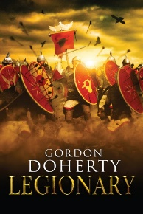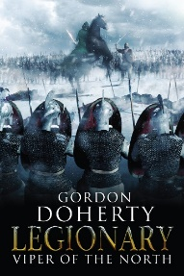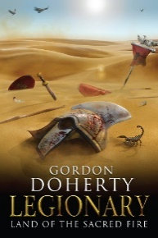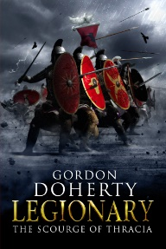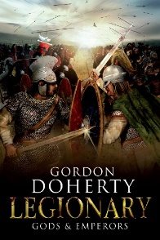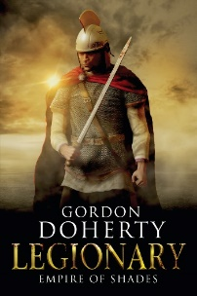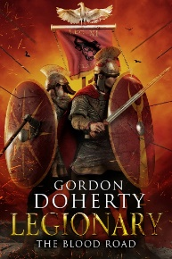

Feel free to get in touch with me at www.gordondoherty.co.uk
And you can follow me online:    

