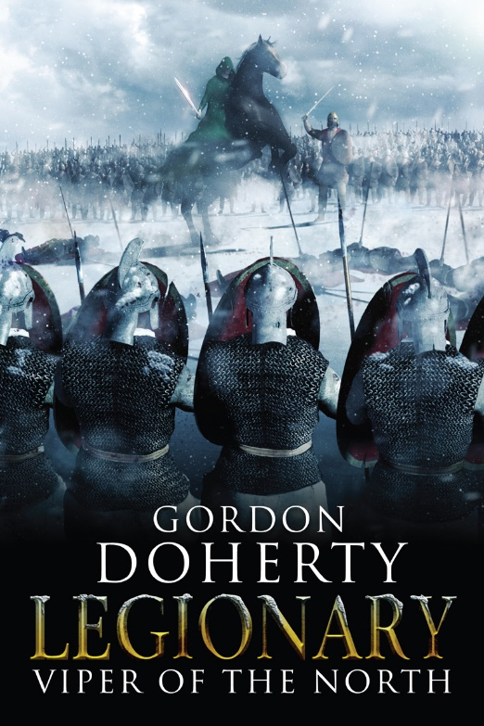
Prologue:
Constantinople, Summer 352AD

On the northern lip of Constantinople, just a stone’s throw east of the Prosphorion Harbour, the midday heat baked a secluded wharf. A small party of legionaries from the wall garrison stood there, gazing across the shimmering waters of the Golden Horn to the northern headland. Behind them, the sea walls hid them from the grandeur and bustle of the great city, with only an occasional muffled roar from the Hippodrome echoing onto the dock.
Optio Traianus shuffled in discomfort; sweat trickled down his back underneath his scale vest and the salty sea air did little to quash his nagging thirst. His hooked nose wrinkled and he shielded his eyes from the sun’s glare as he scanned the waters once more. Only trade vessels and fishing boats dotted the placid surface while the galleys of the imperial fleet lay docked nearby and unaware of what was to take place on this wharf. He shuffled again, one foot tapping restlessly.
‘He’ll come,’ Centurion Valgus muttered.
Traianus looked to his superior and frowned; the ageing, white-haired centurion’s craggy face was curled into a baleful grin, and his hand seemed overeager to rest by his scabbard. He darted a glance around him to see that the other eight legionaries wore the same looks. Then he noticed something on the battlements of the sea walls; a gleaming conical helmet with the distinctive noseguard of a sagittarius. Then another, and another.
‘Archers too, sir, to oversee an exchange of prisoners?’ he asked Valgus. ‘This may seem a little heavy-handed to our . . . visitor?’
‘Then you do not know the true measure of the man who comes here today, Optio.’ Valgus turned to him, his eyes sparkling. ‘You know why they call him the Viper?’
Traianus rubbed his narrow jaw; Iudex Anzo of the Thervingi Goths, a ruthless warlord hailed by his followers as the Viper. As the number of previously disparate Gothic tribes pledging allegiance to the Viper’s banner grew, so did the sense of unease within the senate and the upper echelons of the army. And today, the Viper was to come here, to the heart of the empire. ‘I know of him; the Goths say he earned his name because he is a ferocious fighter and slayer of men. A man with the mind of a strategos. Cunning and lethal.’
Valgus shook his head. ‘Aye, but ask the few Romans who have faced him and lived; they will tell you a different story. Sent whole legions to Hades, he has. Slaughtered just as many Roman citizens too. And he’s slain any Goth who has stood in his way. A stone-hearted, murderous whoreson.’ He turned back to the waters, sucked air through his teeth and squared his shoulders.
The gate clunked open and he turned to see a trio of legionaries leading a boy onto the wharf. This was Draga, Iudex Anzo’s son. Draga had lived as a political prisoner in the capital for over a year. Barely ten by the look of it, he wore his fawn hair in the Gothic style, scraped into a topknot, revealing green eyes that were cold and spiteful. He wore a Roman-style frayed, red tunic. This exposed the skin around his shoulders and a blue-ink snake stigma that wrapped around his collarbone like a torc.
Suddenly, the boy flicked his gaze up and glared at Traianus. Traianus’ jaw stiffened at first at the cold stare. But behind the coldness there was something else there. Perhaps a glimmer of hope at being reunited with his father. Traianus gave the boy a tentative nod.
‘Don’t look at him and see a boy,’ Valgus whispered in his ear, ‘look at him and know that his mind is filled with the same black thoughts as his father. Yes, they’ll be reunited today, one way or another . . .’
Traianus’ face fell as he noticed Valgus again touch a hand to his sword hilt as he said this. He had not reckoned on drawing his own spatha today, but it seemed a certainty now. ‘Sir, the tribunus, he briefed us only on an exchange of prisoners?’
‘Aye, he did,’ Valgus shot a furtive glance around to see who was within earshot, then looked to Traianus with his eyes narrowed, ‘but the senate have paid for an alternative outcome.’ He winked and patted a hand against his purse, which clunked with coins. ‘I briefed the rest of the lads earlier. Don’t worry, follow my lead and you’ll get your share, and the tribunus need never know.’
Dread swelled in Traianus’ gut as he glanced around him, then to the gate leading back into the city. Locked.
‘A vessel approaches!’ one of the archers called out from the walls.
All heads turned to the north. A medium-sized cog slipped from the headland and into full view. Its triangular sails were sun-bleached and at the tip of the mast a dark-green banner embroidered with a viper writhed gently in the breeze. It was a run-down ship with only a few mercenary crewmen dotted around the rigging and rows of crates were piled on the deck. They watched as the vessel drew in to dock; all was quiet apart from the creaking of dried-out timbers, the gentle lapping of water on the wharf side and the screeching of the gulls and terns that followed the vessel in hope of a meal. Traianus watched the birds swooping and darting. Despite his best efforts, he could not shake the thought of the carrion birds he had become so accustomed to seeing on the battlefield.
Two tall Gothic warriors, wearing their hair scooped up into topknots and armoured in red leather cuirasses, emerged from below deck. They roped the vessel to the wharf by leaning from the side of the ship. They then laid a gangplank from the ship’s edge to the dockside and walked over it to stand either side. Silently, each erected a pole bearing a smaller dark-green viper banner. Then, from the far side of the deck, two more figures emerged and walked forward.
The first figure wore a dark-green cloak, hood raised, face in shadows, hands clasped. Despite the heat, Traianus could not suppress a shiver at the sight as the figure drifted forward. Then, ever so slowly, the figure reached up with knotted hands to lift the hood down, revealing sharp, cold features and a thick fawn moustache that hung over taut lips. The hood rested on his shoulders, revealing the fangs and licking tongue of a snake stigma on his collarbone, just like Draga’s. This was Iudex Anzo. This was the Viper. His gaze felt like ice on Traianus’ skin.
The hulking Goth who walked beside the Viper was draped in a fine scale vest and carried a longsword, an axe and a dagger in his belt. His sleek, dark hair was knotted back and his face was flat and broad, with an arrowhead of a nose between dark eyes and a neatly trimmed beard filling out an already bold jaw. From his left ear dangled three bronze hoops. Each of his forearms bore a snake stigma like that on the necks of Anzo and Draga. Most ominously, his hands dangled close to his weapons as he cast a look of barely disguised contempt across the waiting legionaries.
‘Ivo is Anzo’s sword, his trusted man,’ Valgus whispered. ‘Keep your eye on him.’
Traianus shuffled to stand straight as Ivo’s gaze swept past him.
Then two more Gothic warriors emerged from below deck. They bundled before them a bedraggled, bald and ageing Roman in a filthy tunic. So this was the ambassador who was to be exchanged for Draga. Traianus winced at the sight of the torture wounds that pockmarked the man’s skin and wondered when the poor wretch had last seen the light of day.
‘Ave, Romans,’ Iudex Anzo spoke in a rasping Gothic twang, his tone sour. He did not wait for a reply as his gaze quickly fell on Draga, held by two legionaries. ‘My son, you are unharmed?’
The Gothic boy’s face remained grave. ‘That, we can discuss once we have set sail for our homeland, Father.’
‘Aye, Gutthiuda awaits us,’ Anzo replied, casting a glance northwards in the direction of the Thervingi homelands. Then he turned to Centurion Valgus, his face curling into a sneer of contempt. ‘Now, the exchange?’
Valgus’ eyes narrowed and he nodded to the legionaries. They relaxed their grip on Draga, while the Goths did likewise with the old ambassador.
Traianus watched, the breath hanging in his lungs as the prisoners stepped forward. Draga moved towards the Goths as the ambassador moved towards to the legionaries. Then he glanced to the Goths who watched on; each of them seemed as tense as the legionaries, their hands resting unnervingly close to their longswords. Then there was Iudex Anzo and Centurion Valgus; both wore the look of predators waiting to strike as the prisoners stepped carefully towards the middle ground. Then he noticed Ivo’s eyes darting to the Gothic ship and the piled crates. Instinctively, Traianus touched a hand to his sword hilt too, sweat forming on his upper lip. But at last the prisoners passed each other in the centre and the tension eased from all watching on.
A sweet relief flowed through Traianus’ veins momentarily.
Then, something caught his attention; Valgus’ eyes were narrowed. The centurion gulped and moistened his lips, as if readying to give some order. Traianus’ blood ran cold.
Then it ran like ice when he saw the tips of two masts emerging beyond the tapering headland. Dark-green banners rippled at the tips of the masts as they rounded the coast to enter the Golden Horn.
Gothic warships.
Traianus glanced to Valgus; the centurion’s words seemed to catch in his throat at the sight. Then he glanced to Anzo, whose eyes smouldered like hot coals. The Viper lifted a hand, extended one finger, then swiped it down.
Suddenly, and in one fluid movement, Ivo ripped a dagger from his belt, then lunged forward to grab the Roman ambassador, tearing the blade across the old man’s throat. Blood leapt from the gaping wound and the ambassador fell to his knees, clawing at his neck, heaving and retching a pink foam while his eyes bulged from their sockets. At the same time, the Viper leapt forward to pull Draga towards him. He shielded his son and threw off his cloak to reveal his lean, athletic frame, hugged by a scale vest and a swordbelt. Then he drew his longsword, pointed it at Valgus and backed away towards the Gothic cog, casting a wicked grin at the Romans.
‘Whoresons!’ Valgus roared, his eyes bulging as the four Gothic spearmen on the wharf levelled their blades and pushed up to flank Ivo. Holding up round wooden shields, they braced, forming a wall between the legionaries and Anzo, who ushered Draga back towards the cog. Valgus tore his spatha from his scabbard and roared the legionaries forward. ‘Kill them, kill them all! Don’t let the Viper escape!’
At this, the sagittarii shot up from behind the walls, nocking arrows to their bows. But Ivo roared out as they took aim. ‘Chosen archers!’
In a heartbeat, the docked Gothic cog was transformed as a line of red-vested, blonde-locked master-archers appeared from behind the crates stacked on the deck. Thirty of them, bows stretched, targets already sighted. As one, they loosed their arrows at the walls before their Roman counterparts had even taken aim. With a hiss and then a punch of iron cutting through flesh, a score of the sagittarii toppled from the battlements, gurgling their last while those unscathed loosed their volley in reply.
When one Roman archer turned his bow on the Goths on the wharf, Ivo stretched out to wrap an arm around Valgus’ neck, then twisted the centurion round to use him as a shield. The arrow aimed at Ivo smashed into Valgus’ thigh. Then Ivo wrenched sharply. With a crack, Valgus’ neck snapped and he fell limply to the ground, blood pouring from his lips and his eyes rolling in their sockets. The purse fell from Valgus’ belt and the coins spilled across the wharf where they were quickly swamped by the centurion’s blood.
As arrows flew overhead from both sides, Traianus instinctively joined shields with the other eight legionaries. Then he set his sights on Anzo, who was lifting his son onto the Gothic cog. At the same time, Ivo readied the Gothic warriors to cover the Viper’s retreat, roaring them towards the legionaries with grand swipes of his longsword.
‘At them!’ Traianus roared, sensing the other legionaries’ hesitation at having lost their centurion. The legionaries rushed forward and smashed against Ivo and his line, the screeching of iron upon iron filling the wharf. One of the legionaries was felled by Ivo’s sword, white bone and pink lung glistening from a gaping wound in his chest. Then a Roman head was sliced from its shoulders and the wharf was soon slick with blood. Traianus held up his spatha to parry the giant’s next strike, but the force of the blow shook him to his bones and sent him staggering backwards. But he leapt back into the fray, seeing the Viper and his son were now onboard the cog.
But Draga was struggling, snarling. ‘Let me fight!’
Then the boy shrugged free of his father’s grasp, then pushed his way from the ship and into the melee, taking up a longsword from a slain Goth.
‘Draga, no!’ Anzo roared, ‘Get onto the ship!’
But Draga plunged into the fray, heedless of his father’s cries. He bore the weighty blade like a seasoned warrior, swiping and parrying with force and guile that belied his years. Then he ripped the blade across the chest of the legionary by Traianus’ side.
Iudex Anzo lunged forward, slicing through the thigh of a legionary then thrusting an arm out to pull his son from the skirmish. But the Viper’s step faltered as an arrow from the walls punched into his stomach, then another burst through his throat. Dark blood showered over Draga, who gawped in horror as his father toppled to the wharf side, his body shuddering in a pool of crimson.
A cheer rang out from the sagittarii on the walls as the corpse stilled. ‘The Viper is dead!’ they roared.
Traianus staggered back from a longsword blow and saw that Draga was crouched by the pool of his father’s blood, a single tear dancing down his cheek at the sight as he touched a hand to the corpse. Then the boy lifted the dark-green cloak, soaked in gore. With that he stood and stared straight at Traianus, eyes shaded under a furrowed brow. Traianus shuddered; the glimmer of hope was snuffed out. There were no more tears. Only cold conviction.
Then he saw a wounded legionary, blood pumping from a mortal wound to his thigh, stagger up behind Draga, spatha raised. The legionary punched his spatha into the boy’s shoulder, then ripped it clear, before toppling to the ground himself.
Traianus remained, frozen, watching as Draga swayed by the wharf’s edge, blood washing from his wound, soaking the snake stigma coiled around his shoulders. The boy’s brow wrinkled as he looked to the cloak in his arms, then to his wound and then up to Traianus. For a heartbeat his gaze grew murderous, eyes burning like hot coals. Then his legs trembled and he toppled towards the water.
‘No!’ Ivo cried, rushing to the wharfside to reach out a ham-like hand. But the boy’s body toppled into the waters and Ivo swiped at thin air.
Ivo fell to his knees, his fingers outstretched to the ripples in the water before they curled into a shaking fist. Then he leapt up with an animal roar, spinning to swipe his longsword around him in a fury, slaying the last two legionaries in one blow.
Suddenly, Traianus realised he was alone on the wharf with the giant Goth, while the two bands of archers exchanged fire over their heads. Ivo glared through a mask of blood at Traianus, then he stalked forward.
Traianus’ body tensed in fear at the creature that came for him, but he readied himself, raising his sword, setting his feet. He filled his lungs and let loose a roar, then surged forward to meet the challenge. Then there was a smash of iron and a spray of sparks as a Gothic arrow smacked against his blade, then ricocheted up and across Ivo’s face. The big warrior roared, clutching his left eye, a soup of blood and eye-matter sputtering down his cheek.
At that moment the wall gate clunked open and a century of fresh legionaries spilled onto the wharf, clustering around Traianus. Only the covering fire of the Gothic chosen archers kept the legionaries at bay as Ivo stumbled back into the cog, scooping up the Viper’s body on the way. With that, the Gothic warriors onboard untied the ropes and pushed the ship from the wharf side, then dipped one bank of oars in the water to pivot the vessel away from the city.
As the cog departed, the two Gothic warships slowed to flank it. The waters of the Golden Horn were otherwise dotted only with Roman merchant ships. The workmen repairing the Roman warships, docked and crewless nearby, could only cry out in futility. Thus, the three Gothic vessels retreated unopposed.
Regardless, the Roman sagittarii continued to loose arrows at the departing ship and the Gothic chosen archers onboard the cog replied in kind.
Traianus stood amid this deadly hail, transfixed on Ivo. The giant was poised at the stern, holding the Viper’s corpse in his arms. Roman arrows thudded down onto the Gothic cog, some only inches from him. But Ivo did not flinch, his good eye remaining trained on the cluster of legionaries while his ruined eye seeped blood. Then his chest heaved and he roared, his words echoing over the city walls;
‘This is only the beginning, you dogs. The day will come when the Viper will rise again. On that day, the tribes will be united. And on that day, Roman blood will flow like the Mother River!’
His words chilled Traianus’ blood. Then a silence hung in the air. He felt his limbs tremble as the battle rage subsided, and a dull nausea swam in his gut.
‘What in Hades happened here, soldier?’ a voice spoke from beside him. It was the young centurion who led the fresh legionaries. His face was pale as he scanned the carpet of gore on the wharf side.
Traianus looked him in the eye and moved his lips to speak, but found no reply forthcoming.

Hope you enjoyed the sample! You can buy ‘Legionary: Viper of the North’ at http://getbook.at/Legionary2
The series in full (as of July 2018):
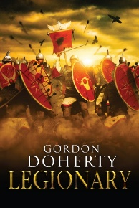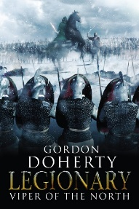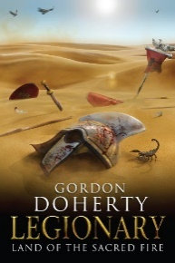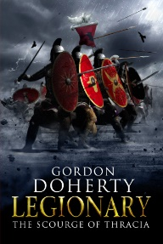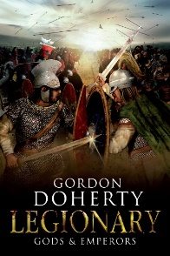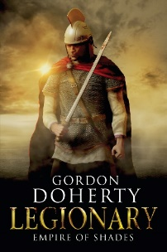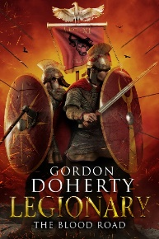

Feel free to get in touch with me at www.gordondoherty.co.uk
And you can follow me online:    

