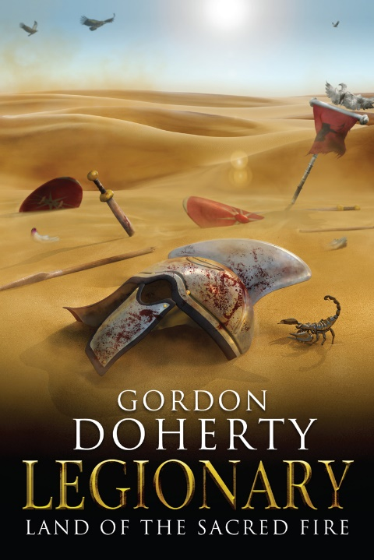
Prologue:
Mesopotamia, Western Persia
25th June 363 AD

The empire’s legions fled. They thundered westwards across the baking plain, the noon sun glaring down upon them like a Persian spy. Legionaries, Syrian archers, Armenian slingers and ironclad riders – more than thirty thousand men all told, gaunt and bathed in sweat, armour battered and caked in dust. Their staggered and untidy formation betrayed great anguish. Each of them shot fearful glances over their shoulders as they jogged, parched tongues darting out over cracked and bleeding lips.
Near the front of the retreat, Comes Domesticorum Jovian led the Imperial Guard. He cut an impressive figure, broad and tall, his face ruddy and well-weathered. But his heavy brow shaded the fear in his eyes. It was a fiery terror that needled at his guts as he thought of those who pursued them. Don’t look back, he mouthed, fixing his gaze on the west. It offered only golden dust and azure sky, but soon they would be back at the eastern banks of the Tigris. Soon they would be reunited with the Roman fleet. Soon he would be safely aboard a bireme and then back in Roman Mesopotamia on the western banks of the river. At that moment, an image flashed through his mind; of the thousands of legionaries who had been slain on this wretched campaign, their grey, lifeless eyes fixed on him. In these last weeks they had fought and died in some of the most ferocious battles he had ever witnessed. They would never again feel the sun on their skin or the caress of their loved ones. Jovian, however, had barely sullied his sword on this journey. Yet here he was, dreaming only of his own wellbeing. He scowled at his timorous thoughts as self-loathing clutched and twisted his heart. He bit into his bottom lip until he tasted blood, then looked up to the figure riding just ahead.
Emperor Julian sat astride a white stallion, wearing a wreath that hugged his flaxen curls like a crown. He wore no armour – only pure-white robes and a sword belt. This epitomised the man. The one who had renounced the Christian God and revitalised the old pagan ways. The strident and fearless leader who had led the army into this burning land, intent on ending the centuries-old Persian threat. The legions loved him, hailing him for his seemingly endless courage. Julian was everything Jovian longed to be.
From where . . . from where do you draw your courage? Jovian mouthed.
But his envy faded when he saw something up ahead; the shimmering golden infinity now offered a faint, sparkling thread of turquoise. The Tigris! His heart soared momentarily, then he frowned, noticing something else; a dark smudge by the banks. The heat haze sharpened to reveal the last wisps of black smoke spiralling from the incinerated Roman fleet. Charred timbers, torn sails and smouldering masts jutting at all angles. Hundreds of vessels. Utterly ruined.
Jovian slowed. The rest of the column slowed, jaws dropping as the tang of wood smoke danced in the stifling air. He shot glances around his imperial guardsmen, cooking alive in their scale vests. They gawped at the fleet, then twisted to behold the still and silent horizons behind them in terror. A chorus of panicked murmurs broke out all along the vast column. Eyes darted around the sweltering land, then all looked to the Emperor.
‘Emperor?’ Jovian gasped, failing to disguise the tremor in his voice. ‘The Persians did this?’
Emperor Julian stared solemnly at the ruined fleet, then gave the faintest shake of his head. ‘No, not the Persians.’
Horror shuddered through Jovian’s chest as he realised what had happened.
Emperor Julian continued; ‘I had no choice. When we set off from these banks, I gave the order to burn the fleet lest it fell into Persian hands.’
‘But how will we . . . ’ Jovian’s eyes darted to the far banks of the river. Safety lay in sight but out of reach, across the tumbling waters of the Tigris. This was not bravery, this was madness! The emperor’s hubris would be the death of them all.
‘The fleet is gone. But the riverbank will protect our rear and our flanks,’ Emperor Julian said as he heeled his mount round to look over his bedraggled army then off to the east. He winked, straining to see through the heat haze that lay out there. Suddenly he sat up straighter in the saddle, a confident rictus spreading across his face. ‘Yes . . . it seems that either death or glory will grace us today.’
Jovian’s flesh crept as he turned to follow the emperor’s gaze.
The eastern horizon offered nothing but a blur where golden dust met azure sky. Then a thunderous boom burst across the land. Then another.
‘Persian war drums!’ one panicked voice wailed. ‘They’re coming for us again!’
The heat haze flickered and a silvery dot appeared, slowly expanding to fill the eastern horizon like the horns of an iron bull. Now the war drums throbbed in an eager rhythm.
Jovian gawped at the sight. The Savaran cavalry, the Persian war machine, Shahanshah Shapur II’s finest. They seemed to rise from the sands like demons. A sea of spear tips, iron helms and riders. Each gund of one thousand men was segmented into ten drafshs of one hundred, and each hundred carried a banner of fluttering fabric – vibrant reds, greens, golds and blues depicting bears, deer, asps and lions. And these endless ranks were punctuated by great, fierce and all-too-real creatures, the likes of which Jovian had never before set eyes upon; beasts with swishing, armour-plated trunks, bronze-coated tusks and archer-packed cabins strapped to their broad backs.
The Savaran were here to annihilate the Roman war machine that had pierced into the heart of Persian lands, the legions that had only days ago dared to attempt a siege of the Sassanid capital of Ctesiphon. A clutch of dark-robed magi walked before this army, holding aloft gemmed, gilt torches, the flames flickering and lurching like serpents’ tongues. The magi carried this, the Zoroastrian Sacred Fire, as a testament to their great god, Ahura Mazda, and to inspire the masses who marched behind.
Jovian felt his throat clenching and the familiar trembling in his limbs. A skinful of wine in the mornings had become a loathsome habit, but one he had been unable to break as he tried to cope with the demands of his lofty post as the emperor’s protector. He looked to his guardsmen, desperately trying to summon the words to rally them. He licked his lips to give an order.
‘For – form up, f-face . . . ’ the staccato uttering died in his throat and drew only confused frowns from his men. Self-loathing now strangled his heart.
But his shame was short-lived as, once more, Emperor Julian led the way.
‘Form up, face your enemy!’ Julian cried, kicking his white stallion until the beast reared up and whinnied. Buccinas were raised to lips, the horns wailing across the ranks as standards waved frantically. Like a silver asp, the staggered mass of the Roman retreat came together and turned to form a broad and deep line facing east. They presented a wall of battered shields and a nest of spears. On each flank, an ala of some five hundred equites sagittarii shuffled on their saddles, nocking arrows to their bows, winking under the rim of their helms as they sighted their targets. These Roman horse archers were well armoured in scale and armed with the finest composite bows, but they would meet their match today.
The rally cry of Emperor Julian had been enough to strike the fear from many thousands of Roman hearts. But not from Jovian’s. Forming part of the Roman right, he and his imperial guardsmen were on the front rank. His tongue was shrivelled and utterly dry, his bladder seemingly full to bursting. There would be no escaping battle today. White lights flashed in his eyes and he felt his guts melt as he beheld the Savaran riders facing them. A solid wall of clibanarii; iron-masked horsemen who betrayed not a glimpse of humanity, armour in every place there should have been flesh and tall, pointed helms with plumes whipping behind them. Thousands of them. Sharpened lances held two-handed. Lithe mounts clad in iron plate-armour and scale aprons. The riders sighted their targets, then kicked their gnashing, frothing mounts forward at a trot with an ululating war cry.
Jovian roared, not in defiance like the imperial guardsmen around him, but in utter terror. He screwed his eyes shut in disgust at his craven heart. In this coward’s darkness, he felt the blistering heat fall away momentarily. He cracked open one eye and saw that the sky had blackened, the azure masked by a thundercloud of Persian arrows, hovering momentarily before darting down like a brood of iron raptors. Jovian’s legs seemed numb and unable to respond to his primal urge to run. He gawped as those around him scattered, some splitting their ranks and others falling back to avoid the incoming hail. They were oblivious to Emperor Julian’s cry to hold their lines. The arrows hammered down into backs, necks and limbs. A fine crimson mist puffed into the air all across the panicked Roman lines and many hundreds fell. Jovian trembled in disbelief; arrows quivered in the earth and in corpses all around him – yet he was unharmed. Then he heard the Persian war horns blare once again, and saw the glint of thousands of enemy lances falling level like outstretched and accusing fingers, the clibanarii riders now lying flat in the saddle and coming forward at a gallop. The Persian arrows had tenderised the Roman ranks, now their lances would cut the legions to pieces.
Jovian met the inhuman eye slits of the masked rider coming for him, clutched the Christian Chi-Rho amulet around his neck – the one thing that gave him courage – and roared his last as the Savaran charge smashed into the Roman ranks. In a flash of steel it was over. A blow wrenched Jovian’s spear from his grasp and threw him from his feet. Sky and ground swapped places, hooves and boots thundering past him, dust and blood filling his throat and blinding him. Then he felt the earth shake fiercely. The trumpeting of the great, tusked creatures filled the air. Then came a terrible chorus of snapping bone, tearing flesh and screaming men. Finally, like an ebb tide, it all died away, and he was numb.
He presumed the long blackness that followed was death. But he still felt something. A crushing pain in his head. Next, a distant, dull cry cut through the blackness.
‘Emperor Julian has been slain! Throw down your weapons and they may spare us!’
In his confusion, Jovian wondered if these voices were those of the dead accompanying him to the afterlife. Perhaps his devotion to the Christian God had been prudent. Then he realised he was floating, or perhaps being carried. He put everything into an attempt at reaching out, but heard only a pained groan topple from his lips.
‘The Comes Domesticorum – he’s alive,’ a voice said.
‘Then there is no doubt about what must happen,’ another added.
At last, Jovian’s eyes cracked open. He was in a torn, smoke-stained Roman command tent, reclined upon a cot. His guardsmen stared back at him; a circle of filthy, bloodied and sullen faces. The nearest of them stepped forward and thrust a white robe and a wreath into his hands. He stared at the dark-red stain on the midriff of the robe; Emperor Julian’s blood.
Then, as one, the guards raised their hands in salute and cried;
‘Imperator!’
He looked up at them. A terror like never before gripped his heart.

It was the morning after the battle. The dawn air was already balmy and still tinged with the scent of decay and death. A cloud of carrion birds shrieked and circled overhead. The battered remnant of the Roman army huddled against the banks of the Tigris – cowering within a mass of hastily erected tents and ramshackle palisades – pinned there by the bullhorn Savaran lines. From the Roman camp, a pocket of eighty figures strode forth, crossing the short stretch of no-man’s land and entering the heart of the enemy camp.
Jovian’s stride was awkward and uneven under the scrutiny of so many eyes. Masses of dawn-silhouetted Persian warriors glared at him and he felt the eyes of his own men burning on his back. This was his first duty, or so the men had advised him; to meet with Shapur and sue for peace. The dust stung in his nostrils and the air felt like fire in his lungs. His white imperial robes were already drenched in sweat. The usual skinful of wine had not been enough this morning. To soothe his battle wounds and to still his nerves he had needed two. Yet still he trembled.
The sea of Persian warriors parted before him, revealing a vast tent at the heart of their lines. Fluttering drafsh banners encircled the tent, and one magnificent banner crowned it, depicting a golden star bursting across a purple background. This was the Drafsh Kavian, the ultimate symbol of Sassanid Persian might. Atop the banner – where the Roman armies would mount their silver eagles – was the broad-winged and soaring guardian angel, half eagle, half man; this was the Faravahar, the sacred image of the Zoroastrian faith. Even this lifeless effigy seemed to glare down upon Jovian, stoking the self-doubt in his gut.
He summoned a speck of courage and they marched on until they reached the tent entrance. There, a pair of tall and broad bodyguards eyed him. These men were pushtigban, the cream of the Savaran army and the shahanshah’s personal guard. They wore flawless iron helms adorned with finely crafted wings on either side, scale and plate-armour vests, iron rings on their arms, and carried bronze-coated spears and shields. Like the clibanarii riders, they too wore iron masks obscuring all but the glint of steely glowers through the eye slits. Each carried a shamshir in his sword belt, the honeycomb-hilted blades cleaned since yesterday’s clash.
Jovian halted before them and his eighty guards stopped behind him. He wiped a hand across his rubicund features, his bloodshot eyes bulging, his lips trembling. He was now Emperor of Rome, rich beyond imagining, power untold. Despite all this, he wanted nothing more than to turn and run from this place. He saw in his mind the waters of the Tigris, imagined throwing himself into its foaming torrents, thrashing to reach the other side. Murmurs swept around the gathered crowd as he remained, speechless, eyes darting in this craven whimsy. Finally, the two pushtigban warriors held the tent flap open. An aged man emerged – well past his fiftieth year, Jovian reckoned. He wore a striking gilded ram’s skull and skin as a crown, and his broad features were taut and unforgiving, not unlike the ram’s. His grey hair hung in thick, tight curls across his shoulders, his beard equally well groomed and oiled. A pleasant scent of perfumed wax emanated from the man, cutting through the stench of death. An emerald and purple silken robe hugged his shoulders. This was Shapur II, King of Kings, Shahanshah of all Persia. Jovian’s terror grew fierce, as if wolf cubs gnashed in his belly.
Shapur dragged his gaze across Jovian, his hazel eyes glassy, before crouching onto one knee and prostrating himself to kiss the dust.
Jovian frowned, his mind spinning. Then one of his guards jabbed an elbow into his back. At once, he realised his error, and hastily fell to one knee and then lay flat too, pressing his lips to the dust. This was the Persian way – a sign of respect between adversaries. Shapur was first to stand, then he turned to his tent and beckoned Jovian inside.
Jovian stepped forward, leaving his guards behind. Inside, it was pleasantly cool and lit only by the gentle orange glow of daylight. A cloying, floral scent curled from glowing cones of incense, sweetening the air. Spoils of war lined the tent’s sides, frames mounted with animal hides, ancient shields and crossed spears. In the centre of the tent sat a squat, oak table, behind which knelt an incongruous pair. One was a white-haired ox of a warrior almost as aged as Shapur, his broad features pinched in discomfort and his breath coming and going in wet rasps. He wore a bloodstained bandage around his abdomen, barely covering what looked like a mortal wound from yesterday’s battle, and a red silk robe held in place by a brooch bearing the image of a golden lion. The other at the table was a slightly-built, sharp-eyed man in a blue silk robe whom Jovian could only liken to a sickly carrion bird. He was hairless, the skin on his scalp and face pallid and stretched so thin that it highlighted every contour of bone and snaking vein. His eyes were gold. His nose curved like a sharp beak over thin, colourless lips.
Shapur knelt beside this pair, then gestured for Jovian to sit opposite. The shahanshah then gestured to the injured warrior and the shrivelled, bald man in turn; ‘Cyrus, Spahbad of the Persis Satrapy, and Ramak, Archimagus of those lands, will be joining us in our negotiations.’ Cyrus nodded curtly, while Ramak remained statue-still, his eyes seeming to search Jovian.
Jovian awkwardly knelt opposite them. As soon as he settled, his eyes latched onto the silver goblet of dark-red wine that a slave placed before him. He poked out his tongue to wet his lips, reaching for the cup, when Shapur spoke in Greek.
‘We find ourselves at an unfortunate juncture, Roman brother.’
Jovian snatched his hand back from the goblet, cursing his shaking fingers. His mouth had never been drier. He shuffled to sit straight and tried to flush the fear from his face, but his upper lip twitched nervously.
‘Your armies are broken,’ Shapur continued, ‘you have nowhere to flee. Persian steel and the dark, cold depths of the Tigris ensnare you. So what am I to do?’
‘I trust we will be able to find a solution to this problem, Persian brother?’ Jovian croaked in reply.
‘Oh, I am sure we will,’ Shapur said. ‘In my years I have seen many brave Romans dare to stride into these lands. I grow tired of their folly and of spilling their blood.’
Jovian heard the retort in his mind. And your armies have just as often marched gaily into Roman Anatolia and Syria, claiming those lands as your own by ancestral right. But fear gripped him before he could muster the courage to voice this, and so he merely nodded.
‘I know the thoughts that dance in your mind, Roman. As masters of east and west, we each have much to take pride in, but more to be shameful of,’ Shapur added, his gaze growing distant and a hint of submission lacing his words.
For a precious moment, Jovian felt his fear ebb just a fraction. This legendary figure who had led Persia and her armies like a god for so long cut a tired figure. Cyrus and Ramak seemed unaffected by their shahanshah’s melancholy though. Cyrus looked on with a barely tempered scowl, his disdain for Jovian plain. Archimagus Ramak, however, perplexed him most of all. The man watched him studiously, as if searching his thoughts, reading them like a scroll. Then the archimagus turned his eyes upon Shapur, and Jovian wondered if he could read the great king of kings as easily. A curious creature, Jovian surmised. He snatched at the goblet and gulped at the wine, anxious to wash away his distress.
Shapur continued; ‘The struggle is endless, Rome tears at our borders and then Persia finds itself battering back at Rome’s. To and fro. Forlorn fathers look on from the afterlife as their sons repeat their follies.’ He stopped, his gaze again growing distant, as if caught in a storm of unpleasant memories. Finally, he snapped out of his malaise, his eyes meeting Jovian’s once more. ‘Today, Persia is the master of this eternal struggle.’ He paused for a moment, the silence from Jovian upholding his assertion, then pushed out a sheaf of paper. It had two passages inked upon it – one in Parsi and one in Greek. ‘If you wish to see your army safely back in Roman lands, then I am sure you will see the wisdom in conceding to me the following imperial possessions.’
Jovian nodded then listened as Shapur read the document aloud. Virtually all of Roman-held Mesopotamia was to be surrendered. Everything between the Tigris and the Euphrates. Five trade-rich and strategically positioned regions, plus fifteen well-walled forts. Worse, the three mighty fortress cities on the western banks of the Euphrates – Nisibis, Singara and Castra Maurorum – were to be abandoned by Rome then garrisoned and populated by Persia. These were the bulwarks of Rome’s eastern frontier. With these three cities, Shapur and his armies would have the perfect staging post to crush the remainder of Roman Syria. The blood pounded in Jovian’s ears. His eyes darted. He clutched the goblet and drank deeply. Yet the wine struggled to quell his panic.
‘You must accept these concessions,’ Shapur concluded, placing the scroll before him. ‘Else I will be forced to darken the shores of the Tigris with yet more blood.’
The words felt like an icy lance through Jovian’s gut.
‘Do you accept?’ Cyrus hissed, thumping a fist upon the table then wincing and clutching at his bandaged wound.
‘At ease, Spahbad,’ Shapur raised a placatory hand to Cyrus. ‘The Roman will agree, I am sure. The new lands will be yours, as we discussed.’
Jovian looked up, blinking. He looked to the scroll. Several copies lay rolled up beside it. His lips trembled. So far, his meekness and cowardice had afflicted his life like an insatiable parasite. Now it threatened the empire. His thoughts swirled like a sandstorm until he saw one possibility. Let them have the fortress cities, let them have Mesopotamia, he thought, but they must give something in return.
‘Permit me to present to you an amendment,’ he croaked.
Shapur’s eyes narrowed at this. Cyrus frowned in confusion, then Ramak leant in close to him, whispering in his ear.
Cyrus nodded, then fixed Jovian with a foul glare, his nose wrinkling; ‘You are in no position to bargain.’
Shapur raised a hand to the spahbad. ‘A bargain is more virtuous than yet another slaughter.’ Then his expression darkened. ‘But it must be the right bargain. Go on.’
Jovian gulped. ‘Have Mesopotamia. But the armies of Persia must never set foot west of the River Euphrates. In return, Rome’s legions will never tread upon its eastern banks.’
At this, Cyrus’ eyes darted this way and that in confusion. Ramak seemed unmoved, then leant in to whisper again in Cyrus’ ear. Cyrus’ pallid face wrinkled in anger, then he cast out a disdainful hand towards Jovian. ‘With our blade at his neck, he endeavours to dictate the destiny of our people?’
Jovian continued before Cyrus could protest further. ‘While such an amendment might be to our advantage now, it may not be so for long. The eternal struggle you speak of will doubtless soon swing back upon Persia eventually. Let us end it. Here. Now.’ He heard the words as if spoken by another. His chest tingled with pride.
Shapur’s eyes darted as he contemplated the suggestion. A long silence passed. ‘A noble proposal,’ he said at last. ‘But will the generations to come abide by such an agreement, when we are both but dust and bones?’
The Persian Shahanshah contemplated his own words in another silence. Jovian willed him to agree. Cyrus and Ramak looked on, eyes narrowed. At last, Shapur gave a faint nod. ‘Perhaps, with some adjustment, an amendment can bring stability between our great empires.’
Cyrus stood up at this, his chest heaving in disgust. ‘I must protest!’
Shapur looked up to his spahbad, and spoke calmly. ‘Leave us then, Cyrus, while we draw up the finer detail of the agreement.’
Cyrus stood, glowered around the gathering, then strode from the table. Jovian instinctively tensed like a strung bow as the man brushed past him. The spahbad stopped at the tent flap, his breath coming and going in a weak and wet rattle, then beckoned Ramak with him. The archimagus hesitated at first, seemingly unable to tear his steady gaze from Jovian. Then he too stood and followed Cyrus outside.
‘Cyrus is a brave and loyal Spahbad,’ Shapur muttered as the pair left the tent, ‘but a troubled soul in these last years. He will not live past sunset with that wound.’
Jovian wished he could share Shapur’s pity for the man, but he could think of nothing other than the scroll before him. As it stood, the detail allowed him and his army to retreat to Roman Syria with their lives. But with the territorial concessions made, his reign as emperor was likely to be short and brutal, with the Persian army free to push home their advantage. Peace of some sort was a must. But would a perpetual peace be truly possible, or would pursuing this endanger his chances of ending this day both free and alive? With a shiver, his mind flitted with the tales of past Roman Emperors who had met their fate at the hands of the Persian rulers. He was yet unsure of how far he could push the great Shapur. The wording of the amendment would be key; it could be the saviour of him, or even of the empire. A question struck him at that moment; which was more important?
How Jovian handled these next moments would define him as a person. A craven or a hero.
He thought of something his father had often repeated in his twilight years of drunken haze, something Jovian had never understood. Until now.
Fear and courage are brothers, warring within the soul.
One will hasten death to you; one will reap a darker toll.

Hope you enjoyed the sample! You can buy ‘Legionary: Land of the Sacred Fire’ at http://getbook.at/Legionary3
The series in full (as of July 2018):
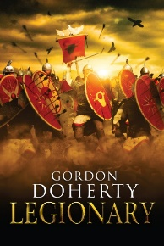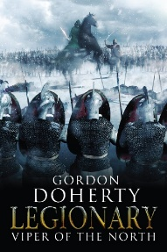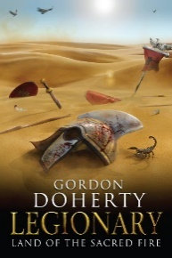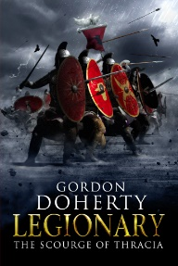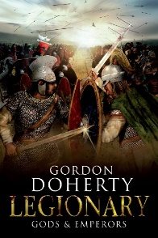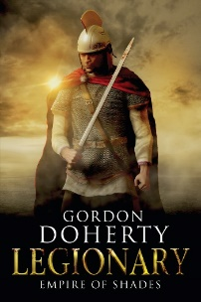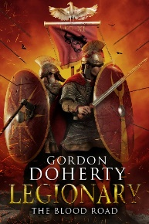

Feel free to get in touch with me at www.gordondoherty.co.uk
And you can follow me online:    

