Tommy Turkey by Uncle Chicken

Once upon a time, there was a turkey named Tommy Turkey. He enjoy learning in school and playing with his fellow turkeys.

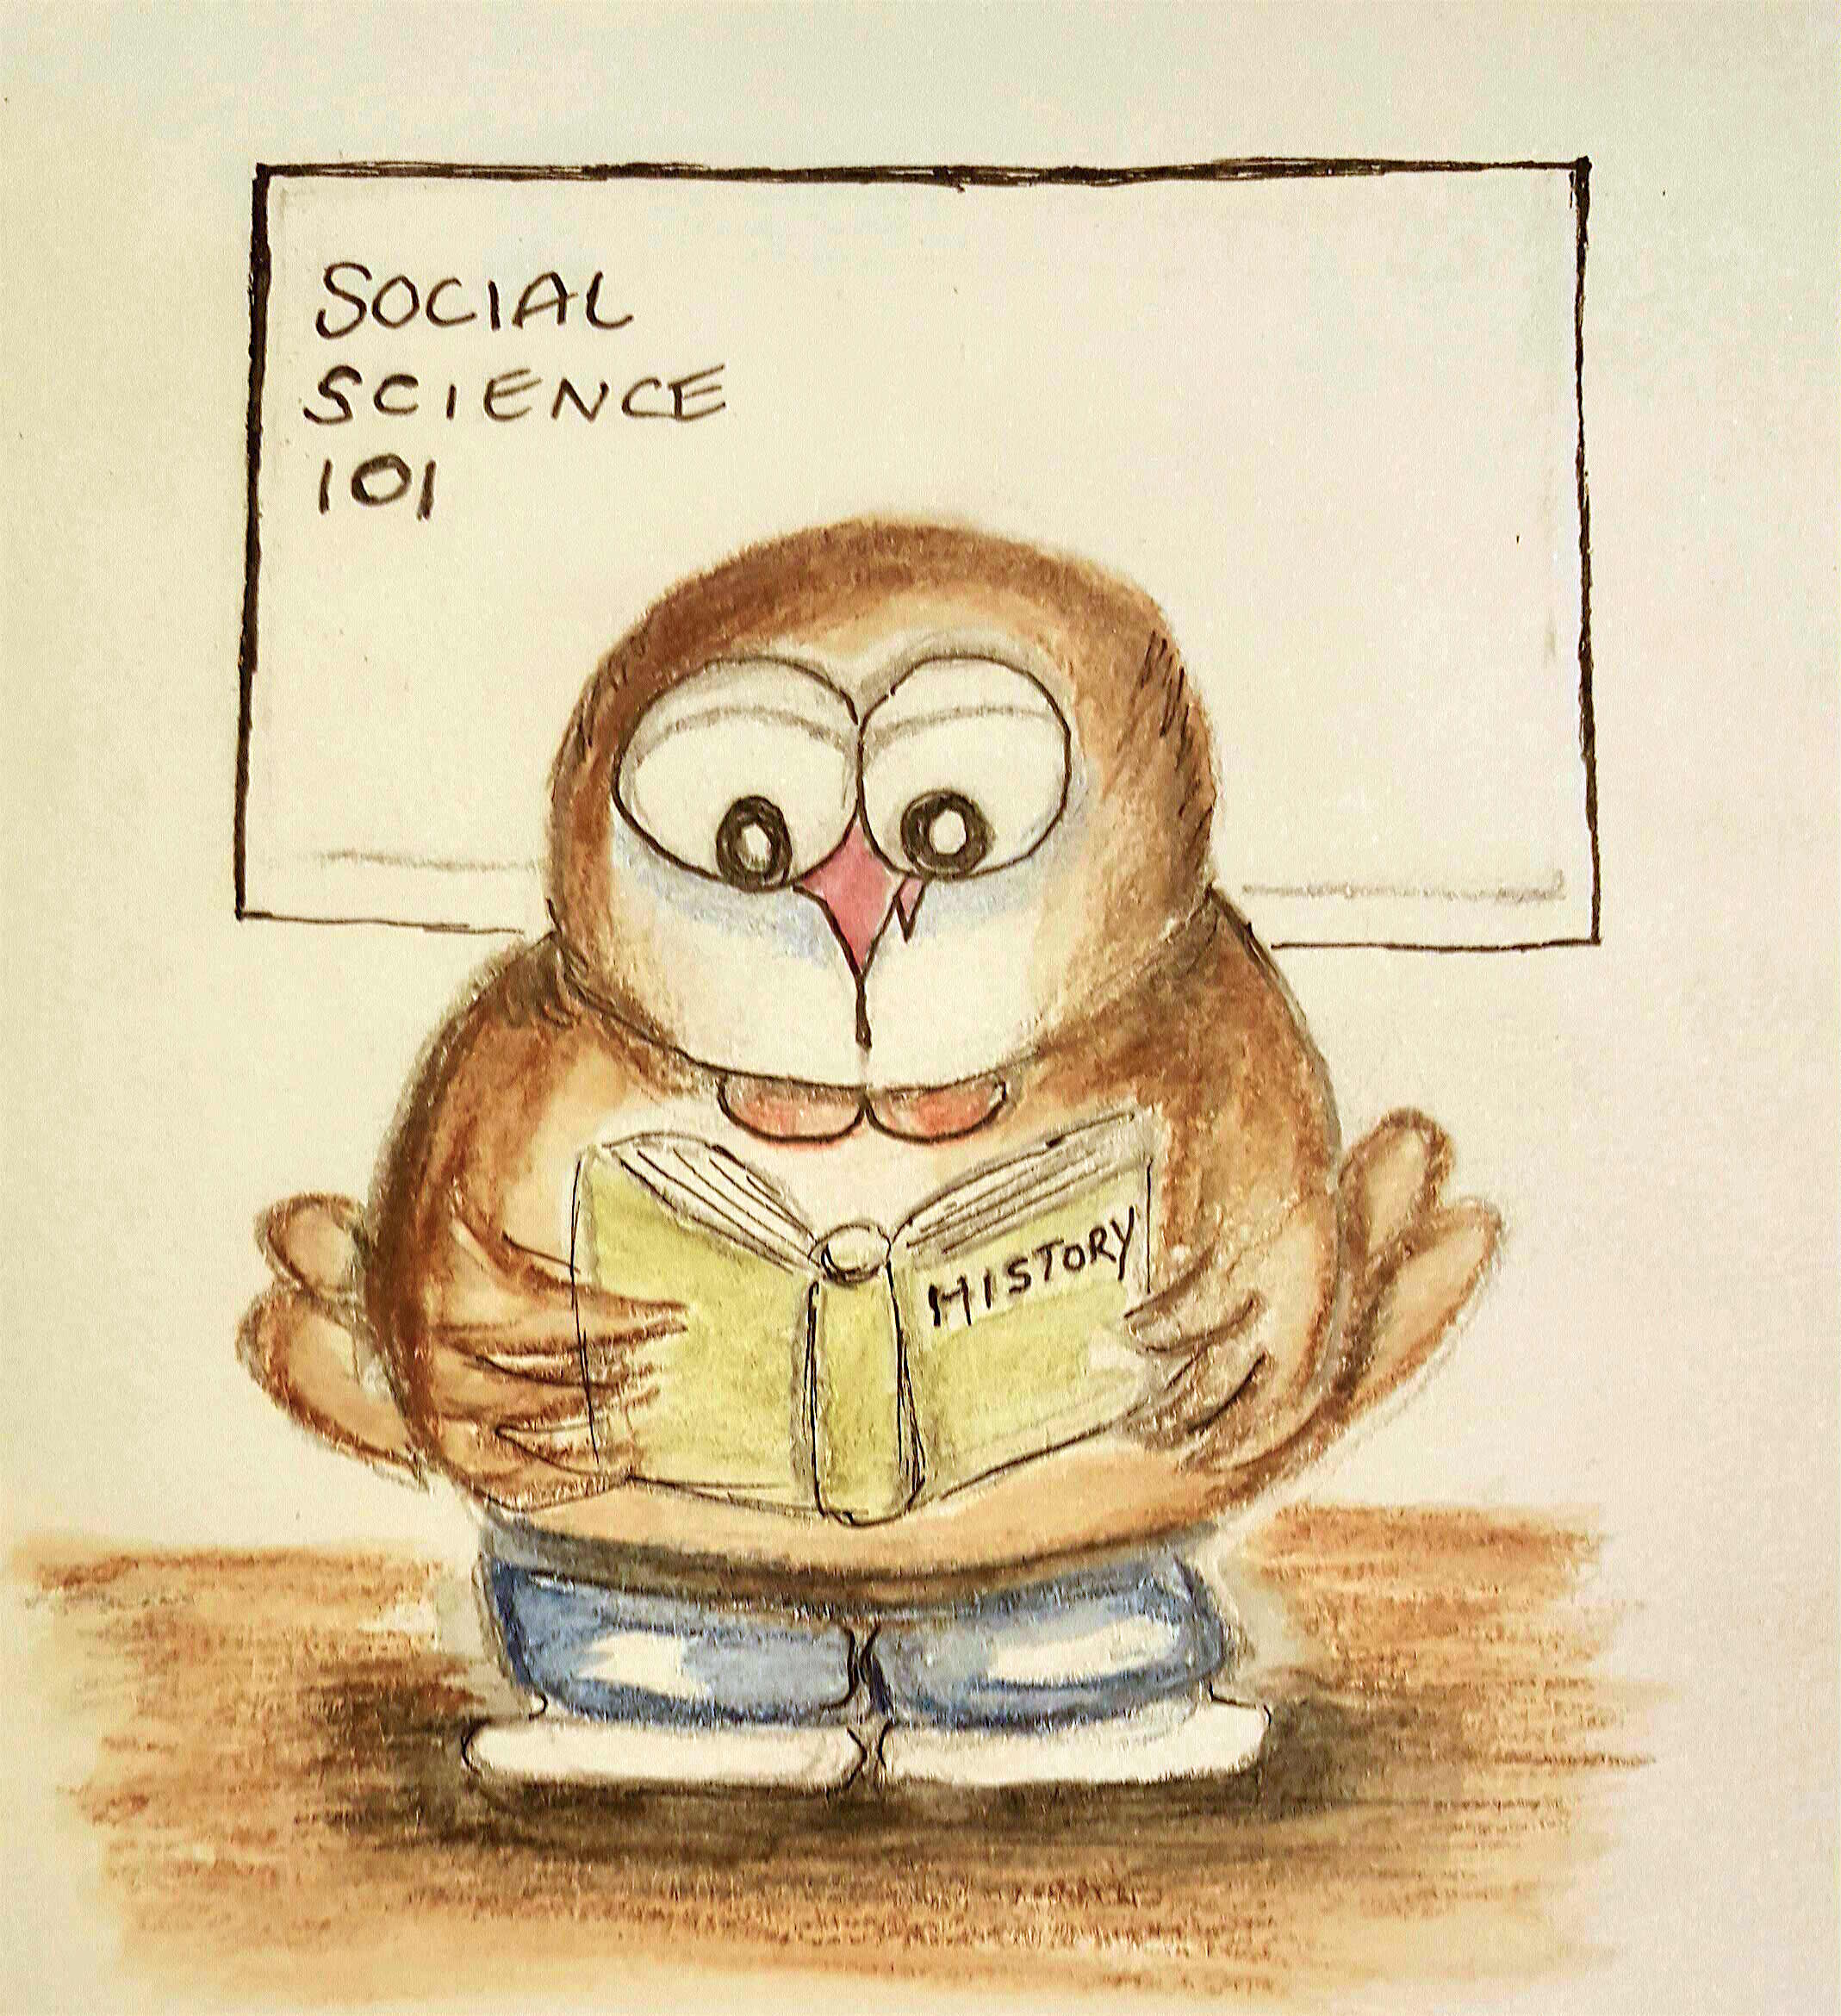

One day in Social Science, Thanksgiving was the topic of the day. Tommy learned about the early settlers in 1621 called Pilgrims and how thankful they were to Native Americans, the Wampanoag tribe, who help them survive harsh winters by teaching Pilgrims how to grow and harvest crops.

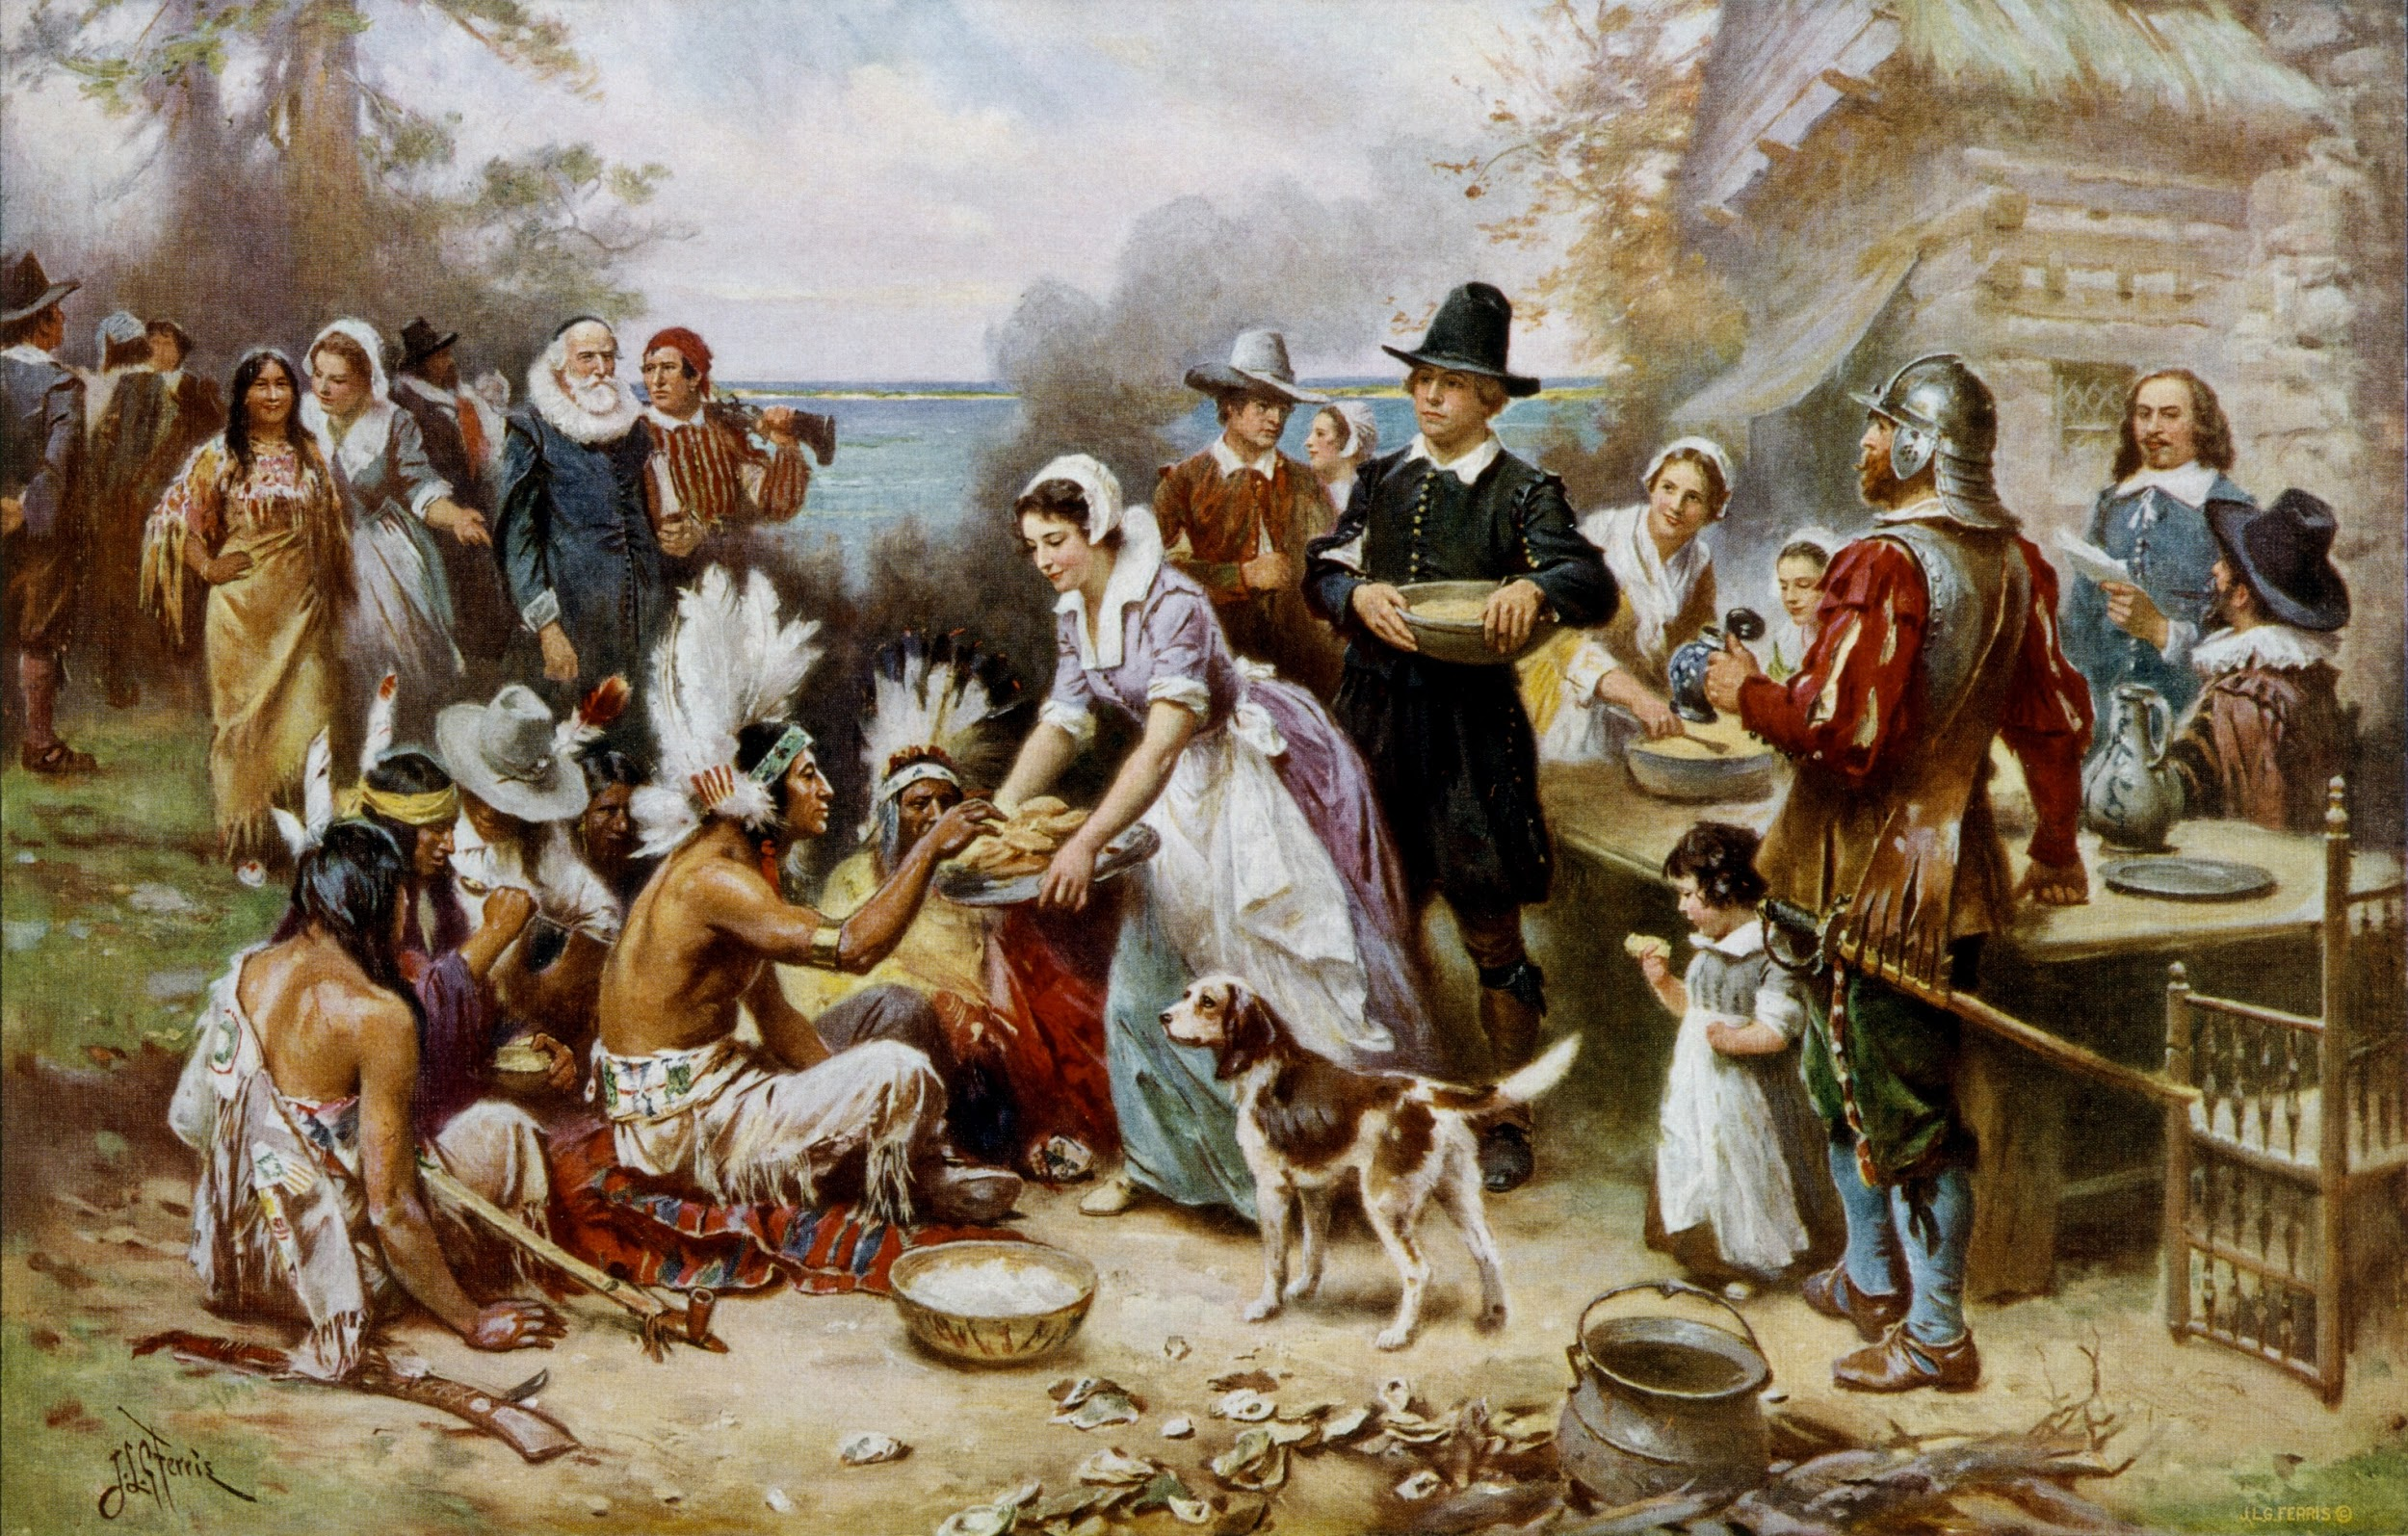

Thanksgiving led to a great feast. There was corn, squash, carrots, venison, shellfish, fish, and to Tommy’s horror...FOWL! In fact, he even learned that turkey wasn’t a popular main dish back then. He also felt upset that goose and duck were on the menu too.
After disturbing day at school, he approached his mother. “Mom, I now know why we stay away from the human world ... You never told us we were a food source.”

Tommy's mother looked at him sweetly. “You were going to find out eventually...but yes, that is why we don't associate ourselves with them.”

“That's a shame mom... We weren’t even the main dish! The Pilgrims were celebrating a good harvest with the help of the Wampanoag tribe…” Tommy passionately continued, “This holiday is about thankfulness and celebrating survival.”

“I know, I know dear... You need to calm down. Things are just the way they are now. So as long as we stay away from humans, then we have nothing to worry about.” Tommy's mother concluded.
Tommy couldn't sleep that night. He felt that people were misinformed and lost the true meaning of Thanksgiving. He had visions of him being the main course. He wanted to coexist with humans without fear.
He thought and thought all night long and came up with an idea that helped him finally fall asleep.

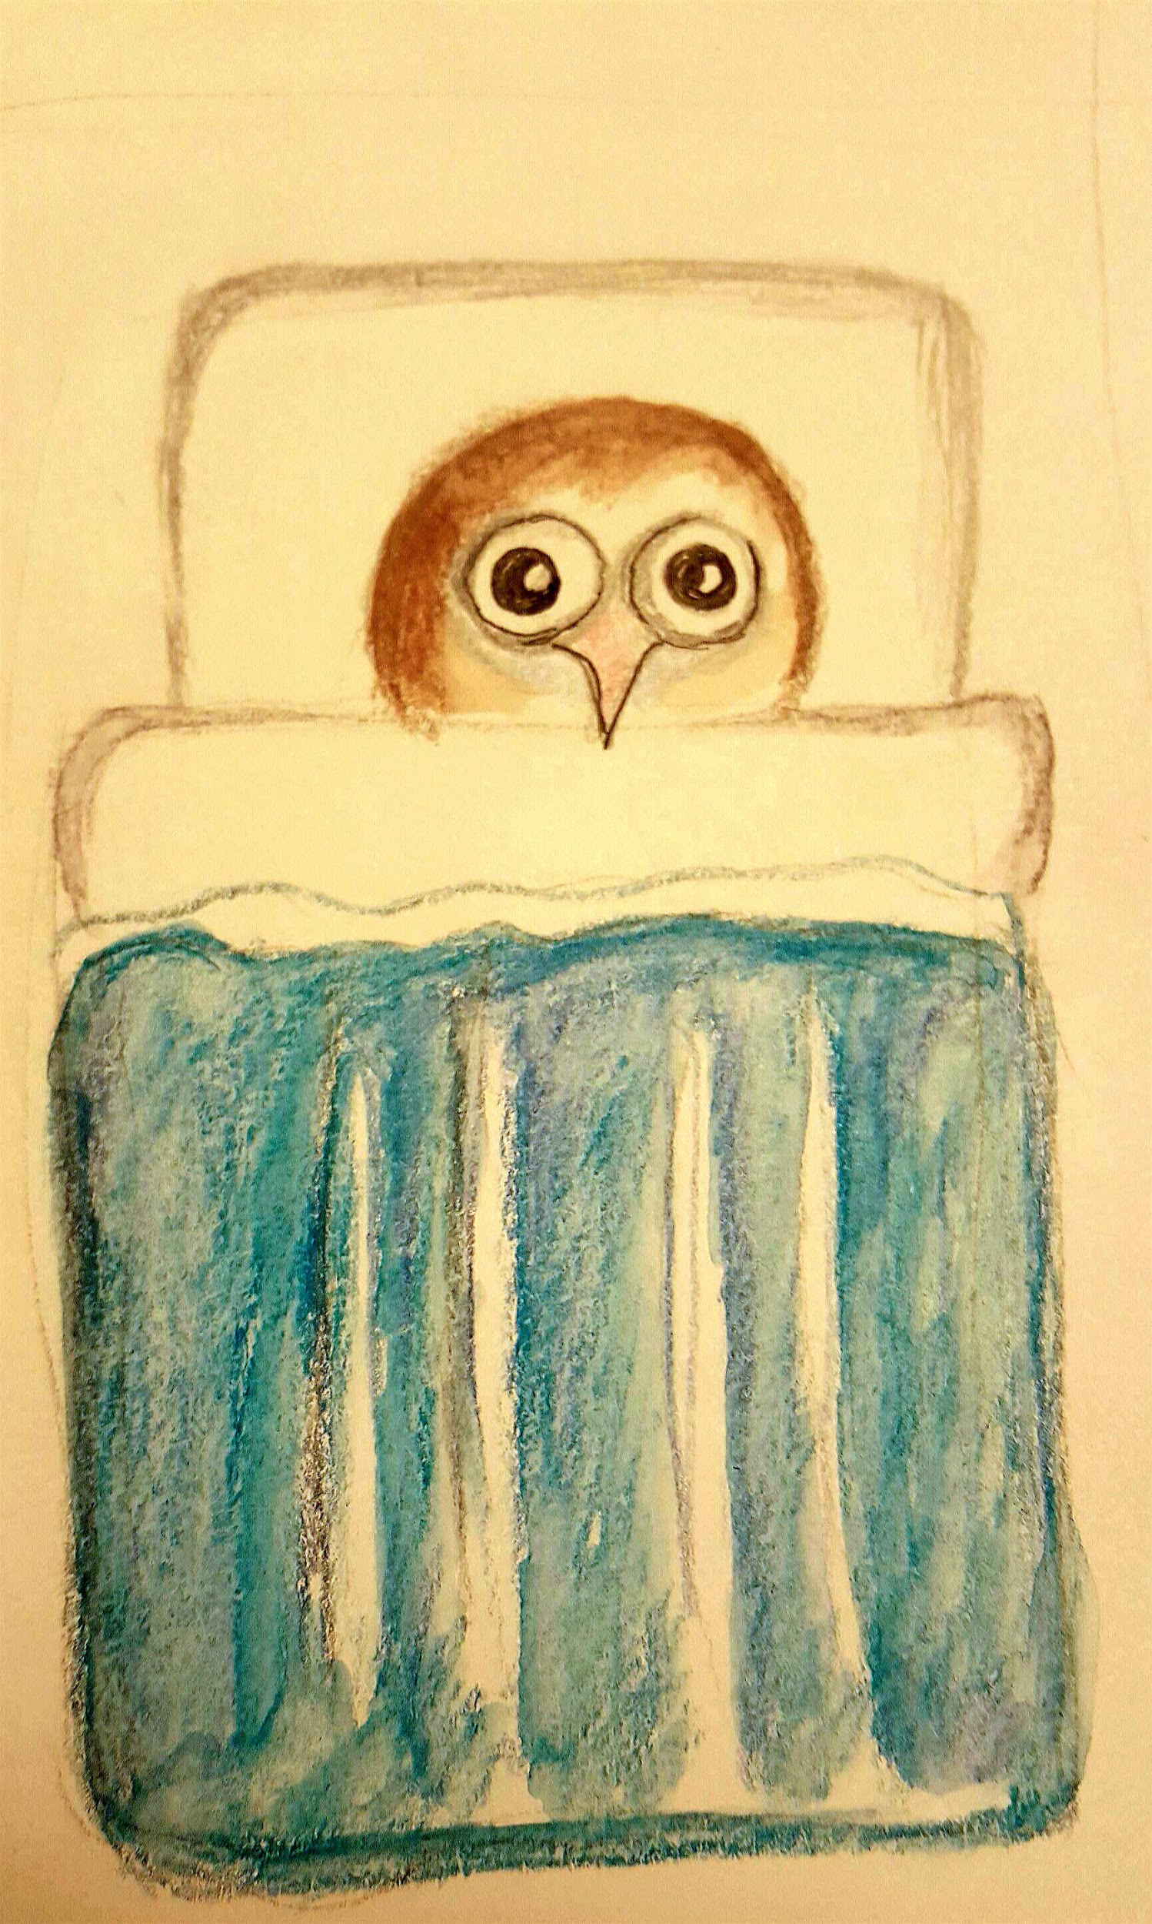

The next day, Tommy decided to bring up the Thanksgiving topic in Student Council. Since he was President of Student Council, he decided to tell the school that he wanted to make change. He stood up on stage and said that a turkey should be a symbol of peace. Turkeys should remind and re-educate humans about the true meaning of Thanksgiving. That way, it would solve the threat of killing turkeys. All the sudden, “boos” echoed throughout the school by fellow students. They thought Tommy was nuts. Discouraged, Tommy got off the stage and walked out of the auditorium.
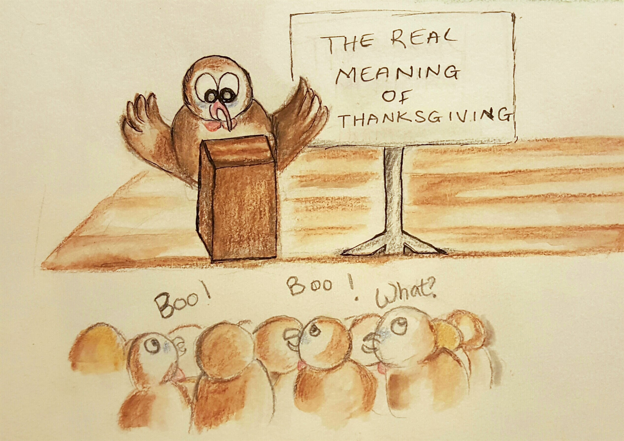

His best friend, Simon, spoke to him in confidence. “Look Tommy, I know you're a smart turkey but your speech was pretty lame.”

“Why would you say that?” Tommy asked defensively.
“First, how would you convince humans? They don't speak Turkey!” Simon remarked.
“I know that. I was going to talk about it but I got booed off the stage!” Tommy retorted.

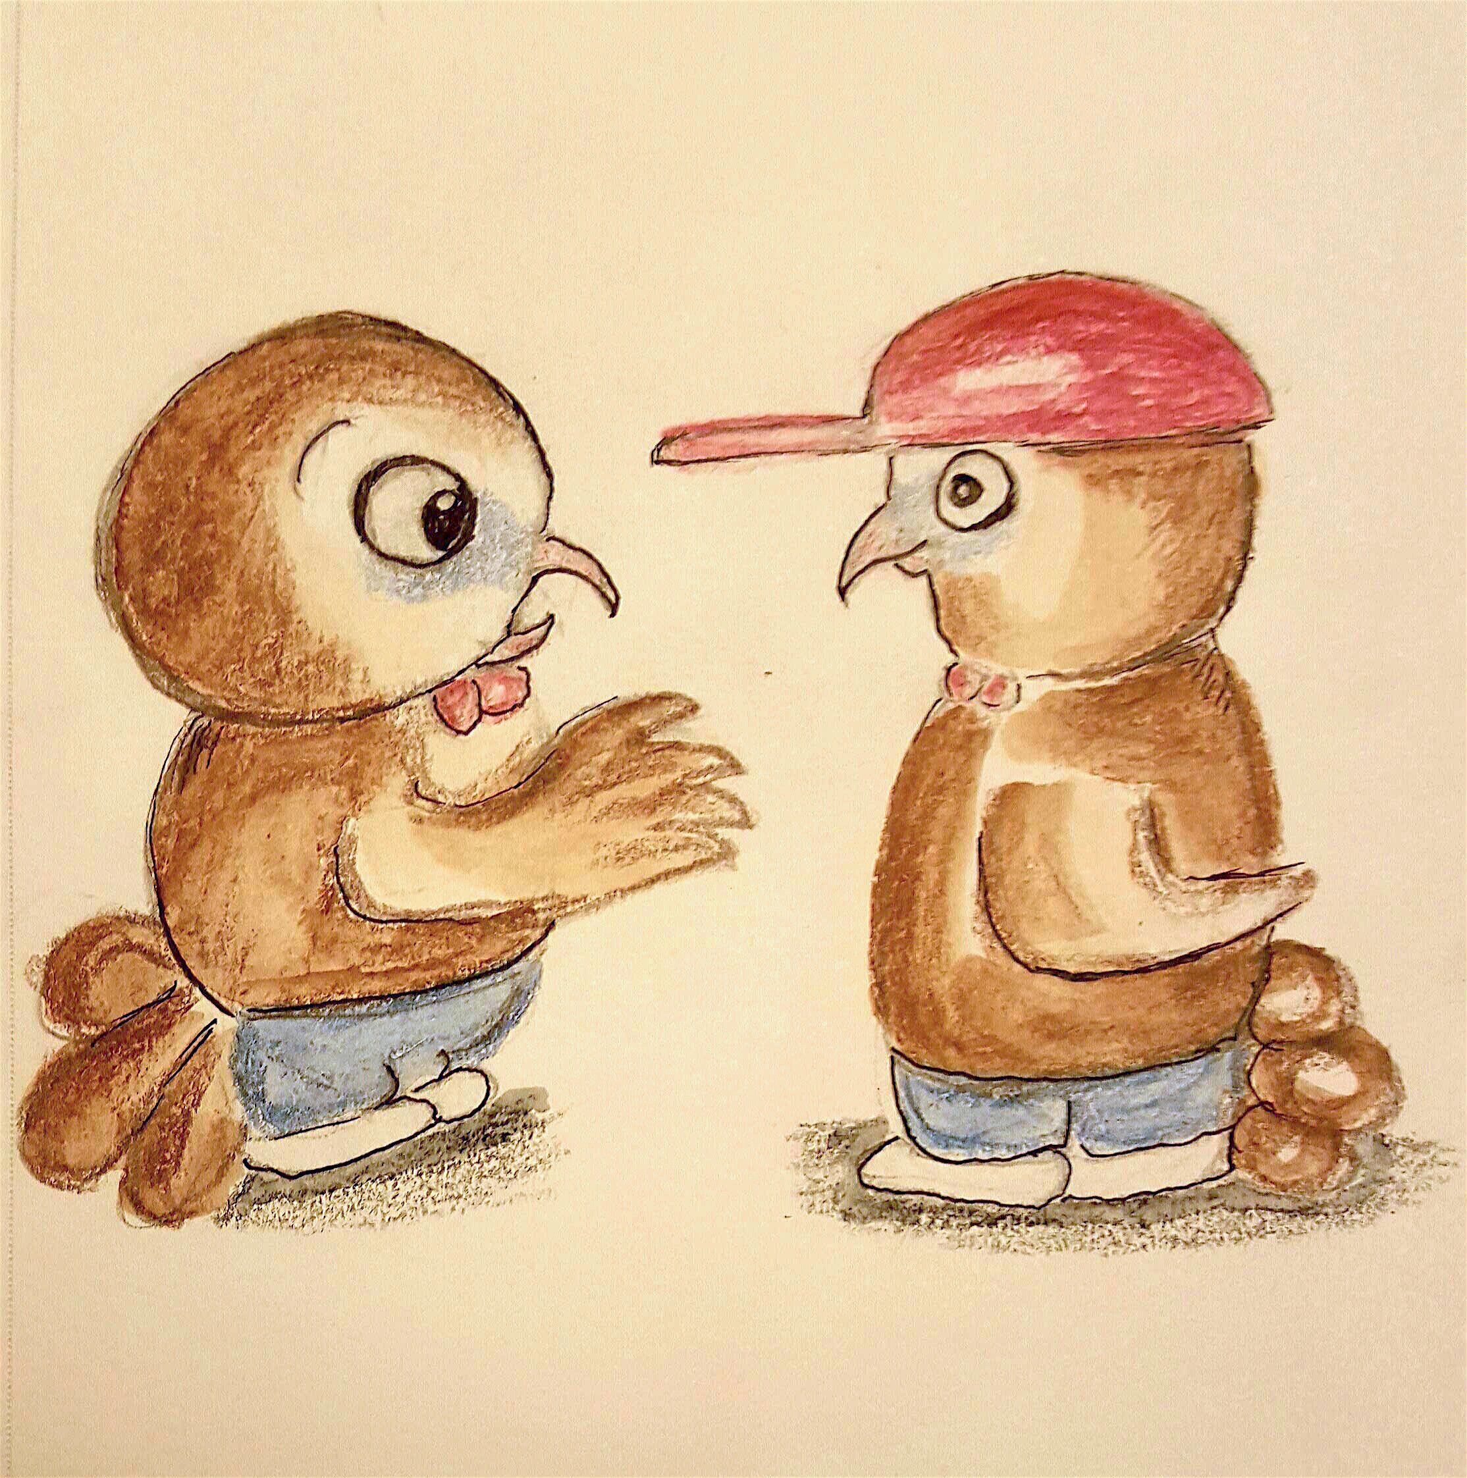

“Fine! I would love to see you do this….but don't say I didn't tell ya.” Simon said as he walked away.

“ I'll prove I can change the world.” Tommy muttered to himself.

But the truth was Tommy didn't have a plan. How was he going to approach humans?

********************

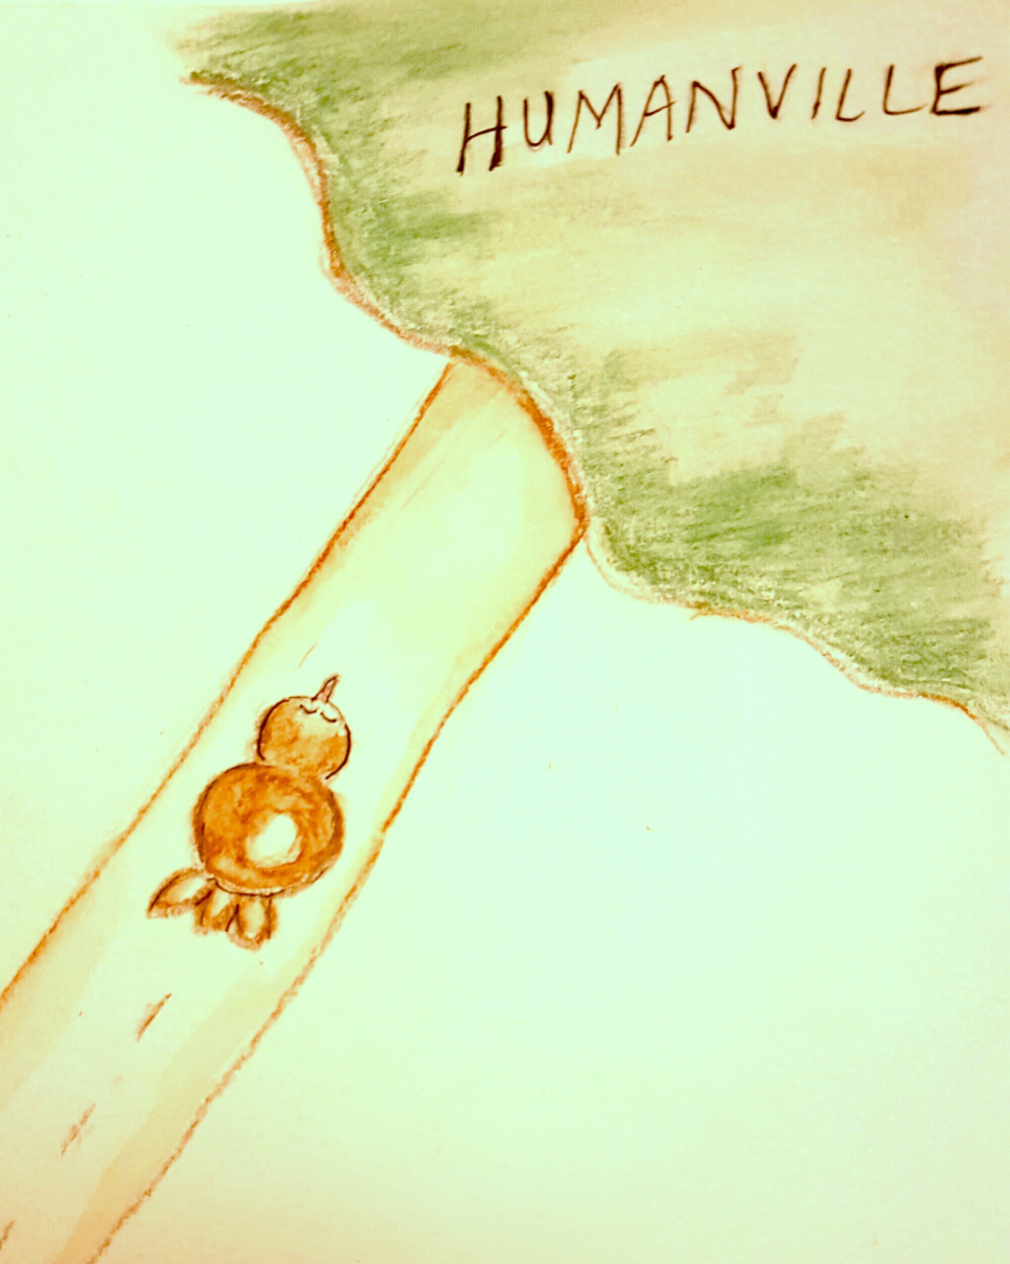

The next morning Tommy woke up extra early to start drawing a picture. Afterwards, he snuck out of the house and went to Humanville (a place where humans lived).

Tommy ran, hid through trees and bushes to not be easily seen. He reached a farm and saw a busy girl arranging pumpkins and butternut squash for the vegetable stand. He slowly walked toward the girl.

“Gobble! Gobble!” Tommy cried out to the girl. Slightly startled, she looked down and stared at him. Then Tommy handed her piece of paper and scurried away.

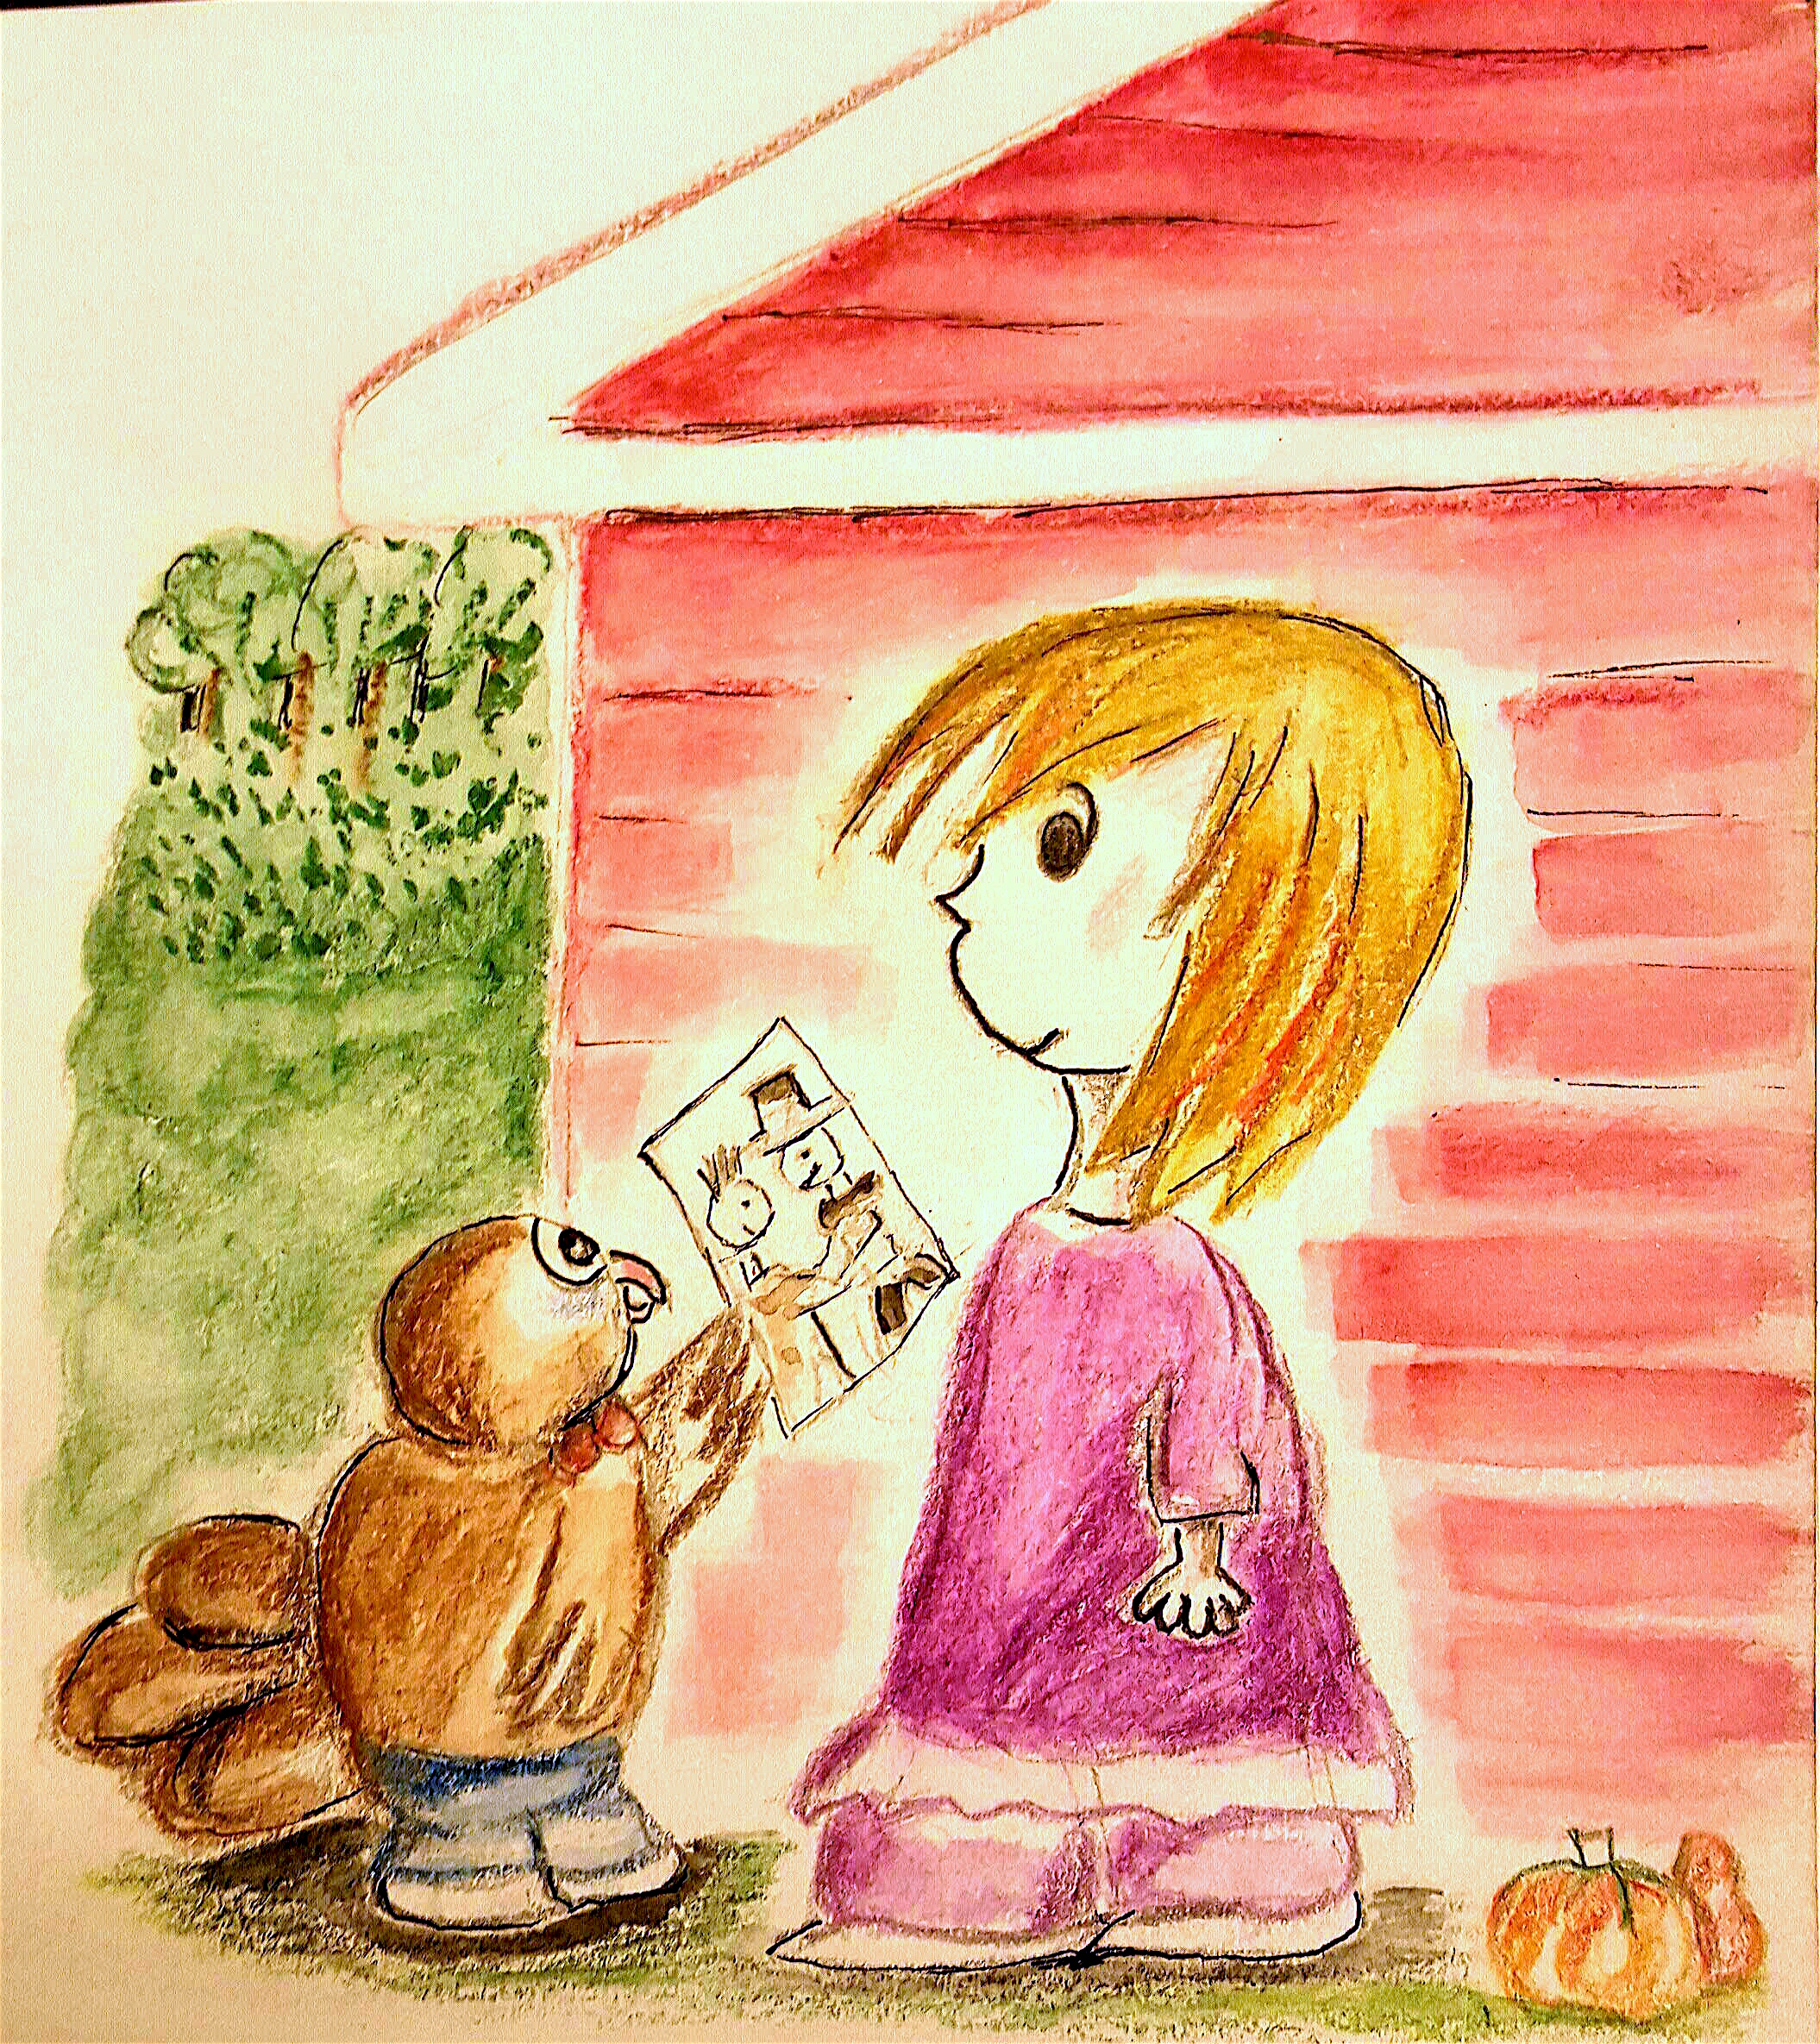
The girl was amazed by the turkey’s behavior. She looked at drawing and ran into the house.
“Mom!” She shouted.
“What’s the matter?” Her mom shouted back.
“Some crazy turkey handed me a picture! It's a picture of a handshake between a Pilgrim and an Native American.” The girl said with excitement.

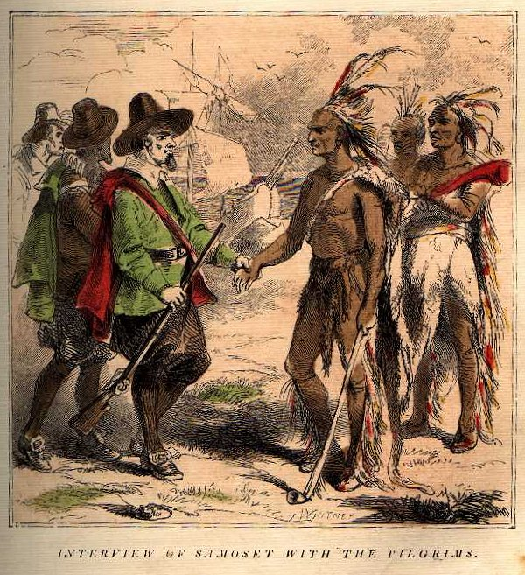

“Hmm... That is strange. What could it mean?” Her mother wondered as she looked at the picture.

Then after few minutes wondering, the girl finally said, “ I think the turkey wanted to tell me something... something about Thanksgiving. I believe he wanted to tell me about friendship. What else could it mean?”

“Smart Turkey. It is true that Pilgrims were thankful and established a friendship with the Native Americans. They helped Pilgrims survive by teaching them to grow and harvest good crops.” The mother answered confidently by recollecting her lessons in third grade American History.

“Well, maybe we should eat more vegetables... and maybe we should give people a flyer about the true meaning of Thanksgiving when they buy our crops. That way, we remind them about friendship and thankfulness!” The girl said with excitement.

*************************

The following week, Simon went up to Tommy in the hallway. “Good job!”
“Huh?” Tommy said cluelessly.
“Whatever you did, worked. Humanville has banned turkey eating for Thanksgiving.”
“Really?” Tommy said in disbelief.
“Yeah, some girl from Humanville started a commotion about the true meaning of Thanksgiving. This happened the day after your lousy speech. The word got out that turkeys had very little to do with the holiday.”

Tommy was ecstatic! Suddenly, a group of classmates grabbed and lifted him up shouting, “Tommy the Savior! Tommy the Savior!” Since then, Tommy never got booed off the stage. Most importantly, turkeys and humans lived together in harmony.

