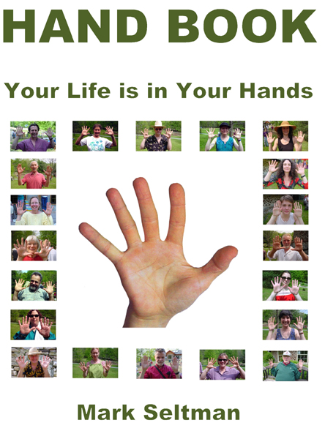
‘Hand Book’ (paperback) revolutionizes how people see their hands. Mark Seltman, master palmist, and author of ‘Real Palmistry’ (e-book), shifts the archaic paradigm of palmistry as a gypsy fortune-telling scam to seeing hands as a valuable way to know self and other. Priceless treasure is waiting to be discovered at the ends of our arms.
Mark logically explains how hands are topographical maps of our character and clearly shows us how our past, present, and future are embodied in our hands. Like a Myers Briggs personality test incarnate, the size, shape, and proportions of hands reveal a combination of four basic archetypes: Intuitive, Practical, Thinking, and Feeling. The texture, color, elasticity and consistency of skin and flexibility of joints explain how we initiate, maintain, and adapt to new ideas and circumstances. The proportions and lengths of individual fingers, phalanges, shapes of fingertips, and qualities of nails represent our relationships with others and how we are fulfilling our potentials in our world around us. Lines in the hands, dermatoglyphics (fixed skin ridge patterns), and gestures reveal more detailed information about our life choices and circumstances.
The arts and crafts of interpretation and counseling require study and practice.
Palmistry is simple and fun. You don’t have to be an expert palmist to see relationship, career, and health potentials in your hands. Self-knowledge and understanding will be acquired through a visual and tactile examination of hands. You must know what to look for and learn how to see it. ‘Hand Book’ will motivate you to look and teach you to see.
You can ask your hands: Who am I? What do I value? What do I want? What do I think? How do I feel? What’s my purpose? How can I improve my relationships? How can I be happier and healthier? What are my obligations and responsibilities? How can I prosper more? How can I be more creative? What do I believe? How can I be more spiritual? What’s next? You can become your own best friend and bull-shit detector.
The value of reading hands is in being able to readily and easily identify basic character and motivation. The mystery and magic of hands is that hands change as a person’s thinking and circumstances change. A tiny change in the direction or quality of a line can symbolize a huge change in a life. As we identify our strengths and weaknesses, we can alter our thinking, exercise our free will, and transform negative thought patterns into positive behavioral patterns. As we make decisions and take action, we can see our successes and failures reflected in the mirrors of our hands over time. After 5,500 years, the ancient science and art of palmistry will be reborn; initiating compelling new opportunities for people to interact and get to know themselves and others better.
In the 20th Century people asked “What’s your sun sign”? In the 21st Century they’ll ask, “May I see your hands?” The paradigm of palmistry as a gypsy fortune-telling scam will be dispelled. ‘Real Palmistry’ (best value) is a must read for anyone who’s curious about what their hands reveal about who they really are. It’s required reading for Mark’s next book, ‘Real Palmistry Stories’. Mark’s mission is to give you a helping hand, your own.
Mark Seltman has read tens of thousands of hands of people of every age, gender, race, color, size, shape, career, and socio-economic diversity. Mark’s been featured on The View, Martha Stewart Living, CBS Evening News, Lifetime TV, Queens, FOX Good Day NY, WNYC Radio, The Frankie Boyer Radio Show, New York Times, NY Newsday, Daily News, Village Voice, New York Magazine, Time Out New York, Manhattan User’s Guide, Family Circle, Modern Bride, INSTYLE, CRUSHfanzine, and Refinery 29.
Mark is also featured in the books: The Esoteric Guide to New York Psychic NY
The 100 Top Psychics and Astrologers in America 2014

