Prologue

Si vox pacem, para bellum.
If you want peace, prepare for war.

12th May 1999

A squad of masked men stormed inside the “Princess Margaret Hospital” in the Kwai Chung district of the former British colony of Hong Kong. They took the entire pediatric ward hostage. Their target, however, seemed to be only one of the little patients – the 7-year-old Chong Kang We, who had been admitted two days earlier as a survivor of a severe bomb explosion downtown. The patient spoke Chinese Mandarin with an accent that resembled the refined speech of Taiwanese businessmen who visited Hong Kong regularly.
Whenever a Mandarin phrase slipped the child’s mind, he would turn to Russian or another bizarre Slavic language. The ward’s only Russian-speaking nurse, an immigrant from the Vladivostok area, could converse freely with the patient. Nurse Novikova admired his fine literary Moscovite pronunciation, which she deemed far superior to her own Far-Eastern dialect. The bright trilingual Chong Kang We had been diagnosed with permanent eyeball damage. It was caused by metal particles caught in his unfortunate eyes during the devastating bomb attack against his family two days ago.
The assigned national police investigation team had already interrogated the father, Dong Pa Kang We, an influential man of mixed Taiwanese-American descent. No known terrorist group had claimed responsibility for the vicious attack. The raid had also taken the life of his Russian-speaking wife, Tatyana – the mother of the wounded child. The investigation was suspended in the early morning of 12th May with a single call from Beijing.
Captain Mingh Ka, a former colonial police captain of Vietnamese descent who had retained his position after the incorporation of his country into China, was also threatened with “severe consequences” if he decided to pursue Mr. Kang We’s case further. The middle-aged captain had gone pale, as he knew perfectly well what atrocities Chinese secret services were capable of. He dreaded the mere notion of those infamous “filtration camps” where disobedient civil servants could quickly end up.
Even “the bimbos at Beijing,” as Captain Mingh Ka called his superiors in the far-off Chinese capital, were well aware of the assassination scheme’s real target. It was neither the poor, innocent Chong nor his mourning dad, but rather the fearsome Tyan Kang We, Dong Pa’s supposed biological father.
They called Tyan ‘The Ghost,” and the man-made his fellow tycoons of the global elite tremble with fear. He had been the mastermind of the most top-secret, gruesome genetic projects in recent human history, those that paved the bath of modern biotechnology. The man was a trillionaire heir who claimed ancient “pure blood” and traced his heritage thousands of years ago.
The old Kang We was considered one of the most dangerous men on the planet. Osama bin Laden was deemed an innocent, harmless child compared to Tyan.
However, the old man’s offspring seemed scattered around the globe, with only a handful accessing the family’s riches. Dong Pa was a legitimate heir of Tyan’s kin and also belonged to an offshoot of the Rothschild family tree through his late Mom’s bloodline. He had come to Hong Kong to claim his Rothschild heritage, for all Capt. Mingh Ka was informed about this.
The Hong Kong police officer rightfully concluded that the perpetrators of the bomb attack in downtown Hong Kong must have been trying to lure Tyan by kidnapping his grandson. No Tyan had ever popped up anywhere near Hong Kong during those two days of suffering and fear after the attack. The old cunning man seemed to have failed to evacuate his family on time, and his innocent grandson was now paying the price.
The terrorist crew that had infiltrated the “Princess Margaret” hospital also knew all too well that Tyan or any of his numerous allies could strike at any moment. They were waving their guns at the crying nurses, but fear was eating up the hijackers from the inside out. Even their squad leader – a bucko under the alias “Rhein” looked somewhat nervous at the mere notion of the old man’s reprisals.
And then it came crashing down on them. Monstrous flashes of lightning lit up the sky above the gray building of the hospital complex, and violent winds and massive waves swept the piers of the harbor around the Kwai Chung area. Rhein looked out of a window on the second floor of the pediatrics ward and noticed something extraordinary. The blizzard was swirling directly above the hospital, the blocked roadway beside it, and the adjacent port. The sun shone brightly everywhere across the bays and headlands of the former British colony. Calm sea breezes gently ruffled the hairs of numerous passers-by.


It looked as though forces from another world had come crashing down the stormy skies to wage war on Rhein’s crew.

‘We have to get out of here, boys,’ Rhein said in flawless English to his masked companions.’ We stand no chance alone against what’s coming at us. Take the child and retreat!
The retreating crew was attacked from all sides in the narrow hallways of the ward. Infant patients cried hysterically at the sight of the bizarre creatures that had come to their rescue. These seemed to have stepped out of a lunatic’s nightmares: large teeth, elongated canine heads, dexterous limbs, and the incredible ability to stand on two feet whenever the alien individual decided to use any firearm or tool. No one in Special Forces training units had prepared Rhein’s crew for this vicious adversary.
The frightened cries of the nurses, orderlies, and children’s screams echoed through the rooms and hallways. Still, none of the newcomers seemed to pay attention to the background noise. Instead, they dispersed methodically throughout the ward and hunted down the hijackers’ squad.
Tyan still had trump cards, such as a rescue team from the other side of the universe. These creatures would never betray him on that foreign planet, for they bore no sympathy for any human besides his grandson. They mercilessly murdered the masked Special Forces operatives either by utilizing their brutally strong teeth or by shooting them down with simplistic laser handguns. The gadgets hit their targets with deadly accuracy.
One of the surviving hijackers simply abandoned all his comrades in arms. He was an Asian man of indeterminable age with short auburn hair, piercing gray eyes, and strange grayish scales that resembled badly rubbed tattoos on his bare elbows. The man hid in a tiny restroom near Chong Kang We’s location. That was the infamous “Rhein,” the leader of the crew. They would also address him as “Colonel Tong” or simply “Colonel”.
After a few minutes, another pack of dog-headed beasts materialized in a cloud of white light in the middle of the adjacent hallway. They immediately spread out across the ward. Their objective was simple – to drive their compatriots out of the building and wipe them away without causing too many human civilian casualties. This “counter monster team” was led by a rather frail-looking, thin creature of their species with intelligent brown eyes and some strange, brownish-yellowish clothing on its elongated body.
Rhein was joined by a short, swarthy Mongoloid with shifty eyes, a scarred face, and a black camouflage uniform. The newcomer asked the commander in a typical Russian street slang :
‘Colonel Tong, where did you dig these creatures up?’
The Russian-speaking Mongoloid had deliberately entered the room where the unfortunate Chong Kang We lay unconscious on his bed. In the meantime, Rhein had littered the surrounding hallways with smoke grenades to make any passage into that particular part of the ward as tricky as possible for the dog-headed creatures. It also hindered the advance of the Hong Kong National Guard, who had already arrived on the scene. The Colonel was walking through the suffocating white smoke with no gas mask, and he seemed relatively unharmed by the toxic gasses all around him. At that point, it occurred to the Mongoloid officer that all intelligence reports he had read had praised the ‘Rhein’ guy for his iconic physical endurance.
‘I’m saving your ass, Ulkhay,’ the Colonel replied in flawless Russian.
Ulkhay gasped as the pronunciation of their mysterious squad leader did not differ from that of a native Moscow resident. However, Tong had never spoken Russian during the last three days of that doomed Hong Kong mission.
‘The subject…’ Ulkhay pointed at the black-haired boy, who was sleeping with a blissful expression on the hospital bed, ‘He will wake up soon. This whole special operation was a terrible mistake. I have no idea why they sent me here…or any of us. That place is gonna turn into a slaughterhouse of civilians if those beasts out there keep raging on.’
‘The masters are never wrong. There’s always a Plan B’, Rhein nodded cunningly.
Before his departure to Hong Kong, Ulkhay Ulan-Tarsy had been presented with Russian intel that pointed out very little about this man. His name was said to be Colonel James Tong, a Hong Kong native of mixed descent and a prominent special operations agent trained and nurtured by the British. No hint of his personal life or past before he joined special forces had ever been found. It looked like the man had erased his troublesome history…or James Tong was just another alias. It did not matter then, as Ulkhay knew the initial operations plan had failed miserably. They had to run for their lives, and the Russian agent was in no mood for kidnapping children.
Rhein, or Colonel Tong, seemed quite relaxed despite the hopeless situation. He opened the door momentarily and pointed at the newly brought dog-head squad. The creatures could not endure the suffocating puff of white smoke, so they were actively putting on some dirty face covers that resembled gas masks. These were part of their equipment and were tailored to their elongated snouts. With the masks on, they had a tremendous advantage over their compatriots of Tyan’s death squad, who had brought no elaborate pieces of clothing other than their laser guns.
‘See, our reinforcements are better equipped than their foes. The soldiers of Leyna-Yassa from the Antarctic Corps will engage them long enough so that all survivors of our ranks can break away into safety. Then, Leyna-Yassa will retreat to the nearest star gate portal. Pretty simple, isn’t it?’
‘But these creatures… even the ones you call your allies… Something ’bout them really bothers me,’ Ulkhay’s voice trembled slightly.
‘What is it?’
‘While we were trained at our home military unit in Komi region, our instructors gave us a lot of valuable insights on aliens. Several species have established relationships with certain elites and intelligence agencies.’
‘Stop beating ‘round the bush, as we have no time for small talk!’
‘The main issue with those dog-like buddies is that, irrespective of their social status and objectives, they’re all men-eaters. They’d rather gobble up all innocent infant patients here than fight their own kind! The monsters will feast on human bodies!’
‘Oh, believe me, Leina-yassa hates all men-eaters and won’t take any of them in her ranks. For this reason, she’s turned away thousands of suitable recruits on her home planet, Uraban. I’ve seen it with my own eyes. So these guys wouldn’t bother with dismembering someone of the inferior race. That's what they call human beings.’
‘You fool, they all eat human flesh regardless of all the lies their commanders tell you!’
‘On the contrary! None of them needs it for their immediate survival. Their usual diet is based on the plants they grow…and some potatoes. They need no living being’s flesh to obtain their daily calories,’ the Colonel hesitated for a while,’ Flesh seems to be more of a drug to them, like alcohol, for example...or cigarettes to human individuals. You smoke, don’t you?’
He nodded to the small cartridge box on the Mongol’s weapon belt where the swarthy man kept a half-empty pack of Rothman’s cigarettes for “emergencies.”
‘If that’s the case, it’s even worse than I thought! They’d turn this place into a freaking slaughterhouse before any Hong Kong National Guardsman can counter them!’
‘Don’t jump to conclusions too quickly! Both squads mean business, not pillaging. They have no time for it. Plus, if you were fair right now, you would note that many places around the Earth don’t accept smokers or druggies. That’s the same rule Leyna Yassa imposed on her Antarctic Corps recruits. It’s just that her species’ counterpart of whiskey and cocaine happened to be human flesh.’
‘That’s sick and disgusting!’
‘Put emotions aside for a while!’ Tong snapped at him, ‘You see, claiming that all “akashassa” are cannibals equals to telling me that all people on this planet are smokers or booze addicts.’
‘You’re an arrogant brat! Too much tittle-tattle and no information about how we’re gonna get the kid outta here!’ the enraged former KGB officer sniffed.
‘Kang We Chong Asian names are always written down or spoken with the surname first in order. There can be single-syllable surnames, or multi-syllable ones (like Mingh Ka or Kang We). A person can have up to three first names as well (such as Dong Pa in the text above). The standard applies for all East Asian countries, and poses an integral part of their languages and culture.... What's your favorite piece of music, Ulkhay? What music do you and your wife love listening to?’
‘Well, my wife likes the opera “Boris Godunov” by Chaikovsky,’ the Mongolian replied with a hint of astonishment, grumbling indignantly,’ Why are you asking me some dumb personal question right now?! We’ve got an emergency here!’
‘Boris…’, the man rubbed his chin thoughtfully with his palm, ‘Such a great name. It belonged to a renowned Tursic emperor a thousand years ago. That’s it, we’ll give the name to this child once we transport it to its destination. We must weaken the Kang We clan at all costs. Taking away one of their descendants is a good starting point, right?’
‘And how are we gonna get outta here?’ Ulkhay turned to the most inferior form of Russian slang prevalent among the newer recruits in his unit who were still stationed at the wasteland of Komy.
‘I already told you. The evacuation of all survivors starts now!’ the colonel replied annoyedly,’ But I’m so proud of you, Ulkhay. You did help us a lot.’
‘What the hell are you talking about?!’
‘You just gave the boy a brand-new identity. We’ll teleport him with my special medallion and collect all your comrades on our way back.’
‘But the kid’s eyes... they’re in terrible condition. I know Mandarin quite well, so I took the time to read all the clinical data in the nurses’ notes.’
‘So what?!’ Rhein replied with a pronounced indifference in his tone.
‘The little Chong could go blind for life if you teleport him with your damned futuristic gadget! These things are dangerous, and you know perfectly well, you butcher!’ the Russian-speaking officer yelled at his visibly unblazed comrade.
The boy had just woken up and was wailing in pain and terror as the painkillers from the disconnected I.V. had stopped taking effect.
‘Dead or alive, he must be transported to the masters!’ Rhein insisted blatantly.
‘Over my dead body!’ Ulkhay pointed his machine gun at his comrade’s forehead,’ I’ll evacuate the boy to mainland China by car. We still have time while the man-eaters are ravaging the ward. He’s gonna undergo an emergency eye surgery at my expense in Guangdong. I value human life, unlike you!’
The Mongol’s weapon flew away from his hands and landed with a crash on the floor. The child whimpered and pleaded for help in something akin to broken Russian.
‘Do you wanna die for the sake of a pest, huh, Ulkhay?!’
‘For heavens’ sake, he’s an innocent child!’
‘He’s not even a real human being!’
‘You’re outta your mind, dude!’ the furious Russian officer cried and pounced on the colonel without further ado.
Ulkhay had been training sambo for seven years in his native Mongolia as a teenager and had almost become a national champion. His harsh training in the Soviet army and then Russian Special Forces had turned him into a murderous machine. He was a skilled telepath, one of the most talented in his country’s armed forces. None of his superiors knew why he had been sent on an absurd, suicidal mission abroad… to kidnap a helpless child. Yet he felt powerless when the slender Colonel Tong clutched him in his iron grip.
In a matter of a single minute, Ulkhay’s body was covered in bruises, and his face was pressed hard against the reeking oak parquet floor. It felt like an invisible heavy rock was pushing his entire body, crushing the poor fellow under its immense weight. The Mongol could barely breathe and could not even groan in pain. Blood was streaming from his mouth, and his nose was strangely crooked, obviously broken by the first blows of the Colonel. Every part of Ulkhay’s body was a knot of unbearable, inhumane pain. He could not use his telepathic abilities, as the Rhein guy was more robust and skillful than he could ever be.
Ulkhay heard the clattering of dozens of feet. With his peripheral vision, he saw the four-legged silhouettes of the ‘akashassa,’ as Tong called the beasts. If he had been able to lift his head, he would have seen blood stains on the muzzles of the Leina-Yassa’s boys. He could hear the guttural sounds with which this slender female creature scolded her subordinates.
Tong interrupted her speech and shouted loudly and clearly in the creatures’ language. His voice mimicked their animal-like, growling speech perfectly. Ulkhay sensed the creatures’ genuine surprise despite the fact he could not see the embarrassment on their alien faces. The Russian special forces officer was knocked to the ground and could not use any telekinesis to slip out of Tong’s clutches.
The last thing the Mongol saw before he lost consciousness was the helpless 7-year-old Chong. The crying kid lay in the arms of a short-statured creature whose body was covered in gray scales. The creature’s face had a distinct round shape, and its skull was slightly arched back. Its limbs were also disproportionately long and thin. The beast looked surprisingly frail... considering the savage beating the commando had suffered by his merciless fists. So this was the real identity of Colonel Tong, or “Rhein,” as his operational nickname was. He was no human being such as the dog-headed beasts under his command.
‘Ulkhay, Ulkhay, the orders of masters are to be obeyed, not twisted and disputed,’ the gray creature addressed him in flawless Russian, still maintaining the characteristic human voice of Colonel James Tong,’ Now fare thee well until we meet again!’
In the next moment, the child, the dog-headed beings’ battle squad, and the terrifying gray creature that had pretended to be a comrade in arms of the attacking party... all disappeared in a cloud of blinding white light. It was so unbearably bright that Ulkhay squeezed his eyes tight and started cussing desperately in his native tongue.
The creature and his comrades had left him behind at the mercy of the Hong Kong authorities. His comrades in the terrorist squad – all elite Special Forces veterans from all over the world – had perished in an unequal fight with the local National Guard and the Tyan Kang We’s “pretty boys,” the alien man-eaters.
To Ulkhay’s utmost relief, the latter did not get to him before the armed men of the local Hong Kong National Guard captured him. He almost embraced the masked Cantonese special ops servicemen.

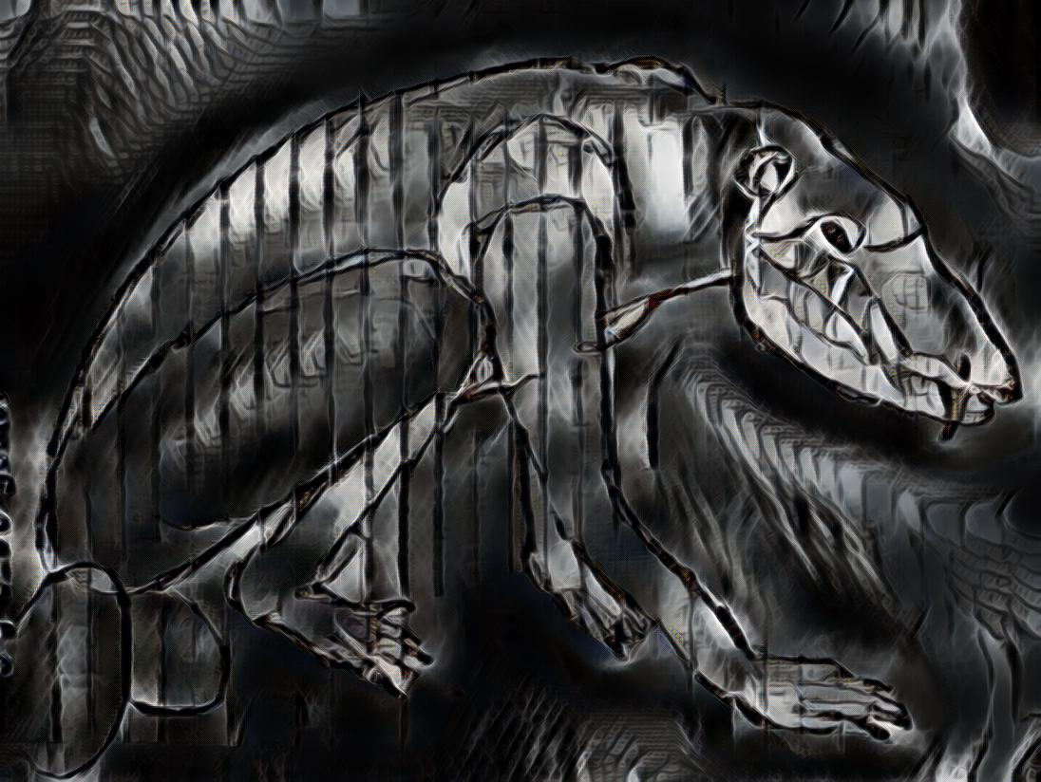

He preferred to rot in a Hong Kong jail rather than face the monstrous creatures who indulged so willingly in feasting on human flesh.

One of the northernmost peninsulas of the European part of Russia. Komi is sparsely populated with Uralic-speaking natives and Russian Siberian settlements. It is an autonomous regional entity inside the Russian Federation. Apart from mass timber production, this remote region is known for its abundance of military bases – many of which are top secret.

