1

Words
“In the beginning was the Word; and the Word was with God; and the Word was God.”
(The Gospel According to John)
“The word is a sign or symbol of the impressions or affections of the soul.”
(Aristotle)

L
anguage contains everything from history, to sociology, economics, philosophy, religious thought, even stories. Think of the word ‘community’ as meaning ‘common unity’. Language has been used and abused throughout history but it still reflects human destiny and reveals all that is known of life itself.
Language is ACTIVE; language USES us!
“The genius of democracies,” wrote Alex de Toqueville in 1840, “is seen not only in the great number of new words introduced but even more in the new ideas they express.” To which, in 1936, Willa Cather might be said to reply, “Give the people a new word and they think they have a new fact.” Let’s look at words.
According to Webster’s Dictionary, ‘to think’ means “to have the mind occupied on some subject; to judge, to intend, to imagine, to consider.” It is a transitive verb which means that thinking requires an object. As Paul Brunton stated in The Hidden Teaching Beyond Yoga, “…we cannot see any object without thinking of it as being seen. If it is to exist for us at all, it must exist as something that is perceived.” And he takes his case a step further. “We perceive the object because we think it; we do not think the object because we perceive it.” First the thought, then the thing. (For an in-depth and fascinating discussion of language and the origin of language verses thought, read Thought and Language by Lev Vygotsky in the ‘newly revised’ edition by Alex Kozulin.) The conclusion of this mini-debate is this. My very existence (as a member of the human race) is defined by thought and whether though or the object perceived comes first is for you to decide. Nevertheless, the use which you utilize the connection between thought and perception is directly related to mankind’s very nature which is social. We co-exist on this planet, for better or worse and we communicate with words.
“Man’s mind enables him to form concepts, use language, build societies and cultures; above all, it enables him to work in intellectual community (where)…the emotional and intellectual life of each man is sustained by his unity with others.”
(J. Bronowski’s review of Teilhard de Chardin’s The Future of Man)
Life is a journey. The base of the word ‘journey’, is ‘jour’ meaning day (from the French). Language reveals the journey, the daily experiences which are life. To be more precise, language reveals our own or some other person’s observation. The testimony of the senses leads us to accept multiplicity and change; every moment we see or observe a new image or mental observation of what we call life. A smell, a sound, a touch, each sense stimulates an entire storehouse of memory. These moments are what Friedrich Nietzsche called the “creative truths”. However, language is more than name-calling. Toni Morrison said in her acceptance speech for the Nobel Prize for Literature in 1993, “The vitality of language lies in its ability to limn the actual, imaged, and possible lives of its speakers, readers, and writers…. It arcs toward the place where meaning may lie.” We will explore what the “meaning” or the “creative truths” are as the chapters progress, but let it be established here that history is not dates and names.History is someone’s point of view, someone’sexperience in a particular time in the development (or decay) of the human race. It can be said that historical fiction is a combination of two nouns. The fiction being what is inside your or the protagonist’s mind at the time of an event. This being said, all history is therefore fiction.
“Novels arise out of the shortcomings of history.”
(F. von Hardenberg, Later Novalis, Fragmente und Studien, 1799 - 1800)
Let us return to another history, the history of words. Open a dictionary and explore. Mark Twain joked, “I have studied [a dictionary] often, but I never could dicover the plot.” Every word in the dictionary, however, has a plot of its own its etymology. We understand that individual words, especially nouns, contain history, sociology, economics, politics, drama, keeping in mind that they change and evolve with each generation and sometimes come and go and return in a new context. It can be very complex to attempt to follow the historical trail of a word. But let us begin anyway choosing a word that depicts the essence of what is called ‘life’. It is a word which is not static. Instead it reflects the flow which is life. The word is inspiration.
“Inspiration is more important than knowledge.”
(Albert Einstein)
“Inspiration may be a form of superconsciousness, or perhaps of subconsciousness—I wouldn’t know. But I am sure it is the antithesis of self-conscious.”
(Aaron Copeland)
Inspiration, as we shall see as the chapters progress can be said to be the alluring voice of creativity. Inspiration is also the genesis of the word ‘creativity’.
“Be but thy inspiration given,
No matter though what danger sought,
I’ll fathom hell or climb to heaven,
And yet esteem that cheap which love has bought.
Fame cannot tempt the bard
Who’s famous with his God,
Nor laurel him reward
Who has his maker’s nod.”
(Henry David Thoreau,
Inspiration, last two stanzas)
The etymology of inspiration is the Latin word, inspiratus, past participle of inspirare meaning to blow or breathe upon. Thus, if we follow the evolutionary/ etymological sequence through, creativity refers to the life-giving force: breath. When a baby comes out of the womb, he breathes for the first time on his own and begins life as we know it. Analogous to this birthing is the creative process represented by the writer, the painter, the musician or the dancer. Isadora Duncan, the great innovative interpreter of dance at the turn of the twentieth century, spoke of the “state of complete suspense” which proceeds the so-called spontaneous creative activity (dance or music or painting or writing). This non-verbal excitement, dreamlike, vague, ambiguous comes before the creative act or action. Stephen Spender, English poet and critic, expressed this time as “a dim cloud of an idea which I feel must be condensed into a shower of words.”
“All writing requires at least some measure of trance-like state: the writer must summon out of nonexistence some character, some scene, and he must focus that imaginary scene in his mind until he sees it vividly as, in another state, he would see the typewriter or cluttered desk in front of him…. But at times…something happens. A demon takes over…and the imagery becomes real.”
(John Gardner)
Be beguiled by your own unconscious mind. Allow the door to your unconscious to open, then watch what flows out on the paper before you and read the words in awe.
“It is our idleness,
in our dreams,
that the submerged
truth sometimes
comes to the top.”
(Virginia Woolf)
Take the word ‘idleness’ and respect it. Idleness does not connote laziness. It is our time to be silent and one with the world around us. The silence is golden when absorbed. “A man should learn to detect and watch that gleam of light which flashes across his mind from within, more than the lustre of the firmament of bards and sages.” (Ralph Waldo Emerson, Self-Reliance) What you did not know that you knew will suddenly come forth and you will begin to write and to write well. “A man never rises so high as when he knows not whither he is going.” (Oliver Cromwell) Isabel Illende, when she wrote the poignant novel/diary to her daughter, Paula, explaining herself, her past, her present, and her life as a writer, counseled that the writer must “believe the unbelievable.”
Once again, to quote the first great philospher born on American soil, Ralph Waldo Emerson, “We but half express ourselves, and are ashamed of that divine idea which each of us represents.” First, believe in yourself. Second, make connections; always make connections. Be aware of what you see, what you feel, what you smell. Sink into the scene. Be ready for and allow “unscheduled flights of fancy!” (Lucia St. Clair Robson, author)
God guard me from those thoughts men think
In the mind alone,
He that sings a lasting song
Thinks in a marrow bone…
I pray—for fashion’s word is out
And Prayer comes round again—
That I may seem though I die old
A foolish, passionate man.”
(William Butler Yeats)
To create is to give birth, the act of bringing forth something new. First and foremost, the artist/author/ musician/dancer is a human being. As such he or she is both created and a creator. As a creator, a person gives birth to something that the rational and language-imbued world has never known before.
As far as we know, the human is the only being who is conscious of being conscious. Not satisfied with just accepting what happens to us, we, as human beings, naturally inspect and challenge every move, every thought. Philosophers from Heraclitus to Plato, from the Buddha to Nietzsche have catechized and questioned the creative process. Friedrich Nietzsche, in Composition on Thus Spoke Zarathustra, wrote about the notion of revelation or the creation of a new idea. A new idea, he said, is something “profoundly convulsive and disturbing” which “suddenly becomes visible and audible with indescribable definiteness and exactness…a thought flashes out like lightning, inevitably without hesitation—I have never had any choice about it.”
According to the Buddha, “…as the mind returns to its natural state of integrity and non-duality, it ceases to clutch at experience with the symbols of discursive thought. It simply perceives without words or concepts.” (A note should be made here about the Buddha. To quote Joseph Campbell, “the reference to the life of the Buddha is quite secondary. The accent in Hinduism and Buddhism is the relevance of the symbolic forms to your own life. You understand these things inward to yourself.”) Following the Buddhist concept, you could say that the ‘truth’ comes like lightening as a flash of understanding (to paraphrase Neitzsche). It is outside of time and space. It is beyond words. Once the mind has perceived this ‘truth’ (Nirvana), it reverts back to reality (as we know it) and to discourse and the written word. James Joyce spoke of an “aesthetic arrest” or “stasis”. It is that point where you are aware of the silence within the very center of activity in the world and of the universe. It is there, he says (marrying the East with the West in thought) that “the mind is arrested and raised above desire and loathing” and “the world is recognized as a revelation sufficient in itself.” For Joyce, even (and most often) the most trivial things could be invested with “epiphanies”. In Portrait Of An Artist As A Young Man, the protagonist Stephen Dedalus says, the ‘soul’ or ‘whatness’ of an object or a gesture or a phrase “leaps to us from the vestment of its appearance.”
Plato, probably one of the greatest of all Western philosophers, 470–399 BC, using the voice of Socrates (who, like the Buddha, never wrote anything down and could represent more than one philosopher or thinker), stated that for art (by this we encompass any of the art forms including creative writing) to be truly noble, it must reveal “something of that essence which is eternal….”
Whether understood from an Eastern perspective or a Western conviction/belief/philosophy, it must be concluded that there is something very mysterious about the concept and the process of creativity. Isn’t it exciting to think that you, the writer, are actively involved in this, the very essence of life itself? To quote Nietzsche again, “For art to exist, or any sort of aesthetic activity or perception to exist, a certain psychological precondition is indispensable: intoxication.” (The italic emphasis is my enthusiasm being expressed visually. The etymology of ‘enthusiasm’, is, by the way, ‘in or of God’. So you see how individual words can speak volumes.)
The word ‘creativity’ seems to be an anachronism to the modern era of high technology with its computer networks, fiberoptics, complex and intrinsically specialized data bases, all of which require logical thought processes, a definite rationale, facts, and information. In this environment, it is difficult to justify, much less explain, the need, actually the necessity, to take time out, to ‘listen’ to the silence, to gaze in wonderment at a leaf or a flicker of light, to be quiet enough to be startled. Fear of sponteneity, nonconformity, irrationality, and the unconscious and subconscious mind has been encouraged by the gurus of computer literacy. Even they had, at one time, to wean themselves from the so-called mystical traditions, be they religious, philosophical, or even folklore.
Tom Robbins cautions, “…the mission of the artist in an overtechnologized society [is] to call the old magic back to life.” We will talk about magic later; just keep it in the back of your mind for now.
“Tools and techniques ought to be an extension of consciousness, but they can just as easily be a protection from consciousness. Then the tools become defense mechanisms…specifically against the wider and more complex dimensions of consciousness that we call the unconscious.”
(Rollo May, The Courage to Create)
Why are so many people frightened to not have the answers? Is the world so scary, so demanding, that we cannot take time out and even admit we simply do not know the answers? Inspiration comes from the roaming of free imagination, but it takes time.
I am writing on my PC computer which has Windows XP and Word 2003, plus many other exciting accessories. I have come to depend on this machine completely for everything from writing to reference, from fax to internet access. Last year, it was attached by a virus (personification in the computer world!). With sheer terror, I ran to my technical guru. “Save my novel,” I cried, loosing all sense of decorum and composure. Fortunately he did, but it was at great expense. I lost both time and money. Nevertheless, to benefit from the experience, I translated it as a sign/warning/omen. The real source of creativity was not my computer but ME! Some sick individual was taking great pleasure in sucking out my words one line at a time (the virus even made a sucking sound: “slop, slop, slop”) and the hacker didn’t even know me! My pleasure had been the process of writing. What was his (or possibly, hers)?
Benjamin Lee Whorf, an American linguistic scientist in the early nineteen hundreds, believed that there was no primitive language per se. Contrary to his contemporaries like Rudolf Steiner, Sigmund Freud, and Carl Jung, Whorf maintained that the structure of language one uses directly influences the way one thinks. “…[T]he content of thought influences the process of thought…so that generalization about process becomes impossible without content’s being taken into account.” Language, according to Whorf, is a “classification and arrangement of the stream of sensory experience which results in a certain world-order, a certain segment of the world that is easily expressible by the type of symbolic means that language employs.” By Whorf’s definition, there is no room for the non-verbal, dreamlike, spontaneous urge. Clearly his logic is appealing; but that is what it is, rational and logical. The computer acts the same rational way. It is programmed based on logic. However, spontaneity, the creative urge, something ‘new’ depicted by the artistic mind does not come from the machine or from logical deductions. Nor is creativity confined to the artist; it is also essential to the scientist and to scientific inquiry. “[N]ature is not perfectly rational and does not efficiently fulfill her own longing for perfection.” (Friedrich Nietzsche) The scientist, if he is going to discover something absolutely new, must be open to the concepts of inspiration, imagination, and creativity.
We have come a long way from the initial search into the source of creativity and even further from the search into the meaning and use of our medium; words. However, I hope my reader will consider the various arguments and opinions and continue to accept little and question all and everything. It is a healthy exercise and, at the very least, will prevent atrophy of the brain.
“As a human being (the artist) may have many moods and a will and personal aims, but as an artist he is ‘man’ in a higher sense—he is ‘collective man’—one who carries and shapes the unconscious, psychic life of mankind.”
(Carl Jung)
André Bréton, author of the Surrealist Manifesto (first edition, 1924), felt (perhaps thanks to Sigmund Freud) that “the imagination is…on the point of reclaiming its right.” Surrealism called up the irrational world of the subconscious to reveal itself through the medium of an art
form, be it painting, music, dance or writing. Way back in the fifteenth century, Leonardo da Vinci had already suggested “the possibility of self-revelation through automatic writing.” (Paul J. Sachs, Modern Paintings and Drawings) A more recent artist, Salvador Dali, is quoted as 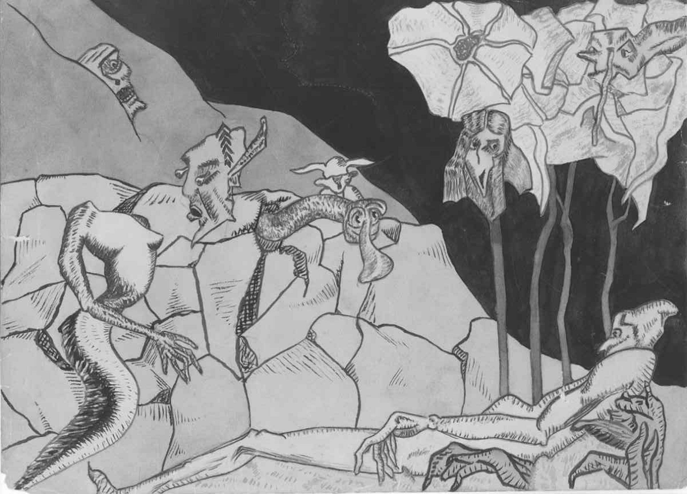
Untitled (c. 1925) Daly Highleyman saying once, “I am the first to be surprised and often terrified by the images that I see appear on my canvas.”
I do believe that deep down within our very being is the source of creativity and it is that very source which connects to the primal rhythms of the universe. There is no clear boundary between ourselves and the world which we observe. Watching the brilliant orange rays descend into a soft rosy glow at sunset; looking at bare, snow-covered limbs of a tree angling upward toward the sky; peering through the newly opened petals of a rose; all these pictures capture our imagination. The observer “plays a creative role in the observation.” (Robert Hand) So do not think you must have something to say before you put words on paper. Let the insights, visions, ideas happen in the process of writing.
“Writing is a process in which we discover what lives in us. The writing reveals what is alive…. The deepest satisfaction of writing is precisely that it opens up new spaces within each of us of which we were not aware before we started to write.”
(Nouwen, Reflections)
Look at the following picture and write keeping this Indian adage in mind, “All this struggling to learn, when all we have to do is remember.”
